QUESTION 1
- Select the correct description of right-hand and left-hand behavior of the graph of the polynomial function.
ƒ(x) = 4x² - 5x + 4
Falls to the left, rises to the right.
Falls to the left, falls to the right.
Rises to the left, rises to the right.
Rises to the left, falls to the right.
Falls to the left.
5 points

QUESTION 2
- Describe the right-hand and the left-hand behavior of the graph of
t(x) = 4x⁵ - 7x³ - 13
Because the degree is odd and the leading coefficient is positive, the graph falls to the left and rises to the right.
Because the degree is odd and the leading coefficient is positive, the graph rises to the left and rises to the right.
Because the degree is odd and the leading coefficient is positive, the graph falls to the left and falls to the right.
Because the degree is odd and the leading coefficient is positive, the graph rises to the left and falls to the right.
Because the degree is even and the leading coefficient is positive, the graph rises to the left and rises to the right.
5 points

QUESTION 3
- Select the correct description of right-hand and left-hand behavior of the graph of the polynomial function.
ƒ(x) = 3 - 5x + 3x² - 5x³
Falls to the left, rises to the right.
Falls to the left, falls to the right.
Rises to the left, rises to the right.
Rises to the left, falls to the right.
Falls to the left.
5 points

QUESTION 4
- Select from the following which is the polynomial function that has the given zeroes.
2,-6
f(x) = x² - 4x + 12
f(x) = x² + 4x + 12
f(x) = -x² -4x - 12
f(x) = -x² + 4x - 12
f(x) = x² + 4x - 12
5 points

QUESTION 5
- Select from the following which is the polynomial function that has the given zeroes.
0,-2,-4
f(x) = -x³ + 6x² + 8x
f(x) = x³ - 6x² + 8x
f(x) = x³ + 6x² + 8x
f(x) = x³ - 6x² - 8x
f(x) = x³ + 6x² - 8x
5 points

QUESTION 6
- Sketch the graph of the function by finding the zeroes of the polynomial.
f(x) = 2x³ - 10x² + 12x
0,2,3
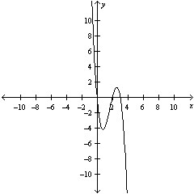
0,2,-3
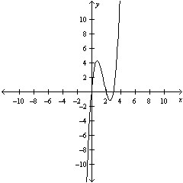
0,-2,3
0,2,3
0,-2,-3
5 points

QUESTION 7
- Select the graph of the function and determine the zeroes of the polynomial.
f(x) = x²(x-6)
0,6,-6
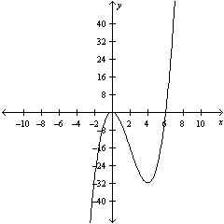
0,6
0,-6
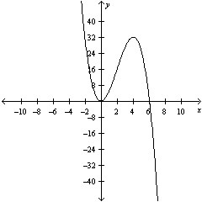
0,6
0,-6
5 points

QUESTION 8
- Use the Remainder Theorem and Synthetic Division to find the function value.
g(x) = 3x⁶ + 3x⁴ - 3x² + 6, g(0)
6
3
-3
8
7
5 points

QUESTION 9
- Use the Remainder Theorem and Synthetic Division to find the function value.
f(x) = 3x³ - 7x + 3, f(5)
-343
343
345
340
344
5 points

QUESTION 10
- Use the Remainder Theorem and Synthetic Division to find the function value.
h(x) = x³ - 4x² - 9x + 7, h(4)
-28
-27
-31
-25
-29
5 points

QUESTION 11
- Use synthetic division to divide:
(3x³ - 24x² + 45x - 54) ÷ (x-6)
6x² - 3x - 9, x ≠ 6
6x² -3x - 9, x ≠ 6
3x² - 6x + 9, x ≠ 6
3x² - 6x - 9, x ≠ 6
3x² + 6x + 9, x ≠ 6
5 points

QUESTION 12
- Use synthetic division to divide:
(x³ - 27x + 54) ÷ (x - 3)
x² + 3x - 18, x ≠ 3
x² - 3x - 27, x ≠ 3
x² + 9x + 18, x ≠ 3
x² + 9x - 6, x ≠ 3
x² + 6x + 9, x ≠ 3
5 points

QUESTION 13
- Use synthetic division to divide:
(4x³ - 9x + 16x² - 36) ÷ (x + 4)
4x² - 9, x ≠ -4
4x² + 9, x ≠ -4
-4x² - 9, x ≠ -4
4x³ - 9, x ≠ -4
4x³ + 9, x ≠ -4
5 points

QUESTION 14
- Use synthetic division to divide:
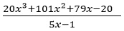
5x² + 45x + 25, x ≠ ¹/₅
16x² + 80x + 20, x ≠ ¹/₅
100x² + 45x + 400, x ≠ ¹/₅
20x² + 180x + 400, x ≠ ¹/₅
4x² + 21x + 20, x ≠ ¹/₅
5 points

QUESTION 15
- Find all of the zeroes of the function.
(x - 3)(x + 9)³
-3,9
3,9
-3,-9
-3,3,9
3,-9
5 points

QUESTION 16
- Find all the rational zeroes of the function.
x³ - 12x² + 41x - 42
-2, -3, -7
2, 3, 7
2, -3, 7
-2, 3, 7
-2, 3, -7
5 points

QUESTION 17
- Determine all real zeroes of f.
f(x) = x³ + x² - 25x - 25
-5,1,0
5,0,-5
-5,-1,5
-5,0,0
5,-1,0
5 points

QUESTION 18
- The height, h(x), of a punted rugby ball is given by 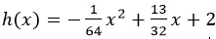 where x is the horizontal distance in feet from the point where the ball is punted. How far, horizontally, is the ball from the kicker when it is at its highest point?
28 feet
13 feet
18 feet
23 feet
16 feet
5 points

QUESTION 19
- The profit P (in hundreds of dollars) that a company makes depends on the amount x (in hundreds of dollars) the company spends on advertising according to the model.
P(x) = 230 + 40x - 0.5x²
What expenditure for advertising will yield a maximum profit?
40
0.5
230
20
115
5 points

QUESTION 20
- The total revenue R earned per day (in dollars) from a pet-sitting service is given by
R(p) = -10p² + 130p
where p is the price charged per pet (in dollars).
Find the price that will yield a maximum revenue.
$7.5
$6.5
$8.5
$9.5
$10.5

