Q1. Determine if the type of relation is linear, nonlinear, or none.
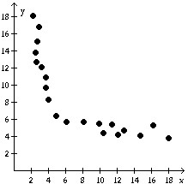
a. None
b. Linear
c. Nonlinear
Q2. Based on the graph, find the range of y = f(x).
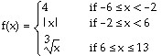
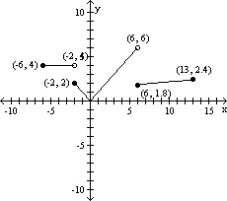<b
</b
a. [0, 6]
b. [0, 6)
c. [0, ]
d. [0, ∞)
Q3. Find the domain of the function.
g(x) = 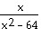
a. {x|x ≠ 0}
b. {x|x > 64}
c. {x|x ≠ -8, 8}
d. all real numbers
Q4. For the given functions f and g, find the requested function and state its domain.
f(x) = 2x + 1; g(x) = 5x - 2
Find .
a. ()(x) = 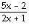; {x|x ≠ }
b. ()(x) = 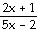; {x|x ≠ - }
c. ()(x) = ; {x|x ≠ - }
d. ()(x) = ; {x|x ≠ }
Q5. Answer the question about the given function.
Given the function f(x) = -3x² - 6x - 6, is the point (-1, -3) on the graph of f?
a. Yes
b. No
Q6. Answer the question about the given function.
Given the function f(x) = x² + 3x - 40, list the x-intercepts, if any, of the graph of f.
a. (8, 0), (-5, 0)
b. (8, 0), (5, 0)
c. (-8, 0), (5, 0)
d. (-8, 0), (1, 0)
Q7. Determine algebraically whether the function is even, odd, or neither.
f(x) = 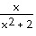
a. even
b. odd
c. neither
Q8. Determine whether the equation is a function.
x + 8y = 5
a. function
b. not a function
Q9. Determine algebraically whether the function is even, odd, or neither.
f(x) = -5x² + 4
a. even
b. odd
c. neither
Q10. Locate any intercepts of the function.
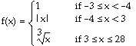
a. (0, 0), (0, 1)
b. (0, 0)
c. (0, 0), (1, 0)
d. none
Q11. Match the graph to the function listed whose graph most resembles the one given.

a. square function
b. cube function
c. square root function
d. cube root function
Q12. The graph of a piecewise-defined function is given. Write a definition for the function.
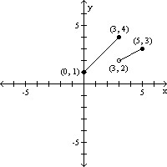<b
</b
a. 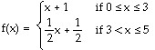
b. 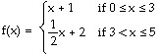
c. f(x) = 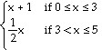
d. 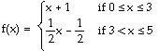
Q13. Answer the question about the given function.
Given the function f(x) = 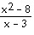, if x = -2, what is f(x)? What point is on the graph of f?
a. ; (, -2)
b. - ; (-2, - )
c. - ; (- , -2)
d. ; (-2, )
Q14. The graph of a function is given. Determine whether the function is increasing, decreasing, or constant on the given interval.
(-2, -1)
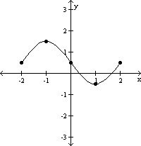<b
</b
a. decreasing
b. increasing
c. constant
Q15. Given: E=I/R and P=IE with the values: P=10 and E=100 What are the values for I and R?
a. R=.001, I=0.1
b. R=100, I=100
c. R=0.1, I=1000
d. Cannot be solved without the value of another variable.
Q16. Answer the question about the given function.
Given the function f(x) = -7x² + 14x + 4, if x = 1, what is f(x)? What point is on the graph of f?
a. 11; (1, 11)
b. 11; (11, 1)
c. -17; (1, -17)
d. -17; (-17, 1)
Q17. Find the value for the function.
Find f(x + h) when f(x) = 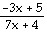.
a. 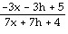
b. 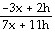
c. 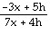
d. 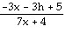
Q18. Determine whether the relation represents a function. If it is a function, state the domain and range.
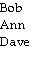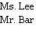
a. function
domain: {Ms. Lee, Mr. Bar}
range: {Bob, Ann, Dave}
b. function
domain: {Bob, Ann, Dave}
range: {Ms. Lee, Mr. Bar}
c. not a function
Q19. Determine whether the relation represents a function. If it is a function, state the domain and range.
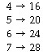<b
</b
a. function
domain:{16, 20, 24, 28}
range: {4, 5, 6, 7}
b. function
domain: {4, 5, 6, 7}
range: {16, 20, 24, 28}
c. not a function
Q20. Find the value for the function.
Find f(x + 1) when f(x) = 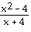.
a. 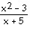
b. 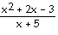
c. 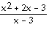
d. 