Introduction:
Streetlights are an important part of living in a city. They serve the purpose of lighting dark streets and sidewalks in order to help people see and deter crime. In Detroit, most all of the streetlights had not worked for about 4-10 years. So, in an effort to combat blight, the city set out a project to replace all old lights with new LED lights and aluminum wire instead of copper to make it less profitable for thieves to steal. There is a clear process for how things are done. First the process will be explained in detail, and following the explanation and flow chart will be provided to help readers visualize the project. In addition, to the explanation and flowchart, the first he steps of the Theory of Constraints (TOC) will be applied to the process of installing streetlights. Finally, the process before the Theory of Constraints will be analyzed and compared to the process following its implementation.

Process Description for Streetlight Installation
The process of replacing streetlights on thoroughfares is different from replacing lights in residential areas. First, the concrete must be either cut or jackhammered next to the existing steel pole to make an area for a new pole to be set. If the concrete is cut, a 2-man labor crew is needed because one person must spray water to keep the dust down. When using a jackhammer, there is setup time when it is taken in and out of the compressor and hooked up. Next, the concrete must be removed down to the dirt. If a saw was used this just consists of breaking the square that was cut into chunks and putting it into a dump truck. Normally this was done by the labor crew that was coming to dig the hole and set the pole. Next, when all the concrete was removed, a 2-man labor crew would hand dig a hole to fit the pole that was specified for that location. In this case, rather than being able to use the digger trucks with the automatic auger to dig the holes, hand digging was necessary in order to not hit gas, water, and electrical lines underground. If a 40’ class 3 pole was needed, then the hole would need to be 6’ deep and about 2-2 ½’ in diameter. After the hole was dug, the digger truck was set up and a pole was set in the hole and straightened. This process is repeated at each new location for a pole.
A crew of linemen would then come and wire up streetlights on the ground and attach them the aluminum masts. Then a lineman would go up in the bucket truck and attach the mast and streetlight to the pole. After all the lights were hung up, then the line crews would run triplex for the length of the thoroughfare on one side of the road and attach the lights to the newly hung triplex.

Streetlight Installation Flow Chart

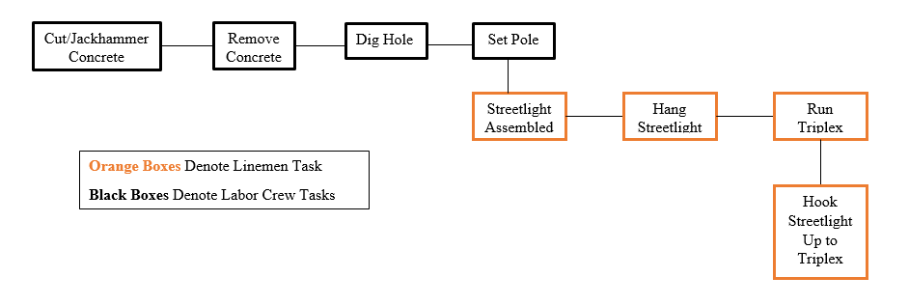

Identify the System Constraint
In this project, the constraint is digging the hole. As identified earlier one crew is responsible for each of the following tasks: removing the concrete, digging the holes, and setting the poles. The holes cannot be dug before the concrete is removed, and similarly, the pole obviously cannot be set before the hole is dug. Line crews can wire-up and hang as many as 20 lights in a day, whereas, a labor crew can at most put in 10 poles a day, but the average is around 4-6. If started to early in the process, the line crews can be starved for work because the labor crews cannot put enough poles in the ground to keep up. Some days can be very bad, you can hit rock hard soil, or you could run into a bunch of pipes and have to re-dig the holes sometimes 2-4 times. When murphy strikes it can slow down the whole project.
One of the biggest constraint causing issues is the idea of multi-tasking. Bad multi-tasking occurs in this project when labor crews have to cut the concrete, remove it, dig the hole, and set the pole. So if the project calls for 100 poles to be set and they are cutting and removing concrete, digging, and setting poles they are delaying each process from being completed which in turn delays the whole project. There has to be a way to alleviate bad multi-tasking from the project.
Another issue that plagues this industry is Parkinson’s Law. People will either not do as much work as they can, or they will not turn in all their work to avoid unreasonable expectations being put on them. The mindset in the industry is the quicker that I do the work, the quicker I am out of a job. So while some of the labor crews could put in 8 poles a day, they might only turn in 5 so that they are not expected to do 8 every day and face the possibility of not living up to the standards they set for themselves.

Exploiting the Constraint
Now that the constraint of digging the holes has been identified, we can work to exploit it. The biggest issue is that the labor crews that are digging are also responsible for cutting and removing the concrete as well as setting the poles. One way to alleviate some of the strain on the pole setting crews is to split this work up and have one crew that is only responsible for cutting and removing concrete, 2 crews responsible just for digging holes, and another crew that comes through and sets the poles. By removing some of the responsibility from the crews that are digging, it will allow them to focus on the task that takes the most time and hopefully increase productivity on the constrained activity.
The next thing that needs to be done to exploit the constraint is to put a system in place, so that while the crews are digging they know exactly what to do. The best crews have a system in place, but in order to exploit this constraint equally it needs to be applied to all crews. When workers first arrive at the location one worker grabs a tarp to put the dirt on and a round point shovel to start the hole. While one member of the crew is starting the hole, the other person on the crew needs to be setting up the rest of the tools and getting everything ready that will be used at the location. By the time the first crew member is done starting the hole, both can dig. This allows for the process to go smoother and not have a worker standing idle at the constraint.
If you have 2 crews that are just digging all day, then they might become upset that they are working so hard while others are not and would slow down as a result. It would be important to set up a system where the 2 digging crews would be rotated into both the cutting and removal as well as pole setting. By using a rotation, everyone stays happy and views the situation as a fair one.
To address the issue of Parkinson’s Law, it is important to cut the time that is currently set aside to complete these tasks. By cutting the time, it will decrease the amount of time people waste when they complete the task. According to Parkinson’s law, the work time will increase in order to fill the time that you have to complete it. If the crews do not have as much time as they did before, they will not feel like they have the ability to slow down and not turn in as much work as they can. With safety built into the project’s activities, workers feel like they have time to drag out the project. When that slack is removed, there is no time for the workers to waste. To make up for removing the slack time for the individual activities, the slack must be cut in half and put at the end of the critical path. This safety will act as a buffer in case the activities are not completed in the time given.

Subordinate Everything to the Constraint
While this is a project, I believe that some of the same principles of manufacturing apply to this particular project. In this case, the diagram listed above is repeated for each light that needs to be put up. So it is important to draw on some of the Drum Buffer Rope (DBR) principles that are often applied in a manufacturing setting. The Drum is the constraint of digging the holes, so everything needs to be synchronized to the output of digging holes. It is important to schedule the work of labor crews, more specifically digging crews, and understand that the capacity is limited. Now that the constrained resource has been scheduled, the rest of the project can be scheduled around the constrained resource. It is important to note that there may be idle resources outside of the constraint, but do not release more work just because they are idle. The only case where this is false is the cutting and removal of concrete. This job takes a lot less time than it takes to dig the holes. After the concrete cutting and removal is complete for the whole project, then the labor crew that was assigned to that activity can be assigned to help dig the holes. Normally this would fall under elevating the constrain, but in this situation there is no extra cost incurred because the workers were not going to be laid off.
In this case, we only have a completion buffer because the entire project is the critical path. So we take sum of the buffer from each activity that was removed, cut it in half, and place it at the end of our critical chain. This not only allows for a buffer time in case tasks take longer than expected, but it also allows for gains in time to have an impact on the system, where as they were not helpful before. In order for the buffer management system to work, the resources working on the projects need to report their progress and estimations of completion often throughout the project.

Project Comparison Before and After Implementation
Before the constraints management principles were applied, labor crews were asked to do a lot and this caused them to resort to bad multi-tasking. Rather than focusing on a specific job, they would jump from step to step. Now, some of the work has been offloaded from the constraint. In addition to work being offloaded from the constrain, workers will be rotated so that they will not be discouraged or become bored of just one job. Most importantly, a standard process will be implemented so that workers know exactly what to do at every stage of the activity, this will reduce the time of idle resources at the constraint. Not only will there be a process in place, but there will be additional resources that will be able to be applied to the constraint.
Now that the project has a process and the additional resources that will be applied eventually, we can see the impact that the DBR system will have. The work after the constraint will be synchronized to that of the constraint (drum). Our buffer is now at the end of the project so that, in addition to losses in time being realized, the project will also benefit from gains in the system.
Overall, we went from not having a system, the constrained resource being overloaded, and having lots of slack time embedded into the project’s activities, to now having a formalized system to avoid idle time at the constraint, separate tasks that were offloaded form the constraint, and to having our slack be more responsibly accounted for. Overall, the project’s time should decrease considerably due to the changes that have been made.

