Task 1 {1.1}
Talabat.com applications is the site for ordering food online gives customers the chance to search for nearby restaurants for their areas and browse lists of various food to order food with online payment options or cash upon receipt of the request. Website services are available to all through computers and mobile applications iPhone, Android, and iPad.
Talabat.com Applications Company was founded in 2004 by a group of young entrepreneurs who have had the vision in the development of ordering food online in the Kuwaiti market. And a decade later, it became the requests website is a leading company in the Food Ordering Online in the Gulf Cooperation Council (GCC).

-Talabat company benefited from e-marketing by marketing more effective, and more profits as the company relied on Internet marketing to showcase their products and services across the Gulf states without interruption, giving this company a greater opportunity to take profits, in addition to access to more customers.

Talabat Company made through e-marketing has many advantages such as:
-Access to a large base of customer data through mailing lists and messages that come on the company's web pages.
-The possibility of targeting specific layers of marketing and targeting different age groups as well.
-Increase awareness among users through the comparison between products on different sites.

E-marketing: it is a commercial deal based on the interaction of the parties to exchange electronically rather than direct physical contact, and is one of the newest ways and means used by companies or Institutions to promote goods and services.

The advantages of e-marketing:
- Access to customers in the short period of time by writing the contents of the marketing of the product or service in the websites and blogs.
- The possibility of the completion of the sale and purchase operations without the need for Buyer to go to item place, as you can quite easily get information about any good.
E- Marketing is characterized by low cost in most cases-
It enables the company to determine the budget that you want by spending.
- Comparability between more than one sites offers the same this item for while getting the most competitive price, with access to some facilities for shipping and other expenses.
- E- Marketing more effective than normal marketing, especially for small businesses that do not have the physical components of the normal marketing such as television, radio or roads ads.

-Despite all these benefits and others, however, e-marketing as well as a number of negative points:
-The Internet may not be the most appropriate means for everyone due to the lack of consumers keep up with development and technological progress.
-Also e-marketing may be unacceptable to some people for the purpose of purchase or sale, in which do not receive acceptance from the consumer side, where some people cannot put trust in some electronic sites due to the spread of many front companies.
-In addition to the use of personal information, a trader for the person with the Internet, can be used in a negative way because of hacker the lack of confidentiality and presence in the deal, and the porosity of devices and customer information and manipulation of the owners.
Comparison between e-marketing and offline marketing:-
Offline marketing | e-marketing | Comparison
Offline marketing: is marketing a product or service to a company or organization by sending a delegate to the customer or through television, newspapers, radio and print ads. | E-Marketing: via the Internet is a marketing service or to a particular product or company through the Internet to access online customers. | Definition
lower cost | High cost | cost of marketing
The difficulty of communicating with customers. | Ease of communication with customers using e-mail and the Internet and other means of communication. | Communication
You cannot order the product directly to it be by customers and other service. | The possibility of product or service Order directly send a request via the website of the company. | Demand for product
Lack of customer retention | making permanent customers | Continuity customers
Hard to follow customer reaction | Is easier to track customer reaction via the website, also know their opinions about products through other websites especially social sites such as Facebook and chat rooms | Follow-up Customer Reviews
Timeliness of the campaign a certain time limit, there must first be a headquarters for the company to receive customers and then begin the campaign. | Ease of work at any time even if there is no headquarters for the company because it also can buy and sell via the Internet. | Time marketing campaign
Is not possible follow-up orders directly. | Ease of follow-up orders directly and quickly received requests. | follow up
Number of Customers is relatively small because the local marketing only on a small scale. | A large number of customers because the e-marketing opens new markets for its products globally, not only at the state level. | Number of Customers
The results in a long time and earn new customers slowly. | The results in little time and gain new customers in quick time. | Results

-This comparison between e-marketing and offline marketing illustrate the importance of e-marketing companies, locations, and the owners of the products with the advancement of technology we see that e-marketing plays an important role in the economy, companies trade is today has become dependent on the means of new technology world of the internet opens up a window to move from the local trade to the World Trade.

Task 2 {1.2}
In this task evaluate Talabat.com for the use of the marketing mix, but you must know what marketing mix is: known as the marketing mix framework helps in the development of a methodology to deal with each market. Mix is a set of variables that are presented to the customer, including product or service features, and availability.
Also the marketing mix is how to put the product or service at the right time and at the right price and for the appropriate age group. It consists of seven elements, namely, (product and price, place, promotions, people, process and physical evidence).

First: product: are anything whether physical, tangible and diverse like commodities, or ethereal and intangible different such as services, can be provided to meet the specific needs and desires of the consumer.
Talabat.com achieve the main dimensions, namely the physical dimension and of all formal elements and objective of the site design, size, and color, and the atmosphere, all of which are considered concrete elements, while the second is the symbolic dimension, a side of an intangible product, but the consumer is usually looking his psychological or social reasons.

Second: Price: is that part of the physical-income consumer who is willing to compromise with him for the sake of obtaining the product (utility) and price evaluates the product, any product value is determined at the price.
Talabat.com Managed from the application of the marketing mix element which is the rate by setting prices fit the consumer and be accessible to everyone, and is placed after the price, inter alia, cost accounting and profit tax policies please add social and moral responsibility towards the society.

Third: Promotion: is the sum of activities and processes aimed at consumers definition of the product, and to promote many functions, including the characteristics of the product news consumers and how to use, and features compared to competitors products, and also information on where and how to get the product.
Talabat.com made marketing mix element which is promoted through:
-Made receptive consumer of the product and tried to remove what has been courting doubts about the product.
-Strengthen the positive side and try to weaken the negative impression about the product and achieve the highest possible percentage of sales.
-The announcement of a new product or service in ways acceptable to the present-day society and to suit all segments of society such as: advertising drama of YouTube channels and advertising in social networks.

Fourth: place: place is all activities associated with the transport of products and goods and services moved from production to places where they are used, any of the product to the consumer.
Talabat.com made distribution element in the marketing mix through:
-Achieving temporal benefits through insurance products at the right time through the store and put it upon request, it provided an opportunity connected to eating and products for homes and in the short period of time. In addition to identifying the sites and places covered by the plug and able to cover all the sites available to them to deliver.

Fifth: People: that people who provide the service and who are in the front row of the definition of the company, are the key to the success of the company's understanding of the direct contact with the client, and they are trying to profess a kind of familiarity, comfort and receptiveness.
Talabat.com applications the achievement of this element of the marketing mix through its interest in training their staff on treatment and good style gentle when dealing with people and customers directly, also trained on how to provide meals and ways of taking orders from customers. Which is a service that will enable intangible translated ahead of us in the form of artistic impression image take them through the Service Provider.

Sixth: Physical evidence elements to assist in providing the service: helping tools are those tools that make it easier to provide the service the customer feel comfortable and calm before and during the process of providing the service.
For example, Talabat.com applications used utilities by providing quick service to clients and the processing of applications in the fastest time, also it provided to customers demand easily and simplified manner.

Seventh: process: that the process of providing the service and the conduct of the submission is an important influence on the degree of customer satisfaction factors, in things as a time to wait, type and accuracy of the information given to the client, and the utmost assistance provided by the staff of the clients that, all factors that help make the customer happy and feel satisfied.
-Talabat.com able to achieve this component by facilitating the ordering process for example, allow for fast search by region or cuisine from a wide range of restaurants.
-Limit your search by selecting the type of kitchen, area Delivery, payment method, and provide different widths.
-Get rid of the problem of misunderstanding arising upon request via telephone.
-Browse lists the different food dishes with a description of the components and provide pictures.
-Providing evaluate orders and write your opinion about property also speed-dial service, non-registration of a username or create an account.
-Customer service via live chat is available 24 hours throughout the week.
TASK 3 {1.3}
With the development of social media has evolved with new opportunities and challenges in the world of marketing companies, it was in 2012 an exciting year for those working in the field of digital marketing and marketing on social networks especially, for the first time agree all the studies in the world of marketing on the specific point: namely, that marketing on social networks or what has become known as social marketing has the attention of all marketers because of its significant impact on the industry view and buyers decisions.
Because of the widespread use of e-tools marketing, which includes a large number of users and tools because there are many tools on the social media networking would help to the high proportion of marketing.



There are many e-marketing tools that tended to Talabat.com for marketing their products, such as:

Website of company:
Website represents a very large and important benefit which represents the link between the company and customers by providing a lot of services, facilities and save time and effort for many consumers.
Talabat.com constructing a website which represents a great importance in the completion of transactions and customer orders, came website design is acceptable and easy for customers and display information in a manner easy convenient for the recipient. Address requests easy and simple selection of images and attractive designs that give the consumer the impression my mind well chosen.

Twitter is a famous program and the most important social networking sites, is characterized as a great way to connect the company's existing customers and easily followed company news and products.
Talabat.com founded the account in Twitter to display their services and products by easy way for everyone. Twitter also contributed to an increase the number of customers by placing images and information relating to the company. Talabat.com were able to be quick to respond to the observers, whereupon responded to observers on the same day or the same time that this was possible, with the addition of expressions and symbols gentle to improve the calculation and convergence strongly with customers form.

Facebook is one of the means of social communication technologies that helped to bind many people, whatever their positions and their places and their time and their work.
Talabat.com exploited Facebook in publishing images and advertisements for their products through downloading videos photocopied on the account to inform customers about new products or how to demand from the website as well as interacted with customers by responding to their questions.
Instagram: is a universal application for sharing photos and videos, a social network connecting all the Customer and from all over the world and allows you to interact with photos or videos by placing a comment.
Talabat.com established the account in instagram for show a daily basis where he was a lot of pictures of restaurants available to the request, and also sharing the audience participation a new meals available for order with a comment on the image, for example, price of the meal or the components of the meal.
YouTube as one of the Web sites depends on adding users to the videos from all over the world and at the same time allows anyone browsing these sections and take advantage of them.
Interact Talabat.com in the YouTube through download videos that increase the duration of display for two minutes and put a display of services and products.

Task 4 {1.4}
In this task will show you how the can order from Talabat.com
1. Open page of www.talabat.com online

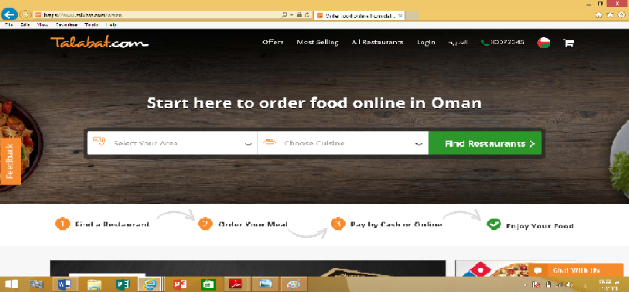

2. We will chose my area
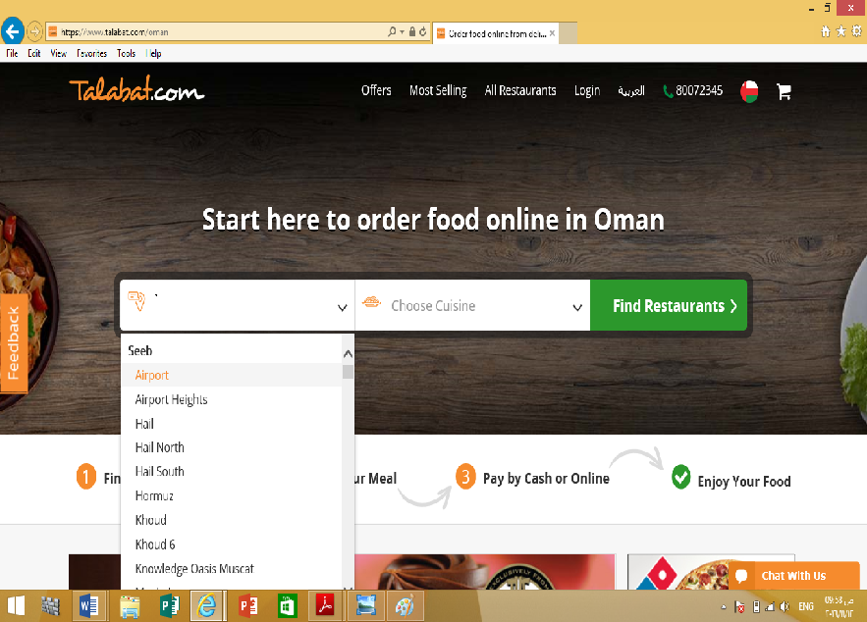
Area: bosher
3. We will choose the cuisine
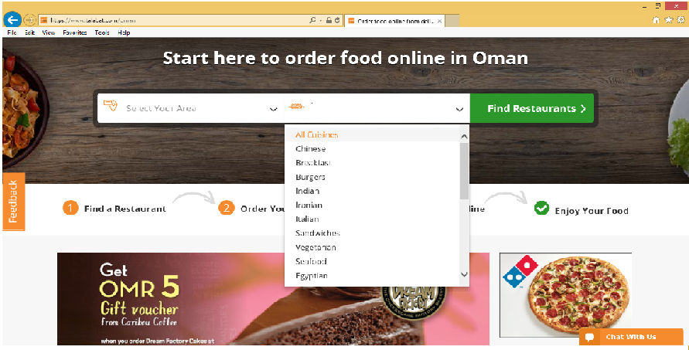
Cuisine: Indian

4. It will show all the Indian restaurants
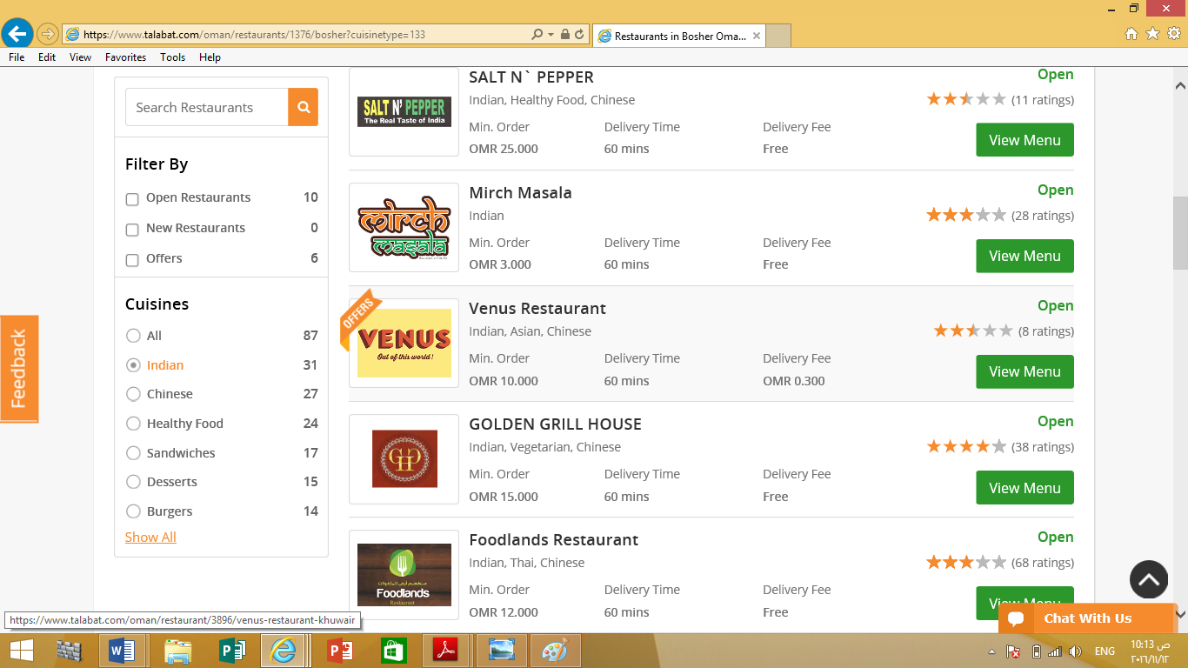
I choose Foodland's

5. After that we will see the menu of Foodland's
ه 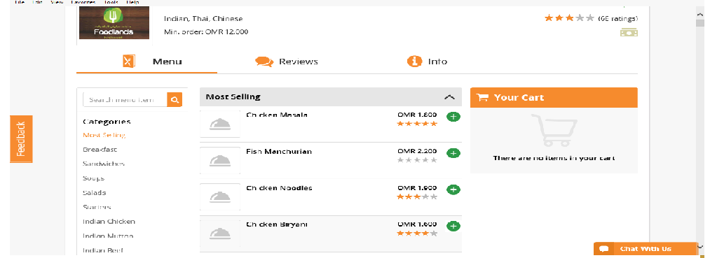
I chose chicken biryani
6. We shoes the meal

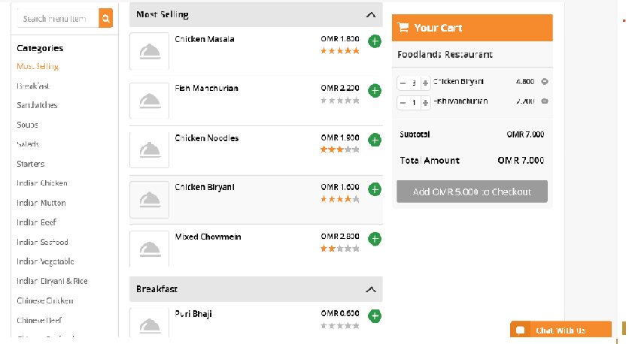
7. It will show me details of our order
The price
Total amount

Add to cart to go to the next step
8. Last step it will show me my cart and tell me what the time need for this order and I chose pay cash

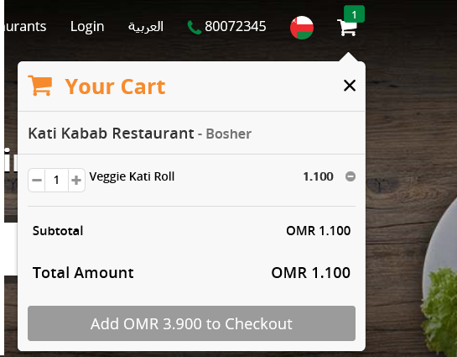

Task 5 {2.1}
Search engine marketing
Search engine optimization is the ability of making a website or a webpage visible by the search engine without paying. Talabat.com has a capability of improving its rank among the search engines in the internet. In order to this there are a number of ways it should consider or do to its website.
Tabalat.com should ensure that they publish relevant content in their website. The search engines always consider the quality of the content in ranking. Many users are always searching for relevant content. For example Talabat.com can publish the best kid of food that is required by many people and hence traffic will be created in their website. A key word for each phrase or page will give it a traffic too. This is reading the minds if the readers on possibly the kind of word they will be using to search for the food they need and repeating the word severally in the page.
Talabat.com should consider metadata in its web pages. A space between then head tag is required to insert the metadata or the information of the page. They include the tittle, description and the keyword metadata. The title metadata is responsible for the page titles displayed at the top of the browser, description metadata is the textual display that is used by the browser in the search return, and the keyword metadata are the search phrases used by users while searching.
Talabat.com should also focus on creating links that arte worth instead of just basic links within pages. The website of talabat.com should contain links of names of its special food in order to catch user’s interests.
Talabat.com should always describe its videos and visuals using alternative tags or alternative text descriptions. It will make the search engines to easily locate tabalat.com. Talabat.com should always update their content on its webpages and websites to ensure that it attracts traffic because of the latest updates. Talabat.com should use keywords in URL, Page title, its headings and thought the body.

Task 6 {2.2}
Opt-in email marketing
Are you looking for a well-paying job?
Talabat.com is a rich and trusted restaurant that offers enjoyable and delicious food online. We are looking for qualified staff in providing Hotel services and preparation of cuisines, we also require experts in delivery and customer care services. Thousands of staff get employed every year in our Hotel destinations in Oman. Applications can be done online using a PC or a mobile phone. Requirement’s for various Job vacancies are available in our website www.talabat.com.
Also feel free to visit our store in Omar open 24/7.

Task 7 {2.3}
Public relation techniques
Talabat.com should ensure that it is always available to the media to bring out news to comment on, comment on public policies affecting its business or speak to the media e.g. on emergence of new kind of food. This will help display their leadership and build their professional credibility. They will also be able to establish themselves as useful and reliable source that the media will want to write about.

Talabat.com should be able to write monthly columns of mainstream publications for greater chance for visibility and great reputation in the area of food industry business. The columns can be very effective in attracting clients and answering queries alongside providing free advices.
Talabat.com can take advantages in speaking at seminars and offering lectures through online videos and audios pertaining their food and their choice, how they are healthy and etc. This will expand professional network and build personal brand among the audience.
Talabat.com should take advantage of the increased number of people spending their time in web to reach out to the target audience. An example is the Pay-per-click offered by Google, Facebook, or LinkedIn which allow you to reach an audience looking for information on the services provided by Talabat.com.
Talabat.com should utilize the social media tools like blogs, Facebook, Twitter, and LinkedIn in which they can connect with potential clients and deliver information about their products and services. It will also help in attracting people to the main website by posting latest products, news, or articles that may be useful to potential customers.
Talabat.com can also employ the strategy of direct mail which can be very effective. They can also D-cards with printed advertisement at the back. A distribution can also be done around a particular area on a lower cost. This is considered especially when targeting a particular demographic region.

Task 8{2.4}
Digital media communities

Talabat.com can use the social media communities to gather information by engaging in listening from the customers data and use them to make smart business decisions.
Talabat.com can use the social medial communities to increase the brand awareness. Customers get to connect with the company through its pages in the social media and they can be able to share information such as pictures, videos, articles, and audio messages.
Talabat.com is able to run live ads that will help in promoting business in the social media communities and are also able to reach the target audience with relevant information by posting company or product pictures and videos. It is possible to segment target audience by location, job title, age, and gender using LinkedIn ad and demography, behavior, connections and interest using Facebook ads.
Talabat.com is able to use the social media communities in creating a regular interaction and timely customer care service and hence will increase sales and customer retention.
Talabat.com can use the social media to increase website traffic as many people will be directed towards its website because the increase in the social media shares will increase higher chances of ranking.
Lastly Talabat.com can use the social media to find out what its competitors are doing. This will help in making a good strategy in having a competitive advantage against the competitors. It will also lead to product and service improvement or fixing missing information.

References
www.talabat.com

Brown, D., 2008. Top 5 PR Strategies. [Online]
Available at: http://www.webanalyticsworld.net/2008/09/top-5-pr-strategies.html

Available at: https://blog.hootsuite.com/social-media-for-business

Available at: http://www.cision.com/us/2014/10/6-best-practices-for-b2b-public-relations
JZAHER, 2016. The Public Relation and Marketing Group. [Online]
Available at: https://theprmg.com/blog/top-ten-pr-and-marketing-tips-for-businesses-and-non-profits

Available at: http://www.mtu.edu/umc/services/digital/seo

