How to Negotiate with Powerful Suppliers

In many industries the balance of power has dramatically shifted from buyers to suppliers. A classic example comes from the railway industry. In 1900 North America had 35 suppliers of cast rail wheels; railway builders could pick and choose among them. A century later no one looking to build a railroad had this luxury, as only two suppliers remained. Today there is just one, which means that railroad builders have no choice but to accept the supplier’s price.
The shift has come about for various reasons, any or all of which may be in play in a given industry. In some cases suppliers have eliminated their competitors by driving down costs or developing disruptive technologies. In others, fast-growing demand for inputs has outstripped supply to such a degree that suppliers have been able to charge what they want. In still others, buyers have consolidated demand and forced suppliers’ prices down so far that many suppliers exited the market, giving the remaining few more clout.
Whatever the reason, companies that have gotten into a weak position with suppliers need to approach the situation strategically. They can no longer rely on hard negotiations through their procurement offices. To help with the strategic reappraisal, we’ve developed an analytic framework with four steps, in order of ascending risk. Companies should start by assessing whether they could help the supplier realize value in other contexts. If not, they should consider whether they could change how they buy. They should then look at either acquiring an existing supplier or creating a new one. If all else fails, they must consider playing hardball, which can have a lasting impact on the relationship and is a last resort.
Let’s look at each step in detail.

#1 Bring New Value to Your Supplier
This is the easiest way to redefine your relationship with a powerful supplier. It can rebalance the power equation and turn a purely commercial transaction into a strategic partnership. You can provide new value in several ways. For example:

Be a gateway to new markets.
The quickest and least expensive way to redress a power imbalance is to offer the supplier a market opportunity that is too good to pass up in exchange for price concessions. Finding the right carrot can take some digging. Here’s a case in point: A beverage company was facing annual price hikes from a beverage-packaging supplier. It seemed to have no way out; the supplier had patented its manufacturing process,and its pricing was lower than that of other sources.
But as it happened, the buyer was about to enter two large developing markets in which the supplier had tried but failed to gain traction. The procurement manager realized that the company could give the supplier’s products a foothold in those markets. She and her team put their heads together with the marketing team and presented the supplier with an offer that was hard to refuse: In exchange for a 10% price reduction globally, the company would use the supplier’s cans in the new markets.

Reduce the supplier’s risks.
If a company is well placed to help a supplier reduce its price risks, it can demand some concessions in return. For instance, a large chemical company was working with a single, recalcitrant supplier. To produce titanium dioxide it required feedstock manufactured to tight specifications, and only that supplier could meet its needs. When the chemical company tried to increase its order, the supplier claimed to have limited capacity and demanded a price premium.
Given the cyclical nature of the industry, the company surmised that the supplier would jump at the chance to lock in a long-term contract—a commitment other customers lacked the financial strength to make. Procurement worked closely with a team from finance, which created detailed models to determine a price range that would let the supplier generate returns of 15% on invested capital. The supplier agreed to a multiyear contract with prices that would not fluctuate more than 10% annually, and the chemical company got a 10% discount from the original quote.

#2 Change How You Buy
If no opportunities exist to help the supplier create new value, your next best alternative is to change your pattern of demand. Because this strategy can have implications for other parts of your organization, it requires close collaboration with any functions that could be affected. A company can change its demand patterns in three ways, all of which may require intensive data collection and analysis.

Consolidate purchase orders.
This is the least-risky option and the easiest one to implement. It may involve little more than acting on an internal audit of procurement data.
At one aircraft manufacturer, various business units were independently purchasing components from a large supplier, which was doubling or tripling the prices it had originally quoted. The supplier was reaping gross margins of about 20%, whereas the aircraft manufacturer’s were only 10%. And deliveries were unreliable, which drove up the manufacturer’s overall costs. Individually the business units lacked the power to force a change in behavior. But the unit CEOs got together, consolidated their spending data, and went to the supplier’s top executive with a threat to suspend all purchases unless changes were made. The supplier became far more responsive, cutting prices so that its margins were also about 10% and improving the timeliness of deliveries.
Small companies that don’t order through multiple units can form purchase consortiums with other firms in their industry. In 2008 an oligopoly of four suppliers controlled the ATM market in one European country. To counterbalance the group’s power, four banks created a purchasing consortium for ATM parts and maintenance, ultimately cutting their ATM costs by 25%. To succeed, consortiums must align their members’ interests and have the right governance in place. To avoid raising antitrust issues, they should not be too powerful themselves, which means that this approach is best suited to relatively fragmented, competitive industries.

Rethink purchasing bundles.
If a company cannot create large purchasing bundles within product categories or geographies, it should consider purchasing across them. One telecom company dealing with a powerful supplier for a particular component gained price concessions by pointing out that it also bought other components from that supplier—ones it could easily obtain elsewhere. Similarly, a global chemical manufacturer accustomed to buying a key ingredient from two suppliers, one in the United States and one in Europe (and each with a monopoly in its region), announced that it was considering consolidating to a single supplier and began a qualification process to choose which one. By awarding a single global contract, it would have given the winner a toehold in the loser’s monopoly territory. Faced with the threat of competition, each supplier agreed to a 10% discount.

At other times the right strategy is to pick apart your existing bundles; this may enable you to create competition among suppliers where none previously existed. When a consumer goods company decided to renegotiate its contract with a powerful information provider that offered an integrated global product and services package, the procurement team quickly realized that it needed to differentiate between data (for which the supplier held a monopoly in some geographies) and analytic services (for which the market was generally competitive). It also decided to negotiate at a country level—enabling suppliers that could cover some but not all geographies to participate. As a result it obtained savings of 10% on data and 20% on analytics.

Decrease purchase volume.
The third way to alter demand is to shift volume away from a powerful supplier, ideally by switching to a substitute or lower-cost product. The mere threat of this can increase the supplier’s openness to negotiation—but the buyer’s organization needs to stand behind its negotiation team and be willing to revisit what it purchases. Determined to reduce IT costs, one retailer we advised determined that most of its staff members did not need to create documents—they needed only to read them. It was able to eliminate 75% of its office software licenses, replacing them with a lower-cost, read-only alternative.

#3 Create a New Supplier
If options for changing your company’s demand profile aren’t available, you should next explore creating a completely new supply source. Like the first two strategies, this ultimately shifts demand away from powerful suppliers, but it tackles the other side of the equation. It is most likely to be necessary in industries where price negotiations have gone so far as to drive most suppliers out of business, effectively giving the survivors a monopoly. Of course, such drastic action risks alienating your supplier completely and may change your company’s business model. It will also alter the competitive dynamics and perhaps even the structure of your supplier’s industry and your own. For these reasons it is a risky proposition, but if well executed, it can transform your prospects. There are essentially two options:

Bring in a supplier from an adjacent market.
The easiest way to create a new supplier is to bring in a competitor from an adjacent geography or industry, one that might not otherwise have entered the market. One major airline reduced its food costs and improved quality by enticing a European catering company to enter the U.S. airline-catering market, which had been controlled by two well-entrenched suppliers that were reluctant to lower prices. The new entrant had an innovative, off-premises production model that enabled it to offer higher-quality food at significantly lower prices in exchange for longer-term contracts.
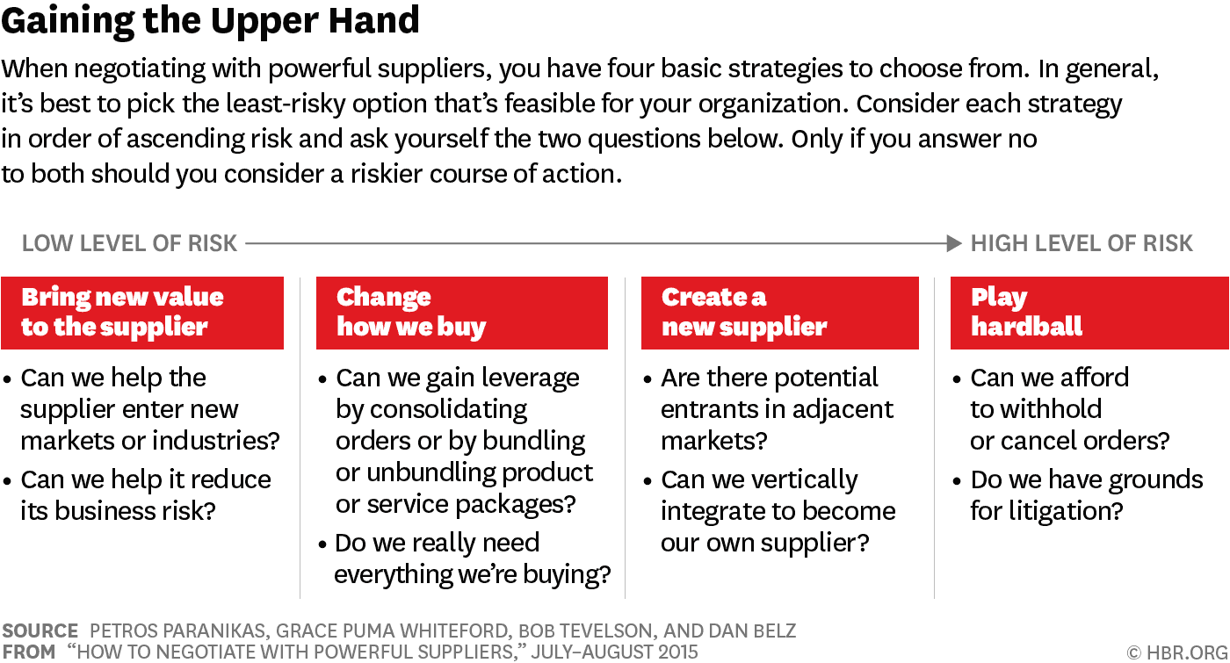
Find this and other HBR graphics in our VISUAL LIBRARY
Because the airline would need to give the new supplier a multiyear agreement, the procurement team shared its plans with the airline’s chief operating officer, its head of airport operations, and its head of catering. After aligning these key functions on the strategy, the airline announced that it had awarded its contract at a major U.S. hub to the new entrant. After losing that share of business, one of the established suppliers replaced its management team and took a more collaborative approach with the airline.

Vertically integrate.
If no plausible new suppliers are to hand, consider making yourself the new supplier by investing in the requisite assets and capabilities, possibly in a strategic partnership or joint venture with a company that has some of those assets and capabilities. If you’re lucky, a credible threat to take this action will be sufficient to shift the balance of power, as was the case with a paper company that relied on a regulated utility for electricity.
Unable to secure a better rate from the utility, the company began planning to build its own power plant—and it made sure the utility knew about its plans. It spent nine months finding a location, securing pipeline capacity, getting permits, and partnering with a dryer company that wanted to use the steam that the plant would generate. The strategy worked—the utility agreed to reduce its rates by 40% to prevent the company from building the plant. The danger with this approach, of course, is that your threat to vertically integrate may be called. So before embarking on this option, make sure that the new venture could deliver value that exceeds the investment costs and compensates for the added management attention and the hidden risks and challenges that might arise.

#4 Play Hardball
If everything else fails, canceling all your orders, excluding the supplier from future business, or threatening litigation—or some combination of those actions—may be the only answer, short of going out of business. These are truly tactics of last resort.
A global financial services firm had its back against the wall because it had to reduce costs by $3 billion. To cut IT infrastructure costs, it asked its major hardware supplier for a 10% price decrease. When the supplier refused, the firm’s chief information officer contacted the supplier’s CEO to say that all the supplier’s projects in the company were suspended, effective immediately. Within an hour the supplier was deactivated in the payment system, and the procurement, IT, and development teams were notified that they were no longer to work with it. Faced with the costly loss of existing and upcoming projects, the supplier quickly agreed to the price cut.
Then there’s litigation. In the early 2000s a security company that provided cash transportation services to banks decided to increase its rates by 40%. Because it controlled 70% of the market, its customers had few alternatives. But one bank that faced significant margin pressures wasn’t ready to accept the price hike. To better understand what was driving the increase, it asked to review the security company’s financial statements, which revealed only a 10% cost increase—nothing that would justify the drastic hike.
If all else fails, canceling your orders, suspending future business, or threatening litigation may be the only answer.
The bank took a two-pronged approach. Its chief operating officer met with the COO of the security company to explain that the increase was unacceptable and would undermine their relationship. And the procurement team threatened to join forces with other financial institutions and bring the matter to the attention of the national authorities in charge of restricting monopolies. The security company backed down and instituted a price increase more in line with its cost increase.
As we’ve shown, companies negotiating with powerful suppliers have plenty of ways to redefine the relationship. Whichever option they choose, they need a clear understanding of the problem, an ability to work on it across functions, a willingness to think outside the box, and strong analytical capabilities that can reveal the enterprisewide picture and generate useful insights. It’s also important that senior executives commit to strategic rather than tactical moves. With these elements in place, what had seemed an impossible negotiating task becomes one that is merely challenging.
A version of this article appeared in the July–August 2015 issue (pp.90–96) of Harvard Business Review.


Petros Paranikas is a partner and managing director in the Chicago office of the Boston Consulting Group where he focuses on procurement and portfolio strategy.

