Real Time Vehicle Tracking on Google Map using Arduino MEGA

Humaid Alshamsi, Veton Këpuska, Hazza Alshamsi
Florida Institute of Technology, Melbourne FL, USA

Abstract

The use of automobiles is necessary to ship goods and products from one place to another. The users face several problems due to delay in the delivery of goods. This delay may be due to choosing wrong or longer routes by the driver. The Global Positioning System (GPS) is being used for fleet management, stolen vehicle recovery, surveillance and mapping. This paper, designing and implementation a real time GPS tracker system using Arduino. When user makes a call on the number which is registered on the GPS-GSM shield attached to Arduino then user receives the location coordinates and data will get stored continuously on SD card at the same time. This work has significant application for vehicle security, salesman tracking and private driver.

Keywords: GPS, GSM, Arduino, Storage card, Adafruit FONA 808 Shield.

Introduction
With the advancements in technology, vehicle tracking systems have become very prominent. The implementation details of a vehicle tracking systems that can display the vehicle position on Google maps. The GPS, GSM/GPRS modules controlled by Arduino MEGA are placed inside the vehicle. The vehicle position is updated every 10 second as the vehicle is moving. A vehicle tracking systems are highly useful now a days; this system enables the owner to observe and track the vehicle and find out vehicle movement and its past activities of vehicle. This technology popularly called real time vehicle Tracking Systems which created many wonders in the security of the vehicle. This hardware is fitted on to the vehicle in such a manner that it is not visible to anyone who is inside or outside of the vehicle. Thus it is used as a covert unit which continuously or by any interrupt to the system, sends the location data to the monitoring unit. When the vehicle is stolen, the location data from tracking system can be used to find the location and can be informed to police for further action by sending GPS coordinates to the specified mobile and this occurs when a request by user, the system automatically sends a return reply to that particular mobile indicating the position of the vehicle in terms of latitude and longitude which can be viewed using Google Map and also has SOS feature the driver can press the button to get help for an emergency with low cost implementation. This information is available to authorized users of the system via website over the internet [1].

Related WORKS
The hardware and software of the GPS and GSM network were developed. The proposed GPS/GSM based System has the two parts, first is a mobile unit and another is controlling station. The system processes, interfaces, connections, data transmission and reception of data among the mobile unit and control stations are working successfully. These results are compatible with GPS technologies [2].
A vehicle tracking system is an electronic device, installed in a vehicle to enable the owner or a third party to track the vehicle's place. This paper proposed to design a vehicle tracking system that works using GPS and GSM technology. This system built based on embedded system, used for tracking and positioning of any vehicle by using Global Positioning System (GPS) and Global system for mobile communication (GSM). This design will continuously watch a moving Vehicle and report the status of the Vehicle on demand [3].
Face Detection System used to detect the face of the driver, and compare with the predefined face. The car owner is sleeping during the night time and someone theft the car. Then Face Detection System obtains images by one tiny web camera, which is hidden easily in somewhere in the car. Face Detection System compared the obtained images with the stored images. If the images don't match, then the information sends to the owner through MMS. The owners get the images of the thief in mobile phone and trace the place through GPS. The place of the car and its speed displayed to the owner through SMS. The owner can recognize the thief images as well as the place of the car and can easily find out the hijackers image. This system applied in our day-to-day life [4].
This system provided vehicle cabin safety, security based on embedded system by modifying the existing modules. This method monitors the level of the toxic gases such as CO, LPG and alcohol within the vehicle provided alert information as alarm during the dangerous situations. The SMS sends to the authorized person through the GSM. In this method, the IR Sensor used to detect the static obstacle in front of the vehicle and the vehicle stopped if any obstacle detected. This is avoiding accidents due to collision of vehicles with any static obstacles [5].
Kai-Tai Song and Chih-Chieh Yang have a designed and built on a real-time visual tracking system for vehicle safety applications. In this paper built a novel feature-based vehicle-tracking algorithm, automatically detect and track several moving objects, like cars and motorcycles, ahead of the tracking vehicle. Joint with the concept of focus of expansion (FOE) and view analysis, the built system can segment features of moving objects from moving background and offer a collision word of warning on real-time. The proposed algorithm using a CMOS image sensor and NMOS embedded processor architecture. The constructed stand-alone visual tracking system validated in real road tests. The results provided information of collision warning in urban artery with speed about 60 km/hour both at night and day times [6].
The remote monitoring system based on SMS and GSM was implemented. Based on the total design of the system, the hardware and software designed. In this paper, the GSM network is a medium for transmitting the remote signal. This includes two parts that are the monitoring center and the remote monitoring station. The monitoring centers consist of a computer and communication module of GSM. The software-monitoring center and the remote monitoring station implemented by using VB. The result of this demonstration shows that the system can watch and control the remote communication between the monitoring center and the remote monitoring station [7].
The proposed tracking system based on cloud computing infrastructure. The sensors are used to monitor the fuel level, driver conditions, and speed of the vehicle. All the data transferred to cloud server using GSM enabled device. All the vehicles equipped with GPS antenna to locate the place. To avoid the drunk and drive, the alcohol sensor installed to monitor the driver status. The proposed technology significantly avoids the accident in highways [8].

Proposed Method
In this proposed work, a method of vehicle tracking system used to track the theft vehicle by using GPS and GSM technology. The GPS receiver and GSM modem with an Arduino MEGA2560. The system is attached to the vehicle. In the other end (main vehicle station) one GSM mobile phone is used to send and receive the information. So the GPS system will send the longitudinal and altitude values corresponding to the position of vehicle to GSM Modem. Imagine a person has forgetting where the car has been parked, he will send an SMS to the vehicle GPS, The SMS sent would come through the GSM service provider and then reach the vehicle, because the vehicle has a GSM device with SIM card. This GSM modem will receive the SMS and send to the Arduino MEGA2560 in the vehicle. The Arduino MEGA2560 will receive this SMS and compare the password and the command. If everything matches then it will perform the request required by the owner with a link that has longitude & latitude for Google Map in order to show the location of the vehicle.
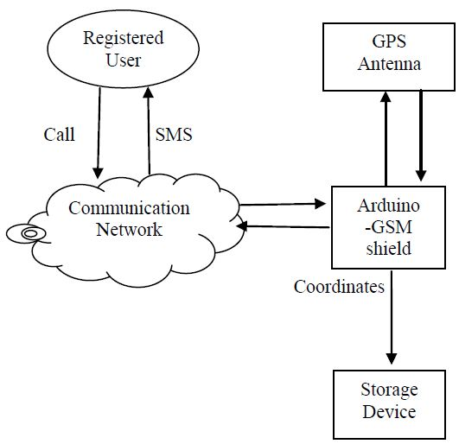

Fig.1. Architecture of Real-time GPS tracking system.
  - Block Diagram

The Block diagram of Vehicle tracking system based on GSM and GPS technology is shown in the figure1. It consists Arduino MEGA2560 with power supply, Adafruit FONA 808 Shield - Mini Cellular GSM + GPS for Arduino, Lithium Ion Polymer Battery - 3.7v 1200mAh, Passive GPS Antenna uFL - 15mm x 15mm 1 dBi gain, Slim Sticker-type GSM/Cellular Quad-Band Antenna - 3dBi uFL, SIM Card (2G network), Ethernet Shield, micro SD card (2GB).

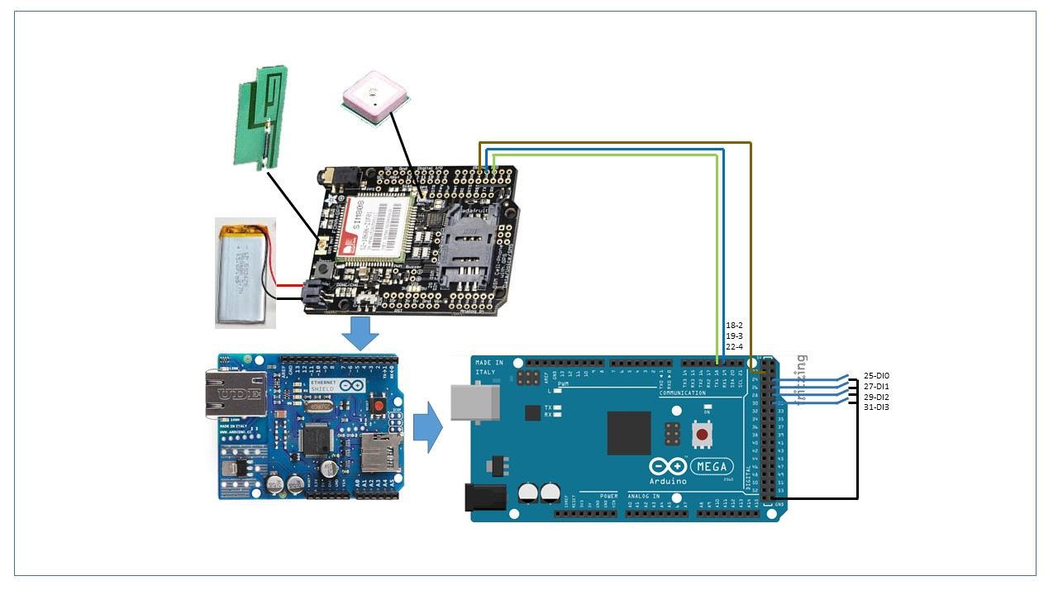
Fig. 1: Block diagram of Vehicle tracking system based on GSM and GPS

  - Circuit Descriptions

An Arduino MEGA2560 is used for interfacing to various hardware peripherals. The current design is an embedded application, which will continuously monitor a moving Vehicle and report the status of the Vehicle on demand. For doing so an Arduino MEGA2560 is interfaced serially to a GSM Modem and GPS Receiver. A GSM modem is used to send the position (Latitude and Longitude) of the vehicle from a remote place. The GPS modem will continuously give the data i.e. the latitude and longitude indicating the position of the vehicle. The GPS modem gives many parameters as the output such as the vehicle is moving or parked which then the data will be sent to the mobile at the other end from where the position of the vehicle is demanded. This vehicle tracking system takes input from GPS and sends it through the GSM module to desired mobile using mobile communication. Vehicle Tracking System is one of the biggest technological advancements to track the activities of the vehicle. The security system uses Global Positioning System GPS, to find the location of the monitored or tracked vehicle and then uses satellite or radio systems to send to send the coordinates and the location data to the monitoring center. At monitoring center various software are used to plot the Vehicle on a map. In this way the Vehicle owners are able to track their vehicle on a real-time basis. Due to real-time tracking facility, vehicle tracking systems are becoming increasingly popular among owners of expensive vehicles.

  - GPS Technology

Introducing Adafruit FONA 808 GSM + GPS Shield, an all-in-one cellular phone module with that lets you add location-tracking, voice, text, SMS and data to your project, in Arduino shield format for easy use. This shield fits right over your Arduino or compatible. At the heart is a powerful GSM cellular module (we use the latest SIM808) with integrated GPS. This module can do just about everything: Quad-band 850/900/1800/1900MHz - connect onto any global GSM network with any 2G SIM, with fully-integrated GPS that can be controlled and query over the same serial port Make and receive voice calls using a headset or an external 32W speaker and electret microphone Send and receive SMS messages Send and receive GPRS data (TCP/IP, HTTP, etc.). [9]

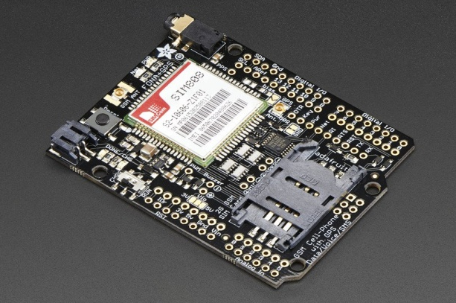
Fig. 2: GPS module

  - GSM Modem (3dBi GSM)
This 3dBi GSM antenna is slim, compact and sensitive, with a 3dBi gain. The antenna juts out from its base with stick-on back so you attach it to an enclosure if you're making something like, say, a DIY phone. It has a tiny uFL connector on the end - which is perfect for the 1946 - but will also work well for any other RF project on the 850/900/1800/1900/2100 bands, such as any other Cellular or GSM/GPRS device. [10]
Features of GSM:
- 38mm antenna, (B) 2mm thick, (C) Adhesive backing.

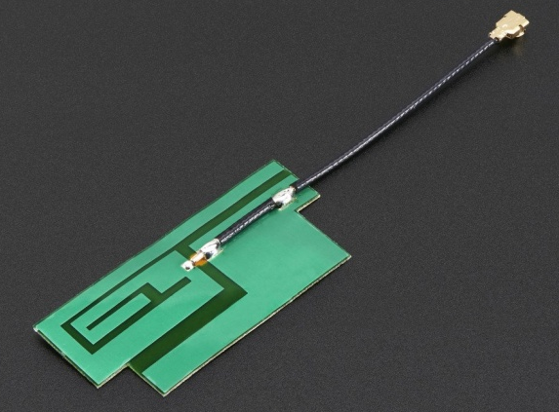
Fig. 3: GSM module

- Work Flow

This flowchart show how the system runs for real time GPS tracking system in figure 4.
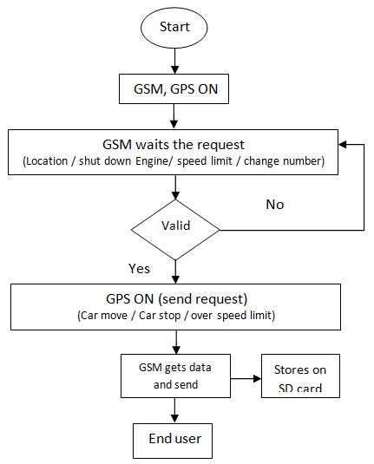
Fig. 4: Flow chart GPS tracking system.

This explain When GPS tracking system insulated in a car, the system will run automatically and get the data update while move by sending SMS massages. So the features that our design have are: a) user can set has own speed limit if the car goes over the speed limit, user will get alert massage says "The car over speed limit of …miles", b) when the car start move or stop somewhere you will get an alert massage of that location, the reason for doing this is to keep track the driver don't go in longer route or stop somewhere that is not allowing him to stop anywhere except in last destination, c) the last one is user can shut down car engine , so if the car start to move user can stop the engine by sending SMS message.

Conclusion
In this paper that demand for vehicle tracking systems used to track the theft vehicle by using GPS and GSM technology. This system can be used in both cases of personal as well as business purpose improves safety and security, communication medium and performance monitoring .Vehicle tracking systems becoming increasingly important in large cities and it is more secured than other systems. Now a day’s vehicle theft is rapidly increasing, with this we can have a good control in it. This technology can also help to advance the system of transportation and can be used in many organizations for security purpose and tracking purpose. Also, this system become more useful by adding different type of sensors which help to protect the owner as well as who tends to use the vehicle by decreasing the chances of losing life in such accident. Whenever accident is alerted the system send the location to numbers that already stored in order to get the help as soon as it could especially when the accidents occurred in deserted places and midnights. This vehicle tracking and accident alert feature plays much more important role in day to day life in future.

References
- Ambade Shruti Dinkar and S.A Shaikh, Design and Implementation Of Vehicle Tracking System Using GPS, Journal of Information Engineering and Applications, ISSN 2224-5758 ,Vol 1,No.3, 2011.
- Asaad M. J. Al-Hindawi, Ibraheem Talib, “Experimentally Evaluation of GPS/GSM Based System Design”, Journal of Electronic Systems Volume 2 Number 2 June 2012.
- Kunal Maurya , Mandeep Singh, Neelu Jain, “Real Time Vehicle Tracking System using GSM and GPS Technology- An Anti-theft Tracking System,” International Journal of Electronics and Computer Science Engineering. ISSN 2277- 1956/V1N3-1103-1107.
- Vikram Kulkarni & Viswaprakash Babu, “embedded smart car security system on face detection’, special issue of IJCCT, ISSN(Online):2231-0371, ISSN(Print):0975- 7449,volume-3, issue-1.
- V.Ramya, B. Palaniappan, K. Karthick, “Embedded Controller for Vehicle In-Front Obstacle Detection and Cabin Safety Alert System”, International Journal of Computer Science & Information Technology (IJCSIT) Vol 4, No 2, April 2012.
- Kai-Tai Song, Chih-Chieh Yang, of National Chiao Tung University, Taiwan, “Front Vehicle Tracking Using Scene Analysis”, Proceedings of the IEEE International Conference on Mechatronics & Automation 2005.
- Chen Peijiang, Jiang Xuehua, “Design and Implementation of Remote monitoring system based on GSM,” vol.42, pp.167-175. 2008.
- Albert Alexe, R.Ezhilarasie, “Cloud Computing Based Vehicle Tracking Information Systems”, ISSN: 2229 - 4333 (Print) | ISSN: 0976 - 8491 (Online) IJCST Vol. 2, Iss ue 1, March 2011.
- http://www.mouser.com/ds/2/737/adafruit-fona-808-cellular-plus-gps-shield-for-ard-765048.pdf
- https://www.adafruit.com/product/1991

