1. * 3 points
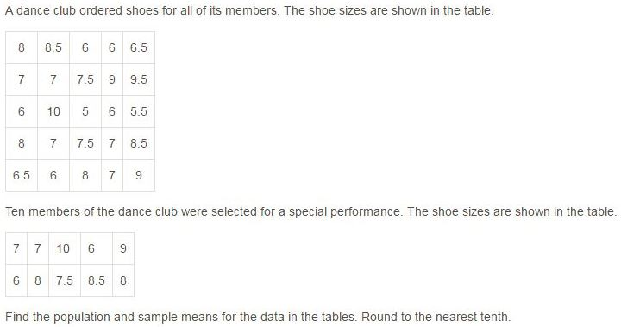
- Population Mean: 7.7; Sample Mean: 7.3
- Population Mean: 7.2; Sample Mean: 7.3
- Population Mean: 7.3; Sample Mean: 6.5
- Population Mean: 7.3; Sample Mean: 7.7
- None of the above

2. Identify all the Parameters from this list of statements. * 3 points
- 85% of the golf teams surveyed have teammates that can break 80.
- According to the survey, each member of the soccer team has an average of 2 jerseys.
- Twelve of the 35 members of our book club play chess.
- Of the 28 swim teams surveyed across America, 5 of them practice 10 hours a week.
- Basketball teams in the district have won at least 3 games for every 5 they have played.
- 78% of the booths at the fair sell food.

3. * 3 points
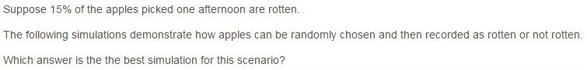
- Place 15 equally sized pieces of paper in a hat. Of the 15, 3 read "rotten", and the rest say "not rotten"
- Place 12 equally sized pieces of paper in a hat. Of the 12, 3 read "rotten", and the rest say "not rotten".
- Place 20 equally sized pieces of paper in a hat. Of the 20, 3 read "rotten", and the rest say "not rotten".
- Place 30 equally sized pieces of paper in a hat. Of the 30, 3 read "rotten", and the rest say "not rotten".

4. * 3 points
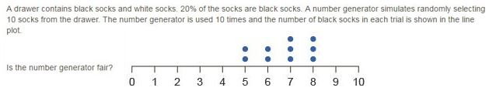
- Yes, the number generator is fair. It only picked black socks half the time.
- No, the number generator is not fair. The correct percentage of black socks was not chosen at all.
- No, the number generator is not fair. In two experiments, it picked black socks 50% of the time two times.
- Yes, the number generator is fair. It picked the approximate percentage of black socks most of the time.

5. * 3 points
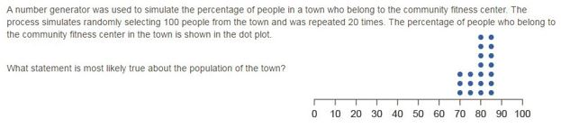
- About 85% of the town most likely belongs to the fitness center.
- Most likely, 30% of the town does not belong to the fitness center.
- Most likely, 70% to 85% of the town belongs to the fitness center.
- Most likely, 50% of the town skateboards.

6. * 3 points
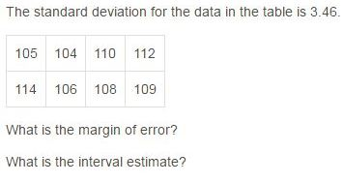
- Margin of error: 6.92; Interval Estimate: (105.04, 111.96)
- Margin of error: 6.92; Interval Estimate: (101.58, 115.42)
- Margin of error: 3.46; Interval Estimate: (105.04, 111.96)
- Margin of error: 3.46; Interval Estimate: (101.58, 115.42)

7. * 3 points
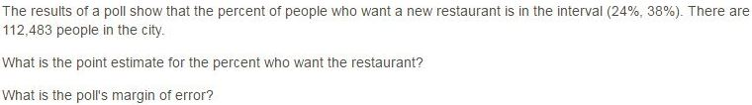
- Point Estimate: 7%; Margin of Error: ±31%
- Point Estimate: 14%; Margin of Error: ±14%
- Point Estimate: 31%; Margin of Error: ±7%
- Point Estimate: 31%; Margin of Error: ±14%

8. * 3 points
- Enter all members' names into a computer software program that will randomly pick the 500 members.
- Pick a letter from the alphabet and the first 500 members whose first or last name begins with that letter will be in the survey.
- Let the gym management decide which members should be surveyed.
- Choose the 500 members who have the highest attendance rates.

9. Identify if the situation describes a survey, an experiment or an observational study? A coach wants to know who his fastest runner is. * 3 points
- This describes a survey.
- This describes an experiment.
- This describes an observational study.

10. Identify if the situation describes a survey, an experiment or an observational study? The investigators analyze data based on a set of responses to questions. * 3 points
- This describes a survey.
- This describes an experiment.
- This describes an observational study.

11. A person wants to count the number of children that play at a playground. He observes the playground for longer than an hour. In what way(s) is randomization not applied in this situation? (Select each correct answer.) * 3 points
- There is no selection process.
- The person observing chose the time frame of longer than one hour.
- There is no control over who is in the study.
- The person is only observing children.
- The person observing can select a group to go to the park.

12. *
3 points
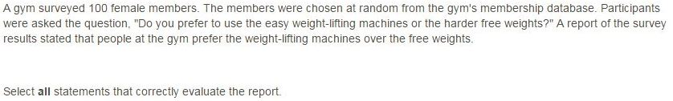
- The question is biased towards a response of preferring to use free weights.
- The question is not biased.
- The question is biased towards a response of preferring to use weight lifting machines.
- The sample is not biased.
- The sample is biased because it does not represent the population.

