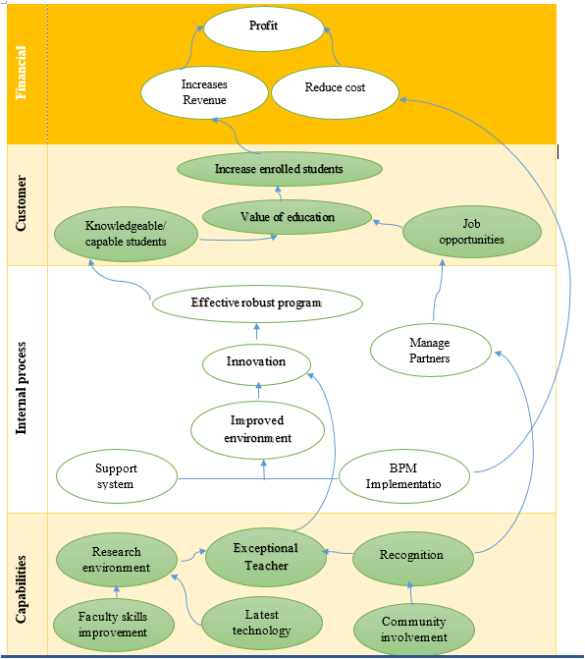

- Shows how activities in one functional area affect outcomes in other areas?

