Project #3: System Security Plan

Company Background & Operating Environment
The assigned case study and attachments to this assignment provide information about “the company.”
- Use the Baltimore field office as the target for the System Security Plan
- Use Verizon FiOS as the Internet Services Provider (see http://www.verizonenterprise.com/terms/us/products/internet/sla/ )

Policy Issue & Plan of Action
A recent risk assessment highlighted the need to formalize the security measures required to protect information, information systems, and the information infrastructures for the company’s field offices. This requirement has been incorporated into the company’s risk management plan and the company’s CISO has been tasked with developing, documenting, and implementing the required security measures. The IT Governance board also has a role to play since it must review and approve all changes which affect IT systems under its purview.
The CISO has proposed a plan of action which includes developing system security plans using guidance from NIST SP-800-18 Guide for Developing Security Plans for Federal Information Systems. The IT Governance board, after reviewing the CISO’s proposed plan of action, voted and accepted this recommendation. In its discussions prior to the vote, the CISO explained why the best practices information for security plans from NIST SP 800-18 was suitable for the company’s use. The board also accepted the CISO’s recommendation for creating a single System Security Plan for a General Support System since, in the CISO’s professional judgement, this type of plan would best meet the “formalization” requirement from the company’s recently adopted risk management strategy.

Your Task Assignment
As a staff member supporting the CISO, you have been asked to research and then draft the required system security plan for a General Support System. In your research so far, you have learned that:
- A general support system is defined as “an interconnected set of information resources under the same direct management control that shares common functionality.” (See NIST SP 800-18)
- The Field Office manager is the designated system owner for the IT support systems in his or her field office.
- The system boundaries for the field office General Support System have already been documented in the company’s enterprise architecture (see the case study).
- The security controls required for the field office IT systems have been documented in a security controls baseline (see the controls baseline attached to this assignment).

Research:
- Review the information provided in the case study and in this assignment, especially the information about the field offices and the IT systems and networks used in their day to day business affairs.
- Review NIST’s guidance for developing a System Security Plan for a general support IT System. This information is presented in NIST SP 800-18. http://csrc.nist.gov/publications/nistpubs/800-18-Rev1/sp800-18-Rev1-final.pdf Pay special attention to the Sample Information System Security Plan template provided in Appendix A.
- Review the definitions for IT Security control families as documented in Federal Information Processing Standard (FIPS) 200: Minimum Security Requirements for Federal Information and Information Systems (see section 3).
- Review the definitions for individual controls as listed in Appendix F Security Control Catalog in NIST SP 800-53 Security and Privacy Controls for Federal Information Systems and Organizations. http://nvlpubs.nist.gov/nistpubs/SpecialPublications/NIST.SP.800-53r4.pdf You should focus on those controls listed in the security controls baseline provided with this assignment.

Write:
- Use the following guidance to complete the System Security Plan using the template from Appendix A of NIST SP 800-18.
  - Sections 1 through 10 will contain information provided in the assigned case study. You may need to “interpret” that information when writing the descriptions. “Fill in the blanks” for information about the company or its managers which is not provided in the case study, i.e. names, email addresses, phone numbers, etc.). Make sure that your fictional information is consistent with information provided in the case study (name of company, locations, etc.).
  - Section 11 should contain information about the field office’s Internet connection Do not include the table. Use the business Internet Services Provider listed at the top of this assignment file. Describe the system interconnection type in this section and service level agreement.
  - Section 12 should contain information derived from the case study. You will need to identify the types of information processed in the field office and then list the laws and regulations which apply. For example, if the case study company processes or stores Protected Health Information, then this section must include information about HIPAA. If the company processes or stores credit card payment information, then this section must include information about the PCI-DSS requirements.
  - Section 13 of the SSP will take the most editing time. Use the information about required security controls as provided security controls baseline.
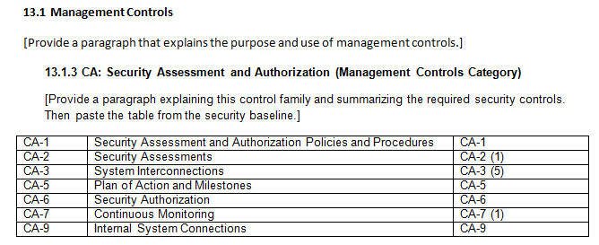
    - Create 3 sub sections (13.1 Management Controls, 13.2 Operational Controls, and 13.3 Technical Controls). You must provide a description for each category (see the definitions provided in Annex 11.B Minimum Security Controls in NIST SP 800-100 Information Security Handbook: A Guide for Managers).
    - Using the information provided in the security controls baseline, place the required control families and controls under the correct sub section.
    - Use the exact names and designators for the security control families and individual security controls. BUT, you MUST paraphrase any and all descriptions. Do NOT cut and paste from NIST documents.
  - Section 14: use the due date for this assignment as the plan complete date.
  - Section 15: leave the approval date blank. You will not have any other text in this section (since the plan is not yet approved).
- Use a professional format for your System Security Plan. Your document should be consistently formatted throughout and easy to read.
- Common phrases do not require citations. If there is doubt as to whether or not information requires attribution, provide a footnote with publication information or use APA format citations and references.
- You are expected to write grammatically correct English in every assignment that you submit for grading. Do not turn in any work without (a) using spell check, (b) using grammar check, (c) verifying that your punctuation is correct and (d) reviewing your work for correct word usage and correctly structured sentences and paragraphs.

