Name:
Date:

Graded Assignment

Semester Test, Part 2: Algebra I
Show all your work.
Total score: ____ of 45 points
(Score for Question 1: ___ of 14 points)
- Roman mixes 12 liters of 8% acid solution with a 20% acid solution, which results in a 16% acid solution. Find the number of liters of 20% acid solution in the new mixture. Construct a table to organize the information, and show all of your work to solve the problem.
Answer:

(Score for Question 2: ___ of 9 points)
- The length of a rectangle is 5 mm longer than its width. Its perimeter is more than 30 mm. Let w equal the width of the rectangle.
- Write an expression for the length in terms of the width.
- Use expressions for the length and width to write an inequality for the perimeter, on the basis of the given information.
- Solve the inequality, clearly indicating the width of the rectangle.
Answer:

(Score for Question 3: ___ of 10 points)
- Solve the system of equations using linear combination.
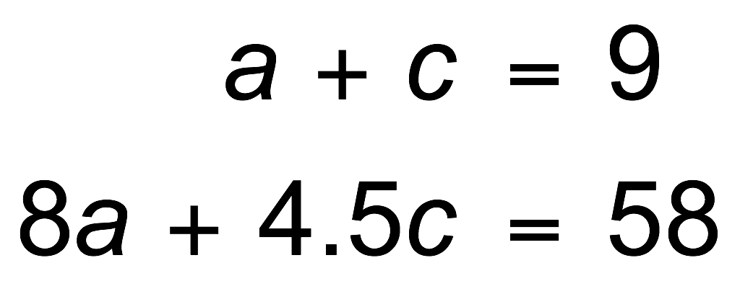
Answer:

(Score for Question 4: ___ of 12 points)
- Gavin and Seiji both worked hard over the summer. Together, they earned a total of $425. Gavin earned $25 more than Seiji. How much did each of them earn?
- Write a system of two equations with two variables to model this problem.
- Use substitution or the elimination method to solve the system.
- Graph both equations.
- Answer the question.
Answer:

