Review the Danone case, and work with your group members to respond to the following questions.
1. (a)Using the values of KM you found in your searches in Week 1 Discussion, (b) describe whether Danone created those values through their KM initiatives. If they did not create value, explain what could have been done differently to create value.
2. (c) Based on what you know now about business processes from Chapter 1 Introduction and (d) the BPT article ‘The Fusions of Process and KM” and about the relationship between KM and BPM, (e) describe the business process that one of Danones’ initiatives is designed to support. (f ) Describe how KM could be adding value to that process.
a- The collective values and benefits of KM from our searches:
- Enabling better and faster decision making:
By delivering relevant information at the time of need through structure, search, subscription, syndication, and support, a knowledge management environment can provide the basis for making good decisions.
- Making it easy to find relevant information and resources:
When faced with a need to respond to a customer, solve a problem, analyze trends, assess markets, benchmark against peers, understand competition, create new offerings, plan strategy, and to think critically, you typically look for information and resources to support these activities.
- Reusing ideas, documents, and expertise:
Once you have developed an effective process, you want to ensure that others use the process each time a similar requirement arises.
- Avoiding redundant effort
Avoiding duplication of effort saves time and money, keeps employee morale up, and streamlines work. By not spending time reinventing the wheel, you can have more time to invent something new.
- Avoiding making the same mistakes twice
Knowledge management allows us to share lessons learned, not only about successes, but also about failures. In order to do so, we must have a culture of trust, openness, and reward for willingness to talk about what we have done wrong.
- Taking advantage of existing expertise and experience
Teams benefit from the individual skills and knowledge of each member. The more complementary the expertise of the team members, the greater the power of the team.
- Communicating important information widely and quickly
How can we get information that is targeted, useful, and timely without drowning in a sea of email, having to visit hundreds of web sites, or reading through tons of printed material? Knowledge management helps address this problem through personalized portals, targeted subscriptions, RSS feeds, tagging, and specialized search engines.
- Promoting standard, repeatable processes and procedures
By providing a process for creating, storing, communicating, and using standard processes and procedures, employees will be able to use them routinely.
- Providing methods, tools, templates, techniques, and examples
Using these consistently streamlines work, improves quality, and ensures compatibility across the organization.
- Making scarce expertise widely available
If there is a resource who is in great demand due to having a skill which is in short supply, knowledge management can help make that resource available to the entire organization. Ways of doing so include community discussion forums, training events, ask the expert systems, recorded presentations, white papers, podcasts, and blogs.
- Showing customers how knowledge is used for their benefit
it is important to be able to differentiate yourself from other firms. Demonstrating to potential and current customers that you have widespread expertise and have ways of bringing it to bear for their benefit can help convince them to start or continue doing business with you. Conversely, failure to do so could leave you vulnerable to competitors who can demonstrate their knowledge management capabilities and benefits.
- Accelerating delivery to customers
Speed of execution is another important differentiator among competitors.
- Enabling the organization to leverage its size
As an organization grows, the increasing size is only a benefit if it can use the knowledge of all of its employees. Through the use of tools such as communities, expertise locators, and repositories
- Making the organization's best problem-solving experiences reusable
Consistently applying proven practices, also known as best practices or good practices, can significantly improve the results of any firm.
- Stimulating innovation and growth
Most businesses want to increase their revenues, but it becomes increasingly difficult as industries mature and competition increases. Creating new knowledge through effective knowledge sharing, collaboration, and information delivery can stimulate innovation.
- Facilitates Decision-Making Capabilities
Data can offer managers a wealth of information but processing overwhelming amounts can get in the way of achieving high-quality decisions. GE’s Corporate Executive Council (CEC) is an example of how one company put a knowledge management system in place to help executives cut through the noise, share information, and improve their decision-making. While information overload or needing knowledge from people in other parts of the company for decision-making can handicap managers, putting in place knowledge management systems can facilitate better, more informed decisions.
- Builds Learning Organizations by Making Learning Routine
The U.S. Army’s After Action Reviews (AARs) are an example of a knowledge management system that has helped build the Army into a learning organization by making learning routine. This approach to capturing learning from experience builds knowledge that can then be used to streamline operations and improve processes.
- Stimulates Cultural Change and Innovation
Actively managing organizational knowledge can also stimulate cultural change and innovation by encouraging the free flow of ideas.
- Bottom Line
By proactively implementing knowledge management systems, companies can re-write the old saying, “Change is inevitable, growth is optional” to “Change is inevitable, growth is intentional.”

- One of the biggest challenges behind knowledge management is the dissemination of knowledge.
People with the highest knowledge have the potential for high levels of value creation. But this knowledge can only create value if it's placed in the hands of those who must execute on it. Knowledge is usually difficult to access – it leaves when the knowledge professional resigns.
- Therefore, knowledge management is often about managing relationships within the organization.
Collaborative tools (intranets, balanced scorecards, data warehouses, customer relations management, expert systems, etc.) are often used to establish these relationships. Some companies have developed knowledge maps, identifying what must be shared, where can we find it, what information is needed to support an activity, etc. Knowledge maps codify information so that it becomes real knowledge; i.e. from data to intelligence.
- In the book Value Based Knowledge Management, the authors advocate that every organization should strive to have six capabilities working together:
- Produce : Apply the right combination of knowledge and systems so that you produce a knowledge based environment.
- Respond : Constantly monitor and respond to the marketplace through an empowered workforce within a decentralized structure.
- Anticipate : Become pro-active by anticipating events and issues based on this new decentralized knowledge based system.
- Attract : Attract people who have a thirst for knowledge, people who clearly demonstrate that they love to learn and share their knowledge opening with others. These so-called knowledge professionals are one of the most significant components of your intellectual capital.
- Create : Provide a strong learning environment for the thirsty knowledge worker. Allow everyone to learn through experiences with customers, competition, etc.
- Last : Secure long-term commitments from knowledge professionals. These people are key drivers behind your organization. If they leave, there goes the knowledge.

b) Danone values through their KM initiatives. (Pending)

(c) what you know now about business processes from (Chapter 1 Introduction) “summary”
What is a business process?
Process is WHAT the organization DOES. In BPM the term “business process” implies certain characteristics. A common understanding of these characteristics can help an organization organize their activities and resources to be efficient, effective and agile. These characteristics include aspects of the definition of a business process, which are coordinated, cross-functional, produce value and measureable objectives. The characteristics also include aspects that distinguish a process from a function and from a project.
Characteristics of a Business Process:
- Coordinated, 2) Cross-Functional, 3) Produce Value 4) Measurable Objectives 5) Event-Driven, 6) End-to-End, 7) Repeatable and 8) Visible
- The definition of a business process is a set of coordinated, cross-functional, sometimes inter-organizational, activities designed to produce business value and directed toward achieving measurable organizational objectives
One of the biggest benefits of a process approach is the focus on coordinating work that flows through multiple functions.
- Notice that the activities in the process are accomplished in different parts of the organization. This is a key distinction between functions and processes. Functions are the areas we typically see in an organizational chart such as marketing, production, finance, human resource management, and logistics
- Major purposes of a process approach is to have a clear understanding of the entire process, manage the flow of work as it moves from one place in the organization to another, and optimize the end-to-end process that spans the white spaces.
- Non-valued added activities are easier to identify when process activities are identified and mapped. It is also easier to identify points in the process where improvements can be made
- Processes are directed toward achieving measurable results. Identifying process metrics that are aligned with organizational goals is critical to knowing whether business value has been achieved.
- Processes such as “order-to-cash” are event-driven – they begin and end with an event. The event that initiates the process is the sales force sells the product. The event that terminates the process is the application of cash received to the customer’s account. The term “end-to-end” is often used to describe how a process encompasses all the activities from the initiating event to the terminal event.
- Another aspect of business processes is that they are repeatable. This is one major difference between a process and a project. Projects are unique where processes have multiple occurrences.
- Business processes should be visible. The ability to visualize an end-to-end business process facilitates the optimization and management of processes.
- Process visibility is accomplished by modeling the business processes of an organization at multiple levels.
Process Levels:
- The goal of process visibility is to diagram or “map” not only what the organization does, but how to do it in an efficient and effective manner. This results in “levels” of integrated processes. The high level view of organizational business processes represents WHAT the organization does which is broken down into more detail to eventually describe HOW to accomplish the processes.

Business Process Architecture;
- Business processes have different views depending on the person’s position in an organization
- Business Process Architecture (BPA). Building a BPA allows a visual representation of how processes are interrelated.
What are the types of processes?
- Michael Porter identified two broad categories of processes; (1) core processes directly add value to organizational products or services, and (2) support processes are the derivative processes that enable the core processes
- In the early 90s Rummler and Brache among others, identified the need for management processes to focus on the management and controlling of the core and support processes.
- Later in the 90s the Supply Chain Council extended their SCOR model to include core, enabling, and planning processes
- Most organizations distinguish between core, support, and management processes. However there is a growing trend to extend the management process beyond the core process to encompass the governance structure of the organization, adding governance processes at a high level
- Governance is the organization of the management process. It refers to the goals, principles, policies and organizational charts that define the authority and responsibilities of managers. A governance process is a process that regulates and constrains other processes that are implemented and deployed in an organization. It is, in essence, the process that governs other processes and ties all of the processes together, keeping them in line with strategic goals.
- A management process is responsible for planning, organizing, leading and controlling processes within an organization. Management processes are integral to the success of core and supporting processes.
- A core process in an organization is one that has strategic value and is considered as one that offers a competitive advantage. A core process, also called a primary process, is a process whose execution plays a primary role in delivering value to the customer.
- Core processes often interact with suppliers and customers. Core processes vary among industries.
- Support processes are those processes that support or "enable" the core processes.
What is BPM?
- BPM has evolved to a “management discipline that treats business processes as assets to be designed, utilized and valued. It is a structured approach employing methods, policies, metrics, management practices and software tools to manage and continuously optimize activities and processes with the goals of improving agility and operational performance”.
- The four stages of BPM are: I. Process Planning and Strategy Formulation; II. Process Analysis, Modeling and Design; III. Process Execution; and IV. Process Controlling and Transformation..
- Rummler and Brache (1995) said very early in the BPM movement that BPM was managing the white spaces in the organizational chart. This remains a fundamental aspect of BPM and has led to the concept of Management by Process.
- In managing by process, the focus is on managing, controlling and improving processes. This is in contrast to Management by Objectives (MBO), where, typically, functional areas set targets and work to achieve them.
- Most recently the Gartner Group has refined their definition of BPM as “a management discipline that requires organizations to shift to process-centric thinking and to reduce their reliance on traditional territorial and functional structures” representing “a fundamental change in how businesses manage and run their operational processes”
Why are companies so interested in BPM now?
- There are several forces that are driving companies to take a process view, as opposed to a functional view of their organization:
- Customer satisfaction: the customer is no longer king – the customer is dictator
- New or refined information technologies: BAM, Dashboards, EAI, SOA, Collaboration
- Global competition: communication and transportation advances
- Global supply chains: availability of labor, skills and knowledge
- Agility and responsiveness: driven by innovations in the other forces
- Compliance and transparency: new regulations

(d) ‘The Fusions of Process and KM” article:

L. Russell Records
Technology Director, Texas CSC Consulting

- While KM and process engineering were being evolved in parallel, there was no serious effort to fuse them into a consistent, holistic architecture. KM programs over the past decade have focused on organizing employees into communities of practice and building repositories of “best” or proven practices.
- Knowledge Management
“Knowledge management is an approach to discovering, capturing, and reusing both tacit (in people’s heads) and explicit (digital or paper based) knowledge as well as the cultural and technological means of enabling the KM process to be successful.”
- Knowledge is differentiated from information in that there is an element of expert review and distillation where knowledge is concerned.
- In my view, Knowledge Management cannot be successfully accomplished at the enterprise level (Generic KM on the desktop), but must be closely linked to a particular group of processes of critical interest to the business.
- Doing KM right also assumes that there are the means in place for organizing what data, information, and knowledge are appropriate for each task in an overall process flow. It also assumes that we have asked the questions about who will use the data, how we get it to them, and how we capture any learning that may occur as they interact with others so that it can be make available the next time the process executes.
- Process shows a notional end-to-end product development process. The implication here is that any type of process design effort must also have a KM dimension as well.
Process Management

- “Business Process Management is the ability to design, evaluate, view, manage, and adapt in real-time a number of related business activities, applications, and people, in one or more companies, in a structured sequence, that together achieve a common goal”.

Fusion of BPM and KM
Service Oriented Architecture
- In these times where Service Oriented Architectures are in vogue, we need to explain how Knowledge Management systems and Business Process Management systems fit into an enterprise SOA.
- A Service Oriented Architecture is an approach to enterprise IT architecture by which business strategies, objectives, and requirements are explicitly supported by IT capabilities provided in the form of services. Services are generally grouped together into applications for convenience and abstraction, but must be defined down to the lowest level of granularity necessary to represent a callable, manageable service capability.

How Fusion Creates Value
-In the following case studies, I will be pointing out that an approach that effectively blends Knowledge Management and Business Process Management can provide a much higher return to the business in terms of customer satisfaction, effective service resolution, and more effective decision making, all of which are great multipliers of a constrained work force
- One of the major causes of process delays is the lack of the right information or knowledge at the right time, which causes the process execution to stop, more people to get involved, and costs to escalate.
- There is a huge body of knowledge that exists in the minds of a company’s expert employees. One of the goals of a successful KM program is to diligently and selectively move the knowledge into the IT infrastructure so that it can be used to improve the execution of key business processes.
Really Interesting Problems - Case Studies
- These two case studies are based on CSC projects that contained elements of the methodologies and technology outlined in the paper. In both cases, the driving need was to shorten the time required to complete the process, reduce the number of people involved, increase the level of collaboration between experts, and increase the economic return of the outcome.

Exploration & Production International Ventures:
Exploration & Production International Ventures (AEPIV) is the international business development arm of a major global oil company. Its responsibility is to determine where to spend the company’s average of $2 billion per year for investments in new projects.
- The process required four phases:
- Innovation – Define as many new promising project ideas as possible and build a high- level plan and case for action. Attempt to reuse any projects that were considered in previous years but eliminated.
- Exploration – Put together and evaluate a deal for each opportunity that would highlight costs and potential benefits, opportunity costs, political risks, and technical risks. Identify potential partners and sources of additional investment.
- Refinement – Compare and cull the number of opportunities to the finalists by doing planning and comparative business modeling. Conduct negotiations with partners and evaluate the progress of the deal with required partners, governments, and technology partners
- Launch and Measure – Select the finalists and launch the projects. Manage the application and approval of operational, environmental, and safety permits. Arrange project logistics, personnel, contracts, and detailed plans. Monitor the project success
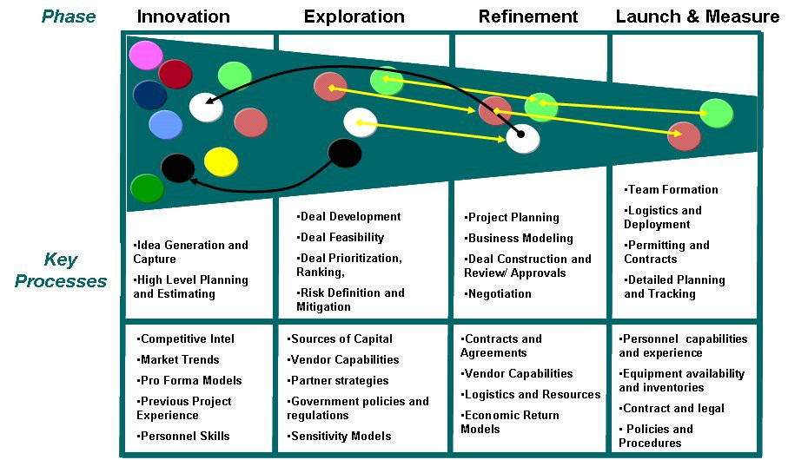
- For each of the key processes, CSC developed a knowledge map that disclosed for the first time, all the data, information, and knowledge assets of the various roles involved in the project. EPIV workers spent about 30 percent of their time just looking for information that was external to their own systems, and when critical information was found, there was no process to add to their process taxonomy, which meant that the next time someone else was looking for the same information, the same loss of productivity occurred.

Service Company
- Service Company is a multi-billion global oil field services and operations company with 52,000 personnel and operations in 80 countries. It designs, builds, and operates complex down hole systems to drill oil and gas wells. Like many companies in the oil and gas exploration and production business, it is facing what the Society of Petroleum Engineers (SPE) is calling the “Big Crew Change,” which alludes to the fact that the work force is rapidly approaching retirement and there are not enough trained personnel to replace the workforce, particularly in the US and Europe. Also, the complexity of its products and services continues to increase as drilling operations move into harsher environments, while global competition requires new tools that can guarantee greater accuracies at lower daily rental costs.
- CSC was engaged to define system requirements and the customer service process through an extensive set of workshops with a wide range of users. The next task was to generate an exhaustive taxonomy to represent the information and knowledge required by the customer field service process. This taxonomy was originally pegged to contain about 1,200 elements, but by the end of the effort contained almost 18,000 elements, driven primarily by the user’s insistence on detail. This size proved unmanageable and was dramatically scaled back before the system was delivered.
- The remaining tasks were to design and construct the web portal by which global access was provided to the technical and operation field staff, and to conduct training and organizational change activities. CSC provided onsite application support for the application for 2 years after the system was delivered.
Fusion Architecture
-Since both KM and BPM solutions must live within an enterprise Service Oriented Architecture, it is useful to construct a services-based architectural model for the fused KM/BPM system.
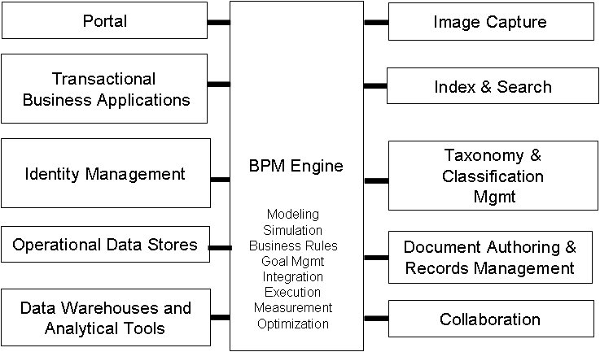

Vendor Capabilities
We have been mapping these architectural services elements to the vendor products that we have been evaluating as possible sources for an integrated solution. Many BPM, enhanced Portal, Application Server, and Workflow products have some of the required components, but seem to be enhancing their tools without a particular strategy in mind. One of the leading BPM vendors, FUEGO, has built adapters for the most ubiquitous document management and portal products, but needs to improve and expand its KM services if it seeks to address this type of need.
There are at least two vendors that are addressing the need for a fused BPM/KM system.

- Kana Resolution is an enhanced call center package that blends workflow and collaboration/guided search to solve tough service resolution problems.
- Appian is a BPM vendor that has a product vision that appears to reflect the BPM/KM fusion concept but needs to strengthen its process design and simulation capabilities
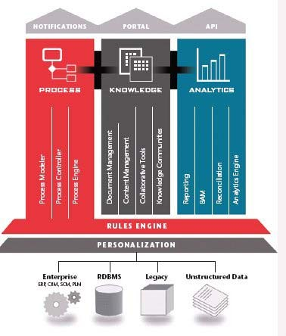
Appian Product Architecture

Lessons Learned
We have learned a number of lessons over the past six years as CSC has been engaged to deliver both Knowledge Management and Business Process Management project work for clients. The most permanent and valuable lesson is that Really Interesting Problems are not simply linear or continuous processes. They contain multiple, asynchronous, long-running processes and lots of content of all types, including data, information, and knowledge. We have also observed that the breaks in the processes, where process execution stops, is where knowledge is being searched for, updated, or created, and where knowledge creation and harvesting must be done. Fused KM/BPM systems must provide this capability.

In the view of a single worker, a task requires him/her to have multiple instances of a number of related processes at different execution stages, with multiple sources of active information in- flight at the same time. While a process is halted, content is likely to change, and this new information may restart or redirect the process. Effective systems must be equally adept at information and knowledge management as they are in process execution and performance measurement.
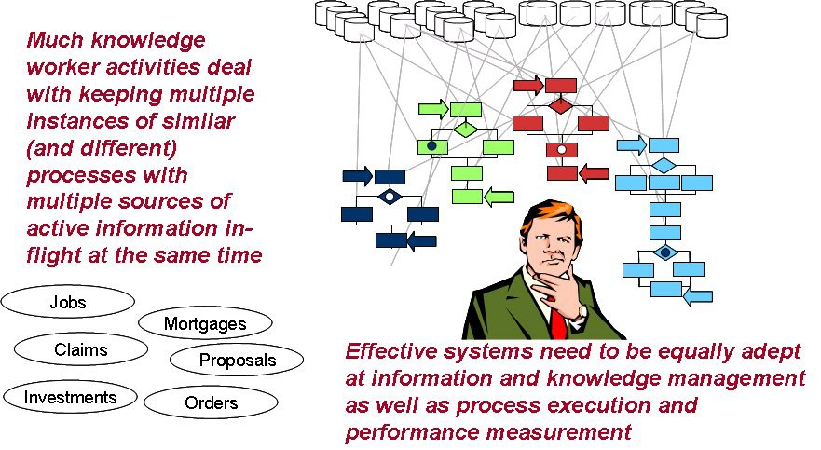
Figure 9 – Really Interesting Problems are Complicated!
Conclusion
We feel that more and more new client applications and vendor products will be designed and constructed as fused KM/BPM systems. We are actively working with vendors who share this same vision. New techniques and integrated services architectures are required to build these new systems, and organizational change issues, which are huge whenever knowledge systems are involved, will become even more important for fused systems. It is difficult to get employee commitment for sharing one’s personal store of professional secrets, yet professionals in high performance companies do it well, and they do it all the time. Yet, despite the challenges, the payoff is worth it. When applied to Really Interesting Problems, fused KM/BPM systems can significantly boost productivity and the effectiveness of decision making when it really counts.

