9 - 512- 004
REV: A PRIL 10 , 2013

DAVID E. BELL

PHI LL I P A NDRE WS MA RY S HEL M A N

Domino's Pizza

Before 2007, wheat prices didn't have a pulse. We'd buy for the next six months and the price would be plus or minus 10 cents a bushel over the last six months. Then one day in 2008 wheat shot up $24 a bushel! Now, as a norm, we strategically consider corn, dairy, and wheat to better leverage our supply chain expertise and improve store economics.
- John Macksood, Executive Vice President, Domino's Pizza

On the morning of August 22, 2011, John Macksood, executive vice president for supply chain services at Domino's Pizza, Inc. (Domino's), was reading the daily headlines while sitting in his office at the Domino's World Resource Center, the company's global headquarters in Ann Arbor, Michigan. Domino's was the world's second-largest pizza company and the largest pizza delivery quick-serve restaurant (QSR) chain. One item in particular jumped out at Macksood. An article, titled "Quiznos chain faces tough finance issues," indicated that Denver-based Quiznos, a privately owned QSR sandwich company with 4,000 U.S. stores, was nearing bankruptcy due to "sharpening competition, waning sales, and debt woes."1 One of the problems cited was Quiznos' "protracted battle" with its franchisees over operating costs and profitability, with some franchisees blaming low or nonexistent store profit margins on Quiznos' requirement that they buy food at "allegedly above-market prices from a Quiznos-mandated supplier network."2 Analysts also blamed Quiznos' problems on rising commodity prices, which had dramatically increased the cost of raw ingredients.
As Macksood finished reading the article, he felt proud to have been part of a team at Domino's that had proactively responded when the prices of wheat, corn, and dairy soared in 2007 and 2008. Since then, Domino's senior leadership had met on the last Thursday of every month to discuss the commodity market outlook and decide how purchasing decisions and supplier relationships should be managed in an increasingly volatile market. The goal of this strategic effort was to maintain an efficient supply chain, competitive prices, and quality menu items. "Now in 2011, we have become a well-informed group that is more comfortable with how we manage risk," Macksood remarked.
Domino's approach to managing risk and costs both within the company-owned domestic supply chain system and at the store level was critical to its approximately 1,150 U.S. franchisees that collectively owned and operated 4,475 domestic stores in 2010. As a company built around a franchise model, Domino's-which itself only owned 454 stores, all in the U.S.-was at the heart a supply chain and brand management business focused on supporting the franchised stores. "We call our headquarters the World Resource Center because Domino's truly operates as a support system and resource for all of our franchisees," said J. Patrick Doyle, CEO and president of Domino's. "There

Professor David E. Bell, Research Associate Phillip Andrews, Global Research Group, and Agribusiness Program Director Mary Shelman prepared this case. HBS cases are developed solely as the basis for class discussion. Cases are not intended to serve as endorsements, sources of primary data, or illustrations of effective or ineffective management.

Copyright © 2011, 2012, 2013 President and Fellows of Harvard College. To order copies or request permission to reproduce materials, call 1- 800-545-7685, write Harvard Business School Publishing, Boston, MA 02163, or go to www.hbsp.harvard.edu/educators. This publication may not be digitized, photocopied, or otherwise reproduced, posted, or transmitted, without the permission of Harvard Business School.

512-004 Domino's Pizza

is a reason we drilled through four floors of concrete to construct a pizza store as the centerpiece of a new atrium inside the World Resource Center. Not only do we use it to train all of our corporate employees to operate a Domino's store, but its visibility serves as a constant reminder that our business hinges on the success of each and every one of our franchised stores."
Maintaining cost control was vitally important for Domino's and the success of its franchisees' stores. The U.S. pizza market was highly competitive, with both chains and independent "mom and pop" pizza stores battling for customers. The recent economic conditions had made the fight even fiercer, with some recession-weary diners trading pizza delivery for less-expensive frozen offerings from the grocer.3 As such, companies like Domino's could not simply pass increased costs on to consumers by raising the price of a pizza. "Domino's was ahead of the curve when we first reacted to how a changing market would affect our supply chain costs," Macksood said. "Chains that didn't take a preemptive approach are hurting and independent pizza shops that have little influence over the price they pay for goods are really suffering."
In 2010, Domino's recorded annual global retail sales of $6.2 billion, the highest in company history and a 23% increase since 2006.a Domestically, the company saw room for another 1,000 stores in the U.S. market and the opportunity to increase sales through the addition of new menu items and by targeting different eating occasions. For example, Domino's had begun to pursue a larger share of the lunch market by introducing sandwiches and pasta dishes to compete with Subway and Pizza Hut. This, however, meant that Domino's historically simple menu would continue to expand with new ingredients, complexity, and costs that Macksood's team would have to manage. (See Exhibit 1 for U.S. same-store sales growth and store counts.)
Outside the U.S., Domino's had identified many markets where the number of stores could be increased significantly. Internationally, Domino's used a "master franchise" system that awarded a franchise for an entire country or region to one entity. This included the master franchisee's right to operate its own supply-chain system. Macksood and his team had to determine how to bring the company's domestic purchasing and supply management capabilities, and particularly its commodity pricing knowledge, to the rest of the world. As global commodity prices showed no signs of dropping, Macksood and others at Domino's wondered if they should attempt to implement global buying for some product categories or develop supply chain partnerships with some or all of the master franchisees in order to control costs and reduce risks across the global brand.

Company Background
In 1960, brothers Tom and James Monaghan borrowed $500 to purchase the Dominick's pizza store in Ypsilanti, Michigan.4 After just a year in the pizza business, James traded his interest in the business to Tom for a Volkswagen Beetle. As the sole owner of the company, Tom renamed the business Domino's Pizza, Inc. The company awarded its first franchise license in 1967 and the first franchised store was opened in Ypsilanti. Domino's continued to license an increasing number of franchisees, which led to the brand's growth regionally and then nationally. Domino's first international franchise license was granted in 1983 for a store in Winnipeg, Manitoba, Canada. By the end of 1983, 1,000 Domino's stores were in operation. When Macksood joined the company in 1986 as the general manager of the North Carolina regional supply-chain center, Domino's had just opened 954 U.S. units during the previous year, making it the fastest-growing pizza company in the country.

a Global retail sales represented sales by company-owned stores and franchised stores.

2

Domino's Pizza 512-004

Unlike its primary competitor Pizza Hut, Domino's focused on pizza delivery and customer carryout and did not traditionally offer dine-in seating areas. As such, Tom Monaghan was dedicated to ensuring the efficiency of Domino's delivery service. Despite the brand's rapid growth, Monaghan kept the menu simple compared to other quick-serve restaurants. From Domino's founding until 1989, the menu consisted of just one type of hand-tossed pizza dough available in two sizes (12-inch "small" and 16-inch "large"), 11 topping choices, and bottled Coca-Cola as the only beverage option. The first menu expansion occurred in 1989 when Domino's introduced "deep-dish" pizza, after market research showed that 40% of U.S. pizza customers preferred thicker crusts. The company's first non-pizza item, breadsticks made from Domino's hand-tossed pizza dough, was added to the menu in 1992. In 1993, industry trends led Domino's to add medium- and extra-large-sized pizzas and to introduce thin-crust dough; in 1994, the menu was diversified even further with the introduction of chicken wings. Still, the menu remained simple in order to streamline production and maximize economies of scale on purchases of principal ingredients.
While changes to the Domino's menu were in response to consumer preferences and competitors' offerings, Domino's had led the competition in innovations that, with time, became standard in the industry. Domino's was the first to utilize the belt-driven pizza oven, which had one temperature setting and a conveyor belt that continuously moved items through the oven, which resulted in consistent and effortless baking. Domino's invented the "spoodle," which was a cross between a spoon and a ladle, in 1985 to help reduce the time it took to "sauce" a pizza (see Exhibit 2 for photos). Domino's was also the first major pizza chain to replace wooden and stainless-steel pizza cooking trays with pizza screens that allowed for more even baking.
To make sure that its pizzas arrived hot, the company was the first of the major pizza chains to use corrugated cardboard pizza boxes in the 1960s, rather than thinner (and less expensive) boxes. Domino's took its commitment to hot pizza a step further in 1998 when it developed the "Heat Wave" electrical delivery bag to keep pizza hot during transit. Between 1986 and 1993, Domino's guaranteed that customers would receive their pizzas within 30 minutes of placing an order or they would get $3 off.
In 1999, with more than 6,500 stores in operation-including more than 1,700 stores outside the U.S.-Monaghan sold 93% of the company to Bain Capital for almost $1 billion and retired as CEO.5 Bain installed David Brandon, the former head of Michigan-based marketing firm Valassis Communications, as president and CEO. While Brandon continued to focus on store operations, he also emphasized the importance of building the Domino's brand. This included better definition and consistent execution of the consumer brand experience across every element-from stores, to trucks, to people-as Domino's sought to accelerate its global expansion. In 2004, Domino's was first recognized as the leading pizza delivery company in the U.S. based on reported consumer spending, a title the company had held ever since. In July 2004, the company completed an IPO and began trading common stock on the New York Stock Exchange (symbol: DPZ). Over the next five years, Domino's expanded its international footprint from 2,987 franchised stores in 2005 to 4,422 by 2010.
Changes were also made to the company's marketing strategy beginning in September 2008 when Russell Weiner was hired from PepsiCo to serve as Domino's executive vice president of Build the Brand and chief marketing officer. Weiner guided Domino's away from its traditional practice of using price-driven "limited time" promotional offers, which created temporary sales spikes, and instead focused on developing new, permanent product platforms that could be promoted through advertising. New offerings such as "Domino's Oven-Baked Sandwiches" and "BreadBowl Pastas" were permanently added to the menu with the intention of creating sustained sales increases.

3

512-004 Domino's Pizza

In 2010, Domino's delivered approximately 400 million pizzas in the U.S., accounting for 71% of its U.S. pizza sales (the other 29% came from carryout) and generated record systemwide revenues of
$1.5 billion, of which $1.4 billion came from domestic operations. (See Exhibits 3a and 3b for company financial reports.) Doyle, a 13-year Domino's veteran who took over from Brandon as CEO in March 2010, was proudest of the increase in same-store sales,b which were up 9.9% domestically and 6.9% internationally. "This is a tremendous feat for any brand, especially one that is 50 years old," he remarked. In 2010, Forbes ranked Domino's the number-one "franchise for the money," and Pizza Today, a leading industry publication, named Domino's the chain of the year, an honor that was repeated in 2011.6
By July 2011, Domino's had grown to 9,436 company-owned and franchised stores in all 50 U.S. states and across 65 international markets, making it the second-largest pizza company in the world behind Yum Brands' Pizza Hut. Domino's had approximately 10,900 employees, referred to as team members, spread across company-owned stores, supply chain centers, the World Resource Center, and regional offices. The company estimated that another 185,000 individuals were employed by independent Domino's franchisees worldwide. For the first time in Domino's history, international retail sales eclipsed U.S. sales in the second quarter of 2011 when overseas markets generated 51% of total company sales.

The U.S. Quick-Serve Pizza Industry
In 2010 there were 67,554 pizza stores in the U.S., which represented 12% of all restaurants in the market.7 Franchised or chain stores made up 60% of the units and generated half of the revenue; the remainder came from independently owned stores, which were often referred to as "mom and pops."8 (See Table A for a list of the top U.S.-based chains.) Independent pizza shops had always been a strong source of competition for consumer dollars, even though these (usually) single units did not have the purchasing power or the advertising ability of the large chains.

The pizza business in the U.S. generated $34 billion in sales revenues in 2010, accounting for 10% of all food industry sales.9 Roughly two-thirds of the annual pizza segment revenue came from the pizza delivery business, where Domino's led the competition with 19.8% of delivery sales.

Table A Leading U.S.-Based Pizza Chains, 2010

Company | U.S. Sales ($ billions) | Share of  U.S. Market | U.S.  Units | International Units | Percent Franchised
Pizza Hut | $5.0 | 14% | 7,566 | 5,715 | 84%
Domino's Pizza | $3.3 | 8% | 4,929 | 4,475 | 95%
Papa John's Pizza | $2.1 | 6% | 2,781 | 688 | 82%
Little Caesars | $1.1 | 3% | 2,500 | 200 | 81%

Source: Jonathan Maze, "2010 Franchise Times Top 200 Franchise Systems," Franchise Times, October 2011, http://www. franchisetimes.com/content/page.php?page=00138, accessed September 2011; and Domino's company documents.

b Same-store sales growth was a statistic used by retailers and industry analysts to compare sales at stores that had been open for a year or more. It allowed investors to determine what portion of sales came from sales growth and what portion came from the opening of new stores. Although new stores were a positive factor, a saturation point-where future sales growth was determined by same-store sales growth and not simply the addition of new units-eventually occurred.

4

Domino's Pizza 512-004

Domino's U.S. Franchise Structure
From the time Monaghan signed the first Domino's franchise agreement in 1967, a central tenet of its strategy was to make it as easy as possible for franchisees and store managers to run their stores. Domino's had developed a cost-effective business model with low capital requirements, a focused menu of affordable pizza and other complementary items, and an interior specially designed to support delivery and carryout. "At the store level, we believe that the simplicity and efficiency of our operations gives us significant advantages over our competitors, who in many cases, like Pizza Hut, also focus on dine-in," said Stan "The Pizza Guy" Gage, vice president for training and development. Domino's domestic stores and the majority of its international locations did not have extensive dine- in areas, which cut costs for space, furnishings, and staff. As a result, Domino's stores were small, averaging approximately 1,200 to 1,500 square feet in size with 15 to 20 employees. The units were relatively inexpensive to build, furnish, and maintain. The amount of capital investment required to open and operate a new Domino's franchise location averaged $150,000 to $250,000, which was considered low in the QSR segment.

The average Domino's U.S. franchisee owned and operated three to four stores, and many had only one or two. At the end of 2010, only seven franchisees owned 50 or more stores, with the largest domestic franchise operating 144 stores. This was different from many QSR franchise models in the U.S., which often awarded franchises on a regional basis, with one franchisee owning many or all of the locations in a metropolitan area or state. Rather than controlling a region, a Domino's franchisee was granted a specified delivery radius. The size of this delivery area was based on the ability to deliver a pizza from the store to the customer's door in 10 minutes or less.
To protect the brand, Domino's placed rigorous standards on its franchisees, such as usually requiring prospects to manage a Domino's store for at least one year before they were granted a franchise. Generally, Domino's also restricted franchisees from pursuing active, outside business endeavors so as to align the interests and success of the franchisees with that of the brand. Based on these two factors, the vast majority of Domino's U.S. franchisees had historically come from within the Domino's system; many started as a Domino's delivery driver.
Under a Domino's franchise agreement, the owner was granted the right to exclusively operate in a particular area for a term of 10 years with an option to renew for an additional 10 years. In 2010, the average length of Domino's relationship with its top 50 franchisees was 19.5 years. Domino's franchise contract renewal rate was over 99%, and its collection rate on domestic franchise royalties and supply chain receivables was also over 99%.

Each franchisee had discretion over the prices charged to its customers, with some national sales promotions set at the corporate level. Domestic franchisees paid Domino's a 5.5% royalty fee on weekly salesc and until 2009 made contributions to fund marketing and advertising at the national and local levels, which varied by market. In 2009, all domestic franchisees amended their franchise agreements to include a flat marketing contribution of 5.5%. As such, franchisees were no longer required to contribute to regional- or local-level advertising campaigns, although they were allowed to if they desired. (See Exhibit 4 for details of initial and ongoing franchisee costs.) In 2010, average reported annual EBITDA per domestic franchise store was between $50,000 and $75,000 on average annual sales volume of $650,000 per unit.

c The royalties generated by Domino's franchise system, which included its U.S. and international franchisees, generated a steady stream of free cash. Domino's used this free cash flow to reinvest in the company, such as funding technology enhancements and supply chain improvements, and also to buy back debt, repurchase stock, and pay dividends.

5

512-004 Domino's Pizza

U.S. Supply Chain System
The supply chain system was the hub of Domino's U.S. franchise model. Domestic franchisees were free to source and purchase their own menu ingredients and supplies as long as the items were approved by Domino's and sourced from approved suppliers. However, the system had earned Domino's a strong and dedicated following among its domestic franchisees; in 2011, over 99% of them chose to be customers of the Domino's supply chain. As such, Domino's provided virtually all of the company's 4,900 U.S. stores with over 240 individual products, including fresh pizza dough, menu ingredients such as cheese and pepperoni, and store supplies ranging from delivery boxes to cleaning products and toilet paper. Macksood explained how the U.S. supply chain created value:
Our centralized purchasing, vertically integrated dough manufacturing, and nationwide distribution system allows us to leverage Domino's combined volume to achieve economies of scale and lower costs, and to tightly control quality. This system allows store managers to focus on store operations and customer service rather than worrying about making dough, grating cheese, and preparing toppings, and sourcing other ingredients. This enhances our relationship with franchisees and ensures that every Domino's customer gets a great pizza.

The Basics
Domino's supply chain system was comprised of 19 facilities located in 15 states, which allowed for nationwide coverage. Of these facilities, 16 were regional dough manufacturing and supply chain centers (SCC). Domino's also operated three other supply chain facilities, which included an equipment and supply distribution center 25 miles east of the World Resource Center in Michigan, a fresh produce facility in Georgia that supplied some franchisees with cut vegetables, and a "pressed- product" plant in Illinois that manufactured thin-crust dough for distribution to the 16 SCCs.d (See Exhibit 5 for map and details of U.S. supply chain system.)
Domestic franchisees were required to purchase and use the company's Pulse point-of-sale computer system. This system was used for taking customer orders, submitting store orders to their designated SCC, and for connecting with the Domino's network. The Pulse system included forecasting software that allowed store managers and owners to track inventory and sales to customers. This differed from the forecasting tools utilized by Domino's at its SCCs, which tallied total product and raw ingredient sales made to franchisees. This information was then used by a group of team members at the World Resource Center who conducted centralized replenishment of all 16 SCCs in the system.
Each SCC manufactured fresh dough on a daily basis and served about 300 stores located within a one-day delivery radius. Each Domino's store received an average of two full-service food deliveries per week, amounting to 515,000 total systemwide deliveries in 2010. Stores placed their orders for dough-which had a seven-day shelf life-and food and other supplies electronically via Pulse, usually by 5 p.m. SCCs actually began manufacturing dough at 5 a.m. using an internal forecast. Domino's fleet of 200 leased tractor-trailers were loaded in the early evening and rolled out of the SCCs starting between 9 p.m. and 10 p.m. Drivers unloaded food and supplies at the stores, stocked coolers and shelves (rotating items so older products would be used first), and even mopped the floor if they had tracked in mud or snow. Deliveries were typically made in the middle of the night to minimize disruptions to store operations. Domino's guaranteed delivery within 48 hours of when the

d Domino's "pressed-product" facility produced thin-crust dough that was parbaked (e.g., cooked for roughly 80% of the normal cooking time and then rapidly cooled and frozen) for distribution to the 16 SCCs.

6

Domino's Pizza 512-004

order was placed, and the company regularly achieved an on-time delivery performance rate of 95%, with the majority of orders delivered within 24 hours. Gage explained that ordering through Domino's offered one-stop shopping and other benefits:
The supply chain eliminates many of the typical back-of-store activities that our competitors' managers must undertake-such as figuring out which supplier has the best price on cooking oil or what cleaning supplies to order. The single most important person in Domino's is the store manager, and this system allows them to focus on the quality and consistency of menu items and customer service.
New franchisees were exposed to the efficiency of the supply chain system long before their first fresh dough order was placed with an SCC. The equipment and supply chain center was the first stop for franchisees worldwide. There, store owners could buy capital items such as ovens, coolers, pizza preparation areas, counters and fixtures, signage, and other large equipment as well as "re-use" items including delivery bags, uniforms, small wares, and promotional materials. "The operation was born out of the concept of selling and shipping a pizza store in a box, a model that dates back to the beginning of the company," explained Jim Murabito, vice president of product management. "With an inventory of over 2,500 individual SKUs, this facility is a one-stop shop able to supply our franchisees with everything they need to set up, open, and operate a Domino's location."

Adding Value
Domino's domestic menu reached its largest and most diverse state in 2010 when the company offered 4 different pizza crusts, over 25 topping choices, 8 oven-baked sandwich options, 5 pasta dishes, 2 types of chicken, 2 styles of breadsticks, and 2 baked dessert options. (See Exhibits 6a and 6b for Domino's menu items.) Menu prices across the highly competitive pizza-delivery industry were relatively identical; therefore, the major pizza chains had to differentiate themselves based on taste, quality, and customer experience. Domino's helped franchisees maintain consistent quality, while improving store economics using various tools, including the spoodle and the pizza oven that Domino's had designed. Another important piece of equipment was "the make-line" station, which served as the assembly line for a pizza. The make-line, which was a metal counter with containers and refrigeration for ingredients and toppings, had been designed-and was continually being updated-to support speedy pizza making. For example, a refrigerated cheese catch tray under the counter-another Domino's proprietary design-allowed pizza makers to quickly spread shredded cheese on a pizza without worrying about food waste. As a result, Domino's head pizza trainer could prepare a pizza (e.g., flatten and shape the fresh dough ball, apply sauce, and top with cheese and pepperoni) in 24 seconds.
"These tools allow stores to consistently produce menu items that meet the Domino's standard and deliver those items in the fast, efficient manner that is required for success in the pizza delivery segment," explained Murabito. In fact, the only piece of cooking equipment in a Domino's store was the belt-driven oven; there were no microwave ovens or stoves. This meant that all of the items on Domino's domestic menu-pizzas, chicken, sandwiches, pasta, bread, and desserts-had been designed to cook at approximately 500 degrees Fahrenheit for six minutes.
Not only were Domino's franchisees attracted to the company's domestic supply chain for its efficiency and consistency; their participation was also encouraged through a profit-sharing arrangement. Generally, Domino's shared 50% of the pretax profits generated by its regional dough manufacturing and SCCs with the domestic franchisees that purchased all of their ingredients and supplies from the company. While franchisees were allowed to opt out of the supply chain with notice, doing so would eliminate their right to profit sharing. Participating franchisees were allocated

7

512-004 Domino's Pizza

a profit share based on the volume of their purchases from SCCs. This profit sharing reached a record level in 2010 and "continued to strengthen Domino's ties with its franchise network by enhancing franchisees profitability while maintaining a source of revenue and earnings for Domino's," noted Macksood. "The greatest advantage of this arrangement is that it brings us closer to our franchisees and encourages us to work together to reduce costs and food waste." Macksood provided an example of how his group responded to franchise feedback:

With nine product groups accounting for 90% of sales volume in our supply chain, our biggest challenge is managing an increasing variety of ingredients. When pasta was introduced to the menu, we began supplying a cheese sauce that was packaged in a one-pound bag. Within a few months, franchisees reported that the amount was more than needed to meet their daily sales volume, which forced them to throw away product. We experimented with smaller packaging options and eventually settled on individual portion-sized packs. Smaller packaging is more expensive for us, but it creates less food waste for our franchisees.

In addition to allowing Domino's to work closely with franchisees to manage costs and gain product feedback, the supply chain also helped the company respond to natural disasters that could disrupt store sales. When Hurricane Katrina struck the U.S. Gulf Coast in 2005, Domino's quickly placed trailers at stores that were destroyed or without electricity, allowing franchisees to feed rescue workers and displaced citizens. According to Macksood, Domino's stores in the area were the last QSRs to close before the storm and the first to reopen. In the time since the hurricane, Domino's encouraged franchisees in the area to build new stores that would be "hurricane ready" with generators, an extra-large cooler, and the ability to reopen quickly.

In February 2011, an ice storm paralyzed usually snow-free Dallas-Fort Worth, Texas, just days before the area played host to the Super Bowl. Super Bowl Sunday was historically the pizza delivery industry's busiest day of the year. The company was expecting to sell 1.2 million pizzas nationwide, with especially strong demand across the 123 stores serving the Dallas-Fort Worth market.10 It was customary for SCC managers to monitor meteorological reports in their respective distribution regions. By doing so in this instance, the supply chain system was able to proactively position extra resources and make early deliveries when warned about the pending Texas storm, allowing Domino's to meet customer demand on the day of the game.

The Agricultural Commodity Market and Domino's Suppliers
Historically, the agricultural commodity market-although cyclical-had been relatively stable and predictable. This continued to be the case even as prices for corn, milk, soybean oil, and wheat rose steadily from 2000 to 2005. However, global commodity prices soared in 2007 and 2008 due to record high oil prices, severe weather events, food security fears, and trade restrictions. The price of wheat, corn, rice, and oilseed crops nearly doubled. Some pricing relief came in late 2008 and in 2009 when the most serious global economic recession since the 1930s dampened demand. However, prices rose again at the beginning of 2010 as demand, driven primarily by developing countries undergoing rises in per capita incomes and population growth, outpaced supply. Reduced global inventories added to the price volatility, which was exacerbated by a high number of severe weather events. In the summer of 2010, droughts followed by fires in Russia, the world's third-largest grain producer, reduced the country's wheat production by 25% and led the government to stop exports.
The U.S. commodity market followed the same global trends into 2011 due to a combination of factors, including droughts in key grain-producing regions, spring flooding on the Mississippi and other U.S. rivers, low stocks, increased use of corn to produce biofuels, and rapidly rising oil prices.

8

Domino's Pizza 512-004

In April 2011, corn futures prices,e which had increased almost 90% over the previous 12 months, reached a record high of $7.44 per bushel and for the first time in a decade surpassed the price of wheat futures on the Chicago Board of Trade (CBOT). Only four months earlier, wheat had traded at a 31% premium over corn. The growing use of corn for ethanol in the biofuels industry and a rise in demand for livestock feed kept demand up and prices high.f Other factors, such as increased demand for corn feed in China, were also blamed for sustained high prices.11
Rising corn prices hit protein producers particularly hard. Tyson Foods, Inc., the largest meat producer in the world, cited higher poultry feed costs for a 21% year-on-year drop in its second- quarter 2011 earnings.12 From July 2010 to July 2011, the price that U.S. meat producers charged for chicken grew 4.3% and was projected to increase another 5% by the end of 2011. Similarly, pork prices had increased 27%, and both pork and chicken had reached record high prices. The trading price for milk, the primary ingredient in cheese, had escalated 56%13 to a record high of $21.39 per cwt (100 pounds) in July 2011,14 a price Macksood called "sticker shock." Many meat and dairy producers started to include increasing amounts of wheat as a feed substitute.15 With corn at record prices, some U.S. farmers switched from growing wheat to corn, which in turn reduced wheat supply and drove wheat prices higher.

Risk Management
Costs at Domino's were directly affected by higher prices. "When you buy enough wheat to produce over 300 million pounds of dough annually, are one of the top cheese volume buyers in the U.S., and purchase about 27 million pounds of pepperoni a year, you have some purchasing power, but small bumps in commodity prices can add up quickly," Macksood said. "The price of wheat had always been important to us, but over time, we found ourselves talking more and more about corn. Conversations would begin with the price of dairy or poultry, but it always linked back to corn." (See Exhibits 7a and 7b for historic commodity price charts most relevant to Domino's purchasing.) In fact, the monthly strategy session was eventually nicknamed "The Corn Meeting." This session brought together the CEO; senior and functional executives from finance, product management, purchasing, and supply chain; consultants from the agribusiness and food industries; and at times, Domino's partners and suppliers.
However educated Macksood and his team had become, continued volatility and unpredictability in the commodity market through 2011 kept them on their toes. Specifically, the price of meat, grain, and dairy products had been on the rise since February, with some reaching record highs,16 leading
U.S. meat processors to modify sales and contracting practices in an effort to shift more of their risk to restaurants and grocers. Poultry processors in particular, such as Tyson Foods, Inc., had pushed for contracts that adjusted with swings in the grain market so as to not get caught on the wrong side of a surge in feed costs. "We have long-term relationships with many of our primary suppliers, some of which have been with us for 20 years or more," explained Murabito. "These were of great value as we had to shift from working to drive cost out to now managing cost increases."

e Futures were standardized, exchange-traded contracts in which the buyer agreed to take delivery, from the seller, a specific quantity of the commodity at a predetermined price on a future delivery date. Domino's closely monitored corn futures prices on the CBOT exchange and hard red spring wheat futures prices on the Minneapolis Grain Exchange (MGEX). Both futures prices were quoted in dollars and cents per bushel and were traded in lot sizes of 5,000 bushels (127 metric tons).
f The U.S. was the world's largest corn-producing nation, and the 2010 domestic harvest yielded 40% of the world's corn crop. According to the National Corn Growers Association, more than 60% of U.S. corn was consumed by domestic and overseas livestock, poultry, and fish production, 27% was distilled for ethanol fuel production, and 12% was used in foods such as alcoholic beverages, cereal, high-fructose corn syrup, starches, and sweeteners.

9

512-004 Domino's Pizza

In order of magnitude, cheese was Domino's largest commodity cost, accounting for 30% to 40% of the cost of a pizza, followed by meat, boxes, wheat, and tomato sauce. Rising corn prices affected the price Domino's paid its suppliers for these items. Uncertainty about how corn would continue to have an impact on wheat supply and cost in the long term required Domino's to act even more strategically. While Domino's maintained multiyear contracts for many of its products, the pricing arrangements were increasingly based on market conditions. Macksood recognized that, as a result, prices could go up significantly or-at the extreme-suppliers would not have sufficient inventory to deliver, which would affect the consistency and quality of Domino's products. "As a result of this new environment, we have changed the way we think about our role," he remarked. "We now push for greater visibility into the basic components of our products. Our goal is to understand all of the cost drivers for every item we purchase, and then work with our suppliers to manage down to that level."
The corn meeting allowed Domino's to make more informed buying and contracting decisions. One of the most important aspects of the corn meeting was to ensure that Domino's "buy teams" were very knowledgeable about global commodity costs. "The information we gain in our monthly sessions allows the buy teams to work more proactively with our suppliers," said Macksood. "In the past, we used to leave risk management to them. Now we are making decisions on when to buy important inputs." This allowed Domino's to manage risk in a volatile commodity market better than most QSRs. For example, Domino's worked with its poultry suppliers to determine the best time to purchase feed and its cheese producer to identify the most opportune time to lock in a dairy contract. The goal was that this would reduce the cost suppliers charged Domino's, thereby limiting the costs passed on to franchisees. Macksood explained that by sourcing the food for substantially all of its domestic stores, "Domino's U.S. supply chain segment enables us to leverage and monitor our strong supplier relationships to achieve the cost benefits of scale and to ensure compliance with our rigorous quality standards."

Domino's International Franchise Model
Outside the U.S., Domino's used a "master franchisee" model that differed significantly from the
U.S. franchise system. Under this system, a master franchisee was granted exclusive ownership rights over the stores and the supply chain system for a country, region, or number of countries. Additionally, the master franchisee was allowed to sub-franchise the brand within its market. (See Exhibit 8 for an illustration of the system.) Prospective master franchisees were required to possess a deep knowledge of the local market as well as the market access needed to develop new Domino's stores. "Getting retail right in international markets is a huge challenge," noted Ritch Allison, executive vice president, international, who explained:
To be successful internationally, you must have the right product, the right service, and the right image for each market. We tried that years ago in Australia and learned the hard way that we can't do this by sending a team from the U.S. to run a country. The master franchise model allows the necessary localization to occur and also allows us to expand faster, since the master franchisee is providing the capital to open new stores or recruiting sub-franchisees. The economics must work for them if they are to put their funds behind Domino's instead of other opportunities. Supply chain is an important part of that business model.

Doyle, who ran Domino's international business from 1999 to 2004, concurred on the benefits of the master franchise model. "Pizza is spectacularly adaptable to local tastes," he remarked. "Bread, sauce, and cheese are dietary basics almost anywhere in the world. The toppings can be localized. A

10

Domino's Pizza 512-004

top-down system run out of Ann Arbor would not be as flexible. This system works well for the customer, for the store, for the master franchisee, and for Domino's corporate. Our job is to provide support to the master franchisee and help them drive more competitive advantage."
"Under this arrangement, our U.S. supply chain group acts much more like a consultant to our international master franchisees," explained Spencer Breidinger, manager for product quality and compliance international. "We advise them on core products but we also take on a brand protection role through safety audits and enforcement of a supplier approval process." The company's U.S. menu was determined at the corporate level, which franchisees had to abide by. The international menu was a set platform with the same core dough, crust choices, sauce, and cheese, but allowed for special toppings and pizza "builds" designed to meet local tastes and food customs. (See Exhibit 9 for examples of international pizza products.) Breidinger explained that master franchisees used Domino's dough recipe, and their ingredients were analyzed by team members at the World Resource Center in order to tightly control the product. Domino's also used lessons from its past to help advise master franchisees about the intricacies of the pizza delivery business and to understand the differences between markets. In the U.S., pizza was a dinner food, unlike in Europe where it was a lunch item. Domestically, 80% of a unit's business came in during 20% of its open hours, whereas in Europe sales were more spread out over the day. In Taiwan, pizza was not something that older adults typically enjoyed, so the master franchisee there wanted to offer chicken dishes to entice whole households to order from the menu, which triggered the approval process in Ann Arbor.
Master franchisee terms lasted for 10 or 20 years with the possibility of extension, and the agreements typically contained growth clauses that required franchisees to open a minimum number of stores during a set time period. The royalty fee paid to Domino's was assessed as a percentage of retail sales and varied across markets. In 2010, that royalty fee averaged approximately 3% of a store's annual sales and represented 90% of Domino's international operating income.g
In 2011, 45% of Domino's international stores were operated by just four of the company's master franchisees, all publicly traded companies. The largest was Australia-based Domino's Pizza Enterprises LTD, which held the exclusive master franchise rights for the Domino's brand and system in Australia and New Zealand, as well as Belgium, France, The Netherlands, and the Principality of Monaco. The next three largest master franchisees were Domino's Pizza UK & IRL PLC, which held the franchise rights in the U.K., Ireland, and Germany; Mexico's Alsea, which had the license for Domino's stores in that country and Columbia; and India's Jubilant FoodWorks Limited, which held the master franchise rights for India, Nepal, Sri Lanka, and Bangladesh. (See Exhibit 10 for market position and potential growth in Domino's top 10 international markets.) Jubilant was the market leader in India's pizza segment with a 50% market share and a 70% share of the home delivery segment. In fact, Domino's Pizza, Inc., and Jubilant had an equal market value of $1.5 billion in July
2011.17 Higa Industries, the Domino's master franchise in Japan, operated 179 locations and in January 2011 was acquired by Bain Capital.18 Bain was Domino's largest shareholder from 2004 to 2010, selling all its shares in 2011 but retaining a director seat on the board.
Some of the larger master franchisees also had franchise agreements with other QSRs and/or restaurant chains. Alsea held the rights to Burger King, California Pizza Kitchen, Chili's, P.F. Chang's, and Starbucks in Mexico. In 2010, Jubilant entered into a franchise agreement with Dunkin' Donuts to develop and operate the brand in India. It was possible that in situations where a master franchisee

g Domino's operations in Canada were an exception to the international master franchisee model. Rather than one master franchisee for the country, four franchisees operated the 345 stores in Canada, and Domino's owned the four SCCs that supplied the Canadian market.

11

512-004 Domino's Pizza

held the rights to multiple franchises in a country, Domino's influence over the master franchisees' supply chain could be complicated.

Penetration and expansion into new international markets was a strategy many of the other large publicly traded QSR brands had employed to fuel growth. While other QSR chains had a larger presence outside the U.S. than Domino's in 2010-McDonald's, Yum! Brands, and Starbucks had 18,909, 18,590, and 6,061 locations, respectively, compared to Domino's 4,475 stores-Domino's was vastly ahead of the other global pizza chains in terms of international expansion (see Exhibit 11 for international net unit growth of the top three pizza chains). "We have the opportunity to capture diners' interests in international markets with our unique menu, and this gives Domino's a huge runway for international growth," said Doyle.

Transparency and a Turnaround
Domino's valued how the quality and consistency of its products affected the brand image. The company kept this in mind whether expanding with new stores domestically and internationally or increasing market share with the introduction of new menu items. Aware of the role that social media and new consumer technologies played in brand image, Domino's began to embrace these tools as networking sites such as Twitter, Facebook, and YouTube increased in popularity. The company's adoption of new technologies was used both to address problems in public perception of its products and to improve efficiencies at the store level.
In 2009, Domino's faced two major threats to its brand reputation and the public's perception for the company. The first incident occurred in April, when employees at a Domino's store in North Carolina made a video that showed food being prepared in an unsanitary manner and posted it online via YouTube. A blogger who had seen the video alerted Domino's communications team, but the video was ultimately viewed more than a million times. References to it were in 5 of the 12 results on the first page of a Google search for "Dominos," and discussions about Domino's had spread throughout Twitter.19
As the company learned about the video, executives focused on determining the identities of the culprits, rather than simply trying to remove the video from YouTube. "What we missed was the perpetual mushroom effect of viral sensations," said Tim McIntyre, vice president for communications. In fact, Domino's found itself in the middle of a public relations crisis, and its reputation took a beating for a few days until the company revealed that the video was a hoax.
The YouTube incident revealed to Domino's that an isolated event of customer experience could go global in minutes. In the wake of the scandal, Domino's adopted a companywide policy that focused on transparency. This developed into a major marketing campaign when the company decided to change its core pizza recipe in late 2009. Earlier that year, Domino's learned that when it came to taste, a consumer survey ranked Domino's pizza products last among national brands, tied with Chuck E. Cheese's, a chain of family entertainment centers with a pizza-focused menu. Yet, Domino's ranked higher than any other pizza chain for overall customer satisfaction. (See Exhibit 12 for results of the consumer survey.)
The company's position at the top for service and the bottom for quality revealed a major opportunity to improve on its weaknesses and, in doing so, gain market share from rivals. "Sure, we had an efficient and reliable pizza delivery business that consumers appreciated, but we had convinced ourselves that fast delivery and great taste were not compatible," noted Brandon Solano, vice president of marketing and retail innovation. On December 29, 2009, just two days before the

12

Domino's Pizza 512-004

beginning of the company's 50th anniversary year, Domino's announced plans to entirely reinvent its pizza and immediately launched a bold and transparent national ad campaign that openly acknowledged problems with the taste of Domino's pizza. At the beginning of the campaign, television and social media aired footage of consumer focus groups criticizing the pizza's quality. A later stage featured the reaction of Domino's critics after tasting the new offering. Others showed the surprise on consumers' faces when they were brought to the tomato and dairy farms that supplied Domino's and its suppliers with domestically grown, fresh ingredients. In other ads, company chefs were featured in the World Resource Center's test kitchen developing the new products.
The "new and inspired" pizza recipe called for adding butter, garlic, and parsley to its crust, switching from diced to shredded mozzarella cheese-shredded melted better-with some added provolone, adding 40% more cheese per cheese pizza overall, and creating a sweeter sauce with a more pronounced red-pepper flavor (see Exhibit 13 for related promotional materials). The "new and inspired" pizza campaign was initially limited to the U.S. market since Domino's reputation had not been associated with poor quality in most international markets. However, master franchisees were welcomed to implement the new recipe as an "improvement" over their already well-regarded pizza.

For the first quarter of 2011, the company posted an historic 14.3% same-store sales growth over 2010. "The performance of our new and inspired pizza resulted in one of the largest quarterly same- store sales jumps ever recorded in the industry," remarked Doyle. Domino's continued to expand the menu beyond the initial turnaround period, including the planned launch in September 2011 of a line of gourmet-inspired "Artisan Pizzas," which would include specialty ingredients such as feta cheese, alfredo sauce, and Italian salami.
The menu changes and sales growth brought on by the "new and inspired" pizza campaign had a direct impact on the domestic supply chain and tested the adaptability of the system. The campaign was strategically launched to coincide with the New Year's Eve holiday and the Super Bowl, two of the top sales days on Domino's annual calendar. As the campaign rolled out nationally, the entire supply chain system experienced a 30% increase in order volume. Coupled with the usual Super Bowl sales bump of 15% to 20%, supply chain volume for first quarter of 2010 was up between 40% and 50% over the same period in 2009. "Supply chain distribution volume was up substantially with the turnaround, especially for our SCCs in parts of the country that had been hit hardest by the economic downturn," recalled Macksood. "Some SCCs went from producing 10,000 to 11,000 trays of dough per day to 21,000 to 22,000 trays per day. Busy became the new norm." In some instances, franchisees showed up at SCCs to pick up dough between their regular deliveries, and many emergency deliveries were scheduled. "We were challenged on all fresh ingredients but especially pepperoni, which has a 21-day cure time. It was a stretch, but we managed to fill all orders and everyone got what they needed," said Macksood. "Our franchisees really appreciated that."

Technology
The transparency brought on by the YouTube scandal and Domino's public reinvention campaign continued beyond the initial success of the "new and inspired" pizza campaign in 2010. In July 2011, Domino's began running some of the customer comments gathered though its "Pizza Tracker"h customer technology tool across a giant digital billboard in New York's Time Square. Barring

h Launched in 2008, Domino's Pizza Tracker was a first for the food-delivery industry. The technology allowed Domino's customers to follow the progress of their order online from the time they placed it via the Domino's website until the delivery person arrived. The customer could see when his order was being prepared, when it was out of the oven, when it was out the door and on its way, and the first name of the delivery person. Pizza Tracker actively solicited customer comments, which were immediately shared with the store via Domino's Pulse system.

13

512-004 Domino's Pizza

inappropriate language, no comments were excluded, no matter how negative. The Times Square ad ran for two hours and 54 minutes per day, displaying approximately 700 comments, both good and bad, in real time at a rate of four per minute. (See Exhibit 14 for images of the Pizza Tracker and the billboard.) In addition to revealing customer comments, Domino's made sure to follow through on its companywide transparency policy in its customer response as well. A dedicated group of team members at the World Resource Center monitored customer comments received via e-mail, the Pizza Tracker, the company website, and through Facebook. This group responded to comments in a personal manner without the use of canned responses and did so quickly. "If we can bake a pizza and get it to the customer in 30 minutes, we should be able to respond to a customer concern in the same amount of time," noted Gage. When a customer sent Domino's a picture of an unacceptable pizza, Doyle even went on television to apologize and promise that Domino's was on the right track.
The use of technology such as the online Pizza Tracker allowed Domino's to more closely monitor its delivery processes and make improvements. Domino's estimated that around 25% of its domestic sales in the first half of 2011 were ordered online or through a handheld device. "Online ordering through dominos.com eliminates many of the hassles of phoning in orders, such as customers being placed on hold, making them feel rushed, or mistakes made in taking down the order," said Doyle. "When customers order online, they see all the menu options, including pictures of different pizzas. They often order more than they do on the phone, where they are ordering from memory."
Increased online ordering also meant Domino's had to direct more resources to managing its information technology (IT). For example, major events like the Super Bowl-watched by 100 million people, many of whom placed orders at kickoff and halftime-could stress the company's online ordering system. To be fully prepared for Super Bowl Sunday in 2010, Domino's began using simulation testing in July 2009 to make sure there was enough server capacity to support sharp spikes in demand. In addition, a group of more than 50 IT team members gathered at the World Resource Center on game day to monitor traffic on Domino's website to ensure continuous service.
In June 2011, Domino's launched an iPhone application that allowed customers to order directly from their mobile devices, search for the closest Domino's location, access local and national coupons, and check on the status of their orders using the Pizza Tracker. The application quickly became one of the top free downloads in the Apple iTunes store. In November 2011, Domino's planned to launch a free iPad game named "Pizza Hero." Players would race against the clock to make their own pizza creation. When the user completed her pizza, she could actually order it and have it delivered.

Conclusion
Domino's ability to leverage its domestic supply chain to control costs, the quality of its core pizza product, and the consistency of its ingredients was critical in the company's continued growth and profitability in a turbulent commodity market and was a key factor behind the successful implementation of the "new and inspired" pizza campaign. In the summer of 2011, even as commodity prices showed no signs of dropping, the company pushed ahead with plans to channel the majority of new store growth internationally in existing and emerging markets. Macksood and his colleagues were proud of the important role Domino's domestic supply chain played in the company's success. While the international master franchise supply chain system had worked well, Macksood wondered if there was an opportunity to apply the purchasing power of the domestic supply chain on the international level.

14

Domino's Pizza 512-004
Exhibit 1 Domino's Pizza, Inc., Same-Store Sales Growth (percentage) and Store Counts, 2006-2010
For the Fiscal Year Ended

Dec. 31, 2006 Dec. 30, 2007 Dec. 28, 2008 Jan. 3, 2010 Jan. 2, 2011
Same-store sales growth:  Domestic company-owned stores | (2.2)% | 1.0% | (2.2)% | (0.9)% | 9.7%
Domestic franchise stores (4.4)% (2.1)% (5.2)% 0.6% 10.0%
Domestic stores | (4.1)% | (1.7)% | (4.9)% | 0.5% | 9.9%
International stores | 4.0% | 6.7% | 6.2% | 4.3% | 6.9%
Store counts:  Domestic company-owned stores | 571 | 571 | 489 | 466 | 454
Domestic franchise stores | 4,572 4,584 4,558 4,461 4,475
Domestic stores | 5,143 5,155 5,047 4,927 4,929
International stores | 3,223 3,469 3,726 4,072 4,422
Total stores 8,366 8,624 8,773 8,999 9,351

Source: Company documents.

Exhibit 2 Images of Domino's Logo, "Spoodle," "Make-Line," and Belt-Driven Oven

Domino's logo Domino's spoodle Make-line and cheese catch

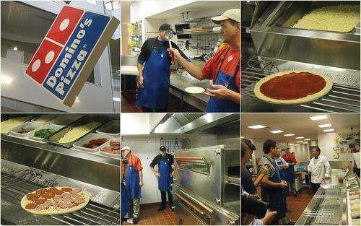
Toppings on the make-line Domino's belt-driven oven Make-line

Source: Company documents.

15

512-004 Domino's Pizza

Exhibit 3a Domino's Pizza, Inc., Consolidated Income Statement, 2006-2010 ($ millions, except per share data)

For the Fiscal Year Ended:

Income Statement Data: | Dec. 31, 2006 Dec. 30, 2007 Dec. 28, 2008 Jan. 3, 2010 Jan. 2, 2011
REVENUES:  Domestic company-owned stores | $393.4 $394.6 $357.7 $335.8 $345.6
Domestic franchise | 157.7 158.1 153.9 157.8 173.3
Domestic stores total | 551.1 552.6 511.6 493.6 519.0
International royalties and other | 60.5 66.3 73.1 77.4 91.3
International supply chain | 62.9 60.6 69.3 69.4 85.1
International total | 123.4 126.9 142.4 146.8 176.4
Domestic supply chain | 762.8 783.3 771.1 763.7 875.5
Total revenues | 1,437.3 1,462.9 1,425.1 1,404.1 1,570.9

COST OF SALES:

Domestic-company owned stores | 312.1 317.7 298.8 274.4 278.2
Domestic supply chain | 681.7 710.9 699.6 680.4 778.5
International | 58.9 55.4 63.3 62.1 75.4
Total cost of sales | 1,052.7 1,084.0 1,061.9 1,017.1 1,132.3
OPERATING MARGIN | 384.5 378.9 363.3 387.0 438.6
GENERAL AND ADMINISTRATIVE | 170.3 184.9 168.2 197.5 210.9
INCOME FROM OPERATIONS | 214.2 193.9 195.0 189.5 227.7
INTEREST INCOME | 1.2 5.3 2.7 0.7 0.2
INTEREST EXPENSE | (55.0) (130.4) (114.9) (110.9) (96.8)
OTHER | -- (13.3) -- 56.3 7.8
INCOME BEFORE INCOME TAXES | 160.4 55.6 82.9 135.5 138.9
INCOME TAX EXPENSE | 54.2 17.7 28.9 55.8 51.0
NET INCOME | $106.2 $37.9 $54.0 $79.7 $87.9
OTHER COMPREHENSIVE INCOME, BEFORE TAX:  Currency translation adjustment | 0.6 0.3 (0.8) 0.3 (.03)
Unrealized gains (losses) | 1.8 (13.5) -- -- --
Reclassification adjustment for losses | (8.5) 0.2 2.1 1.8 2.8
TAX ATTRIBUTES OF ITEMS IN OTHER | (6.1) (13.0) 1.3 2.1 2.8
COMPREHENSIVE INCOME (LOSS):  Currency translation adjustment | N/A N/A (0.2) (0.2) (0.3)
Reclassification adjustment for losses | N/A N/A (0.8) (0.7) (1.1)
 | 1.5 5.1 (0.8) (0.9) (1.4)
OTHER COMPREHENSIVE INCOME, NET OF TAX | (4.5) (7.8) 0.4 1.2 1.3
COMPREHENSIVE INCOME | $101.7 $30.0 $54.4 $80.9 $89.2
EARNINGS PER SHARE:  Common stock-basic | $1.68 $0.61 $0.93 $1.39 $1.50
Common stock-diluted share | 1.65 0.59 0.93 1.38 1.45
Dividends declared per share | $0.48 $13.50 $-- $-- $--

Source: Company documents.

16

Domino's Pizza 512-004
Exhibit 3b Domino's Pizza, Inc., Consolidated Balance Sheet, 2006-2010 ($ millions)

ASSETS | Dec. 31, 2006 | Dec. 30, 2007 | Dec. 28, 2008 | Jan. 3, 2010 | Jan. 2, 2011
Current Assets:  Cash and cash equivalents | $38.2 | $11.3 | $45.4 | $42.4 | $47.9
Restricted cash and cash equivalents | -- | 81.0 | 78.9 | 91.1 | 85.5
Accounts receivable | 65.7 | 68.4 | 69.4 | 76.2 | 80.4
Inventories | 22.8 | 24.9 | 24.3 | 25.8 | 27.0
Notes receivable | 0.9 | 0.4 | 0.6 | 1.1 | 1.5
Prepaid expenses and other | 13.8 | 11.1 | 6.2 | 6.1 | 9.7
Advertising fund assets, restricted | 18.8 | 20.6 | 20.3 | 25.1 | 36.1
Deferred income taxes | 5.8 8.9 9.0 10.6 16.7
Total current assets | 166.3 226.8 254.1 278.6 305.1
Property, Plant, and Equipment:  Land and buildings | 21.8 21.9 22.0 21.8 23.2
Leasehold and other improvements | 83.5 86.9 83.3 83.2 83.4
Equipment | 162.1 176.6 167.4 170.2 175.1
Construction in progress | 2.1 2.3 1.8 4.5 4.0
269.6 |  | 287.8 | 274.7 | 279.7 | 285.8
Depreciation and amortization (152.4) (164.9) (166.3) (176.9) (188.4) Property, plant, and equipment, net 117.1 122.9 108.4 102.8 97.4
Other Assets:

Investments in marketable securities | 1.3 | 1.9 | 1.2 | 1.4 | 1.2
Notes receivable | 0.5 | 0.7 | 1.7 | 1.9 | 2.6
Deferred financing costs | 8.7 | 33.1 | 24.4 | 17.2 | 12.2
Goodwill | 21.3 | 20.7 | 17.6 | 17.6 | 17.3
Capitalized software | 16.1 | 10.1 | 3.6 | 3.2 | 7.8
Other assets | 8.6 | 10.8 | 9.2 | 9.0 | 8.5
Deferred income taxes | 39.9 45.8 43.0 21.8 8.6
Total other assets | 96.7 123.4 101.1 72.3 58.4
Total assets | 380.2 473.2 463.8 453.7 460.9

LIABILITIES
Current Liabilities:

Current portion of long-term debt | $1.4 | $15.3 | $0.3 | $50.3 | $0.8
Accounts payable | 55.0 | 60.4 | 56.9 | 64.1 | 56.6
Accrued compensation | 21.6 | 13.3 | 10.3 | 17.1 | 27.4
Accrued interest | 19.4 | 18.7 | 17.8 | 17.5 | 16.0
Insurance reserves | 8.9 | 9.1 | 9.1 | 12.0 | 13.7
Advertising fund liabilities | 18.8 | 20.6 | 20.3 | 25.1 | 36.1
Other accrued liabilities 28.5 36.3 32.4 33.1 35.3
Total current liabilities 155.2 175.5 149.5 219.4 186.1 Long-Term Liabilities:
Long-term debt less current portion | 740.1 | 1,704.7 | 1,704.4 | 1,522.4 | 1,451.3
Insurance reserves | 22.0 | 20.4 | 20.3 | 15.1 | 17.4
Other accrued liabilities | 27.7 | 22.5 | 14.0 | 17.7 | 16.6

Total long-term liabilities 789.8 1,747.7 1,738.8 1,555.3 1,485.3 Total liabilities 945.0 1,923.3 1,888.4 1,774.7 1,671.4

Source: Company documents.

17

512-004 Domino's Pizza

Exhibit 4 Domino's Pizza, Inc., Initial Investment Expenditures and Ongoing Fees for a U.S. Franchisee Store, 2010

Initial Investment Expenditure | Low | High
Franchise fee | $0 | $25,000
Leasehold improvements | 25,000 | 150,000
Furniture, fixtures, and equipment | 62,000 | 145,000
Signage | 2,500 | 30,000
3-month's rent | 3,000 | 12,000
Security deposit | 1,000 | 4,000
Opening inventory and supplies | 2,750 | 6,500
Opening advertising and promotion | 0 | 3,000
Training expense | 1,000 | 1,000
Domino's PULSE point-of-sale system training | 1,200 | 1,200
Insurance | 9,000 | 17,000
Miscellaneous opening costs 2,500 7,000
Total $119,000 $461,700
Ongoing Fees Paid to Domino's Amount

Royalty fee 5.5% of store's weekly royalty sales
Advertising fund 5.5% of store's weekly royalty sales
Advertising cooperatives 1 to 4
Fresh dough and supply delivery $19.95 per delivery (avg. 2 per week) Inspections Varies
Annual software enhancement fee $415 per store, per year, after first year Gift card transaction processing fee 2.5% of gift card redemption transactions

Source: "Domino's Pizza Franchise Disclosure Document," Franchise Direct, 2011, http://www.franchisedirect.com/foodfranchises/dominos-pizza-franchise07460/ ufoc/, accessed September 2011.

18

Domino's Pizza 512-004

Exhibit 5 Domino's Pizza, Inc., U.S. Supply Chain System and Services Structure, 2011

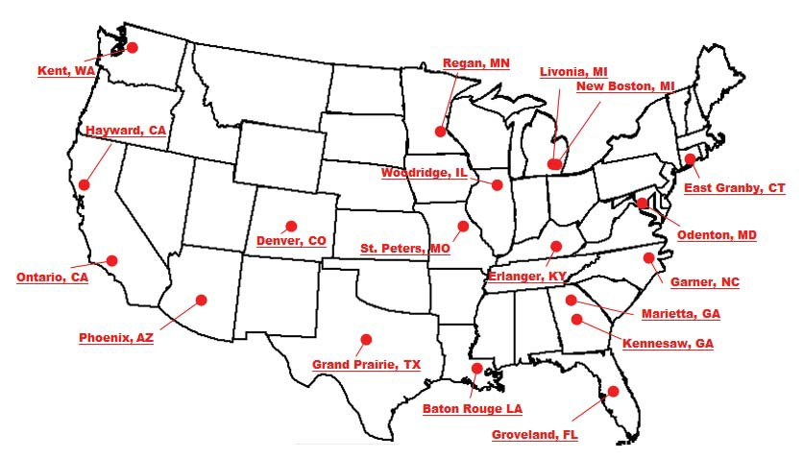

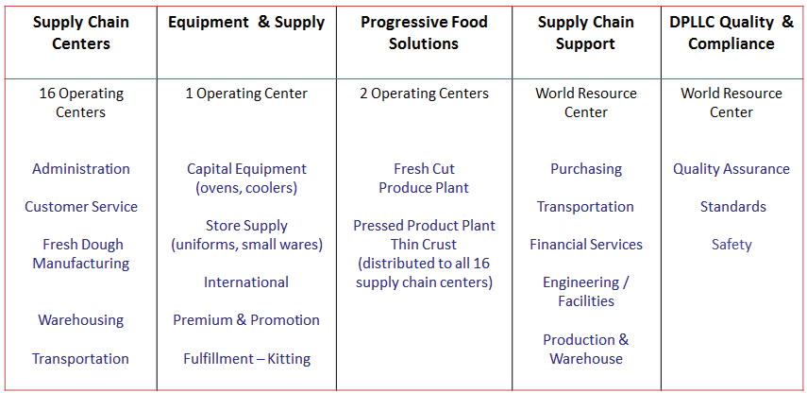

Source: Company documents.
Notes: In addition to its 16 supply chain centers in the continental U.S., Domino's owned and operated an "international supply chain" comprising a total of six dough manufacturing and supply chain centers in Alaska, Hawaii, and Canada.
Progressive Food Solutions was a Domino's subsidiary responsible for products that fell outside the core business.

19

512-004 Domino's Pizza

Exhibit 6a Domino's U.S. Menu, July 2011

PIZZA  Small (10"), Medium (12")  Large (14"), or X-Large (16")  Crusts  Hand Tossed Deep Dish Thin Crust Brooklyn Style  American Legends Wisconsin 6 Cheese Honolulu Hawaiian  Philly Cheese Steak  Cali Chicken Bacon Ranch Fiery Hawaiian  Buffalo Chicken  Feasts  ExtravaganZZa Feast MeatZZa Feast Deluxe Feast  American Favorite Feast Ultimate Pepperoni Feast  Available Toppings  Alfredo sauce, pepperoni, Italian sausage, slices sausage, green peppers, black olives, pineapple, mushrooms, onions, beef, ham, bacon, salami, Philly steak, premium chicken, jalapeno peppers, banana peppers, roasted red peppers, spinach, shredded parmesan, feta, tomatoes, diced tomatoes, BBQ sauce | PASTAS  Baked and served in a dish or in a bread bowl  Chicken Alfredo  Italian Sausage Marinara Chicken Carbonara Pasta Primavera  Build Your Own Sauces  Alfredo Cheddar  Hearty Marinara  SANDWICHES  Oven baked  Italian Sausage and Peppers Buffalo Chicken  Chicken Habanero Mediterranean Veggie Philly Cheesesteak Chicken Bacon Ranch Italian  Chicken Parm  Dipping Sauces  Blue Cheese  Garlic Dipping Sauce Hot/Spicy  Marinara  DESSERTS  Cinna Stix (8-pieces)  Chocolate Lava Crunch Cake (2-pieces) | CHICKEN  8, 14, or 40 pieces  Boneless Chicken Chicken Wings  Dipping Cups  Kicker Hot Sauce  Sweet Mango Habanero BBQ  Ranch  Blue Cheese  Wing Sauce  Fire Hot Mild  Sweet Mango Habanero BBQ  Plain  BREADS  Breadsticks Cheesy Bread  Sauce  Blue Cheese  Garlic Dipping Sauce Icing  Marinara Ranch  Jalapeno Cheese
DRINKS
2-liter or 20-oz.
Coke Coke Zero Diet Coke Sprite

Source: Company documents.

20

Domino's Pizza 512-004
Exhibit 6b Selected Domino's U.S. Menu Items, 2010 and 2011
American Legends Pizzas

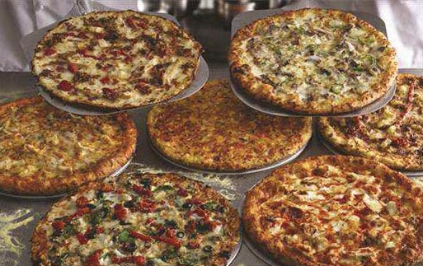

Chicken Wings Chocolate Lava Crunch Cakes

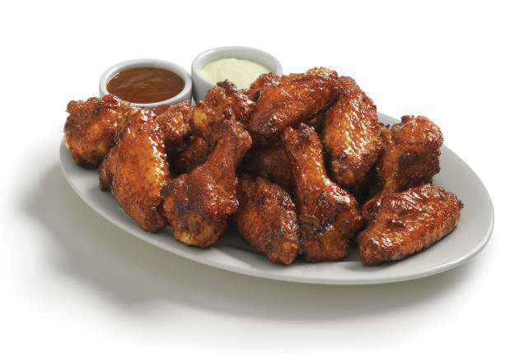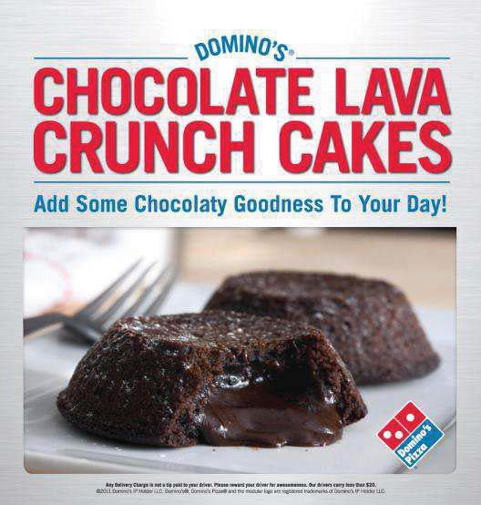

Source: Company documents.

21

512-004 -22-
88

Exhibit 7a Chicago Board of Trade (CBOT) Corn Futures and Minneapolis Grain Exchange Hard Red Spring Wheat Futures, January 2000-September 2011, Price per Bushel ($)

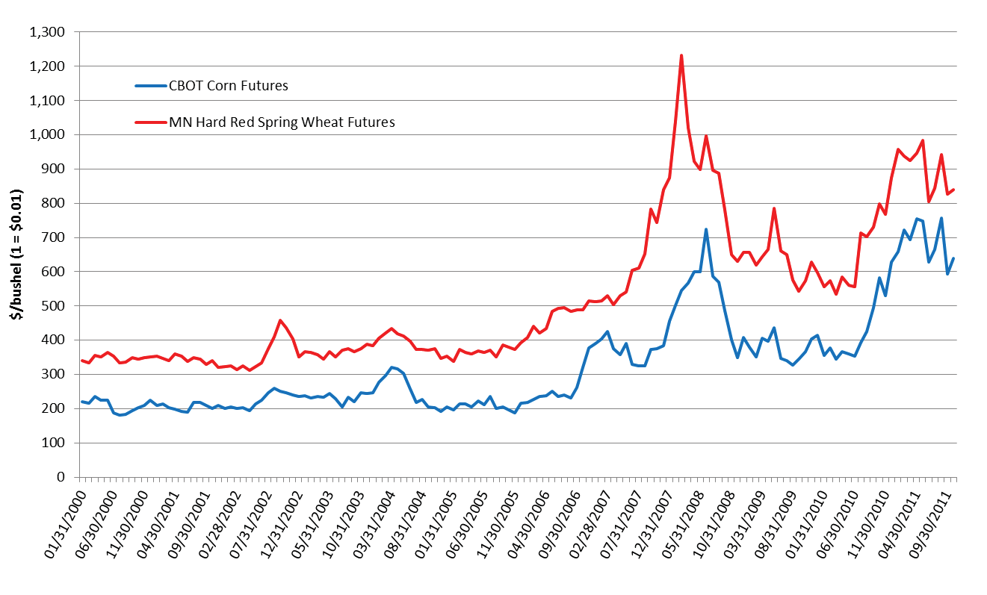

512-004 -23-
89

Exhibit 7b Price per Pound of Block Cheddar Cheese, Chicago Board of Trade (CBOT), January 2000-September 2011 ($)

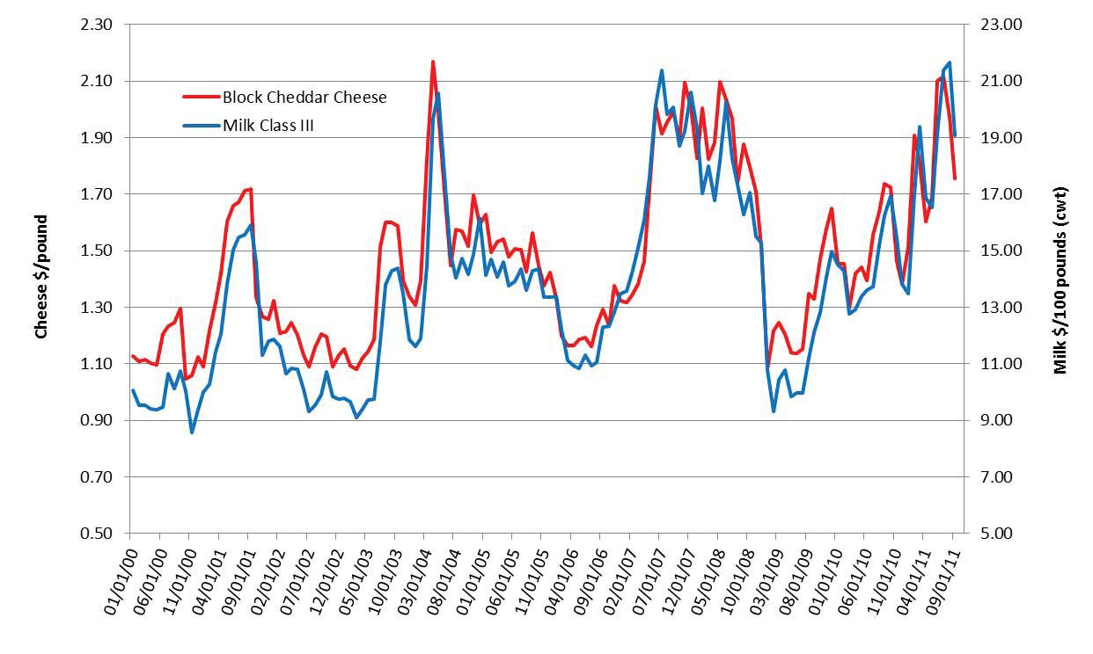

512-004 Domino's Pizza

Exhibit 8 Domino's Pizza International Structure

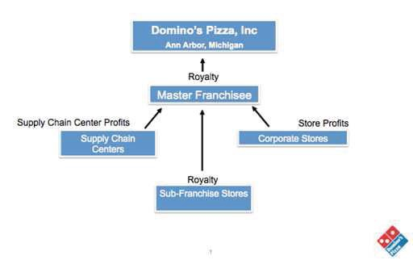
Source: Company documents.

Exhibit 9 Domino's International Pizzas

Country Pizza Name Description

Australia Satay Prawn, Bacon, and Feta Prawns, Rasher bacon, Feta, Capsicum, Tomato, Garlic Oil,
Mozzarella, Oregano, Chili Flakes

France | Divine Pepper | Tomato sauce, Mozzarella, Fresh tomatoes, Double spice beef meatballs, Herbes de Provence, Pepper sauce.
France | La Forestière ("The Forrest") | Crème fraîches, Mozzarella, Double-Smoked bacon, Onions, Ham, Mushrooms, Oregano
France | Saumonetä | Crème fraîches, Mozzarella, Onions, Potatoes, Smoked salmon, Dill
Japan | Camembert Mille-Feuille Quattro | Camembert cheese sandwiched between two crispy crusts.
Japan | Goryeo Galbi | Juicy galbi with hot spicy sauce, garlic, paprika (no tomato sauce)
Japan | Mayo Jaga | Potato with sizzling hot mayo
Japan | Prime Seafood | Seafood pizza with creamy white sauce
India | Peppy Paneer | Chunky paneer, Crisp capsicum, Spicy red pepper
India | Keema do Pyaaza | Double keema, Onion, Jalapeno

Source: Online menus from Domino's franchises in Austria, http://www.dominos.com.au/menu/pizzas/; France, http:// www.dominos.fr/carte pizzas.php; Japan, http://www.dominos.jp/eng/; and India, http://www.dominos.co.in/, all accessed November 2011.

24

Domino's Pizza 512-004

Exhibit 10 Top 10 International Markets for Domino's Pizza, Inc., 2011

International
Q1 2011 | 2010 Sales | Delivery Market | Potential
Store Count | (USD Mil.) | Position | Store Count

Market Master Franchisee
United Kingdom Domino's Pizza 626  UK & IRL PLC |  | $754.1 | 1 | 1,100
Mexico Alsea 579 |  | $186.9 | 1 | 700
Australia Domino's Pizza 433  Enterprises Ltd. |  | $154.7 | 1 | 650
India Jubil  FoodWo | ant 388  rks Ltd. | $91.9 | 1 | 750
South Korea Domino's Pizza Korea 348 |  | N/A | 2 | 400
Canada Pizza Deliv | ery Corp.a 345 | N/A | 3 | 400
Japan Higa Ind | ustries 186 | $192.2 | 3 | 700
France Domino's Pizza 189  Enterprises Ltd. |  | $81.9 | 1 | 850
Turkey N/A 192 |  | N/A | 1 | 400
Taiwan Pizzavest | Co., Ltd. 138 | N/A | 2 | 150
Total | 3,381 |  |  | 5,900

Source: Company documents.

Exhibit 11 International Net Unit Growth of the Three Leading Global Pizza Chains, 2006-2010

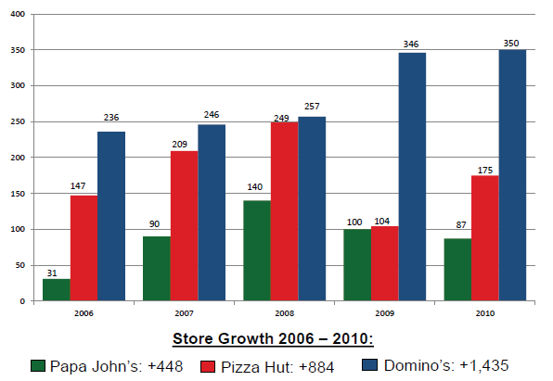

Source: Company documents.

25

  - Domino's Pizza

Exhibit 12 U.S. Pizza Market Consumer Survey Results, 2009

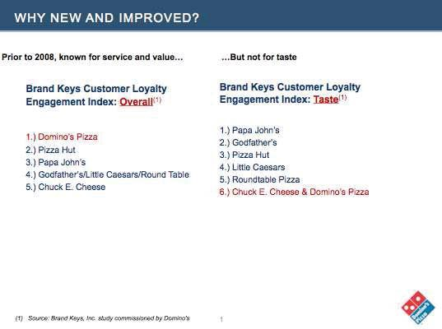

Source: Company documents.

26

512-004 -27-
93
D

Exhibit 13 Print and In-store Promotional Materials for Domino's New and Improved Pizza Advertising Campaign, 2010

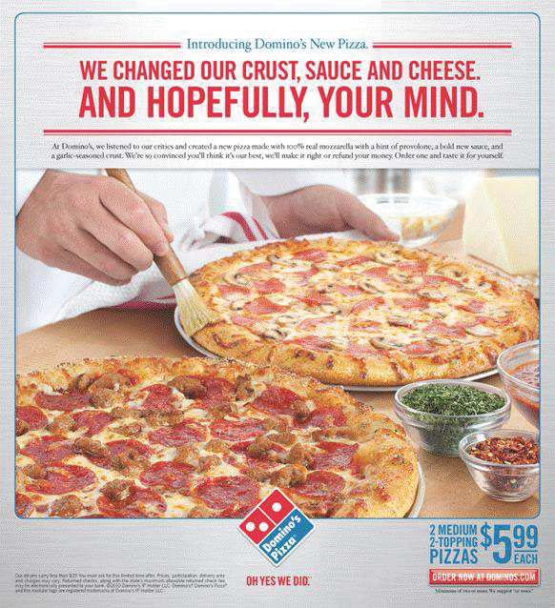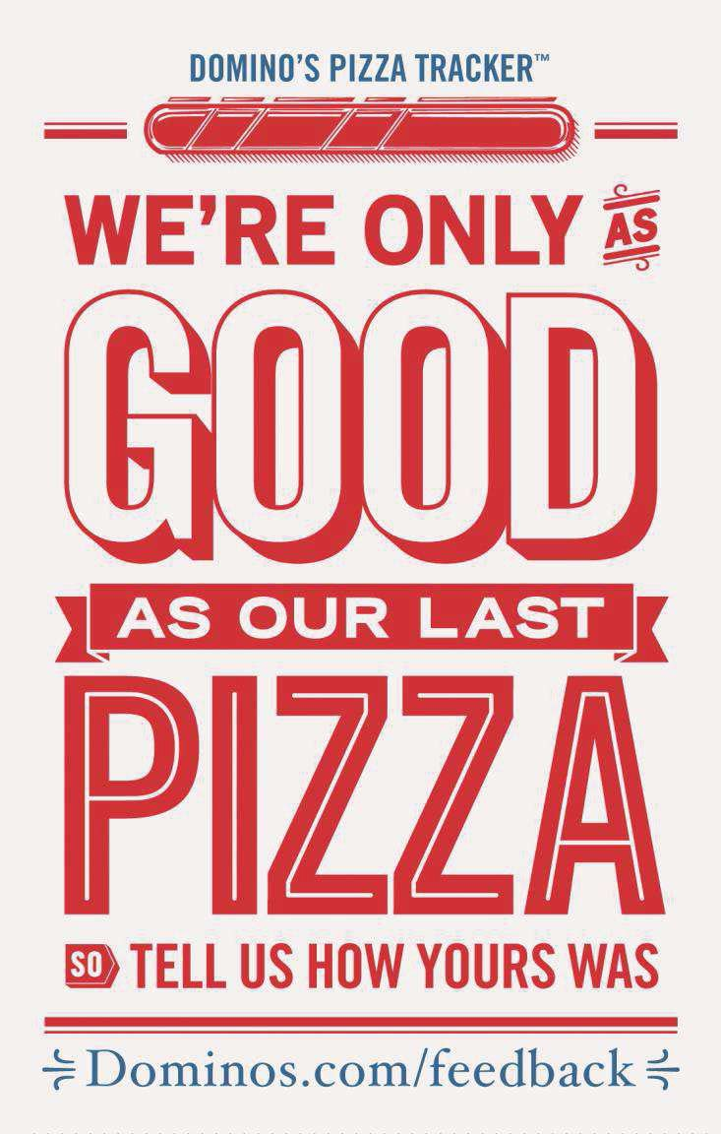

Source: Company documents.

512-004 Third-Generation Sequencing: Hype, Hope and Reality

Exhibit 14 Image of Domino's Online Pizza Tracker and Digital Customer Feedback Billboard in Times Square, New York, 2011

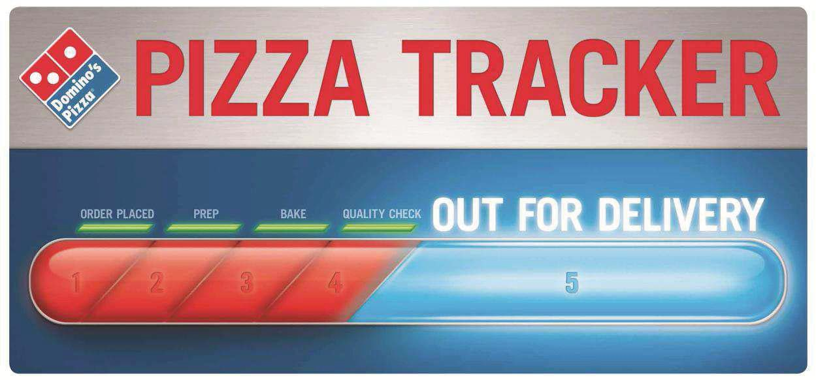

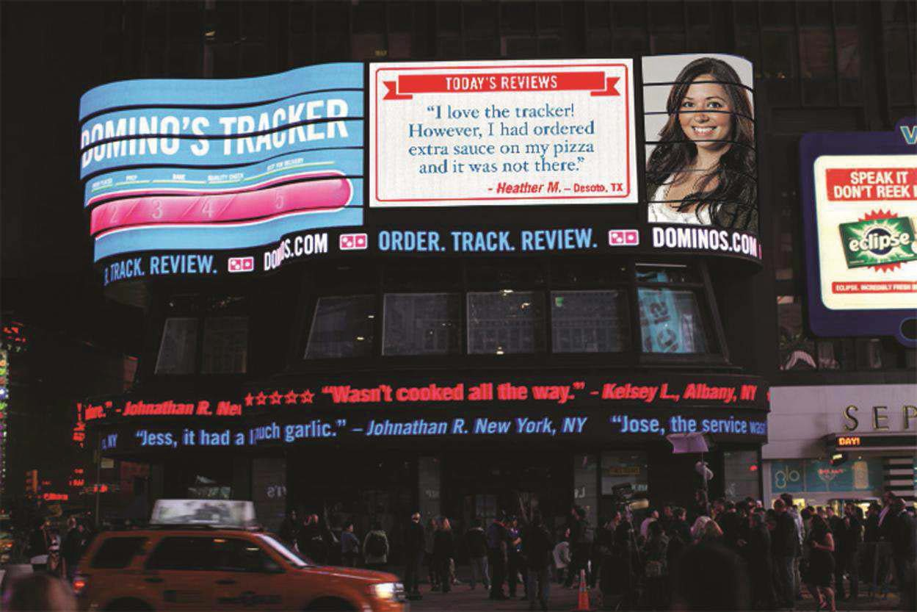

Source: Company documents.

28

94

D

Third-Generation Sequencing: Hype, Hope and Reality 512-004

Endnotes

    - Steve Raabe, "Quiznos chain faces tough finance issues," Denver Post, August 21, 2011, http://www.denver post.com/business/ci 18721934, accessed November 2011.
    - Raabe, "Quiznos chain faces tough finance issues."
    - Julie Jargon and Mike Spector, "Hamburgers, Fries and a Shakeout," Wall Street Journal, November 2, 2011, http://online.wsj.com/article email/SB10001424052970203752604576645300258978190lMyQjAxMTAxMDAwM TEwNDEyWj.html?mod=wsj share email, accessed November 2011.
    - Domino's Pizza, Inc., "About Domino's Pizza," Domino's Pizza, Inc., website, http://www.dominosbiz.com/Biz-Public-EN/Site+Content/Secondary/About+Dominos/History/, accessed August 2011.
    - "Domino's Pizza Founder to Retire and Sell Stake," New York Times, September 26, 1998, http://www.nytimes.com/1998/09/26/business/company-news-domino-s-pizza-founder-to-retire-and-sell-a- stake.html, accessed September 2011.
    - Domino's, "About Domino's Pizza"; and Mandy Wolf Detwiler, "Change is Good," Pizza Today, June 2010.
    - "Pizza Franchise Industry Report," Franchise Direct, 2010, http://www.franchisedirect.com/food franchises/pizzafranchises/pizzafranchiseindustryreport2010/80/275, accessed September 2010.
    - Jonathan Maze, "2010 Franchise Times Top 200 Franchise Systems," Franchise Times, October 2011, http://www.franchisetimes.com/content/story.php?article=02285, accessed September 2010.
    - Company documents.
    - Karen Robinson-Jacobs, "Pizza players predict super sales for Super Bowl," Dallas Morning News, January 20, 2011, http://www.dallasnews.com/sports/super-bowl/local/20110120-pizza-players-predict-super-sales- for-super-bowl.ece, accessed December 2011.
    - Robinson-Jacobs, "Pizza players predict super sales for Super Bowl."
    - Robinson-Jacobs, "Pizza players predict super sales for Super Bowl."
    - "Meat Price Spreads," United States Department of Agriculture (USDA), October 19, 2011, http://www. ers.usda.gov/Data/MeatPriceSpreads/, accessed October 2011.
    - "Dairy Market Outlook," United States Department of Agriculture (USDA), September 2011, http://www. ers.usda.gov/Briefing/Dairy/Outlook.htm.
    - Carolyn Cui, "Corn, Wheat Swap Roles as Prices Increase," Wall Street Journal, August 9, 2011, http://online.wsj.com/article/SB10001424053111904480904576496610907800774.html, accessed August 2011.
    - "Dairy Market Outlook," USDA.
    - Nishanth Vasudevan, "Jubilant Foodworks valued almost at par with Domino's Pizza, Inc.," Economic Times, July 6, 2011, http://articles.economictimes.indiatimes.com/2011-07-06/news/29739402 1 jubilantfood works-domino-s-pizza-market-value, accessed November 2011.
    - "Bain Capital to Acquire Higa Industries, Domino's Pizza Master Franchisee in Japan," PR Newswire, January 25, 2011, http://www.prnewswire.com/news-releases/bain-capital-to-acquire-higa-industriesdominos- pizza-master-franchisee-in-japan-82577642.html, accessed November 2011.
    - Stephanie Clifford, "Video Prank at Domino's Taints Brand," New York Times, April 15, 2009, http://www. nytimes.com/2009/04/16/business/media/16dominos.html, accessed November 2011.

29

95

