http://www.kmworld.com/Articles/Editorial/What-Is-.../What-is-KM-Knowledge-Management-Explained-82405.aspx downloaded January 30, 2016
What is KM? Knowledge Management Explained
May 4, 2012
Michael E. D. Koenig
Knowledge Management, (KM) is a concept and a term that arose approximately two decades ago, roughly in 1990. Quite simply one might say that it means organizing an organization's information and knowledge holistically, but that sounds a bit wooly, and surprisingly enough, even though it sounds overbroad, it is not the whole picture. Very early on in the KM movement, Davenport (1994) offered the still widely quoted definition:
"Knowledge management is the process of capturing, distributing, and effectively using knowledge."
This definition has the virtue of being simple, stark, and to the point. A few years later, the Gartner Group created another second definition of KM, which is perhaps the most frequently cited one (Duhon, 1998):
"Knowledge management is a discipline that promotes an integrated approach to identifying, capturing, evaluating, retrieving, and sharing all of an enterprise's information assets. These assets may include databases, documents, policies, procedures, and previously un-captured expertise and experience in individual workers."
Both definitions share a very organizational, a very corporate orientation. KM, historically at least, is primarily about managing the knowledge of and in organizations.
The operational origin of KM, as the term is understood today, arose within the consulting community and from there the principles of KM were rather rapidly spread by the consulting organizations to other disciplines. The consulting firms quickly realized the potential of the Intranet flavor of the Internet for linking together their own geographically dispersed and knowledge-based organizations. Once having gained expertise in how to take advantage of intranets to connect across their organizations and to share and manage information and knowledge, they then understood that the expertise they had gained was a product that could be sold to other organizations. A new product of course needed a name, and the name chosen, or at least arrived at, was Knowledge Management. The timing was propitious, as the enthusiasm for intellectual capital in the 1980s, had primed the pump for the recognition of information and knowledge as essential assets for any organization.
Perhaps the most central thrust in KM is to capture and make available, so it can be used by others in the organization, the information and knowledge that is in people's heads as it were, and that has never been explicitly set down.
What is still probably the best graphic to try to set forth what KM is constituted of, is the graphic developed by IBM for the use of their KM consultants, based on the distinction between collecting stuff (content) and connecting people, presented here with minor modifications (the marvelous C, E, and H mnemonics are entirely IBM's):
 | COLLECTING (STUFF) & CODIFICATION | CONNECTING (PEOPLE) & PERSONALIZATION

DIRECTED INFORMATION & KNOWLEDGE SEARCH  EXPLOIT | - Databases, external & internal  - Content Architecture  - Information Service Support (training required)  - data mining best practices / lessons learned/after action analysis  (HARVEST) | - community & learning  - directories, "yellow pages" (expertise locators)  - findings & facilitating tools, groupware  - response teams  (HARNESS)
SERENDIPITY & BROWSING  EXPLORE | - Cultural support  - current awareness profiles and databases  - selection of items for alerting purposes / push  - data mining best practices  (HUNTING) | - Cultural support  - spaces - libraries & lounges (literal & virtual), cultural support, groupware  - travel & meeting attendance  (HYPOTHESIZE)
From: Tom Short, Senior consultant, Knowledge Management, IBM Global Services
Another way to view and define KM is to describe KM as the movement to replicate the information environment known to be conducive to successful R&D—rich, deep, and open communication and information access—and deploy it broadly across the firm. It is almost trite now to observe that we are in the post-industrial information age and that an increasingly large proportion of the working population consists of information workers. The role of the researcher, considered the quintessential information worker, has been studied in depth with a focus on identifying environmental aspects that lead to successful research (Koenig, 1990, 1992), and the strongest relationship by far is with information and knowledge access and communication. It is quite logical then to attempt to apply those same successful environmental aspects to knowledge workers at large, and that is what in fact KM attempts to do.
Explicit, Implicit and Tacit Knowledge
In the KM literature, knowledge is most commonly categorized as either explicit or tacit (that which is in people's heads). This characterization is however rather too simple, but a more important point, and a criticism, is that it is misleading. A much more nuanced and useful characterization is to describe knowledge as explicit, implicit, and tacit.
Explicit: information or knowledge that is set out in tangible form.
Implicit: information or knowledge that is not set out in tangible form but could be made explicit.
Tacit: information or knowledge that one would have extreme difficulty operationally setting out in tangible form.
The classic example in the KM literature of true "tacit" knowledge is Nonaka and Takeuchi's example of the kinesthetic knowledge that was necessary to design and engineer a home bread maker, knowledge that could only be gained or transferred by having engineers work alongside bread makers and learn the motions and the "feel" necessary to knead bread dough (Nonaka & Takeuchi, 1995).
The danger of the explicit-tacit dichotomy is that by describing knowledge with only two categories, i.e., explicit, that which is set out in tangible form, and tacit, that which is within people, is that it then becomes easy to think overly simplistically in terms of explicit knowledge, which calls for "collecting" KM methodologies, and tacit knowledge, which calls for "connecting" KM methodologies, and to overlook the fact that, in many cases, what may be needed is to convert implicit tacit knowledge to explicit knowledge, for example the after action reports and debriefings described below.
What does KM really consist of? What operationally constitutes KM?
So what is involved in KM? The most obvious point is the making of the organization's data and information available to the members of the organization through portals and with the use of content management systems. Content Management, sometimes known as Enterprise Content Management, is the most immediate and obvious part of KM. For a wonderful graphic snapshot of the content management domain go to realstorygroup.com and look at their 2012 Content Technology Vendor Map.
In addition to the obvious, however, there are three undertakings that are quintessentially KM, and those are the bases for most of what is described as KM.
(1) Lessons Learned Databases
Lessons Learned databases are databases that attempt to capture and to make accessible knowledge that has been operationally obtained and typically would not have been captured in a fixed medium (to use copyright terminology). In the KM context, the emphasis is typically upon capturing knowledge embedded in persons and making it explicit. The lessons learned concept or practice is one that might be described as having been birthed by KM, as there is very little in the way of a direct antecedent. Early in the KM movement, the phrase typically used was "best practices," but that phrase was soon replaced with "lessons learned." The reasons were that "lessons learned" was a broader and more inclusive term and because "best practice" seemed too restrictive and could be interpreted as meaning there was only one best practice in a situation. What might be a best practice in North American culture might well not be a best practice in another culture. The major international consulting firms were very aware of this and led the movement to substitute the new term. "Best Practices" succeeded by "Lessons Learned" became the most common hallmark phrase of early KM development.
Nothing of course is totally new and without something that can be viewed as a predecessor. One such possible antecedent was the World War II debriefing of pilots after a mission. The primary purpose was to gather military intelligence, but a clear secondary purpose was to identify lessons learned, though they were not so named, to pass on to other pilots and instructors. Similarly, the U. S. Navy Submarine Service, after an embarrassingly lengthy fiasco of torpedoes that failed to detonate properly and an even more embarrassing failure to follow up on sub captains' consistent torpedo failure reports, instituted a system of widely disseminated "Captain's Patrol Reports" with the intent of avoiding any such fiasco in the future. The Captain's Patrol Reports were very clearly designed to encourage analytical reporting, with reasoned analyses of the reasons for failure and success. It was emphasized that a key purpose of the report was to make recommendations about strategy for senior officers to mull over and about tactics for other skippers to take advantage of (McInerney and Koenig, 2011).
The military has become an avid proponent of the lessons learned concept. The phrase the military uses is "After Action Reports." The concept is very simple: don't rely on someone to make a report. There will almost always be too many things immediately demanding that person's attention after an action. There should be a system whereby someone, typically someone in KM, is assigned the responsibility to debrief, separate the wheat from the chaff, create the report, and then ensure that the lessons learned are captured and disseminated.
The concept is by no means limited to the military. Larry Prusak (2004) opines that in the corporate world the number one KM implementation failure is that so often the project team is disbanded and the team members reassigned before there is any debriefing or after-action report assembled. Organizations operating in a project team milieu need to pay very close attention to this issue and to set up an after- action procedure with clearly delineated responsibility for its implementation.
A wonderfully instructive example of a "lesson learned" is recounted by KM consultant Mark Mazzie (2003). The story derives from his experience in the KM department at Wyeth Pharmaceuticals. Wyeth had recently introduced a new pharmaceutical agent primarily for pediatric use. They expected it to be a substantial success because, unlike its predecessors, it needed to be administered only once a day, which would make it much easier for the caregiver to ensure that the child followed the drug regimen. Sales of the drug started well, but soon turned disappointing. One sales rep (what the pharmaceutical industry used to call detail men), however, discovered, by chatting with her customers, the reason for the disappointing sales and discovered the solution. The problem was that kids objected strenuously to the taste of the drug, and caregivers were reporting to prescribing physicians that they couldn't get their kid to continue taking the drug. The solution was orange juice. A swig of orange juice quite effectively masked the offensive taste. If the sales rep illuminated the physician that the therapy should be conveyed to the caregiver as the pill and a glass of orange juice taken simultaneously first thing in the morning, then there was no dissatisfaction and sales were fine.
The implementation of a lessons learned system is complex both politically and operationally. Many of the questions surrounding such a system are difficult to answer. Who is to decide what constitutes a worthwhile lesson learned? Are employees free to submit to the system un-vetted? Most successful lessons learned implementations have concluded that such a system needs to be monitored and that there needs to be a vetting and approval mechanism before items are mounted as lessons learned. How long do items stay in the system? Who decides when an item is no longer salient and timely? Most successful lessons learned systems have an active weeding or stratification process. Without a clearly designed process for weeding, the proportion of new and crisp items inevitably declines, the system begins to look stale and usage and utility falls. Deletion, of course, is not necessarily loss and destruction. Using stratification principles, items removed from the foreground can be archived and moved to the background but still made available.
All these questions need to be carefully thought out and resolved, and the mechanisms designed and put in place before a lessons-learned system is launched. Inattention can easily lead to failure and the tarring of subsequent efforts
(2) Expertise Location
If knowledge resides in people, then one of the best ways to learn what an expert knows is to talk with that expert. Locating the right expert with the knowledge you need, though, can be a problem. The basic function of an expertise locator system is straightforward: it is to identify and locate those persons within an organization who have expertise in a particular area. Such systems were commonly known as "Yellow Page" systems in the early days of KM. In recent years, the term expertise locator or expertise location has replaced yellow pages as being rather more precise.
There are now three areas which typically supply data for an expertise locator system, employee resumes, employee self identification of areas of expertise, typically by being requested to fill out a form online, or by algorithmic analysis of electronic communications from and to the employee. The latter approach is typically based on email traffic but can include other social networking electronic communications such as Twitter and Facebook. Commercial packages to match queries with expertise are available. Most of them have load-balancing schemes so as not to overload any particular expert. Typically such systems rank the degree of presumed expertise and will shift a query down the expertise ranking when the higher choices appear to be becoming overloaded. Such systems also often have a feature by which the requester can flag the request as a priority, and the system will then try to match higher priority requests with higher presumed (calculated) expertise rank.
(3) Communities of Practice (CoPs)
CoPs are groups of individuals with shared interests that come together in person or virtually to tell stories, to share and discuss problems and opportunities, discuss best practices, and talk over lessons learned (Wenger, 1998; Wenger & Snyder, 1999). Communities of practice emphasize the social nature of learning within or across organizations. Conversations around the water cooler are often taken for granted, but in geographically distributed organizations the water cooler needs to become virtual. Similarly, organizations find that when workers give up a company office to work online from home or on the road, the natural knowledge sharing that occurs in social spaces must be replicated virtually. In the context of KM, CoPs are generally understood to mean electronically linked communities. Electronic linkage is not essential, of course, but since KM arose in the consulting community from the awareness of the potential of Intranets to link geographically dispersed organizations, this orientation is understandable and inevitable.
The classic example of the deployment of CoPs is that of the World Bank. When James Wolfensohn became president in 1995, he focused on the World Bank's role in disseminating knowledge about development. To that end he encouraged the development of CoPs. A CoP might, for example, focus on road construction and maintenance in arid conditions, and the point would be to include not only participants from the World Bank and the country where the relevant project was being implemented, but also participants from elsewhere who had expertise in building roads in arid conditions, such as staff from the Australian Road Research Board and the Arizona Department of Transportation.
The organization and maintenance of CoPs is not a simple or easy undertaking. As Durham (2004) points out, there are several key roles to be filled, which she describes as manager, moderator, and thought leader. They need not necessarily be three separate people, but in some cases they will need to be. For a CoP some questions that need to be thought about are:
- Who fills the various roles of: manager, moderator, and thought leader?
- How is the CoP managed?
- Are postings open or does someone vet or edit the postings?
- How is the CoP kept fresh and vital?
- When and how (under what rules) are items removed?
- How are those items archived?
- Who reviews the CoP for activity?
- Who looks for new members or suggests that the CoP may have outlived its usefulness?
The Stages of Development of KM
Looking at KM historically through the stages of its development tells us not only about the history of KM, but it also reveals a great deal about what constitutes KM.
First Stage of KM: Information Technology
The initial stage of KM was driven primarily by IT, information technology. That first stage has been described using an equestrian metaphor as “by the internet out of intellectual capital”. The concept of intellectual capital provided the justification and the framework, the seed, and the availability of the internet provided the tool. As described above, the consulting community jumped at the new capabilities provided by the Internet, using it first for themselves, realizing that if they shared knowledge across their organization more effectively, then they could avoid reinventing the wheel, underbid their competitors, and make more profit. The first use of the term Knowledge Management in the new context appears to have been at McKinsey. They realized quickly that they had a compelling new product. Ernst and Young organized the first conference on KM in 1992 in Boston (Prusak, 1999). The salient point is that the first stage of KM was about how to deploy that new technology to accomplish more effective use of information and knowledge.
The first stage might be described as the “If only Texas Instruments knew what Texas Instruments knew” stage, to revisit a much quoted aphorism. The hallmark phrase of Stage 1 was first “best practices,” to be replaced by the more politic “lessons learned.”
Second Stage of KM: HR and Corporate Culture
The second stage of KM emerged when it became apparent that simply deploying new technology was not sufficient to effectively enable information and knowledge sharing. Human and cultural dimensions needed to be addressed. The second stage might be described as the “ ‘If you build it they will come’ is a fallacy” stage—the recognition that “If you build it they will come” is a recipe that can easily lead to quick and embarrassing failure if human factors are not sufficiently taken into account.
It became clear that KM implementation would involve changes in the corporate culture, in many cases rather significant changes. Consider the case above of the new pediatric medicine and the discovery of the efficacy of adding orange juice to the recipe. Pharmaceutical sales reps are compensated primarily not by salary, but by bonuses based on sales results. What is in it for that sales rep to share her new discovery when the most likely result is that next year her bonus would be substantially reduced? The changes in corporate culture needed to facilitate and encourage information and knowledge sharing can be major and profound. KM therefore extends far beyond just structuring information and knowledge and making it more accessible.
As this recognition unfolded, two major themes from the business literature were brought into the KM fold. The first was Senge’s work on the learning organization (Senge, Peter M., 1990 The Fifth Discipline: The Art and Practice of the Learning Organization.) The second was Nonaka’s work on “tacit” knowledge and how to discover and cultivate it (Nonaka, Ikujiro & Takeuchi, Hirotaka, 1995 The Knowledge-Creating Company: How Japanese Companies Create the Dynamics of Innovation.) Both were not only about the human factors of KM implementation and use; they were also about knowledge creation as well as knowledge sharing and communication. The hallmark phrase of Stage 2 was “communities of practice.” A good marker of the shift from the first to the second stage of KM is that for the 1998 Conference Board conference on KM, there was for the first time a noticeable contingent of attendees from HR, human resources, departments, and by the next year, 1999, HR was the largest single group, displacing IT attendees from first place.
Third Stage of KM: Taxonomy and Content Management
The third stage developed from the awareness of the importance of content, and in particular the awareness of the importance of the retrievability of content, and therefore of the importance of the arrangement, description, and structure of that content. Since a good alternative description for the second stage of KM is the “it’s no good if they don’t use it” stage, then in that vein, perhaps the best description for the new third stage is the “it’s no good if they try to use it but can’t find it” stage. Another bellwether is that TFPL’s report of their October 2001 CKO (Chief Knowledge Officer) Summit reported that for the first time taxonomies emerged as a topic, and it emerged full blown as a major topic (TFPL, 2001 Knowledge Strategies – Corporate Strategies.) The hallmark phrases emerging for the third stage are content management (or enterprise content management) and taxonomies.. At KMWorld 2000 a track on Content Management appeared for the first time, and by the 2001 KMWorld Conference, Content Management had become the dominant track. In 2006, KMWorld added a two-day workshop entitled Taxonomy Boot Camp, which still exists today. The hallmark terms for the third stage of KM are taxonomy and content.
Other KM Issues
One issue is the need to retain the knowledge of retirees. Of course the fact that the baby boomer bulge is now reaching retirement age is making this issue particularly salient. KM techniques are very relevant to this issue. One technique is the application of the lessons learned idea—just treat the retiree’s career as a long project that is coming to its end and create an after action report, a massive data dump. This idea seems obvious, but only in special cases is it likely to be very useful.
Much more likely to be useful is to keep the retiree involved, maintain him or her in the CoPs and findable through expertise locater systems. The real utility is likely to be found not directly in the information that the retiree leaves behind, but in new knowledge created by the interaction of the retiree with current employees. The retiree says "it occurs to me that ..." and elicits a response something like “yes, but here ...,” a discussion unfolds, the retiree contributes some of the needed expertise, and a solution is generated. The solution arises not directly from the retiree’s knowledge but rather from the interaction.
Another major development is the expansion of KM beyond the 20th century vision of KM as the organization’s knowledge as described in the Gartner Group definition of KM. Increasingly KM is seen as ideally encompassing the whole bandwidth of information and knowledge likely to be useful to an organization, including knowledge external to the organization—knowledge emanating from vendors, suppliers, customers, etc., and knowledge originating in the scientific and scholarly community, the traditional domain of the library world. Looked at in this light, KM extends into environmental scanning and competitive intelligence.
Is KM here to stay ?
The answer certainly appears to be yes. The most compelling analysis is the bibliometric one, simply counting the number of articles in the business literature and comparing that to other business enthusiasms. Most business enthusiasms grow rapidly and reach a peak after about five years, and then decline almost as rapidly as they grew.
Below are the graphs for three hot management topics (or fads) of recent years:
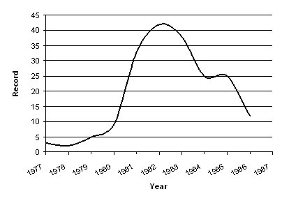  Quality Circles, 1977-1986  Source: Abrahamson ,1996 | 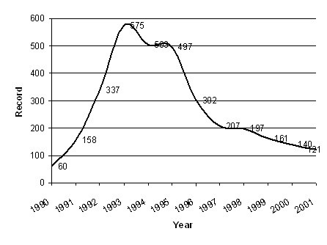  Total Quality Management, 1990-2001  Source: Ponzi & Koenig, 2002 | 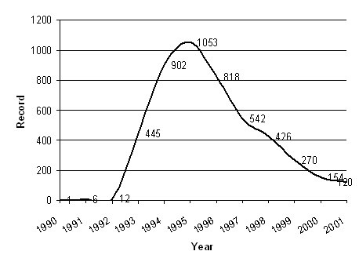  Business Process Reengineering, 1990-2001  Source: Ponzi & Koenig, 2002
KM looks dramatically different:
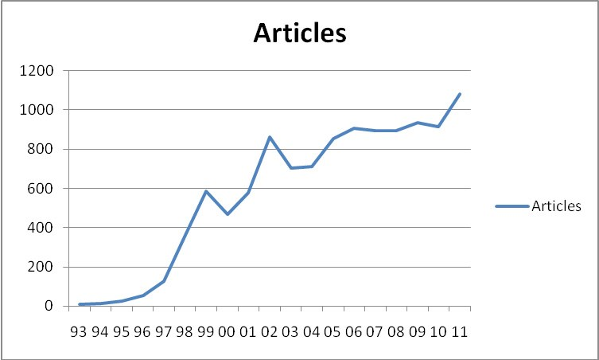
This graphs charts the number of articles in the business literature with the phrase “Knowledge Management” in the title.
If we chart the number of articles in the business literature with the phrase “Knowledge Management” or the abbreviation “KM” in the title, we get the chart below, with an order of magnitude more literature:
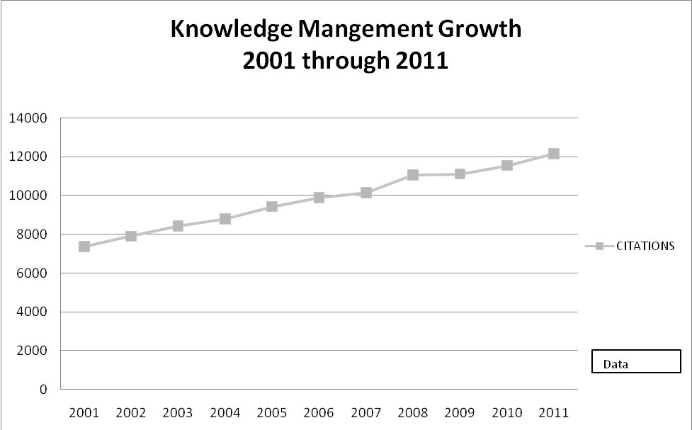
It does indeed look as though KM is no mere enthusiasm; KM is here to stay.
References
Abrahamson, E. & Fairchild, G. (1999). Management fashion: lifecycles, triggers, and collective learning processes. Administrative Science Quarterly, 44, 708-740.
Davenport, Thomas H. (1994), Saving IT's Soul: Human Centered Information Management. Harvard Business Review, March-April, 72 (2)pp. 119-131. Duhon, Bryant (1998), It's All in our Heads. Inform, September, 12 (8).
Durham, Mary. (2004). Three Critical Roles for Knowledge Management Workspaces. In M.E.D. Koenig & T. K. Srikantaiah (Eds.), Knowledge Management: Lessons Learned: What Works and What Doesn't. (pp. 23-36). Medford NJ: Information Today, for The American Society for Information Science and Technology.
Koenig, M.E.D. (1990) Information Services and Downstream Productivity. In Martha E. Williams (Ed.), Annual Review of Information Science and Technology: Volume 25, (pp. 55-56). New York, NY: Elseview Science Publishers for the American Society for Information Science.
Koenig, M.E.D. (1992). The Information Environment and the Productivity of Research. In H. Collier (Ed.), Recent Advances in Chemical Information, (pp. 133-143). London: Royal Society of Chemistry. Mazzie, Mark. (2003). Personal Communication.
McInerney, Claire. M and Koenig, Michael E. D., (2011), Knowledge Management (KM) processes in Organizations: Theoretical Foundations and Practice , Morgan and Claypool.
Nonaka, I. & Takeuchi, H. (1995). The knowledge creating company: How Japanese Companies Create the Dynamics of Innovation. New York: Oxford University Press.
Ponzi, Leonard., & Koenig, M.E.D. (2002). Knowledge Management: Another Management Fad?" Information Research, 8(1). Retrieved from http://informationr.net/ir/8-1/paper145.html
Ponzi, L., & Koenig, M.E.D. (2002). Knowledge Management: Another Management Fad?", Information Research, 8(1). Retrieved from http://informationr.net/ir/8-1/paper145.html
Prusak, Larry. (1999). Where did Knowledge Management Come From?. Knowledge Directions, 1(1), 90-96. Prusak, Larry. (2004). Personal Communication.
Senge, Peter M.. (1990). The Fifth Discipline: The Art & Practice of the Learning Organization. New York, NY: Doubleday Currency.
Wenger, Etienne C. (1998). Communities of practice: Learning, meaning and identity. Cambridge: Cambridge University Press.
Wenger, Etienne C. & Snyder, W. M. (1999). Communities of practice: The organizational frontier. Harvard Business Review, 78(1), 139-145.

