CHAPTER 5: Privacy Policies Comparison

5.1 Introduction
Studies have indicated that reading full privacy policies is time consuming and challenging. Users must spend a long time reading full privacy policies and have difficulty correctly answering questions about privacy practices stated in service providers’ full privacy policies (Kelley et. al, 2010). We think that users will find more difficulties in comparing the two service providers’ privacy policies. They will have to switch between two policies, memorize what information they read in one policy, and then compare it to the other.
Previous studies have introduced several approaches to improve privacy policy readability. Some studies have proposed standardized policy formatting to simplify the readability of a single privacy policy. To the best of our knowledge no study has been introduced to highlight privacy policy contents and help users compare privacy practices of two or more service providers.
In this chapter we highlight the privacy policy contents that describe privacy practices. (Users found them important or not clear in privacy concerns study results, as explained in chapter 3.) We present contents related to information collection, sharing, and control in pairs of policies. Each policy in a pair is from the same domain as the other, and they are both presented side-by-side to allow users to locate and compare this information easily between the policies. We conducted a survey to study how effective highlighting these contents would be in helping users to gain information, reduce time to look up information, and simplify the comparison of specific information between two policies. Moreover, we examine users’ privacy preferences based on the presented privacy practices, which will help us to rank privacy policies in the next chapter.
5.2 Privacy database
5.2.1 Information category
The output lists from our information extraction process are used in this chapter to be presented to the surveys’ participants to answer questions. The specific information of each privacy practice is categorized into general levels. The categorization of the information could help the users to add context to a specific piece of information and help users find information easily. For example, categorizing “card number” into “Financial information” will help users to recognize the collected number is either related to their credit card or debit card. Personal information is classified into four categories: contact, financial, geolocation, and identity. The controls and options provided to users are classified into six categories: activity, advertisements and marketing, communication, geographical, personal information, and research. The third parties with whom users’ information is shared are divided into four categories: user, affiliate, non-affiliate, and unspecified party. Parties are classified as “user” when the policy states that the information is shared with other users using the same service. Parties are classified as “affiliate” when the word “affiliate” is used or when the policy states that the party is within the same company network or service providers. Parties are classified as “non-affiliate” if the policy uses the word “non-affiliate” to describe the party. Finally, parties are classified as “unspecified” when they do not fall into any previous categories. Table 5.1 shows data categories for each privacy practice.
 | Personal information | Controls | Parties
1 | Contact | Activity | User
2 | Educational | Advertisement and Marketing | Affiliate
3 | Financial | Communication | Non-Affiliate
4 | Geographical | Geographical | Unspecified Party
5 | Identity | Personal information | -
6 | - | Research
Table 5. 1 Categorizations of privacy practices
5.2.2 Database schema
To build a database of privacy practices, we first designed a schema to define tables, attributes of the tables, and relationships between the tables. Four tables were created to store information related to collected personal information: extracted personal information table, PI terms table, PI terms to category table, and PI category table. We created four other tables to store control related information: extracted controls table, control terms table, control terms to category table, and controls category table. To store sharing-related information, four tables were created: extracted parties table, party phrases table, phrases to category table, and controls category table. A common table, a policies table, was used to define policies IDs and names. Figure 5.1 shows the schema design of the tables and the relationship between these tables.

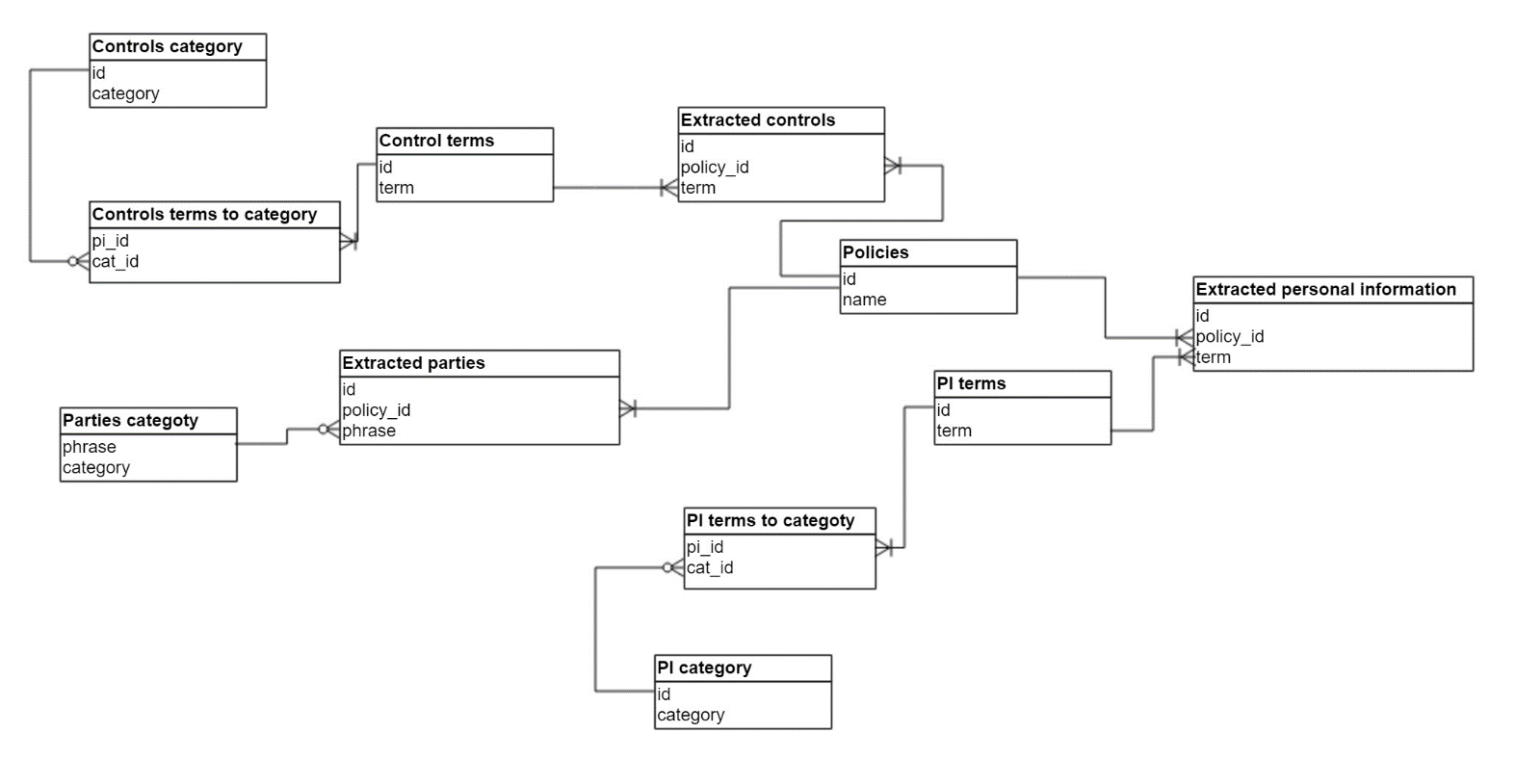
Figure 5. 1 Schema design.

5.3 Comparison tables
Comparison tables were designed to present information related to service providers’ privacy practices. The first column in the personal information comparison table shows the categories of personal information, the second column shows a list of personal information collected by service providers, and the third and fourth columns represent a pair of service providers. An “x” is used to indicate that a specific piece of information is collected by the associated service provider. An example of personal information comparison table is shown by Table 5.2. In the controls comparison table, the first column shows the categories of controls or options related terms, the second column shows the specific control-related term, and the third and fourth columns represent a pair of service providers. An “x” is used to indicate that the user can control the specific data or behavior for the associated service provider. Table 5.3 shows an example controls comparison table. In the sharing comparison table, the first column shows the categories of the parties with whom users’ information is shared, while the second and third columns represent a pair of service providers. An “x” is used to indicate the party with whom users’ information is shared for the associated service provider. Table 5.4 shows an example of sharing comparison table.
Table 5. 2 Personal information comparison table.
Table 5. 3 Controls comparison table.
Table 5. 4 Sharing comparison table.

5.4 Research questions
Our study was designed to answer the following questions:
- Are users able to compare the privacy practices of two policies shown side-by-side in a comparison table faster than when reading each policy’s text?
- Are users able to gain accurate information when looking at two policies shown side by side in a comparison table compared to when reading each policy’s full-length text?
- What is the company most preferred by the users based on its information collection, sharing, and control practices?

5.5 Study design
We used 20 privacy policies from four domains with five policies per domain. For the comparison purpose, we created ten pairs of providers per domain. We got a total of 40 pairs of the same domain providers and a total of 120 pairs of the all domains. For each pair, three versions of the survey were created. One version shows privacy policies’ highlighted information in tables, another version shows privacy policies’ highlighted information in lists , and the third version shows the original policies’ text. We got 40 pairs represented by tables, 40 pairs presented by lists, and 40 pairs represented by the policies’ original text. In the survey we chose to anonymize the service providers’ name to avoid bias from brand effect and previous knowledge. Table 5.5 shows each service provider’s anonymized name.

Domain |  | Service Provider |  | Anonymized name
1 | Health care | 1 | CIGNA | Company A
1 | Health care | 2 | Mayo Clinic | Company B
1 | Health care | 3 | Quest Diagnostics | Company C
1 | Health care | 4 | Humana | Company D
1 | Health care | 5 | Massachusetts General Hospital | Company E
2 | Financial | 6 | Bank of America | Company F
2 | Financial | 7 | Citibank | Company G
2 | Financial | 8 | Visa | Company H
2 | Financial | 9 | JPMorgan Chase Bank | Company I
2 | Financial | 10 | Western Union | Company J
3 | Social networking | 11 | Facebook | Company K
3 | Social networking | 12 | Twitter | Company L
3 | Social networking | 13 | Instagram | Company M
3 | Social networking | 14 | LinkedIn | Company N
3 | Social networking | 15 | Tumblr | Company O
4 | Shopping | 16 | Bloomingdale’s | Company P
4 | Shopping | 17 | Neiman Marcus | Company Q
4 | Shopping | 18 | Net-A-Porter | Company R
4 | Shopping | 19 | Barney NY | Company S
4 | Shopping | 20 | Shopbop | Company T
Table 5. 5 Service providers' anonymized name.

We used Quicksurveys.com to design the surveys. Each survey is divided into several sections.
- Demographic: Information about participants’ gender, age range, and educational level will be collected.
- Privacy concerns: We will ask participants about their privacy concerns level. They will be asked to classify them according to one of the five concern levels as extremely concerned, very concerned, moderately concerned, slightly concerned, and not at all concerned.
- Information collection: Participants will be shown either a personal information comparison table, two lists of highlighted personal information, or two texts of privacy policies related to information collection practices. Then participants will be asked which company collects specific information and which company collects more information. These questions will be asked to test the hypothesis that participants using comparison tables and lists will find it easier to find the correct answers to the questions than participants using a text version of a privacy policy. Also, in this section participants will be asked whether they prefer to deal with one company rather than the other based on the presented information related to its collection practices.
- Controls: Participants will be shown either a controls comparison table, two lists of provided controls, or a full text version of two companies’ policies text. Then participants will be asked which company allows its users to control specific data or behavior and which company gives their users’ more controls over information collection and sharing. Finally, based on the control-related practices of the two companies surveyed, participants will be asked if they prefer one company to the other.
- Sharing: Participants will be shown either a sharing comparison table, two lists of parties with whom users’ information shared, or part of a text policy containing the parties with whom two companies share users’ information. Then participants will be asked which company shares user’s information with a specific party and which company shares users’ information with more parties. Finally, based on sharing practices, participants will be asked to choose whether they prefer one company to the other.
- General preference and comparison simplicity/easiness: In this section participants will be asked if they prefer one company to the other based on their general privacy practices. Then they will be asked if they found it easy to compare two policies and find the requested information.

5.5.1 Survey sample of tables version
Worker ID:

Gender:
- Male
- Female

Age range:
- 18-25
- 26-35
- 36-45
- 46+

Highest level of education:
- Some high school
- High school diploma
- Associates/ professional degree
- Some college
- Bachelor’s degree
- Master’s degree
- PhD
- Other postgraduate degree

In general, regarding the privacy of your personal information on the Internet, which of the following best describes your current level of concern?
- Extremely concerned
- Very concerned
- Moderately concerned
- Slightly concerned
- Not at all concerned

INFORMATION COLLECTION
The following table represents the content of the information collection sections of the privacy practices of two financial institutions. The first column displays a list of data categories. The second column shows a list of personal information that falls within each category. The “x” symbol under each institution indicates that specific personal information is collected by the associated institution.
Please refer to the table to answer the following questions.

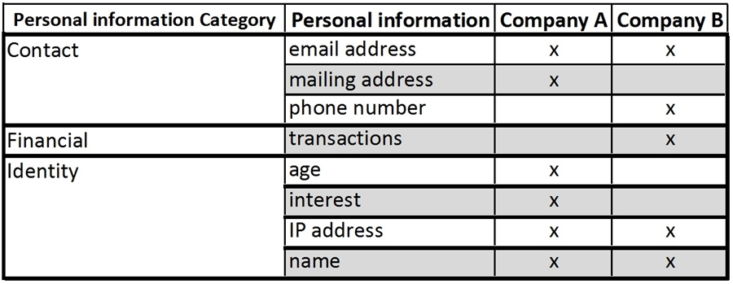
Which company collects the user's phone number?
Company A
Company B
Both companies
Neither company

Which company collects more personal information about its users?
Company A
Company B
No difference
Cannot determine from the table

Assuming both companies offer the exact same services, based on their information collection practice which company would you prefer to use?

Company A
Company B
I do not have a preference

CONTROLS
The following table represents information related to user’s controls and options for specific data and practices as stated in the privacy policies of two financial institutions. The first column displays a list of categories in which users are able to have direct control over the use of their personal data. The second column lists specific types of data or action within each category. The “x” symbol indicates that users have control over specified data or action with the associated institution.

Please refer to the table to answer the following questions.

Which company allows their users to opt-out of receiving marketing materials?
Company A
Company B
Both companies
Neither company

Which company gives users more control over the use of their personal information?
Company A
Company B
No difference
Cannot determine from the table

Assuming that the two companies offer the exact same services, based on the control options provided by each company, which service provider would you prefer to use?

Company A
Company B
No preference

SHARING
The following table represents the content related to the sharing practices of two financial institutions as stated in their privacy policies. The first column displays the categories to which third parties may belong. The “x” symbol under each institution indicates that users’ information may be shared with the specified party of the associated institution.

Please refer to the table to answer the following questions.

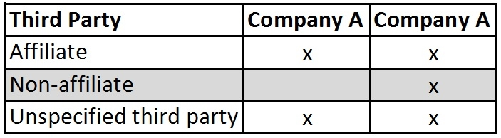

Which company shares users’ information with Non-affiliate third parties?

Company A
Company B
Both companies
Neither company

Which company shares users' information with more parties?

Company A
Company B
No difference
Cannot determine from the table

Assuming both companies offer the exact same services, based on the information sharing practices, which company would you prefer to use?

Company A
Company B
No preference

Based on the general privacy practices of the two companies, which one would you prefer to use?

Company A
Company B
No preference

How easy was it to compare the two companies’ privacy practices and find answers to the given questions?

Very easy
Easy
Moderate
Hard
Very Hard

We chose the crowd sourcing tool Amazon Mechanical Turk (AMT) to publish the survey to target diverse workers where participants are paid to complete a task. A human intelligent task (HIT) were created to link for each survey. Every HIT contains an introduction of the survey explaining briefly the survey contents, the purpose of the study, and the time required to complete the survey. The HIT also contains a link to a survey and a box for a survey code to be entered for verification and approval.
Our study uses a between-subject design where different participants answer different survey versions. This study design helps avoid learning effects. For information collection and controls sections-related questions, participants will be sked the exact same questions of the three survey versions of a specific pair. However, for sharing section-related questions, in the comparison table and lists versions participants will be asked about a specific party’s category, while in the text version they will be asked about parties as mentioned in the text.
We published a survey’s version at a time and required 5 participants per HIT. On average Participants spent an average of 3:27, 3:17, and 5:44 minutes to complete a survey for table, list, and text versions respectively. The participant were all American as we required that as one of the HITs requirements. Being a master worker was another qualification we required for a participant to participate in the survey. We added this requirement to get reliable results as workers with this qualification supposed to have good performance. Participant were paid at a rate of $0.75 per HIT.
We collected a total of 120 participants were x% were males and x% were females. Table X show the age distribution of the participants.
Age range | 18-25 | 26-30 | 31-35 | 36-40 | 40+ | Total
Number of participants | x | x | x | x | x | 120
Percentage | y | y | y | y | y | 100%

5.4 Results
In this section, we summarize timing results, describe accuracy results, and conclude with the results of users’ preferences of different companies in terms of its information collection, sharing, and control practices.

5.4.1 Timing results
We calculated the average time took the participants to complete each pair of survey in a specific domain. Then we averaged the time of that specific domain. This process repeated for all other domains for all three survey versions. The following tables shows the average time spent by the participants to answers survey questions.

The results show that in the highlighted information survey’s versions (table and list) less time needed by the participant to find answers to survey’s questions compared to the time needed in the original text. We did a t-test analysis between the highlighted information survey’s versions and the original text survey version. In health domain, we found a significant relationship between table and text versions with a p-value of 0.0003. Additionally, the relationship between list and text versions is significant too with p-value of 0.0001. In Financial domain, we analyzed the results and found a significant relationship between table and text versions with a p-value of 0.006. We also found significant relationship between list and text versions with a p-value of 0.009. In Shopping domain, the same results were found with a p-values of 0.001 and 0.0007 for the relationships between table-text and list-text respectively. In social networking domain, we found a significant relationship between table and text versions with a p-value of 0.006. Further, the relationship between list and text versions is significant too with p-value of 0.009.
In the next step, we averaged the time of all the domains and summarized the results in table X. The aggregated results show that the participants took less time finding information and answers questions related to two companies when the information displayed side by side in table and list versions compared to displaying the original text of those companies in text version.

5.4.2 Accuracy
Each participant was asked six accuracy test questions to verify his/her ability to find correct information in the different survey versions. These questions were distributed (two in each section) in three survey sections: personal information, controls, and sharing. One question testifies if the participant can find which company perform a specific practice (collects, gives control, share). “Which company collects the user's phone number?.” The other question checks participant’s ability to know which company collects more information, gives more controls, and share information with more parties. “Which company gives users more control over the use of their personal information?.” For each pair of companies in each domain we calculated the average percentage for the three sections of correct answers chosen by the participants. This calculation is done for each survey version and each service domain. The following tables show the averages of each pair of each survey version and the average of all pairs of that specific version for each individual domain.
Health
Social Netwok
Shopping
Financial

Based on the displayed results we can say that participants could find correct/accurate information when they are provided with highlighted and side by side data compared to original text of pair of policies. A t-test were performed to examine that notice and the results show a significant relationship between the (table, list) and text survey versions. Table X shows the p-values of the t-test between the versions. The values are all significant except the relationship between list-text versions in financial domain. An explanation of this exception is that the financial domain’s original text is displayed as a table showing highlighted information which made it for the participants as easy as the list format to get an information.

The overall accuracy percentage of different versions of different domains are displayed in Table X. The overall results also indicate that the highlighted side-by-side versions are more helpful for the participants to find accurate information compared to original text version.

5.4.3 Preferences
Based on the results in the previous section stating that participant can gain more accurate information in the highlighted side-by-side versions we decided to investigate these versions to specify participant privacy preferences. We calculated the percentages of participants whom prefer the policy that collect less personal information, provide more controls, and share information with less parties. Table X shows participants’ preferences for the two versions of all domains.

Thus, the percentages show that users prefer a company that collect less information, provide more controls over the data, and share information with less parties.
In the next chapter, we will investigate the preferences collected data further to compare and rank more than two policies.

