Baltimore Renewable Energies

Logo goes here

Baltimore Renewable Energies

Baltimore Renewable Energies was founded back in 2011 and is located in the Baltimore Metropolitan area. Our company focuses on implementing renewable energies, including solar and wind power, to provide energy to clients in efforts to help the environment, and cut electricity costs. We have chosen to submit a proposal for the project of implementing these technologies into the Baltimore Metropolitan area on a wide scale because we feel that we are the right company for the job, as we have been installing these systems for clients in the area for about 5 years now.
Our goal is to come up with a solution to incorporate renewable energy systems, such as solar panels and wind turbines, into the city’s infrastructure and produce enough energy with these systems to provide power to as much of the city as possible. We will accomplish this by strategically placing these systems in areas where their operation will be most efficient, like placing solar panels on top of the buildings that receive the most sunlight, or wind turbines in areas with high wind speeds.
A preliminary tour and study of the city will be conducted to figure out these optimal locations as we will be looking to satisfy certain criteria for each technology system. Optimally, for the solar panels, we want to place them on the buildings that have the longest exposure to sunlight throughout the day. This is the same case for the wind turbines; we will survey the metro area for locations that have a steady and powerful wind flow. Once the systems are all installed, they will feed the generated electricity back to a central power station which will relay that power on to substations around the Baltimore Metro area, which will then finally distribute the power back into the city’s infrastructure. The end goal of the project is to generate as much electricity with these technologies and power as much of the city as possible, while reducing the carbon footprint the city makes as a whole.
For the year of 2015, it is estimated Baltimore City used a total of 6,484,248,110 kWh, which translates to about 17,765,063 kWh per day. With our solution, we will be able to provide the city with approximately 56% of its daily energy use through renewable resources.

Table of Contents

Business Description

General

Baltimore Renewable Energies is an American electric company that is focused on using renewable energy resources to provide electricity to the Baltimore Metro area, and reduce the area’s carbon emissions. Currently, cities produce over 70% of the global greenhouse-gas emissions (Falk) that contribute to dangerous climate changes, which could leave the Earth uninhabitable in the near future. Our company aims to solve this issue by installing renewable energy technologies in the metro areas, reducing the carbon emissions. The technologies our company uses in this endeavor include solar panels and wind turbines; both of which are installed in locations that are determined by testing to be the most efficient.

Workforce

Baltimore Renewable Energies employs a local workforce of around 30,000 employees. We have multiple divisions including: Construction team, field technicians, operation control and monitoring, management, and a community outreach division.

Mission Statement

Metropolitan areas are the leading force in carbon emissions, driving our planet to undergo dangerous changes. Baltimore Renewable Energies was founded to combat these harmful emissions in the Baltimore metro area using green technologies.

Vision Statement

Baltimore Renewable Energies aims to turn the Baltimore metro area into a self- sustaining, low emissions, green city for the rest of the world to follow, in hopes that one day all cities will adopt green technologies.

Products and Services

Baltimore Renewable Energies uses commercial grade renewable energy technology. These technologies include:

- SunPower E20 435 W Solar Panels (81.36 x 41.18 in.)
- GE 1.7-100 1,700 kW Wind Turbines

Baltimore Renewable Energies also provides lifetime maintenance and service to these technologies with our field technician team. We feel that the installation of these technologies is just the first part of the job, and maintenance and improvement must always happen.

Unique Aspect

The unique aspect of Baltimore Renewable Energies is that we are a local company that is working to improve the area in which we live by working closely with the local governments and community to implement green technologies.

Technical Section

Problem Statement

The Baltimore City metro area produces a large amount of carbon emissions, and uses a great deal of energy. The harmful greenhouse gas emissions are starting to take a toll on our planet, and Baltimore Renewable Energies looks to solve that problem here at home.

Solar Technologies
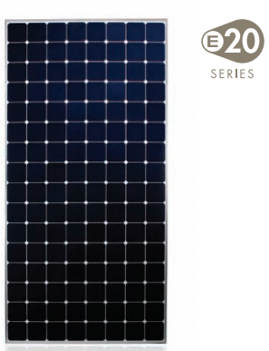
The solar panels we use are some of the highest efficiency rated panels on the market. The SunPower E20 solar panels provide 435 w per panel, and are rated with 20% efficiency. This means 20% of the energy (sunlight) available is actually converted into electricity. These panels are approximately 81 x 41 inches.
After our initial testing of the area, we determined we can install 800,000 - 435 W solar panels across 200 different buildings and locations, providing a total of 348,000 kWh equating to 8,352,000 kWh per day.

Wind Technologies
The wind turbines we use are offered by General Electric(GE), the GE 1.7-100 wind turbine. The turbine stands at approximately 329 feet and has a hub-span of the same, 329 feet. Each wind turbine is capable of generating 1,700 kW of electricity with optimal wind speeds of between 9 and 23 m/s.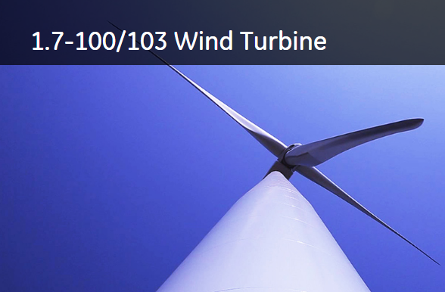
For the wind turbines, because of the size we thought it best to place these outside the city in locations along the Patapsco River and Chesapeake Bay where winds are strong. We determined we can install about 40 of the 1,700 kW turbines in 4 different farms, with 10 turbines in each. The total amount of electricity generated by these farms is about 68,000 kW which equates to 1,632,000 kWh per day.

Our Solution
For the year of 2015, it is estimated Baltimore City used a total of 6,484,248,110 kWh, which translates to about 17,765,063 kWh per day. With our technologies and solution, we will be able to provide the city with approximately 56% of its daily energy use through renewable resources.

Management Section

Description of Work

Deliverables

Schedule

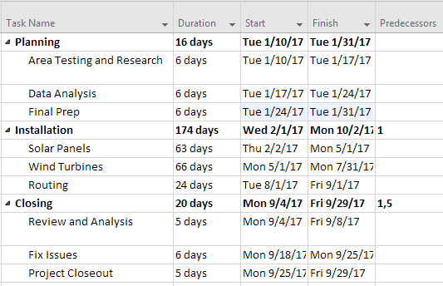

Cost Section

- Cost Breakdown

1. Material Costs

2. Labor Costs

3. General Expenses

- Cost table

Market Opportunity

Competition

Logo Design and Feedback

Works Cited

http://www.zdnet.com/article/un-cities-contribute-70-percent-of-global-greenhouse-gas-emissions/

