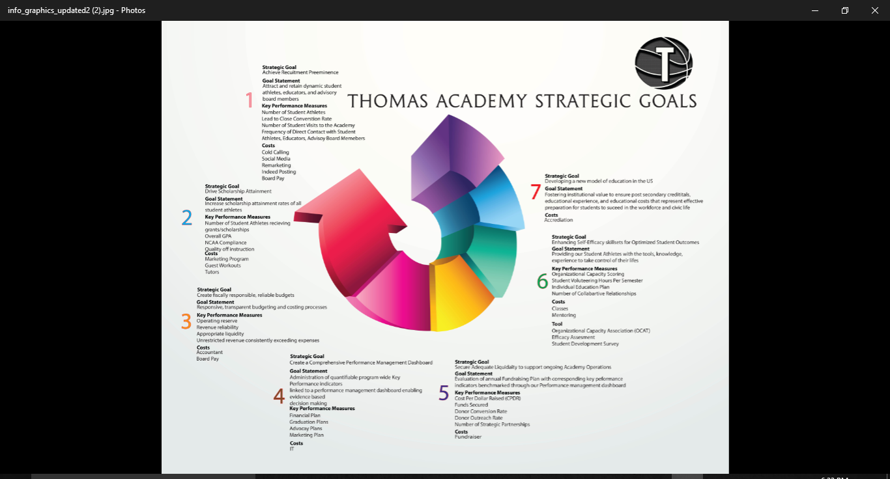

STRATEGIC GOAL
Achieve Recruiting Prominence
Goal Statement
Attracting and retaining dynamic student athletes, educators, and advisory board members.

RATIONALE
"Realizing the Value of People Management From Capability to Profitability", (this looks sourced by the Boston Consulting Group which I would note; gives credibility) reveals that recruiting is the most important human resource function when it comes to return on investment. More than 4,000 respondents from 102 countries were surveyed to compare high-performing companies with low-performing ones in terms of 22 different people-management capabilities. The study calculated the dollar impact of each of the different HR functions and ranked them. Companies that excelled in recruiting experienced 3.5 times more revenue growth than their less-capable peers. Recruiting Impacts Everything companies adept at hiring talent also had two times better profit margins than those that were less capable recruiters.
STRATEGIES

Deploy agile recruitment tactics to attract a dynamic student athletes, educators, advisory board members by:
- Appointment of a senior level Academy official responsible for implementing and overseeing recruitment plan.
- Creation of an inventory of Academy points of contact within each customer segment, in order to identify duplication, gaps, hidden gems, champions, and best practices.
- Creation of a prospecting list and documenting communications on excel spreadsheets
- Increased awareness by leveraging technology and social media marketing
- Employment of Lead Developers with cold calling scripts
- Quarterly report outs by program goal owners on their progress on recruitment goals set in the strategic plan
- Development of an Academy workforce plan that outlines workforce needs for the medium and long term
- Increase outreach by hosting free skill camps and other resources
- Development of web-based media kits
- Foster collaborative relationships with universities
- Increase the production and dissemination of evidence based research

Key Performance Indicators

- Number of Student-Athletes
- Lead to close conversion rate for Educators, Board Members, and Student-Athletes
- Number of Student Athlete visits
- Frequency of direct contact with Educators, Board Members, and Student Athletes
- Number of Direct Key Stakeholder interactions
- Number of media publications

STRATEGIC GOAL
Drive Scholarship Attainment

Goal Statement
Increase scholarship attainment rates for all student athletes

RATIONALE
Over the past three decades, average tuition and fees at a public four year college have increased 231 percent, while incomes for typical families grew only 16 percent. One of the realities confronting the United States is that a major proportion of minority students in this country have unequal access to higher education. Many experience a variety of personal, environmental, and institutional barriers that result in limited or no access to college and university education. Some of these barriers include financial difficulty and lack of financial aid, lack of support, low scores on traditional college admission tests, and often, an absence of role models who have gone to college. Disparities in higher education, and society in general, have existed for many years without receiving adequate attention

STRATEGIES
- Appointment of senior level Academy official responsible for implementing and overseeing of a marketing program for the Academy and each student. Providing a higher level of visibility and direct engagement with Colleges/Universities
- Intense Player Development program
- Exposure Camps maximizing promotional opportunities for our student athletes
- Scheduled Games providing visibility and ability benchmark against the world’s competition

KEY PERFORMANCE INDICATORS
- Percentage of Graduates receiving grants/scholarships
- Overall GPA
- Number of students meeting NCAA Compliance standards ensuring the eligibility of our student athletes
- Number of guest lecturers/ workout sessions
- Number of active domestic university partnerships
- Extent of or number of Alumni participation

Trends in College Pricing 2013, The College Board; US Census Bureau, Current Population Survey, Mean Income Received by Each Fifth and Top 5 Percent of Families, 1982-2012 (in 2012 dollars)

STRATEGIC GOAL
Create a Comprehensive Performance Management Dashboard

Goal Statement
Administration of quantifiable program wide Key Performance indicators linked to a performance management dashboard enabling evidence based decision making

RATIONALE

We aim to create a culture of excellence by formulating strategy, introducing clear measures to accomplish it, and aligning our processes and actions accordingly. Our Performance Management System and quantifiable performance targets will enable us to make evidence based decisions. It also enable potential achievement of positive results in facilitating an effective delivery of strategic and operational goals.
STRATEGIES

The Academy will create quantifiable performance targets enabling evidence based decision making by:

- Form a special management team to guide the Performance Management Process
- Educate athletes and employees on what exactly is expected of them by defining role-based competencies and behaviors.
- Establish standards for managing Academy programs/projects and providing oversight to measure their performance
- Establish a data management program that enables data analytic informing policy and decisions
- Implementing a shared case management solution that provides case tracking and reporting, and work-flows.
- Analyze complaints and appeals to elucidate opportunities to better meet the needs of our student athletes

KEY PERFORMANCE INDICATORS
- Reduction in operational costs
- Percentage of milestones met
- Reduction of project overruns
- Improved management control
- Increase in the proportion of training and certification managed through a shared service platform.
- Creation of a dashboard of Key Performance Indicators to increase agency awareness and drive improvement efforts

STRATEGIC GOAL
Secure adequate liquidity to support on going Academy Operations

GOAL STATEMENT
Evaluation of annual Fundraising Plan with corresponding key performance indicators linked to a performance management dashboard enabling evidence based decision making.
RATIONALE
Our fund development plan coordinates various forms of fundraising, marketing, communications, volunteer management, collaborative relationships. We are concerned not only with raising money, but doing so in a way that develops reliable sources of income that will sustain the Academy through the realization of our long term mission and vision. The creation of strategic and financial goals, identification of target markets, cultivation strategies, solicitation strategies, roles and responsibilities of staff and volunteers, measurable benchmarks and a timetable, and the process for monitoring progress and evaluating performance, are all critical elements of our fund development program.

STRATEGIES
- Hire a dynamic experienced results orientated Fund Developer(s)
- Drafting of an Annual Fund Development Plan and tracking it on the Academy's Performance Management Platform
- Creating compelling marketing collateral to explain our mission and help influence prospective donors.

KEY PERFORMANCE INDICATORS
- Cost per dollar raised
- Secured Funds
- Donor Conversion Rate
- Donor outreach rate
- Number of strategic partnership
- Operating reserve
- Revenue reliability
- Unrestricted revenue consistently exceeding expenses

STRATEGIC GOAL
Enhancing Self-Efficacy ( you know what this is, but not sure others will… maybe use more commonplace words or explantion) I knowskillsets for Optimized Student Outcomes

GOAL STATEMENT
Providing our Student athletes with the tools, knowledge, experience to take control of their lives.

RATIONALE
Rather than breeding dependency all students, must learn through opportunities and experiences to explore, establish personal goals, take risks, learn from consequences, become self-motivated, develop positive self-esteem and gain control over their lives. Through our Learner-centered teaching Holistic model that incorporates daily living, school, work, health, relationships, and recreation. Furthering to support our students to exercise greater choice, self determination, and to engage in leadership activities in their communities by enhancing their ability to regulate their own maturation, thought processes, performance level, emotional states, and altering environmental conditions. We are empowering our students and teaching the necessary learning skills essential to mastering material in any discipline

STRATEGIES

- Form a special management team to administer each student's Self Advocacy Plan
- Tracking Pre and Post test Key Performance Indicators on our Performance Management Dashboard
- Hiring the best Educators to provide the highest level of instruction our budget allows

KEY PERFORMANCE INDICATORS

- Individual Education Plans
- Organizational Capacity Scoring
- The Perceptions of Educational Barriers Scale (PEB-R)
- Perceived Academic Control Assessment
- Self-Efficacy for Learning Assessment
- PASCI Student Self-Concept Inventory
- College- Going Outcome Expectation Scales
- Number of Strategic Partnerships
- Individual Goal Setting Toolkits

STRATEGIC GOAL
Advance student driven, learner-centered approaches to education

GOAL STATEMENT
Help create an education system where student-centered alternatives are available to everyone.
RATIONALE
The organized educational system is about compliance, accreditation and most of all, certifying the students know how to obey. As Seth Godin, XYZ, noted: "The culture of schooling as we all know it is radically at odds with the culture of learning that produces innovators."
http://www.forbes.com/sites/ericaswallow/2012/04/25/creating-innovators/#7cf5f6103d7a
Schools are using too narrow a definition of intelligence and, worse, in their obsession with tests, are actually educating children out of being creative. Ken Robinson “Do skills kill creativity”

Colleges are focused on teaching kids content, not on teaching them skills, and too many students are focused on passing the multitude of tests in the multitude of classes they take, rather than really learning. One of the best college grads I ever hired (a graduate of Dartmouth) majored in history. In his job at ITIF (a technology policy think tank) he didn’t need to know history. What he needed to know was how to think, how to write, how to speak intelligently, how to find information and make sense out of it, how to argue coherently, and how to do basic math.
http://www.huffingtonpost.com/robert-d-atkinson-phd/the-failure-of-american-h_b_626289.html

The teetering behemoth of Industrial Civilization is literally crumbling around us. Accelerating decay is becoming apparent everywhere: mounting job losses and financial ruin of families; bankruptcy of nations, states, and municipalities; increased social atomization and break-down of communities; un-checked looting of both our natural and financial resources by rapacious corporate entities; debilitating price-spikes and shortages of many key natural resources; a cresting of profound absurdity in the political realm; and mounting environmental degradation coupled with an ominous incipient climatic destabilization. What will arise from the ashes of industrial collapse?
http://www.educationrevolution.org/AERO_EdRev62.pdf
A report from the Spellings Commission (named for Margaret Spellings, then the U.S. Secretary of Education). The report called for greater “transparency and accountability” in colleges and universities that receive federal aid, and for “better data about real performance” to allow students, parents, and policymakers to compare institutions on the basis of measurable outcomes. According to the commission, such measures are needed in order to determine if “the national investment in higher education is paying off.” The report was a signal that “outcomes testing,” long used in elementary and secondary education, was about to be introduced into higher education as well.
Colleges devote too many resources to luxurious dormitories, student centers, and expensive athletic facilities

Universities entice potential students with all sorts of easy loan packages, hip orientations, and perks like high-tech recreation centers and upscale dorms. On the backside of graduation, such bait-and-switch attention vanishes when it is time to help departing students find jobs. College often turns into a six-year experience. The unemployment rate of college graduates is at near-record levels. Universities have either failed to convince employers that English or history majors make ideal job candidates, or they have failed to ensure that such bedrock majors can, in fact, speak, write, and reason well. RELATED: To Improve Higher Education, Scale Back Federal Involvement The collective debt of college students and graduates is more than $1 trillion. Such loans result from astronomical tuition costs that for decades have spiked more rapidly than the rate of inflation. Today’s campuses have a higher administrator-to-student ratio than ever before. Those who actually teach are now a minority of university employees. Various expensive “centers” address student problems that once were considered either private matters or well beyond the limited resources of the campus.
Finally, the federal government should hold universities fiscally accountable. The availability of federal grants should be pegged to a college’s ability to hold annual tuition increases to the rate of inflation.

Read more at: http://www.nationalreview.com/article/416673/modern-university-failing-students-every-respect-victor-davis-hanson

Read more at: http://www.nationalreview.com/article/416673/modern-university-failing-students-every-respect-victor-davis-hanson

1. Learner-centered teaching engages students in the hard, messy work of learning.
I believe teachers are doing too many learning tasks for students. We ask the questions, we call on students, we add detail to their answers. We offer the examples. We organize the content. We do the preview and the review. On any given day, in most classes teachers are working much harder than students. I’m not suggesting we never do these tasks, but I don’t think students develop sophisticated learning skills without the chance to practice and in most classrooms the teacher gets far more practice than the students.

2. Learner-centered teaching includes explicit skill instruction.
Learner-centered teachers teach students how to think, solve problems, evaluate evidence, analyze arguments, generate hypotheses—all those learning skills essential to mastering material in the discipline. They do not assume that students pick up these skills on their own, automatically. A few students do, but they tend to be the students most like us and most students aren’t that way. Research consistently confirms that learning skills develop faster if they are taught explicitly along with the content.

3. Learner-centered teaching encourages students to reflect on what they are learning and how they are learning it.
Learner-centered teachers talk about learning. In casual conversations, they ask students what they are learning. In class they may talk about their own learning. They challenge student assumptions about learning and encourage them to accept responsibility for decisions they make about learning; like how they study for exams, when they do assigned reading, whether they revise their writing or check their answers. Learner-centered teachers include assignment components in which students reflect, analyze and critique what they are learning and how they are learning it. The goal is to make students aware of themselves as learners and to make learning skills something students want to develop.
4. Learner-centered teaching motivates students by giving them some control over learning processes.
I believe that teachers make too many of the decisions about learning for students. Teachers decide what students should learn, how they learn it, the pace at which they learn, the conditions under which they learn and then teachers determine whether students have learned. Students aren’t in a position to decide what content should be included in the course or which textbook is best, but when teachers make all the decisions, the motivation to learn decreases and learners become dependent. Learner-centered teachers search out ethically responsible ways to share power with students. They might give students some choice about which assignments they complete. They might make classroom policies something students can discuss. They might let students set assignment deadlines within a given time window. They might ask students to help create assessment criteria.

5. Learner-centered teaching encourages collaboration.
It sees classrooms (online or face-to-face) as communities of learners. Learner-centered teachers recognize, and research consistently confirms, that students can learn from and with each other. Certainly the teacher has the expertise and an obligation to share it, but teachers can learn from students as well. Learner-centered teachers work to develop structures that promote shared commitments to learning. They see learning individually and collectively as the most important goal of any educational experience.

As lined out in his book, "The Global Achievement Gap," that set of core competencies that every student must master before the end of high school is:
- Critical thinking and problem solving (the ability to ask the right questions)
- Collaboration across networks and leading by influence

