14.1 Wordo
One of our favorite word games is Wordo, a takeoff of Bingo. A 5 × 5 game card grid is used, very similar to the one in Bingo; however, instead of each box being filled with a number, in Wordo, each box contains a word.
To play, select at least 24 or 25 words and provide a Wordo card for each player (see Figure 14.1). The words can be spelling words or words from specific word recognition lessons, a word bank, or various content areas. List the words on the chalkboard and ask students to copy them randomly on their game cards, one word per box. The center box can be marked Free. Random word placement is important; if everyone uses the same order, all players win at the same time! The teacher also writes the words on a set of 3 × 5 cards, shuffles them, and spreads them out, written side down, on a table.

Figure 14.1 Wordo Card
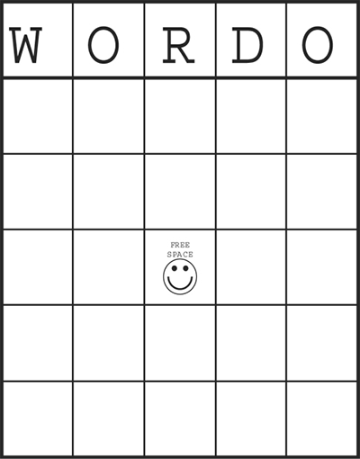
The game begins when the teacher (or a student) draws a word card from those spread out and calls out the selected word. Students search for this word, and if it appears on their card, they cover it with a marker (dried lima beans make good, inexpensive markers). The game continues in this way until a student achieves Wordo by getting a line of markers in a row, column, or diagonal. A small prize is often given to the winner, game cards are cleared, and a new game begins.
Rather than simply call out selected words, the moderator may want to give other clues such as the definition, a sentence in which the selected word is deleted, or structural clues, such as “The word I selected has two syllables, begins with a consonant blend, and contains a diphthong.” To use these more subtle clues students must examine the words on their cards in a little more depth.
Younger students may be a bit overwhelmed by games cards that contain 24 empty boxes. For students just beginning to learn about words and Wordo, you can use games cards that are made up of a 3 × 3 or 4 × 4 matrix.
The Wordo concept can also be used to teach initial letters and letter sounds. In this version of Wordo, usually done with a 3 × 3 game card for younger children (see Figure 14.2), students write initial consonant letters or blends on their cards in random fashion—​one letter or blend for each box . Then, the teacher calls out words that contain one of the sounds or shows a picture that begins with one of the sounds. Students find the appropriate beginning letter or blend and cover it with a marker. The same idea can also be employed with ending letters and sounds, affixes, and vowels and their corresponding sounds.
Students love to play Wordo. It is certainly an enjoyable way to review words you want students to learn and to provide the necessary practice for adding the words to their sight vocabularies.

Figure 14.2 3 X 3 Wordo Card
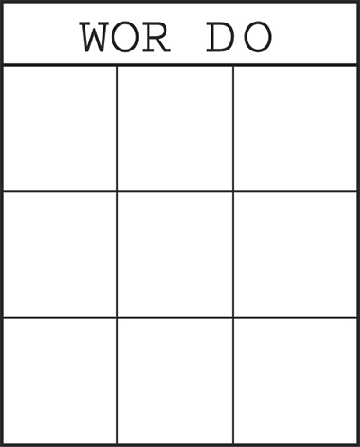

14.2 Word War
Word War, a version of the card game War, is best played by a group of two to four students. A deck of word cards is needed. This can be accomplished by giving each group of students a deck of 3 × 5 cards, asking students to divide them up, and having them write a word on each card. Students can use word wall words (see Chapter 9), words related to some area of study, or interesting words. Once created, the Word War cards can be used for many weeks, and new words can be added to the deck as needed.
Students can also use words from their word banks (see Chapter 11 for more on word banks). Of course, if you choose this option, students will need to mark their own cards in some way (perhaps their initials) so that they can retrieve their cards at the end of the game.
Once the deck is established, all the word cards are put together, shuffled, and distributed to each player, face down. An agreed‐on time limit is set, usually 5 or 10 minutes, and the game begins. Each player plays one card face up from his or her deck. The player must be able to pronounce the word in order to continue the play. Once each player presents a card and pronounces it, the player with the longest word wins the round and all the cards that were played. These words go to the bottom of the player’s pile.
New rounds are the same. If, however, the longest word is shared by two or more players, then a war ensues. Each of the players involved in the tie plays another card face down and then one face up and pronounces it. The player with the longer of the second face‐up cards wins all the cards played in that round. Another tie brings on another war, and so forth.
Play continues in this manner until the timer bell goes off. At this point, players count their cards. The player with the most cards wins.

14.3 Pick Up Sticks
Played with two to four students, Pick Up Sticks requires a set of popsicle sticks with words to be practiced written on one end of each stick. One stick has the word ZAP! written at the end. All sticks are placed word‐end down, into a can, cup, or some other opaque container.
Play begins with one student pulling a stick up from the container. If the player can pronounce the word, he or she gets to keep the stick. If the word cannot be pronounced quickly it must be returned to the container. In turn, each player pulls one stick at a time. Play continues until the ZAP! stick is pulled. At this point, the player with the most sticks is the winner. Students love the suspense that develops as the number of remaining sticks becomes smaller and smaller.

14.4 Match (Concentration)
Match is another word card game and is best played in pairs. Two word cards are made for each word used in the game. Usually, between 10 and 15 words (20 to 30 cards) are sufficient. Students can make word cards from a clean deck of 3 × 5 cards, or they can be drawn from students’ personal word banks. If drawn from word banks, the cards need to be marked for easy return to the owner, and players must ensure that each card has a match.
The card deck is shuffled and laid out in a grid, face down. Students take turns turning over and pronouncing two cards at a time. If the two word cards match, the student wins the pair and selects another two cards. If the cards do not match, the cards are turned back over and the next player takes a turn. Play continues until all cards have been matched. Players count the cards they have accumulated, and the player with the most cards is the winner.
Variations of the game can be created by changing the criteria for matching cards. The matched pairs could be rhyming words; words with the same beginning letter, letter combination, or sound; words with the same ending; words with the same number of syllables; or words that are synonyms or antonyms. Match can also be played with pictures and words, which is a useful adaptation for English language learner (ELL) students.

14.5 Go Fish
Another matching game is a variation of the classic card game Go Fish. Go Fish also requires a deck of word cards that match in some way (e.g., same words, rhyming words, words that begin with the same letters or sounds, words with the same meaning). Ideally played with four or five players, students are each dealt five cards and the remaining cards are spread out in the middle of the table as the card pond. The object of the game is to find matches to the words in your hand.
A turn begins when a player examines his or her cards and asks a second player for a card that matches a criterion (e.g., “Do you have a word the rhymes with cat?”). If the second player has such a card, it’s given to the first player, who matches it and lays the pair down face up. The first player then makes another request for a card. If the second player doesn’t have the requested card, the first player must “go fish” and draw a card from the pond. If the card matches one in the player’s hand, he or she lays it down, face up, and takes another turn. If a match cannot be made, the next player’s turn begins. Play continues until one player matches all the cards in her or his hand.
Scoring is variable; usually players get one point for each card matched but must subtract a point for each card that remains in their hands at the end of a round. The game continues until one player’s cards are all on the table or until a certain point limit is reached, usually 50 to 100.

14.6 Make Words with Cubes
Make Words with Cubes requires a set of blank cubes or dice that can be purchased at many teacher supply stores. Individual letters or letter combinations are written on each side of the cube. If cubes cannot be found, you can take a set of dice, white out the dots, and write in individual letters and letter combinations. Alphabet blocks can also be used. (Another variation is simply to list 6 to10 letters or letter combinations on the chalkboard.)
The game can be played in groups of three to five or with a larger group in which teams of two to three students work together. If cubes are available, they are shaken and spilled out on the table. A timer is set for 5 to 10 minutes and students are challenged to make as many words as they can from the given list of letters. Bear, Invernizzi, Templeton, and Johnston (2011) suggest that students record the words they make by length (see Figure 14.3). Once time has expired, students check their words and assign points (one point per letter). Other recording and scoring sheets are possible. For example, students could sort their words by number of syllables, number of consonant blends and digraphs per word, or short and long vowel sounds, with more points given to words with more syllables, more blends and digraphs, or long vowel sounds.

Figure 14.3 Cube Word Record Sheet
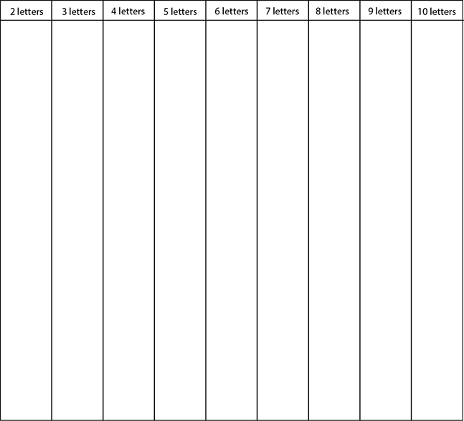

14.7 Word Maker Cups
One age‐old practice is to have students blend beginning consonants and blends with rimes or word families to determine the words that can be made, such as pr + ay = pray. Often this involves creating “sliders” in which a strip containing the beginning consonants, consonant blends, and consonant digraphs is slipped through slits in a larger piece of construction paper that contains the rimes. Moving the beginning consonant slider through the rime sheet, the student determines all the words that can be made.
This is a good activity for students learning how to blend onsets and rimes, but making sliders is time‐consuming. Furthermore, sliders tend to fall apart easily when used a lot by young hands.
An alternative is to use large Styrofoam coffee cups. When two cups are stacked, their lips fit together nicely; they can also be rotated. The lips of one set of cups, then, can contain beginning consonants and blends (8 to 10 per cup should do). And the lips of the other set of cups show rimes or word families (two to four rimes per cup work best).

Figure 14.4 Word Maker Cups

Then, have students simply take one of the beginning consonant and blend cups and one of the rime cups, fit them together, and rotate them so that all the combinations of consonants, blends, and rimes can be analyzed (see Figure 14.4). Students should jot down the words they make. Although this is not necessarily a game, it is enjoyable practice in using rimes to decode and spell words. Since word cups are inexpensive (usually 100 for a dollar or less) and easy to make (even students can make them), this is an attractive option for busy teachers (isn’t that all teachers, all the time?).

14.8 Scattergories
Scattergories can be played with large groups of students; we find it best, however, if students work in teams of two or three. Scattergories is a generative game that is a great way to get students thinking about word patterns. The only requirement is a Scattergories sheet for each student or team (see Figure 14.5).
Along the top row, the teacher (and students) brainstorm about five word patterns—​rimes, derivational patterns, and so on. Down the left‐hand column, the teacher provides a random set of consonants and consonant blends. Then, for the next 5 to 10 minutes students think of words that begin with each consonant or blend and that contain one of the targeted patterns (see Figure 14.6 for an example).
At the end of the given time period, students score their sheets. If students are allowed to put only one word into each box, they can be given a point for every letter used in each acceptable word. This encourages students to think of longer words containing the targeted patterns. In another scoring scheme, students list all the words they can think of that fit each box. One point is given for each acceptable word. In this case, students are rewarded for thinking of many words that fit the given specifications.

Figure 14.5 Scattegories Form
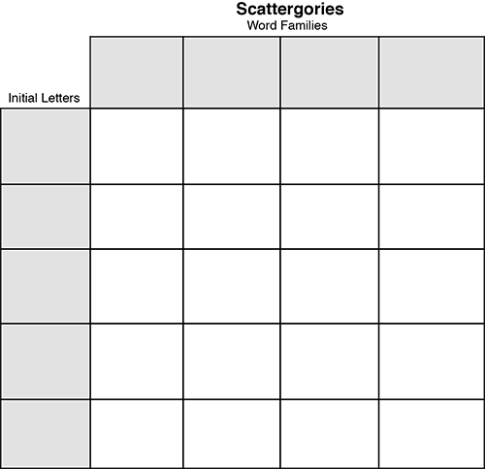

Figure 14.6 Scattergories
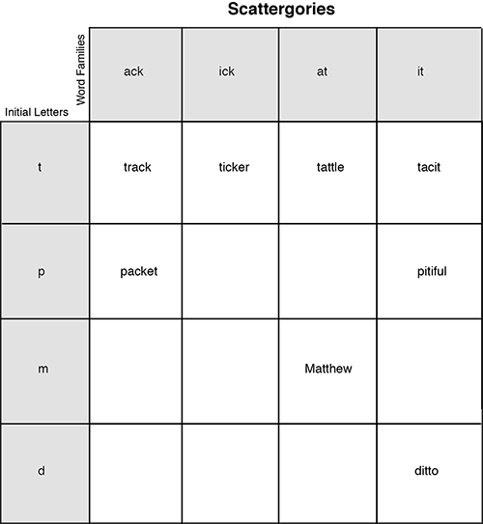
The game has many variations. For example, the left‐hand column could contain prefixes or semantic categories that require students to orchestrate their knowledge of word patterns with the meanings of words that contain such patterns. For example, word patterns such as il(l), en, ack, ip, and on could be used on the top row. The left‐hand column could contain semantic categories such as people’s names, animals, cities and states, and plants. For people’s names, Bill, Dennis, or Jack could be used. For animals, killer whale, hen, and hippo would work. Philadelphia, Hackensack, and Boston would fit the cities and states category, and dill and tulip would be in the plants category. The many variations of Scattergories that can add depth and interest make it a very useful game for the later primary to middle school grades.

14.9 Sentencing
Word recognition also involves the ability to use context to determine unknown words in texts. One of the best games we have found for supporting this ability is called Sentencing (Hall 1995), a game similar in nature to Wheel of Fortune and Hangman, except that it uses sentences instead of individual words. Sentencing challenges students to use syntactic and semantic cues to reconstruct a sentence the teacher creates or extracts from an appropriate level text. The game involves teams of three to eight students and can be played with students in grade 3 and up. Student teams try to determine unknown words in a sentence.
After teams are set, the teacher finds a meaningful sentence of 7 to 15 words that makes strong use of syntax. The sentence should not include proper nouns or contractions. For example:
If you are hungry, look inside the refrigerator.
The sun has been shining all week long, and I love it.
Each team gets two “free letter” cards to use during the game.
The game begins with the teacher listing the sentence on the chalkboard with only one key word revealed (see Figure 14.7). This word should help students use background knowledge in making predictions about the sentence. Also, the teacher should point out to students any clues such as punctuation.

Figure 14.7
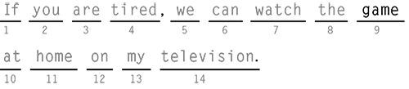
Each turn begins with the revelation of one unknown word of the team’s choice. Upon revelation of the word, the team can either guess another word in the sentence, for which they will receive 2 points if correct, or they can use their “free letter” card in order to get the first (or another) letter of any unrevealed word. After seeing this letter, they must guess any unknown word in the sentence. Guessing a word that has one or more letters revealed earns 1 point.
Correct guesses allow the team to continue. An incorrect guess ends that team’s turn. Play is over when the entire sentence is guessed, at which time the score is tallied for each team.
In the example shown in Figure 14.8, Team One asked for word five to be revealed. It then used its “free letter” card for the first letter of the first word of the sentence. They correctly guessed If after the I was given and earned 1 point. They then guessed the for word eight and received 2 more points. Their next guess, we for word two, was incorrect, so the turn went to Team Two.
Team Two began by asking for word fourteen to be revealed. The word was television. Then they used a “letter card” for the first letter in word four. This was a t and Team Two then guessed word two to be you and word three to be are. These guesses were worth 2 points. Team Two then guessed tardy for word four, which was incorrect (see Figure 14.9).

Figure 14.8
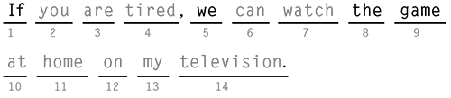

Figure 14.9
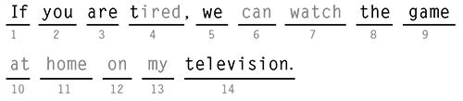

Figure 14.10
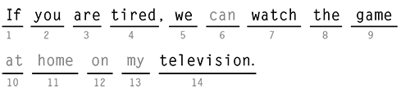

Figure 14.11
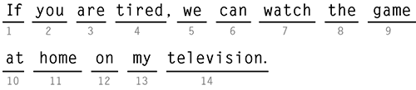
Team One then used its last “letter card” for the second letter of word four—​an i. Team members correctly guessed the word to be tired for 1 point. From this point, Team One correctly guessed word seven to be watch, but missed word six by guessing will (see Figure 14.10).
Team Two asked for word ten, which was at, and used its “letter card” for the first letter of word eleven—​an h. At this point, Team Two guessed word eleven to be home (1 point) and then correctly guessed the remainder of the sentence: word six can (2 points), word twelve on (2 points), and word thirteen my (2 points) (see Figure 14.11). Points were tallied: Team Two—​12 points and Team One—​6 points.
Although the game may seem somewhat complex, it is simple to play, and once students become familiar with the format, games tend to take no more than five minutes. Once the game is over, the teacher engages students in a quick debriefing, asking what strategies they used and what helped them figure out the sentence. Students will inform one another, within teams and later between teams, of significant and useful syntactic and semantic clues.

14.10 Word Sketches
Word Sketches (Padak and Rasinski 2009) is based on Pictionary. To play it, choose words from a text your students are currently reading or have read. Be sure to choose words that lend themselves to images. Write each word on a slip of paper, and put the slips in a cup or container. Students form teams of four to five players per team and play the game the same way they would Pictionary. One student on each team selects a word and makes a sketch that reflects its meaning without saying the word itself. Other members of the team try to guess the word. Determine the time required to guess the word correctly (limit the time to about a minute per word). Once a word is guessed, the other team has its turn. The game ends when all members of both teams have had a chance to be the “sketcher.” The team that takes fewest total seconds to determine their words is the winner.

14.11 Word Theater
Word Theater (Padak and Rasinski 2009) is a classroom version of Charades. Set the game up in the same way that you set up Word Sketches—​you’ll need a set of words on paper slips in a cup and two teams of students. Then play the game as you would Charades. Instead of drawing sketches of the words, students act out their chosen word while other members of the team attempt to guess it. Each member of both teams has a chance to choose and act out a word. The team that requires the least time to guess their words wins the game.

14.12 Word‐Part Rummy
This is a card game in which the cards contain word parts (prefixes, suffixes, roots) that can go together to form words (Padak and Rasinski 2009). Prepare about 10 cards per player, shuffle, deal five to each player, and place the remaining cards face down in a stack. Players look for cards that create words (prefix‐root, root‐suffix, prefix‐root‐suffix, root‐root) and place them face up on the table. Then they take turns drawing cards from the pile. If the drawn card does not make a match, the player discards a card, which the next player may take. Play continues until someone has matched all of his or her cards. The player with the most cards used is the winner.

14.13 Other Games
We have only scratched the surface of the possible word games teachers and students can develop and enjoy. Note also that word games can easily be adapted for home use as well (Padak and Rasinski 2009). What could you do with cookie sheets and magnetic alphabet letters, for example? Online resources, such as those listed in the box, may also work well. Many of the word activities described in previous chapters (e.g. Making Words, Making and Writing Words, Word Ladders) also have game‐like qualities.

Online Resources for Word Games
Preschool Home Activities for Parents and Children (See Rhymes and Alphabet) http://www.preschoolrainbow.org
Word Central.com www.wordcentral.com/
Puzzlemaker.com http://puzzlemaker.school.discovery.com/index.html
Text Twist http://games.yahoo.com/game/text‐twist‐applet.html
Reading Is Fundamental http://www.rif.org/kids/readingplanet/gamestation.htm
PBS’s “Between the Lions” http://pbskids.org/lions/games/
Miscellaneous word game sites
http://www.funbrain.com/words.html
http://www.eastoftheweb.com/games/
http://www.wordgames.com/
http://games.yahoo.com/word‐games
Games derived from the words on the word wall (see Chapter 9) are also possible. Second‐grade teacher John has students do word sprints using the word wall words. Throughout the school year John adds five sight words each week to the sight word wall. The words come from the second group of 100 words from the Fry Instant Word List (Appendix B). Students pair up about once a week and each pair is given a stopwatch. While one student keeps time and checks for errors, the other student tries to read the wall as accurately and quickly as possible. The student records his or her scores, and the roles are reversed.
Scores for accuracy and time are recorded on a “personal best” sheet that each student keeps. “It’s really only a tiny part of my word study and reading program, 10 minutes a week or so, and I want to make sure the students compete against themselves not others,” John says, “but the improvement that the students make . . . ​is simply amazing. Based on their original readings of the wall, students set a goal for themselves for accuracy and speed, and if they can meet or beat their individual goals they win a certificate. The level of intensity as students practice the words on their own is impressive.”

In Conclusion
Word learning and automatic word recognition require repeated exposures to words. Word games are a superb way to add those exposures, which build students’ sight vocabularies. Children love to play games, and the nature of words themselves—​their meaning, their grammatical categories, their orthographic makeup—​make them excellent material for classroom and home reading games. Although games are only a minor part of any reading or word recognition program, they can play a significant role in adding variety, life, and practice to students’ word learning.

