Use the following data for options expiring in February 2018 on Boston Scientific (BSX) to answer questions 2 and 3. Note: use the “last price” for all your calculations.
2. What is a straddle, and why would an investor choose to buy one? Assume an investor buys a $28 straddle on BSX. At what stock prices at expiration will that positon be profitable? Assume at expiration BSX sells for $22: what will the % return be on the straddle? How much profit or loss will the investor earn per share?

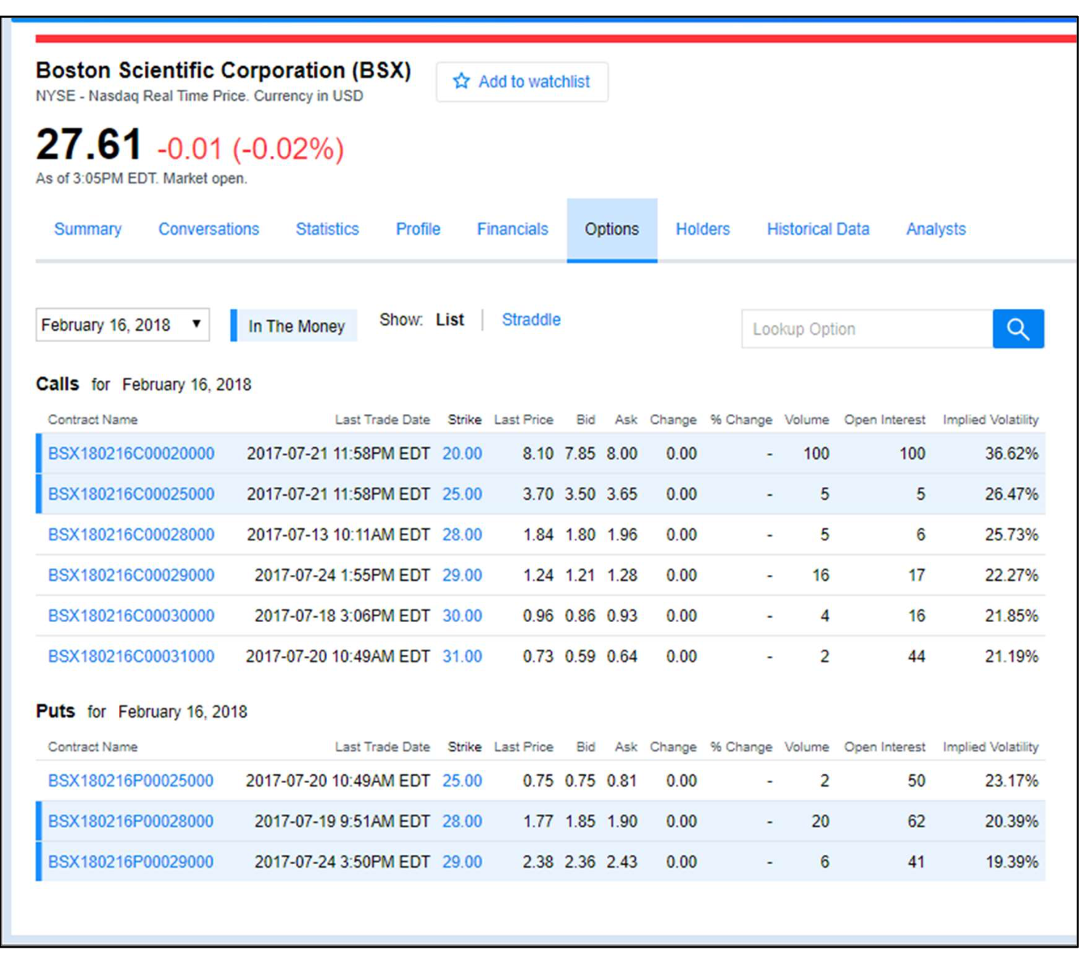

3. Assume a different investor is bullish on BSX, and is considering the following three potential investments. If at option expiration in February the stock price is $32, what will the return be (% and $ per share) for each choice:
a. Just buying the stock at $27.61.
b. Just buying the $28 call.
c. Buying a bull spread using the $28 and $31 contracts.

