Suppose you are a molecular modeling scientist working in a pharmaceutical company. (Congratulations for your new job). Your friend, a medicinal chemist, from another section came to ask your opinion on what she/he should synthesize next. According to her/his story, they have synthesized a series of compounds and examined their biological activities. The chemical structure of the parental compound is shown below.
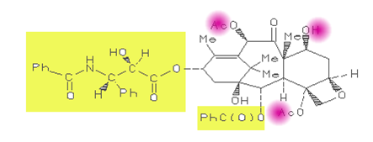
Biological activity data of the 125 compounds examined indicated that the substituents marked with yellow do not play any role in biological activity. On the other hand, if you change the substituents marked with purple, these changes affect significantly the biological activity. Provided you have a permission to examine these compounds from your boss, please describe how you are going to approach this problem including the tools and steps involved.
Please note that I am not asking you to give me any numerical data. Just describe your approach. However, just a general description of drug design process which can be applied to any systems is not sufficient (just do not copy SYBYl manual or Web documents). You must specifically address the above chemical system (with the number of compounds, yellow and purple regions etc etc.) in your description. Describe how you generate data and analyze it. If necessary, provide an additional scenario (conditions) when it is needed to justify your approach
Q2.Another friend from biological chemistry section is visiting your office. She/He is interested in this particular protein system and performing a lot of biochemical experiments including measurement of binding constants for various compounds the company owns. She/He shows you the sequence of the mature protein they are interested in. They searched PDB but it seems no crystal structure for this protein has reported. The first question she/he asked was whether you can build a 3D model of this protein. How are you going to answer the question? Assume again you have a permission to work on this project from your supervisor. Answer cannot be just yes or no. You must explain to your friend what you are going to do, why you choose a particular approach over others, what steps are involved in this approach, what is a potential pitfall etc.

I will assure him that we can build a 3d model of this protein by using SYBYL software

