Data for Item analysis project.

Tom is a 16 year old male student. He lives with his grandparents. He is a loner and has few friends.
The grandmother attends parent teacher conferences and tries to work with the school staff to help Tom. The grandpa works 2 jobs to support the family.
His mom left the family when he was 10 and his father is in jail for selling drugs.

He plays the drums in a rock band that has 3 other adult members who are ages 18-20.
He reads at a 4th grade level.
Tom does not have an IEP.
He has missed 15 out of 60 days of school.
He has 6 referrals to the office for refusing to do his work and being disrespectful to teachers.
His grade card for the first 9 weeks:
C math
B Social Studies
C Science
D in Language Arts
The Ohio Graduation Test (OGT) is the high school graduation examination given to sophomores in the U.S. state of Ohio. Students must pass all five sections in order to graduate.
Tom scored Limited in reading, Basic in writing, Proficient in mathematics, Basic in science and Proficient in social studies.
See Example descriptions below.

What do the Performance Levels mean?
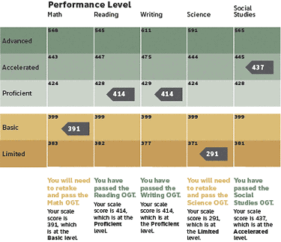
Look at the first page of your report to see how you performed overall on the Ohio Graduation Tests. Performance Levels are based on scale scores. Your raw score (number correct on the test) is translated into the scale score. Scale scores show the level of student skills, and can be compared across grades. There are five levels (called Performance Levels) to indicate the extent to which you meet the Ohio Academic Content Standards, the statements that summarize what students should know and be able to do. The five Performance Levels are:
Advanced: Scoring within the Advanced range shows that you perform at a much higher level than expected to show that you understand the standards for the subject area at your grade level.
Accelerated: Scoring within the Accelerated range shows that you perform at a higher level than expected to show that you understand the standards for the subject area at your grade level.
Proficient: Scoring within the Proficient range shows that you meet the standards for the subject area at your grade level. You must score within the Proficient range or higher in each subject area tested on the OGT.
Basic: Scoring within the Basic range shows that you do not meet the standards for the subject area at your grade level. You show some skill in the area, but you need more help to show that you understand the standards (that you are Proficient in the subject).
Limited: Scoring within the Limited range shows that you do not meet the standards for the subject area at your grade level. You need more help to show that you understand the standards (that you are Proficient in the subject).

