FC Expert Blog

How Green Is Your Boardroom?
BY FC Expert Blogger Alice KorngoldSun Jun 12, 2011
This blog is written by a member of our expert blogging community and expresses that expert's views alone.

No, I don't mean green as in money. I mean green as in environment. At Kimberly-Clark, sustainability is not only discussed in the C-suite; it's also on the board of directors' agenda. At the Corporate Eco Forum (CEF) annual meeting held last week, Kimberly-Clark announced its Sustainability 2015 goals built on a framework of People, Planet and Products. Suhas Apte, Vice President, Global Sustainability, shared with me his experience in presenting the plan to the K-C board of directors and their feedback.
K-C's 2015 plan "commits to reducing the company's environmental footprint, building healthy work environments, innovating products and business models to reach new consumers globally, focusing K-C's social programs on global issues and in the company's communities, and addressing broader global commitments such as the U.N Millenium Development goals." The company has also released metrics that the company will measure and track related to these goals.
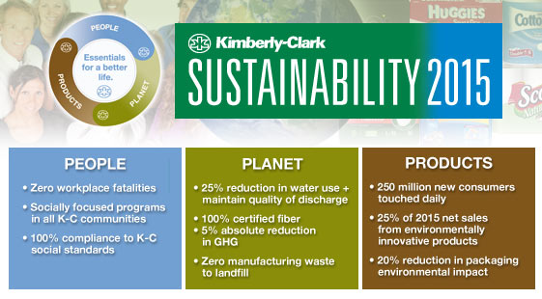
Apte told me that not only did the board endorse the plan, but the board asked how the plan could be accelerated. Under the leadership of K-C Chairman and CEO Thomas J. Falk, the board asked Apte for an annual review including discussions of longer-term aspirations, impediments, and ways in which the board can help. K-C also has an external advisory board for sustainability that meets with the company's C-suite executives twice a year to ensure that K-C is fully engaged in current thinking and discuss "what K-C should be worried about."
Apte defines the full scope of the company's interests in terms of sustainability. "K-C is not only looking at the supply chain - looking backwards at sourcing, procurement, design, and manufacturing," explained Apte, "but we are also interested in matters of safety and environment after our goods are produced. We define the entire continuum as the 'value chain,' thereby including marketing/selling and also disposal."
The business case
"Our tissues and paper towels are manufactured from trees and water, and our super absorbent materials are made from oil based polymers. It's in our company's interest to make sure that essential resources are available to the company well beyond 2015," explained Apte.
Furthermore, the younger generation of employees understand sustainability, so in order to attract the best talent, and engage the people who will be our future leaders, our company needs to be at the forefront.
Apte said that Sustainability 2015 is the "Right to Play" plan, ensuring that K-C has an opportunity to stay in the game with the resources it will need. The next sustainability plan for the board will be the "Right to Win," defining how K-C will gain the long-term advantage.
When the board of directors recognizes that sustainability is not only essential to the company's future, but also the key to the company's competitive advantage, then the company wins. So does the world.
http://www.fastcompany.com/1759311/how-green-is-your-boardroom?partner=rss

