TOWSON UNIVERSITY

College of Education

EDUC 203: Teaching and Learning in a Diverse Society
Professor Arnita Hicks McArthur

“No race can prosper till it learns that there is as much dignity in tilling a field as in writing a poem.”
― Booker T. Washington

“Segregation shaped me; education liberated me.”
― Maya Angelou

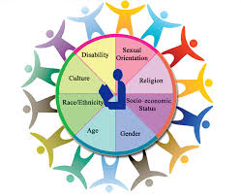

In-class activity
You tube
- Gov. Wallace Attempts to Block Integration
- The Civil Rights Era From BBC Motion Gallery

Select any one of the videos below to view; write a personal response to the information presented in the video in your online journal. (PENZU) Please print out the journal entry and attach it to your completed assignment.

- The Rise and Fall of Jim Crow/ view and review
- Jim Crow and Apartheid (segregation systems in racist America) view and review

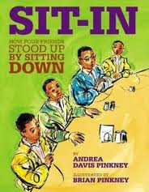

ETHNICITY

In-class activity

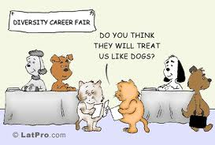

READ: Critical Incidents in Teaching
Answer: Questions for Classroom Discussion

DIMENSIONS OF DIVERSITY
Chapter 2: Ethnicity and Race
Pages 36-73

Historical Perspective: Looking Back
A Brief History of the Immigrant Population
Pages 36-46

- Identify some of the immigrant population that voluntarily settled in the United States.
- What group did not immigrate to the United States voluntarily? What problems did this group face?
- According to the chart on page 41, what four states have the highest foreign-born population?
- Explain the 1790 Naturalization Act.
- What did the Dillingham Commission recommend in 1917?
- Explain the purpose of the Johnson-Reed Act in 1924 and the 1986 Immigration Reform control Act.
- A state senator from Arizona introduced the Support Our Law Enforcement and Safe Neighborhood Act in 2010. What did this act require?
- Define refugee, and in 2009 how many people were admitted to the United States as refugees?
- Is language a barrier for immigrants’ success in American schools? What are some of the factors that could improve the children’s chances for success?

RACE
- African Americans have become a single pan-ethnic group. Why? What types of discrimination does this group usually experience?
- According to the textbook, “Many whites see themselves are raceless.” What does this mean? Do you agree with this statement? Why? Why not?
- One third of the nation is African American, Latino, Asian America or American Indian. These groups will comprise about 40% of the U.S. population by 2020 and 50% of the population by 2042. (Mather, 2009) What factors contribute to this growth?
- Psychologist William E. Cross (1992) identified several stages in the racial development of African Americans and whites. READ THEM. Do you agree with his assessment?

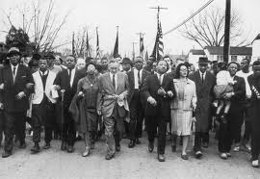

THE STRUGGLE FOR CIVIL RIGHTS

- Identify at least five movements or incidents that pushed the U.S. government to make changes in civil rights for African Americans. Add details to explain each movement or incident.
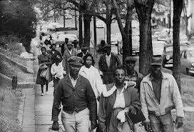

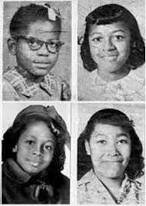

CLOCKWISE: Addie Mae Collins, Cynthia Wesley, Carole Robertson, Denise McNair
Montgomery, Alabama
Church Bombing
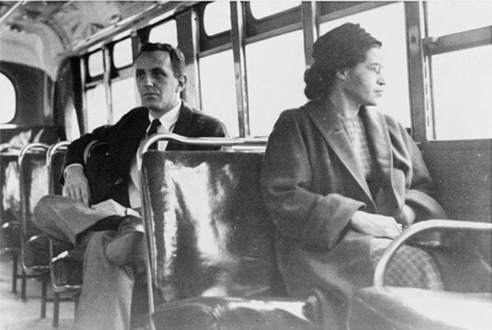
ROSA PARKS
- Discuss the history and details of the Brown v. Board of Education (1954) decision. Explain the Gong Lum v. Rice in 1927, Mendez v. Westminster and Lau v. Nichols.
- Review Table 2.1 Milestones in Desegregating and Resegregating Schools

RACIAL AND ETHNIC DISCRIMINATION

- What are some of the reasons for continued interethnic conflict?
- How does the Federal Bureau of Investigation (FBI) define hate crime?

Pause to Reflect 2.2 page 62

Penzu: On-line Journal Entry

AFFIRMING RACE AND ETHNICITY IN THE CLASSROOM

- Should teachers acknowledge the race and ethnicity of their students? Why? Why not? Do you think this will be difficult? Explain
- How can teachers confront racism in the classroom?
- Explain ethnic studies, ethnocentric curriculum and multiethnic curriculum. What does each emphasize?
- Why do a disproportionately high number of students of color score lower than whites and Asian Americans on standardized tests?
- What can teachers and schools do to reverse this trend?

INTERNET SEARCH

- Find at least two hate group websites. What do you think of the information provided here?
- Look up the Civil Rights Act of 1964. What did it provide?

