Social Network Security
Marion Scott

The following security settings can be made on the Facebook account for ether privacy or security reasons. For all the below actions to be performed, one must be logged into the Facebook account

- Limit access to Work and Education info to "Friends" or "Only me."
The following steps should be followed to achieve the above
- Login Facebook account
- Select on Timeline on your profile
- Under Intro, select
- Select Education and/or Work and set info to friends
- Save changes
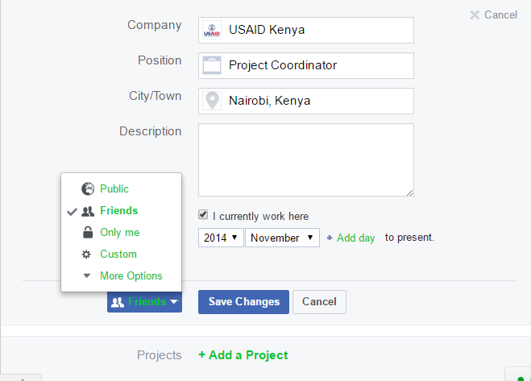
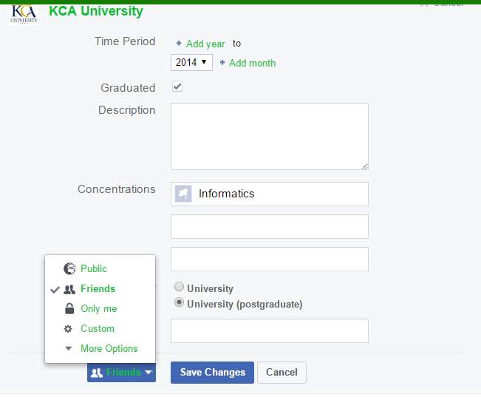
- Set a strong password consisting of a passphrase that is alphanumeric, at least 10 characters, and includes a special character.
The following steps should be followed to achieve the above
- Go to settings
- Under general settings select Security and login
- Select on change password
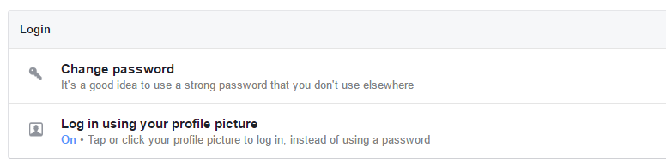

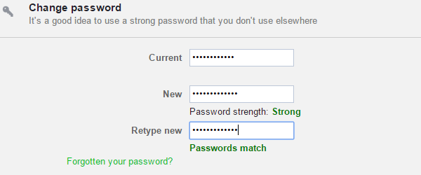
Sample Password: ?@40Hillcrest#

- Select a separate "App Password" under Security Settings
The following steps should be followed to achieve the above
- Go to Security settings
- Scroll down to Use two-factor authentication and then click Edit
- Go to App Passwords and click Generate
- Follow the on-screen instructions
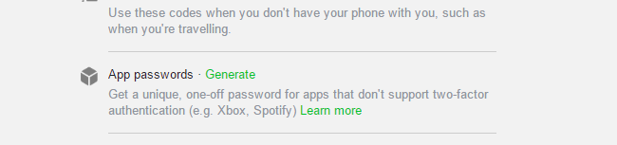
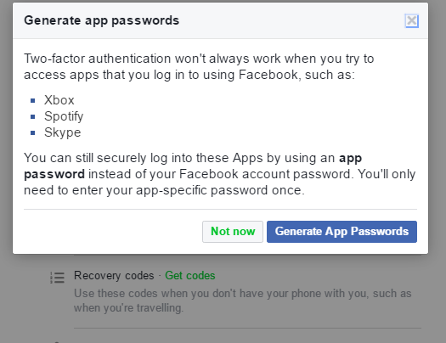
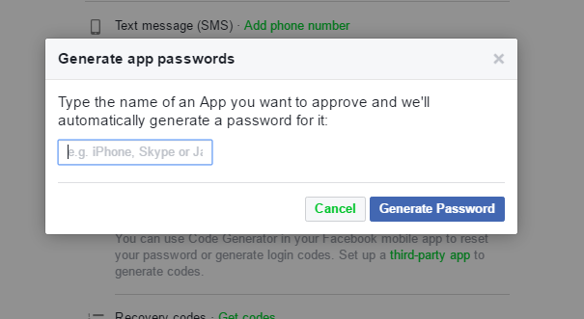
- Adjust "Privacy Settings" to Friends.
The following steps should be followed to achieve the above
- Go to settings
- Select privacy settings and tools
- Under who can see my stuff, edit and select “Friends”
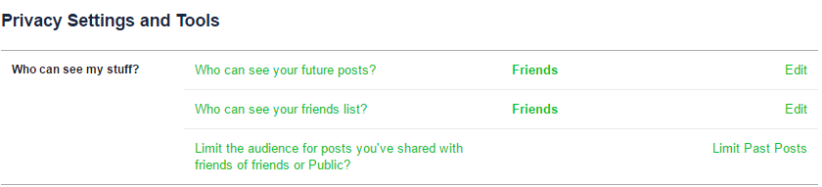

- Limit "Who can contact me" to "Friends of Friends" or "Friends."
- Under Settings
- Select privacy settings and tools
- Under who can contact me click edit and select "Friends of Friends" or "Friends."
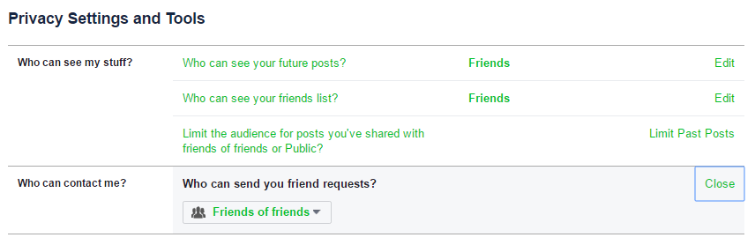
- Adjust "Who can look me up" to "Friends of Friends" or "Friends."
- Under Settings
- Select privacy settings and tools
- Under whom can who can look me up edit and select "Friends of Friends" or "Friends".

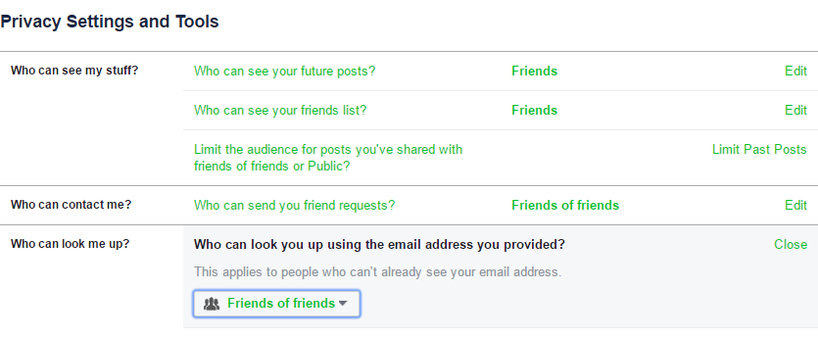
- Set "Timeline and Tagging" to "Friends."
- Go to settings
- Select on Timeline on your profile
- Click on Timeline and Tagging
- Click on edit and select "Friends”
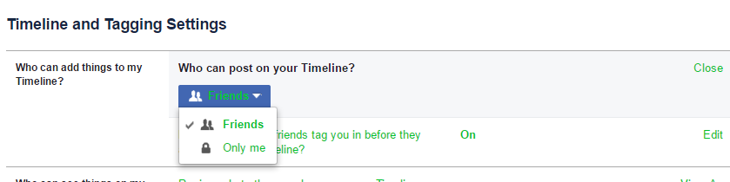
- Apply "Always Play Anonymously."
- Under the settings, click on apps on the left hand side of the page
- On “Always Play Anonymously” box click on Edit.
- Click on Turn on “Play Anonymously”
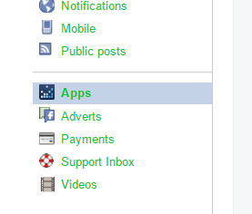

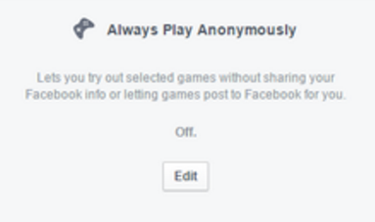
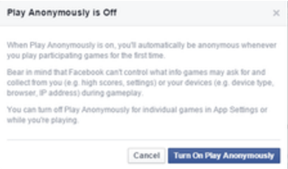

- Adjust "Ad Settings" to "No One."
- Go to settings
- On the left hand side of the page select adverts
- Click on advert settings
Under social tab, select "No One."
