Kelly Smith
MKTG325
3.19.2017

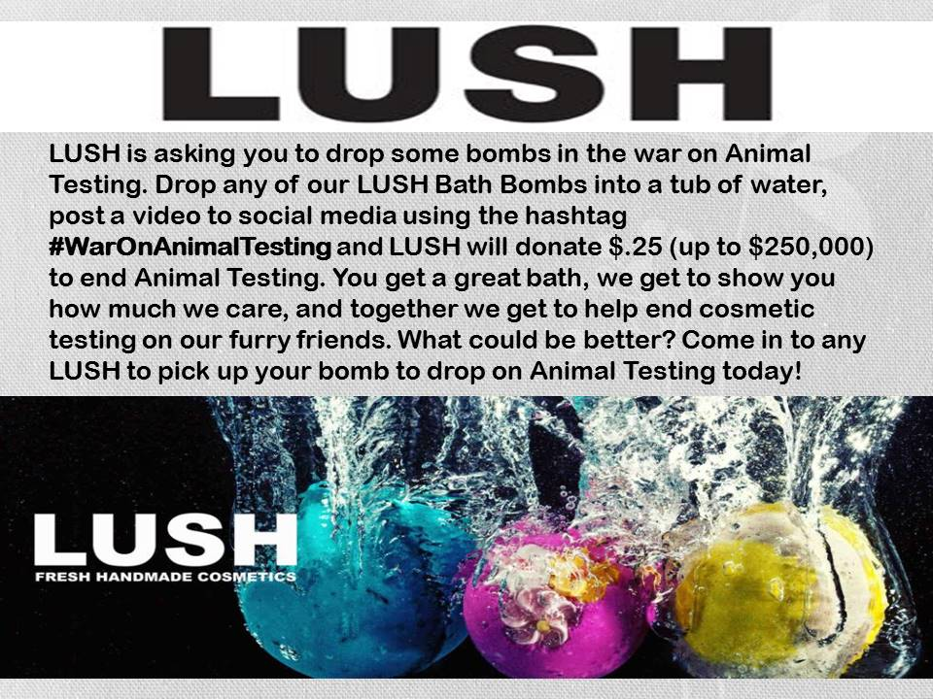

Summary: This digital ad will be placed all over all social media outlets. This will be the initial onset of the campaign and this ad will be placed on Google, Facebook, Twitter, Instagram, SnapChat, and in print for store signage. We will also be able to have some YouTube influencers to produce content for videos on this campaign to spread the message and way to participate. Once the ad has been placed we can implement the campaign starting on the specified date, running for a total of two weeks over the first two weeks of spring. This will coincide with our new spring bath bomb launch. The goal is to sell as many bath bombs as possible while helping a good cause and garner some exposure on our customer’s social media platforms to further brand recognition.

Our target market is socially conscious millennials with disposable income and a desire to help ethically responsible causes. These are in the median age group and have professional or well-paying jobs. Most of these will not have children and live and work in an urban area. It is important to this target market to help socially responsible causes and by linking our brand with a good cause we can increase our brand value with them. Using social media to allow them to participate will help create brand ambassadors and word-of-mouth advertising will spread due to this.

This ad will connect us with our target by directly teaming the company and the consumer up for a common goal and shared good. Not only does the company get to show our customer what is important to us ethically but they also get to try and then show off our products for us and feel good about being a consumer. Not only will they feel good about helping end animal testing all over the world but they can also feel good about the fresh, ethically sourced ingredients that we put in every product.

Once the campaign is underway and customers start posting pictures and videos using the hashtag more of their peers will want to get involved thus spreading the message and selling more product. Not only will the photos and videos draw attention to the campaign but they will also draw attention to the vivid colors and lovely actions of our bath bombs. The explosion of color as the bombs hit the water will pique interest and make people want to try the product even if it’s not in connection with this particular ad campaign.

An added layer of this will be to see if we can get the hashtag trending worldwide on Twitter and other media outlets. Possible news outlet coverage could help in this aspect and the higher we can get the hashtag to trend the larger and more successful the campaign will be. A trending hashtag has reached millions of consumers by the time it reaches the trending lists and with numbers like that how can we possibly go wrong? The trick to getting a hashtag to trend rests in participation. As an incentive to create buzz around the campaign the company could offer to donate additional funds to the cause if the hashtag trends.

LUSH could have a buy one get one free promotion to kick off the spring bath bomb launch and coincide with the “war on animal testing” campaign. Not only would this sell more products in the end but it would also encourage participants in the hashtag campaign to post more than one photo or video of their purchases.

Pitch:

“New spring bath bombs are arriving at LUSH Fresh Handmade Cosmetics and we want you to try them all! Come in to any LUSH location between March15 - 30, purchase one bath bomb and get a second bath bomb of equal or lesser value free. Mix and match any of our bath bombs including our year-round classics and location exclusives. Come stock up on bath bombs and help us fight against animal testing online! #WarOnAnimalTesting “

The above blurb would be paired with the digital ad campaign across social media and popular blog sites for maximum effectiveness of both sale and campaign. This buy one get one free promotion along with the social responsibility campaign during the spring product launch would not only reach but engage customers, spread brand recognition, and move product. The company politics, best ingredients and hand crafted products would draw new customers and then retain them.
All of these elements would come together beautifully to reach and keep our target customer. In today’s market place it’s not enough to have a good product. Millennials want good products made from good ingredients that are ethically sourced, that are not only good for them but also good to the environment. These are things that LUSH offers and this combination attack would adequately show off the product and our ethical nature as a company thus giving our millennial consumer what they want all around.

If we properly engage the consumers with this experimental approach the campaign (and in turn, the company and products) could end up trending world-wide on social media. Utilizing social media to connect the company with its target market is the key element in this campaign and is also the key in measuring its success. The real measurement metric of how successful this campaign is will be how high we can get the hashtag to trend world-wide.

This campaign could not only prove to be very successful in selling product and spreading brand recognition but it could also prove to be very helpful to the fight against animal testing and bringing attention to the issue. Since what is important to our customers is important to us we will make sure that the funds donated from the use of the hashtag be split up equally amongst non-profit organizations that fight animal testing.

By giving the consumers something to feel good about we are connecting the company image with that good feeling and that, along with the quality of the products, is what will end up driving repeat business. This combination approach would best saturate the market, hit our target demographic, and create the most good for the company, consumer, and the cause being supported.

Ref:
Johnston, E. (2016, May 18). 5 steps to understanding your customer's buying process. Retrieved from https://www.b2bmarketing.net/en/resources/blog/5-steps-understanding-your-customers-buying-process
Youssef, M. M., & Abdallah, H. A. (n.d.). Rise of Experiential Marketing in Emerging Markets. Ethical and Social Perspectives on Global Business Interaction in Emerging Markets Advances in Business Strategy and Competitive Advantage, 284-312. doi:10.4018/978-1-4666-9864-2.ch015
Easter treats are here! (n.d.). Retrieved March 19, 2017, from https://www.lushusa.com/

