Question 1
The tax rates are as shown. Your firm currently has taxable income of $83,200. What are the average and marginal tax rates? How much additional tax will you owe if you increase your taxable income by $24,600?
Taxable Income | Tax Rate (%)
$0 – 50,000 | 15
50,001 –75,000 | 25
75,001 –100,000 | 34
100,001 –335,000 | 39

For Question 1 use the following financial statements of Woodlands Inc.:
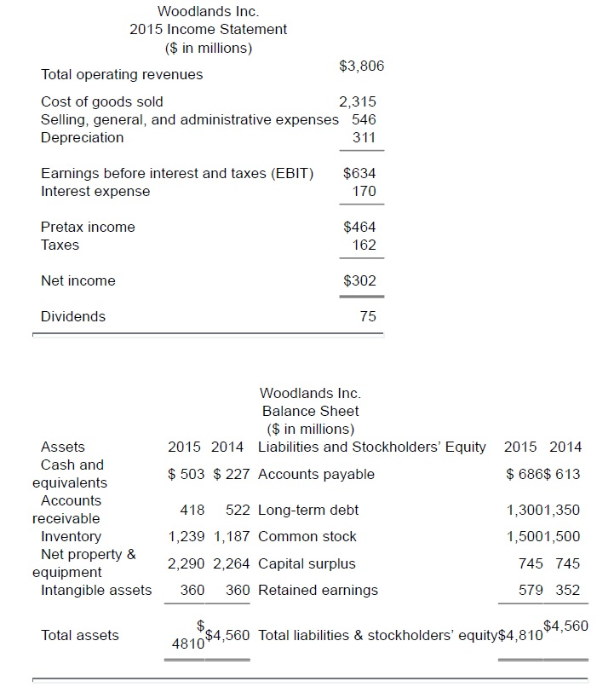
a.
What is the change in the net working capital from 2014 to 2015?

b.
What is the amount of the non-cash items for 2015?

c
What is the amount of the net capital spending for 2015?

d
What is the operating cash flow for 2015?

e
What is the cash flow of the firm for 2015?

f
What is the cash flow to stockholders for 2015?

g
What is the cash flow to creditors for 2015?

2) Seven years ago, Carlos took out a 30-year mortgage for $185,000 at 5.6 percent. He has made all of the monthly payments as agreed. What is his current loan balance?
Hint: You would have to first compute what the monthly payment is. Then figure out what the value of the remaining payment is after seven years.

3) Your employer contributes $50 a week to your retirement plan. Assume you work for your employer for another twenty years and the applicable discount rate is 5 percent, compounded weekly. Given these assumptions, what is this employee benefit worth to you today? Assume each year has 52 weeks.

