8.1 Rewind—Fast Forward
In this chapter you will discover how the developing EF networks of highest cognitive function in the prefrontal cortex, which undergo their greatest rate of change during the school years, can be strengthened when incorporated into learning experiences involving judgment, analysis, and other executive functions. This fortification of the EFs prepares students for solving as yet unknown future problems and for the opportunities ahead for individuals with the skill sets to guide creative innovation.
This chapter will also expand on what you learned in the previous chapters about constructing students’ long-term memory. You’ll discover the strategies that extend students’ rote memories into expanded neural networks of concept memory. When you provide opportunities for students to apply learning to novel problems and process learning with their executive functions, enduring understanding develops and extended networks of concept knowledge are created.

8.2 An Overview of Executive Functions
In several of the previous chapters, we discussed the prefrontal cortex (PFC). This area of the brain was defined as an area that completes higher cognitive functions, an area where we want information to reach. In comparison to other animals, humans have the largest PFC. It makes up about 20% of the brain’s volume, and does not fully develop until adulthood (see Figure 8.1). It is also one of the newly evolved areas of the brain. As previously noted, the higher cognitive functions completed by the PFC are referred to as EFs. Executive functions are a constellation of cognitive abilities that largely reflect a capacity to engage in goal-oriented behavior and include prioritizing, reasoning, organizing, making judgments, analyzing, focusing attention, and managing emotions.

Figure 8.1: Development and maturation of the cerebral cortex
The volume of an individual’s gray matter continues to increase into early adulthood.
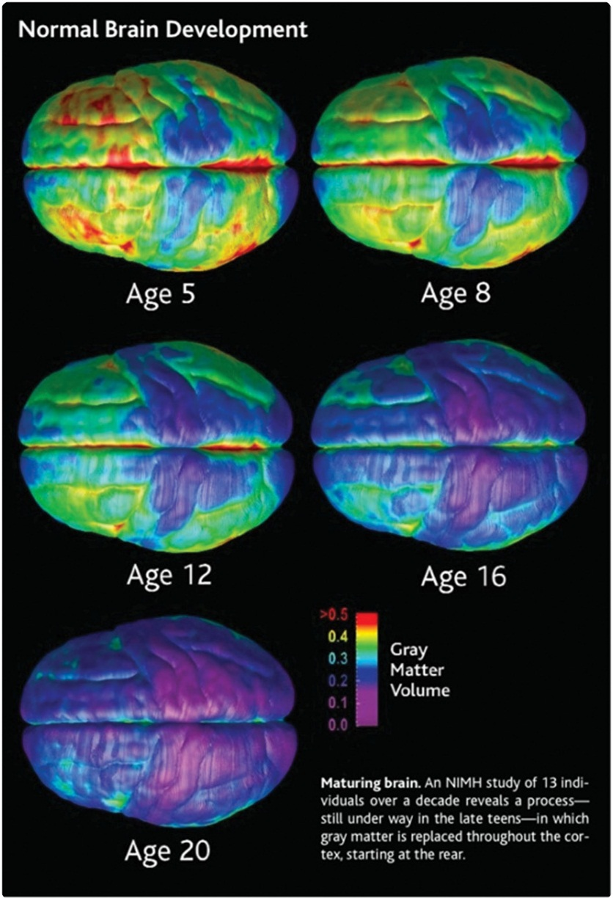
Source: Courtesy of Dr. Paul Thomson, USC Institute for Neuroimaging and Informatics.
The network of EFs is particularly important in learning because they are critical for a student’s success in the classroom and later in the workforce. It is also important to note that the PFC and the EFs are not fully mature until late adolescence. Although the PFC does go through rapid maturation during the school years, it is the last area of the brain to mature, and maturation is not complete until early adulthood (Gogtay et al., 2004). The exciting thing about the PFC and EFs is that new research is illustrating that these functions can be strengthened through activation and training (e.g., Diamond, Barnett, Thomas, & Munro, 2007; Moreno et al., 2011). As such, incorporating learning experiences that allow children to use their EFs can be a way to increase learning and their success as students and later in their careers as well.

8.3 The Executive Function System: The CEO in Residence
Executive functions are the control centers that are able to consider and evaluate input to and direct output from the PFC so responses are goal directed and reflective and not reactive. These networks are considered to be the chief executive officer or orchestra conductor that manages interpretation of new information and directs decision making; predictions; and cognitive, social, and emotional choices.
The neurology literature dating back almost a century has emphasized the importance of assessing the functioning of patients’ prefrontal cortexes by mental status assessments of the executive functions. Much of the focus in neurology research has been with the goal of evaluating interventions to restore or enhance these central components of human cognition that are damaged by degenerative conditions such as Alzheimer’s disease.
Humans are the only creatures who have the higher brain capacity to analyze our thoughts and reflect on our emotions and then act in accordance with interpretation of these experiences to achieve goals. This includes our unique ability to experience an emotionally stressful event and choose how to respond to it.
The EF networks direct our conscious responses and behaviors to areas throughout the brain. For example, to make predictions or decisions, the EF networks send out directives to scan memory storage throughout the brain’s cortex in an effort to gather prior knowledge that relates to the question or choice. These retrieved memories are brought back together in the PFC and nearby related regions such as the hippocampus, anterior cingulate, and medial temporal lobe (see Figure 8.2). Further communication among these areas, led by EF input, determines the final decision/response.

Figure 8.2: The executive functioning system
Your prefrontal cortex is continuously communicating with many other parts of your brain in order to see, read, and comprehend everything around you, including all the aspects of this textbook.
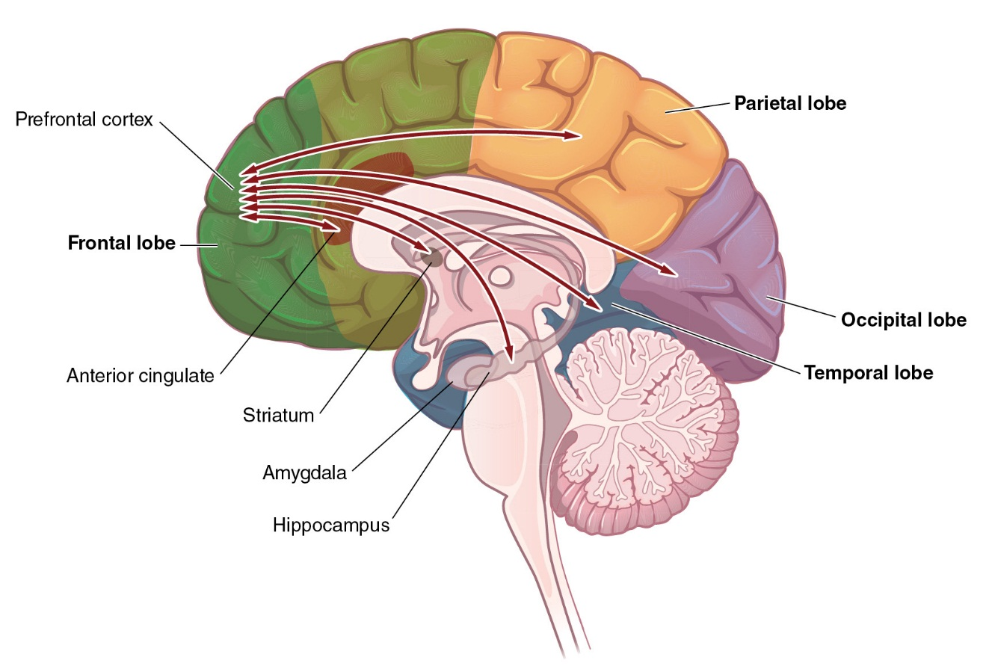
This section describes in greater detail the individual EFs, many of which are essential for academic and professional success in the 21st century. They are as follows:

Ask Yourself
Which of the executive functions do you feel are the most critical to a 21st-century workforce? Pick out the five you feel are the most important and explain your rationale.
- goal planning
- organizing
- prioritizing
- using judgment
- thinking flexibly
- analyzing critically (evaluating validity)
- reasoning (deduction/induction)
- focusing attention/inhibiting distraction
- controlling emotions

Goal Planning
Goal planning is actually a cluster of functions starting with setting goals and extending to strategizing and applying effort to achieve those goals. Success demands the ability to resist immediate gratification in favor of the goal-directed behavior, which is the ability to monitor one’s progress toward goal achievement and make adjustments as needed along the route in response to setbacks or new information.
When students are beginning to build this executive function, they have limited experience setting realistic and manageable goals. They will also need guidance to sustain their goal-directed motivation and effort. Your scaffolding, guidance, and frequent feedback about the ongoing incremental progress they make as they apply effort en route toward their larger goals strongly influences their perseverance and success.
Goal planning can be done in two different ways. Students can set process goals, which focus on the individual steps to achieving the overall goal. In contrast, students can set outcome goals, which focus on the overall goal, or the outcome. For example, if you have a goal to be an A student, this would be an outcome goal. The steps you would complete along the way to achieve this goal would be the process goals. You might then set a process goal of studying for 1 hour a day. Or you might set a goal of attending all classes. Achieving these process goals will help you reach the overall goal of getting an A. Many students are able to set the outcome they desire, but they have a hard time understanding the steps that it will take to reach that goal.
In an examination of process goals versus outcome goals, Kitsantas, Reiser, and Doster (2004) reported that 9th- and 10th-grade students assigned to a process goal group showed higher performance on animation skills than students assigned to an outcome goal group. Additionally, students in the process goal group were found to have higher self-efficacy. The researchers interpreted this as providing support for the idea that students who focus on process goals have enhanced performance and attitudes as a result of focusing on learning the various steps of a skill. It should also be noted that the participants in the process goal condition rated the quality of instruction more highly, suggesting that students appreciate guidance about building and achieving goals. This study and other research like it (e.g., Kitsantas & Zimmerman, 1998; Zimmerman & Kitsantas, 1997) highlights the need to help students set appropriate process goals as they are learning new information.

Organizing
Organizing is an executive function that some children develop while quite young, as seen in their behaviors to sort their toys or to develop patterns and routines of daily behaviors such as getting dressed or bedtime preparation. For other children, developing these behaviors is elusive, and they may enter school unprepared to successfully engage in activities that require organization skills, such as the placement of items in the classroom or the routine of daily activities.
Successful organization is needed for the preparation and completion of most activities related to school, and the development of this executive function becomes even more critical when the responsibilities and requirements increase as students are required to organize not only daily homework but also projects and plans for extracurricular activities. Anderson, Munk, Young, Conley, and Caldarella (2008) report that disorganization can become a problem for children after they enter elementary school. This is because teachers’ expectations grow and supervision decreases. Another area where disorganization may be a problem for students is in the online environment. Here, students have the least amount of supervision and are likely to have trouble organizing the important information on their own. The importance of organization can be seen in research. In a study of cumulative GPA in college students, it was noted that long-term planning was associated with a higher GPA (Plant, Ericsson, Hill, & Asberg, 2005). The authors report that careful organization associated with long-term planning supported a more focused approach to studying.

Prioritizing
Prioritizing involves determining hierarchies of importance and separating information or material based on relevance and time requirements. Prioritizing also involves managing time effectively to make sure that the appropriate tasks are completed and that more or less time is allotted to tasks that are more difficult or less difficult. However, prioritizing can also be looked at as a task-specific concept, whereby students need to prioritize information to be able to effectively solve problems. This type of prioritizing might include determining which information in math word problems is extraneous, and what information is needed to solve the problem. Similarly, in reading, prioritizing involves the ability to recognize main ideas and essential characters and give this information more attention than lower-relevance details. In this type of prioritizing, individuals use their working memory to keep important information in mind and work on it with respect to more incoming information.
Prioritizing also increases in necessity as school years progress and long-term projects and reports become more prevalent, while students are also diversifying and taking on more social, athletic, club, and community activities. The development of prioritizing skills during the early school years is critical for time management in higher levels of education or employment, when monitoring decreases and routines vary constantly.
Helping students build their prioritizing skills includes guiding them to recognize main ideas in sentences and then in paragraphs, discerning which facts are consistent with the larger pattern of concepts and selecting the strategies they find most efficient for the use of their time and effort.

Using Judgment
The use of judgment is necessary for successful navigation of social and emotional choices and decisions, as well as for evaluating academic information. Judgment is the characteristic by which children evaluate the meaning and importance of comments, expressions, and behaviors of peers and teachers. Judgment is also used when students evaluate their academic decisions and responses to open-ended questions. Tools that build up judgment include estimating, self or peer editing, and evaluating what information is most valuable and important to study for tests or include in papers and projects. Judgment is also the trait that needs to be developed so that students are able to assess and monitor their own attention and emotional states and to handle conflict and ethical dilemmas.
The development of judgment is also influenced by culture and past experiences. Weber and Morris (2010) report that living in a particular culture creates many different schemas, categories, rules, and procedures that get associated in memory. These representations then guide judgment when they become activated during problem solving. As such, they may guide attention, or the search for evidence. Recognizing how a particular culture may influence or guide your students’ judgment process can be helpful in guiding them toward more effective judgment.

Analyzing Critically (Evaluating Validity)
Analyzing is another multifaceted executive function. Critical analysis is the capacity to recognize when a first or automatic response is indeed the best or complete response or the most appropriate action to be taken. Analysis also includes evaluating situations to determine the meaning of questions, what information needs to be gathered, what resources are needed to achieve success, and where to find the most valid sources of information.
With the increasing variety of sources, analysis also includes comparing multiple sources of information and synthesizing this information into coherent understanding.
Interpreting source bias or accuracy is increasingly critical as it becomes increasingly challenging for students to evaluate the blurred margins between fact and opinion in articles, in books, on the Internet, or heard on the nightly news. Successful analysis includes the ability to select the best sources of evidence or information and then to evaluate the validity.

Reasoning (Deduction/Induction)

Sasty Photo/SuperStock
What deductive and inductive reasoning strategies could an individual use to test predictions about why oil floats on top of water?
Reasoning represents one’s ability to interpret information and think logically based on prior knowledge, new information, pattern expectations, and deviation from expected patterns. There are two primary forms or reasoning: inductive reasoning and deductive reasoning.
Inductive reasoning is the ability to recognize or construct the rules or concepts gleaned from existing information. Inductive reasoning includes evaluating the rules that appear to apply to situations or information and using those consistencies or rules to make accurate predictions or responses in the interpretation and use of the information. An example is the use of trial and error to test a predicted rule based on the information available, such as by evaluating what items are responsive to magnetism by testing a magnet on a variety of materials.
Deductive reasoning relies on the activation of patterns from stored existing prior knowledge to predict new rules and appropriate responses to new information or situations perceived as similar to these past experiences. For example, when reading a new word, the brain is responsive to aspects of the word that are part of patterns from prior knowledge. On seeing the new word “pedestrian,” the brain will seek familiar patterns and recognize the prefix “ped” from a word like “pedal” and activate the concept of “foot.” With further context cues, deductive reasoning can consider that the new word can relate to “foot,” as in “walking.”

Judy Willis on Inductive vs. Deductive Reasoning

Thinking Flexibly
Thinking flexibly, or cognitive flexibility, is the capacity to be not only tolerant, but also receptive and open-minded to new experiences, unfamiliar customs, variations of opinions and interpretations, alternative points of view, and multiple approaches to problem solving. Diamond (2006) describes this as the ability to switch perspective or focus of attention. As students build this flexibility of thinking, they grow in their proficiency at predicting a variety of possible outcomes in response to choices or decisions and at considering which might be their best option. In addition, this flexibility allows students to be open to new or changing data and multiple perspectives, and to adjust their choices, answers, or predictions in response to the additional information.
This is another area where culture can come into play. Recall that culture will influence schemas, categories, or rule sets that individuals have in mind. Cultures that promote obedience or rule following may lead children to be less flexible in their thinking. Rather than adopt a new strategy, they may tend to be more set in their ways. However, having a good understanding of culture and cultural differences can lead individuals to be more flexible in their thinking.
Ang et al. (2007) examined cultural intelligence in undergraduate students. Cultural intelligence is the ability to grasp, reason, and respond effectively in culturally diverse situations. The results from Ang et al. (2007) illustrated that cognitive abilities like being able to question and adjust schemas and prior knowledge of cultural schemas are important for exhibiting flexibility in culturally diverse situations. Maddux and Galinsky (2009) also found increased creativity in individuals who had lived abroad. In today’s global marketplace as well as culturally diverse classrooms, these findings are important to consider. Promoting knowledge of other cultures can help your students adapt and think flexibly when they are in situations that are culturally diverse.

Focusing Attention (Inhibiting Distraction)
In Chapter 2, attention focus was emphasized with regard to the role of the attention filter, or reticular activating system (RAS). Until executive functions are developed, children have very limited ability to voluntarily control what information is accepted in through their attention filters, just as they have limited ability to block the sensory input of distracting data.
As executive functions, such as those that promote goal development and achievement, are practiced and increased in strength, students develop more ability to use “top-down” control (see Chapter 2) such that they can influence what sensory input is accepted through the attention filter and block the flow of distracting data. Strategies that help build students’ abilities to intentionally focus attention and inhibit distraction have profound influence on their success in school and far beyond.

Controlling Emotions
Chapter 4 emphasizes the impact of emotion on how the brain processes information. With the development of the executive functions of emotional self-awareness and control, students become more successful at recognizing their emotional states and using strategies they learn to avoid the high stress levels that hijack the successful flow of input to and output from the prefrontal cortex. See Table 8.1 for examples of interventions and outcomes.

Table 8.1
Executive Function Deficit→ | Possible Intervention→ | Neuroscience→ | Intended Outcomes
Failure to organize materials, time, effort, or rules | - Modeling and scaffolding  - Promote awareness of organization in readings, the classroom, classification systems  - Require students to use calendars and other organizational techniques  - Use estimation and prediction | - Circuits between the prefrontal cortex and the striatum that mediate planning and skill learning are reinforced  - Increased practice on tasks, can lead to increases in dopamine to the prefrontal cortex improving the ability to organize and plan | - Students understand organizational techniques and how to implement them with respect to classroom material and daily life  - Students use organizational techniques to help them effectively meet deadlines and keep track of their work
Failure to effectively use judgment, decision making, reasoning, and flexible thinking | - Have students evaluate the criteria they use to make choices  - Practice using classification  - Ask open-ended questions  - Promote self-reflection and perspective taking | - Brain areas involved in cognitive control are strengthened | - Students understand strengths and weakness in their strategies and improve on weaknesses  - Students develop conceptual understanding of different principles and are able to adapt to new information Students get an opportunity to practice reasoning and practice defending reasoning  - Students recognize their ability to be flexible and take the perspective of others
Failure to regulate emotions | - Meditation exercises  - Classroom discussions that focus on self-regulation and self-reflection | - Brain pathways between the prefrontal cortex and amygdala are strengthened  - Better control is seen when the prefrontal cortex is able to inhibit impulsive responses from the amygdala | - Students learn the ability to calm themselves in emotional situations  - Students develop emotional control and communication skills
Emotional control might relate to things like delay of gratification or recognition of the consequences of actions. Research into executive functions suggests a link between executive functions and social-emotional development in children (Riggs, Jahromi, Razza, Dillworth-Bart, & Mueller, 2000). Improvements in other executive functions, such as focused attention, might help improve emotional control.

Negotiate the Globalized and Digitized World
Globalization and technology continue to change the knowledge and skills needed by the students who will lead us in the coming decades. Information is increasing at an algorithmic rate and the speed of media access is simultaneously accelerating. Availability of new information, changes in “facts” provided by more sophisticated tools of analysis, and technological innovations are rapidly increasing.

Ask Yourself
You’re reading about an increasingly digitized world in this e-book. Do you think that e-book reading accesses different EFs than reading from a conventional hardcopy text? If so, how? If not, why?
The increased information availability is accompanied by a lack of source accountability. Strong executive function networks serve to help individuals effectively think through what they know. To be ready for college, workforce training, and life in a technological society, students need the ability to gather, comprehend, evaluate, synthesize, and analyze a high volume and extensive range of media.
As technology evolves, if a job can be automated or done by computers, it will be. To be competitive in the job market, students need to do what computers cannot do, such as conduct original research, innovate, solve problems, and communicate clearly verbally and in writing.

8.4 The Prefrontal Cortex: The Executive of Executive Functioning
The control center that directs the brain’s executive function is in the prefrontal cortex. Humans’ brains have the largest prefrontal cortex (PFC) by volume of all animals. This 20% of high-value cortical real estate contains the networks that direct the advanced systems of executive functions. Although the brain’s most rapid growth spurt occurs during gestation followed by a second period of accelerated growth between ages 2 and 4, it is during the school years that the prefrontal cortex undergoes its significant structural changes as it goes through its rapid maturation phase (see Figure 8.3).
However, emergence of executive functions occurs much earlier than the school years. In a series of studies, Diamond (1988, 1990, 2006) has shown that the ability to goal plan and inhibit emerges between 8–12 months of life. This example illustrates that by the time students reach school, they have had a multitude of experiences with executive functions. How skilled their executive functions are will depend on a combination of genetics and experience. Hughes and Ensor (2009) suggest that genetics is likely to have a more general effect on ability, but experience is more likely to have specific effects. Moreover, change can be understood through looking at experiences.
Recall from Chapter 6 that the brain has tremendous ability for neuroplasticity. It was once thought that the first 3 years of life were critically important for directing the development of the brain; however, it is now known that experiences can help direct the development at any age (see Bruer, 1999, for a review of the myth of the first 3 years). To understand how you can be an effective force in the change of the development of executive functions, it is important to continue to consider how the brain changes during the school years.

Figure 8.3: Timing of synapse and dendrite formation in areas of the brain
The synapses and dendrites of the prefrontal cortex keep growing after childhood and continue to change throughout an individual’s life.
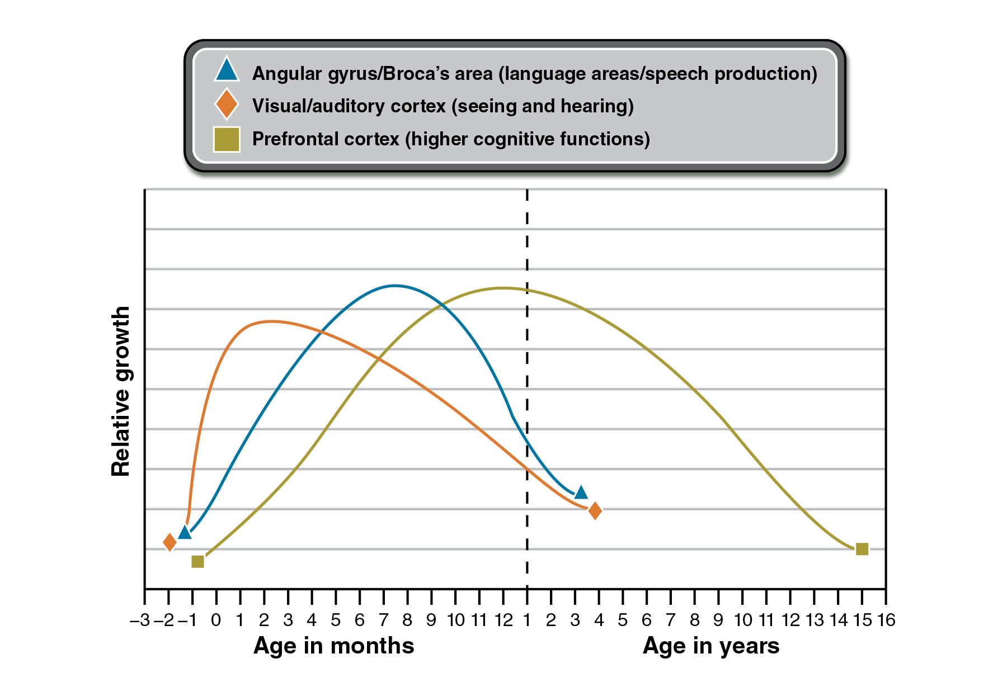
Source: Thompson, R. A., & Nelson, C. A. (2001). Development science and the media: Early brain development. American Psychologist, p. 8.

Neuroplasticity Throughout the School Years
The changes of maturation in the brain take place first in the posterior and lower regions of the brain (the more basic function areas), essentially following the progression of the evolutionary developments of animals. The more primitive brain centers in the lower and posterior brain are vital for animals to evaluate and react to rapid changes in their unpredictable environments.
Humans depend less on those primitive survival abilities and rely more on the higher cognition that takes place in the prefrontal cortex that is the last part of the brain to go through its maturation phase. Although the brain is 98% of its full size by age 6, and neuroplasticity takes place throughout life, the most rapid neuroplastic changes in the PFC take place during the school years. During these years, there are particularly accelerated periods of thickening of both gray matter (the branching dendrites of the neurons and the synaptic connections they form) and white matter (fatty myelin sheaths that insulate the axons) in the prefrontal cortex (Giedd et al., 2004). More myelin results in faster speed of transmission of messages along the circuit as the electrical depolarization now jumps along the axon instead of having to travel along its full length (Giedd, 2008).
Maturation in the brain increases its efficiency. This involves both the pruning away of networks that have not been frequently activated and the strengthening of the networks that are most frequently activated by use. Pruning adds to the efficiency of the neural networks that are active because the unused circuits are eliminated, with more energy available to those in use. This pruning and strengthening is highly defining of the skill sets students bring with them into adulthood. The end of the accelerated maturation phase does not mean that further change does not occur. During these rapid maturation years, the neuroplastic activity response appears more intensified. However, neural networks change in response to use throughout life.
Unlike the physical maturation going on in students’ bodies, their networks of executive functions and emotional controls will not develop to their maximum potential passively. The brain’s rudimentary executive-function neural circuits need experiences during the school years to promote their activation and strengthening. In a review of interventions to increase EFs in children, Diamond and Lee (2011) noted that EFs need to be continually challenged in order for improvements to be seen. When difficulty on tasks does not increase, EFs will not increase. Additionally, they report that executive functions should be worked on throughout the day. Diamond and Lee concluded their review by noting that the best interventions for EFs will be approaches that address students’ interest, bring them joy, attempt to solve problems in their lives, include vigorous exercise, and bring students a sense of belonging and acceptance.
Executive function activation in young children is linked to increased school readiness, attention, memory, literacy, and numeracy (Blair & Razza, 2007). Executive function activation throughout the school years is associated with increased social, cognitive, emotional, and academic success, as well as preparedness for vocation and higher education success.
Executive function networks, like other neural circuits, are strengthened by use through neuroplasticity. Left to its own rate of maturation, the brain’s circuits of judgment, prioritizing, and resisting immediate gratification do not reach high efficiency until the mid-20s, when it may be too late to take maximum advantage of educational opportunities under the mentoring of teachers. Additionally, it has been speculated that because a period of synaptic reorganization occurs during puberty, this might be a sensitive period for the interventions to promote greater development of executive functions, such that incorporating executive functions into the brain after the networks have matured would be more difficult (Blakemore & Choudhury, 2006). Recall from Chapter 1 that a sensitive period is a specialized time when learning a skill is easier.

The Roles of the PFC
Executive functions are mediated by the PFC, but they require the input and output of other brain areas to function correctly. The PFC is connected (either directly or indirectly) with a wide variety of brain structures. This connectivity allows the PFC to have a unique role in collecting and integrating different sources of information (Tnaji & Hoshi, 2008).
One of the connections that is important for many executive functions is the connection between the PFC and the striatum. The striatum is a structure in the basal ganglia (refer back to Figure 8.2). It was once thought that the basal ganglia only played a role in voluntary movement; however, more research into the area has illustrated that the basal ganglia also play a role in cognitive and emotional functions (Kandel, Schwartz, & Jessell, 2000). Leh, Petrides, and Strafella (2010) reported that the frontal-striatal system was involved in planning, skill learning, and the ability to modify behavior in response to the changing environment or changing goals. Kandel, Schwartz, and Jessell (2000) note in animal research that dysfunction in the PFC and its connections with the basal ganglia often leads to disorders of action and not sensation or perception. In this case, an individual is able to appropriately sense and perceive the world around him, but initiating the appropriate response to the environment is impaired. For example, a student may know that he needs to study for an upcoming exam; however, he is unable to appropriately prioritize time and organize information needed to initiate studying behavior.
Neurodevelopmental data indicate that maturation of the brain involves changes in the frontal-striatal system that are associated with changes in executive functions. Luna et al. (2001) recorded fMRI activity of children (8–13 years), adolescents (14–17 years), and adults (18–30 years) performing a task that required them to suppress reflexive eye movements toward a light. The task measured the ability to voluntarily suppress information that is irrelevant and interferes with current information processing. Results indicated that activation in the striatum appeared in adolescents and adults, but not in children. It is suggested that this activation represents the development of the frontal-striatal system that allows adult-like control of behavior. In comparison to adults, adolescents also showed increased activation in the prefrontal cortex, indicating a greater reliance on frontal systems in controlling behavior, while brain activation in adults was found to be more efficient. Results also indicated that children activated a number of brain areas responsible for suppressing behavior. Luna et al. (2001) suggest that while activation in brain areas occurs early in life, the lack of connectivity between brain areas makes it difficult for them to integrate activity and successfully control behavior. As a result, they are unsuccessful on tasks that require behavioral suppression. However, as the brain matures and areas become more connected, more adult-like behaviors are noted.
Another important function of the PFC is its connection to the limbic system, which includes the amygdala (Tnaji & Hoshi, 2008). You were first introduced to this connection in Chapter 4, when we discussed the role of emotion in learning. Recall that the reactive amygdala can either send information to lower brain areas or it can send information to the PFC. Decreased activity in the amygdala and increases in positive emotion increase the likelihood that information will reach the PFC. However, the PFC also has the ability to send input to the amygdala and inhibit its response. Consider, for example, a response to a fake snake. If you see a fake snake, you are likely to experience fear as a result of activation of the amygdala. After more consideration of the snake, though, your PFC will be able to determine that it is in fact fake, therefore calming the amygdala and inhibiting the fear response. This inhibitory relationship is necessary for the proper control and regulation of emotions.
Additionally, the PFC cortex uses a number of neurochemicals for optimal functioning. One particular group of neurotransmitters that has been found to be important for PFC functioning is the catecholemines. The catecholemines include neurotransmitters such as norepinephrine and dopamine. Depletion or excessive amounts of dopamine and norepinephrine in the prefrontal cortex have been found to have detrimental effects on performance. Arnsten and Pliszka (2011) describe an inverted U function for norepinephrine and dopamine in the PFC, such that low levels of dopamine and norepinephrine lead to a fatigued state, while moderate levels produce optimal arousal levels and high levels lead to a stress state. In both the fatigued and stressed states, executive functions will suffer. However, optimal levels produce optimal performance. The described relationship is supported by several lines of research (Cools et al., 2007; Kayser et al., 2012).

Executive Functioning Deficits
The importance of training and developing EFs becomes clear when reviewing research that illustrates negative trajectories for individuals with problems in EFs. Although there is no DSM diagnosis of an executive function disorder, increasing concerns from parents, teachers, and professionals has led to increased exploration of EFs and their role in a child’s success. Children who have problems with EFs tend to be characterized as lazy and unmotivated. Their forgetful behaviors combined with trouble regulating moods are often seen as deliberate (Hosenbocus & Chahal, 2012). In some cases children like this meet the criteria for disorders such as attention deficit and hyperactivity disorder (ADHD) or autism, or have suffered some sort of trauma to the frontal lobes.
ADHD in particular has been associated with serious deficits in EFs. EFs affected by ADHD include goal setting, planning, persistence (Johnson & Reid, 2011), and impulse control. In light of these findings, Johnson and Reid (2011) suggest that teachers should work directly with individuals with ADHD to help them employ strategies that will improve their goal setting, planning, and persistence on tasks. Hosenbocus and Chahal (2012) point out that using traditional behavioral management techniques, such as rewards and punishments, has not been as successful with children with EF deficits. As a result, it is important to recognize EF deficits and implement appropriate strategies for improving those deficits.
Some individuals who have sustained frontal lobe injuries may not display deficits on intelligence tests; however, their day-to-day functioning can be impaired (Shallice & Burgess, 1991). These individuals typically get labeled as having “dysexecutive syndrome” because their primary impairment is in the executive functions. Behaviors associated with dysexecutive syndrome include the inability to stop and modify behavior when stimuli change; inability to handle sequential information that is needed for organization, planning, and problem solving; impairments in working memory; a lack of self-awareness; and trouble inhibiting responses (D’Espisito & Gazzaley, 2005).
Frontal lobe deficits such as these are often looked at as disorders of intention because the individual is unable to initiate the correct behavioral response. Others around the affected individual often feel that the behavior is deliberate. However, it is important to note that the lack of behavioral initiation occurs as a result of biological changes in the brain. Just as an individual cannot simply stop being depressed, someone with EF deficits cannot simply start initiating goal-directed behaviors. Instead, these individuals will need to be treated with different strategies to help them overcome the deficits.

Meeting the Needs of Individual Learners: Executive Functioning
Many parents come to professionals for help with their children who are experiencing behavioral and emotional issues in and out of the classroom, such as impulsivity, difficulty completing homework and managing their schedules, inattention, poor self-control and planning, and difficulty with organization. These behavioral issues, often described as problems in executive functioning, may have a variety of causes, such as trauma, a learning disability or developmental disorder, or deeper psychological concerns. Most kids will act out and display some type of behavioral disinhibition throughout the years. However, children with poorer executive functioning demonstrate these behaviors more consistently and frequently and also exhibit more symptoms both in and out of the classroom.
Think back to your teenage years—what risks did you take? Would you engage in the same behavior now as an adult? The answer is probably no. As a teenager your prefrontal cortex, the area of your brain responsible for making important decisions, was still developing and therefore perhaps not fully equipped to handle the task. Additionally, the nucleus accumbens, the pleasure-seeking reward center that is implicated in risky behavior, is also developing during this time (Thayer et al., 2012). This makes sense considering that children and adolescents often seek pleasure, engage in activities that produce rewards, and enjoy the rush of that “feel-good sensation” even more frequently than adults do.
As their executive functions become more challenging to manage, students can fall further behind in school, and their social and family lives can become isolating and unsupportive. Additionally, children who have problems with executive functioning are more likely to have a learning disability or ADHD. The best approach when working with these children is to personalize the strategies and techniques to meet their individual needs, knowing that not all children will respond to the same strategies. When these individuals act out, refrain from making judgments and be supportive and consistent. Provide specific and concrete examples of how they could have made a better decision or handled a situation more appropriately. Then, when they engage in a more positive way, reinforce that positive behavior and encourage them to do it again. Find the individual’s strengths. Set an example by modeling appropriate organizational strategies and teaching them to the individual, such as using a calendar or electronic device to manage time and activities. Color code folders to organize homework and create a specified workspace for studying and schoolwork. Becoming more organized and keeping a schedule will help these individuals gain some control over their daily lives. Teach these individuals self-regulation and encourage mindfulness and exercise. Be patient with these individuals, and make sure to speak to your children, students, or clients about their difficulties in order to allow them to feel heard and validated. Most importantly, help these individuals become more in tune with and more appreciative of themselves—regulated or not.
Joanna Savarese, Ph.D.

8.5 Teaching That Strengthens Executive Function Networks
The key to maximizing students’ mental potentials is to activate and exercise the neural networks of executive functions, especially during their growth spurt in school years. Correlations between neuroscience research and learning offer insights about the conditions that promote activation of the EF neural networks in the prefrontal cortex.
It is not what our students learn, as much as what they can do with what we teach them, that needs to be the primary focus of designing units of study and carrying out instruction. This section offers guidance for planning of learning experiences enriched with instructional strategies that provide opportunities to activate executive functions by offering situations for learners to apply these highest forms of cognition.
The shift toward applying more executive function (EF) within learning and assessment does not eliminate the need for memorization, as automaticity and solid, accurate foundational knowledge are necessary underpinnings for most domains of knowledge. However, memorized facts, procedures, and algorithms are inadequate preparation for students to be able to transfer learning to applications beyond the test and classroom.
You can extend students’ learning to transferable wisdom and build their highest cognitive networks by providing opportunities to apply EFs to learning, especially through authentic, personally meaningful activities, inquiry, and project-based learning. Students need to be explicitly taught and given opportunities to practice using their executive functions to plan ahead, anticipate consequences, organize, prioritize, compare, contrast, participate in open-ended discussions, synthesize information from a variety of sources, make judgments, support their opinions, and communicate clearly.

Goal Setting
Self-control and self-regulation are the key factors in goal setting and achieving. These abilities increase when students have opportunities to practice retrospective and anticipatory thinking, including setting goals, tracking progress toward them, adjusting strategies along the way, and assessing outcomes.
For students to engage in independent, purposeful work toward goals, you must communicate the clear and desirable goals of each unit and topic of learning. Students are more likely to engage responsively as self-directed learners when they know they will do something desirable with the information. Student-centered and project-based learning that students consider valuable and relevant increases their willingness to take on the challenge of new learning. “Student-centered approaches to learning require students to be self-directed and responsible for their own learning” (Wiggins & McTighe, 2008). To be successful, these student-centered approaches engage and activate executive functioning skills such as goal setting, planning, and monitoring progress.

Effort-to-Goal Graphs
Perseverance through setbacks and challenge is necessary for students to sustain effort toward long-term goals at a time of brain development when their drive is stronger for immediate gratification. As we discussed with regard to the video game model, motivation and perseverance increase when students believe that their effort will progressively lead to goal achievement. Effort-to-goal graphs, described in Chapter 4, help students build their own goal-directed behavior patterns by selecting the progress points they want to achieve en route to the final goal. Goals can range from time spent preparing for tests or number of answers correct on spelling tests, to progressing up rubric levels of proficiency in any subject.
For students to build the skills needed to become self-directed, they need to have experiences evaluating realistic goals and adjusting them as needed. Using the effort-to-goal graphs, students can create their own process goals en route to the larger outcome goal and use small Post-its or write in pencil when they believe they can reach each goal subdivision. As they progress, they will be able to examine the accuracy of their projections and revise subsequent goal achievement dates and strategies accordingly. This opportunity for goal and strategy reevaluation should be recognized by students as part of building their skill set of self-direction responsibility, rather than as signs of failures.
The effort-to-goal graph can also help your students understand the value of effort and hard work in school versus the value of an A grade. If students receive poor grades, this might lead them to believe that they have a lack of ability. Dweck (2008) reports that a belief in a lack of ability decreases student motivation. However, when students believe that their lack of effort leads to poor performance, they are more likely to continue trying when problems get tough. As a result, success in the classroom can be improved by focusing on individuals’ efforts toward their goals.
Dweck’s work also suggests that changing student mindset by focusing on effort can promote future success. You were first introduced to this work in Chapter 4 when we discussed growth mindsets versus fixed mindsets. Dweck (2008) reports that students with growth mindsets are destined for better academic outcomes because they hold the belief that intelligence is developed through education and effort, not a fixed trait. They believe that putting forth effort will increase their learning (Blackwell, Trzesniewski, & Dweck, 2007; Grant & Dweck, 2003). In contrast, students with a fixed mindset believe that having to work hard means that they are not as smart as their peers. They avoid challenges because they are afraid that failures indicate a lack of ability. The effort-to-goal graph provides students with that opportunity.
Another way to encourage effort and change mindset might be to focus on areas outside of the classroom. If students learn that effort in other areas, like athletics, performing arts, chores at home, work, etc., pays off, they will be more likely to transfer these ideas to the classroom. As such, students could be encouraged to use effort-to-goal graphs outside of the classroom as well. Additionally, Dweck’s work can be applied in other settings outside of the classroom, including the workplace, counseling, or parenting. The main idea is to encourage and reinforce effort to promote achievement in an individual.

The Brain at Work
Effort-to-goal graphs can also be used to motivate employees on the job. The graphs would be altered in format to measure progressive improvements in the action or behavioral response that is the goal. For example, if the goal is to recognize a greater percentage of the items on an assembly line that are not up to standard, the employee would be given suggestions to increase that attentive focus, and the graph would measure the likely increase of below-standard items appropriately removed from the assembly line. Another example would be to promote staff to take the hand-washing, cough-covering, and other hygiene procedures to decrease spread of infection with documentation of the improvement in work attendance (decrease in sick days). And motivation to engage in these programs could be an increase in “personal days” when full staffs reach the goal of reducing sick-day absences.

Discuss Setbacks
Having discussions about frustrations and setbacks will also help students build their goal-directed perseverance. Share your own experiences about goals you set for yourself that caused you to have frustration and even to give up temporarily along the way. Explain how you felt at these frustrating times and the strategies you used to persevere. Remind students of their own successes where they went through previous struggles and setbacks and how they ultimately achieved goals, such as in athletic skills, playing musical instruments, and learning how to read. Remind them of famous people who set goals for themselves and persevered despite setbacks. President Lincoln lost more elections than he won, but ultimately achieved his goal of being president and effecting the policy changes that were his goals.

Journal for Self-Awareness
Self-awareness is also a skill set that will promote goal-directed behavior, especially for students who are frequently deflected from what they need to do to achieve their goals. For example, if it is the goal of students to do their homework when they first return home from school, to organize their long-term projects and stick to the schedule, or to begin studying for major tests days or weeks before the exams, have them write down what happens just before they go off of the goal track. If students with the goal to begin homework right away answer their phone whenever it rings or always immediately respond to texts they receive, they can realize that receiving communication from others is the prompt that gets them off task because they then respond to the communication. They can then brainstorm interventions, such as not studying with their phone beside them, turning off their cell phone, or limiting their access to other social media.
This procedure can be used in the workplace too. Employees might journal about things at work that distract them, such as co-workers talking, surfing the Internet, emails, etc. Individuals cannot change behaviors that they are not aware of, so having them journal to increase awareness provides an opportunity to discover what needs to be changed.

Organizing
To build organizational executive functions, students need opportunities to recognize all goals and how they will be assessed, and to participate in the planning of how that will achieve success. You will promote this organizational practice by emphasizing the goals of each instructional unit and building their skills at recognizing the core concepts and gist of information to hear, see, or read. Continuing to emphasize these goals throughout the unit will help students’ brains continue to pattern incoming information as it relates to the core topics of the unit.
Organizing is also developed when students organize their time, resources, and effort with regard to procedures they need follow. These can be from behaviors for what students do when they enter class, return from recess, transition between classes, gather or replace materials, set up teams and positions for playing sports, and organize materials for projects.

Modeling and Scaffolding
Building these organizational skills starts with strong modeling and scaffolding and increasing students’ awareness of what you are doing to promote their organization. Modeling refers to you engaging in the activity to show students how to complete it, while scaffolding, as defined in Chapter 3, refers to the process of providing different levels of support for students as they learn a new task. To begin, explain how you’ll be gradually giving them more and more opportunities to take over their self-organization. Initially when providing organizational strategies, emphasize them verbally, giving clear instructions for procedures, projects, or class transitions and provide them also in writing. Modeling will also help here.
Stopping between segments of complex or multipart instructions is useful to allow students to ask questions and to ask students to repeat back their understanding of the instructions. Having selected students model the procedures you describe, such as the right way and the wrong way to organize class teams for sports or academic events, will provide yet another opportunity for students to become successful at the organizational task at hand. Some students will be able to pick up on organizational strategies quickly, while others will take longer. Here is where scaffolding comes in. You can provide additional examples or opportunities for practice for individuals who are having trouble.

Prompt Recall of Existing Knowledge
Promote student awareness of their existing organizing skills by asking questions such as these:
- How do you sort your music on playlists?
- How do you find and sort art materials for others?
- How do you organize your classroom desk materials?
Ask questions about things that are already organized, especially when organized systematically:
- How is this book chapter organized?
- How is the content of this book organized into chapters?
- What organization do you see in the periodic table of elements or the dividing of plants and animals into classifications such as kingdom, genus, and species?

Use Graphic Organizers
Scaffolding is helpful as students become increasingly responsible for their organizing. Graphic organizers are obvious organizers, and you can help students find which type of graphic organizer they find most helpful depending on what they are organizing. You can find templates for graphic organizers that you can try, as discussed in previous chapters, at both http://www.eduplace.com and http://www.enchantedlearning.com.
You can provide organizing checklists and gradually decrease the specifics on checklists as you move into just writing the categories. For example, on a checklist for a report under “checking grammar,” you might initially include categories that specify capitalization, punctuation, spelling, and sentence structure. Later, students build independence for organizing when you just list the category of grammar but omit the specifics. When using rubrics to show students how they did on the different aspects of the report, they can use that information (or information you write on their reports directly) to personalize their checklists by adding things they need because these were parts of organizing where they were less successful. You can also invite them to remove from checklists areas where they feel they have become self-sufficient.

Using Organizational Tools and Calendars
Another way to get your students organized is to have them use actual organizational tools for keeping track of material and assignments. For younger students, you can employ strategies like colored folders to help them organize different types of material from the course or material from different subject areas. You could also ask students to maintain weekly or monthly assignment calendars. Older students might enjoy the use of technology in these types of calendars. For example, they could set it up on an electronic tablet, or you could have them enter assignment due dates into a course management system, like Blackboard. Another option for promoting organization might be to have students maintain a notebook or binder for the course. Students could also be encouraged to label items and use sticky notes to mark different pages in their notebook or in their textbook.
While these strategies are discussed in terms of the classroom, you might also encourage students to use schedules and calendars in other areas of their lives as well. Being organized across the board will help transfer organization to the classroom. For example, you might have students enter important dates for sporting events, musical performances, or different activities that they are a part of in their calendars. In this way students will be able to see how an important game might occur the night before an exam. They will need to be organized and plan to study early in this case.
However, an important aspect to consider in all of these strategies is that students will need to be checked on for compliance. You can show your students the importance of good organizational skills by providing them with regular feedback about their strengths and weaknesses and providing them with reinforcers for maintaining good organization. Note, though, that external reinforcers can sometimes diminish motivation. So, it is best to use them to establish behavior and then remove them as students begin to understand the merits of organization.
Maintaining organization within the class yourself will also help students pick up on skills and strategies to use when trying to maintain organization. Increased organization can come from creating routines. For example, in the online world, you might want to set up each learning module for students in the same manner. Providing them with organized structure to the course will direct them through appropriate task completion and help students who have difficulty with organization.
Workplace organization could be improved by having employees maintain daily or weekly calendars for important meetings or events. Employees could also be encouraged to set up daily schedules for completing tasks. Schedules will help individuals effectively manage their time and help them make the time to complete all necessary work.

Prioritizing
From elementary school through college and beyond, students can be challenged by the task of culling the most important information from each paragraph or from each chapter they read, the information provided in lectures and discussions, or the aspects of an assignment to which they should give priority.
Prioritizing involves distinguishing low-relevance details from the main, such as the order in which to take on tasks and how to make the most efficient use of time. As always, it increases student expectation of success and therefore motivation when you help them recognize that they have already been successful in prioritizing tasks. You can do this by asking questions such as the following:
- How do you select your choices of which television programs to prerecord for your 3 hours of TV during the school week?
- How do you plan which of your favorite stuffed animals you should pack for a trip when there is only room for two?
- How do you select what to write down as you take notes in class?
- When you were successful on a test, how did you decide which information was most important to learn in studying for the test?
These questions illustrate the importance of prioritizing in the real world, as well as in the classroom. Using prioritizing in and out of the classroom will help your students be successful in selecting what is most important. As students get older, they will have more activities to engage in. As a result, proper prioritizing will continue to be important. For example, consider the options college students have throughout the day. They likely have class, club meetings, sporting events, work, social events with friends, or even child care duties to attend to throughout the day. Students who are able to effectively prioritize their time and energy related to different goals will be the most successful in school and in life.

Summarize Class Lesson Goals
During a unit of study, as you continue to emphasize big ideas and goals of the unit, give students an opportunity to also prioritize the gist or important concepts of the class before its conclusion. This can be done with exit cards, or students can assume the roles of newspaper or magazine editors and write a powerful headline that they would give to an article describing the information taught during the class.

Evaluate Student Note Taking
Evaluating note taking also gives you the opportunity to see how successfully students are able to prioritize the importance of information that they hear or read and provide immediate corrective feedback. Students would evaluate paragraphs you put on a whiteboard or PowerPoint presentation or direct them to in their texts. You would ask them to select the most important sentence in a given paragraph. If you designate a number to each sentence, they can respond with their individual response devices (see Chapter 3) so you can evaluate their understanding. When you give them the correct answer, you can provide additional coaching as needed.
To plan for differentiated scaffolding for independent note taking, you need to start with notes from students the year preceding the application of this strategy. You will then be able to use variations of these notes for the students in subsequent years who use the same text. Select notes that are excellent and inclusive, with clear designation of prioritized main topics and lesser subtopics.
After making your initial copy of these notes and removing the student’s name, you would create three different versions of the notes. One would have only a small amount of the content blacked out for students beginning to build note-taking skills. For example, if there is the subheading of Types of Clouds and the scaffolded notes list three different types of clouds, you might black out one of those types of clouds for the student using the scaffold to fill it. As students’ note-taking skills progress, you will have the same exemplar notes but with greater amounts blacked out for the current student to fill in. The third copy for students of almost complete mastery would have only a few designations remaining from the past student’s notes to use as they take their own notes.

Use Graphic Organizers
Graphic organizers are not only helpful for building organizational skills, as previously noted, but also for helping students determine what are the main categories and what are the subcategories. These can be represented by different demarcations on the graphic organizer. Not only are students characterizing and recognizing relationships, but also they are able to prioritize and build understanding of the overriding concepts as they place them in the major sections in their graphic organizer, with subcategories below the major ones. Timelines are graphic organizers on which students prioritize information from text and lectures that they determine are particularly significant to select as the events or dates that they include on their timelines. See Figure 8.4 for a graphic organizer illustrating the major concepts in this text.

Estimation
Estimating time planning provides guided opportunities for students to work together as a class and then individually as they prioritize. For example, ask them how long they predict or estimate it will take them to complete each part of one night’s homework or each section of a term-long project. After the discussion and creation of individual planning schedules, follow up with class discussions or conference with students, providing opportunities for them to evaluate the accuracy of their estimations, such as which tasks took more time than they predicted. Offer suggestions and invite classmates to share ways to improve these types of plans. For younger students, this would work for a single night’s homework, and for older students for a long-term project prioritized for time and effort allotment. This is certainly something that students will need to do as they move on to higher education and careers.
Teachers play an important role in using estimation in the classroom. Students are unlikely to engage in estimation activities unless you prompt them to. They are also unlikely to complete activities, like outlines or blueprints for papers or projects, that will help them estimate the time it will take to complete a paper or project unless it is assigned. As a result, encouraging estimation should be something that you do with your students throughout the class. It should also be something that you think of when assigning activities for students.

Figure 8.4: Concept map of The Neuroscience of Learning
Here is a concept map that ties together just some of the important brain structures, concepts, and learning strategies discussed in this text.
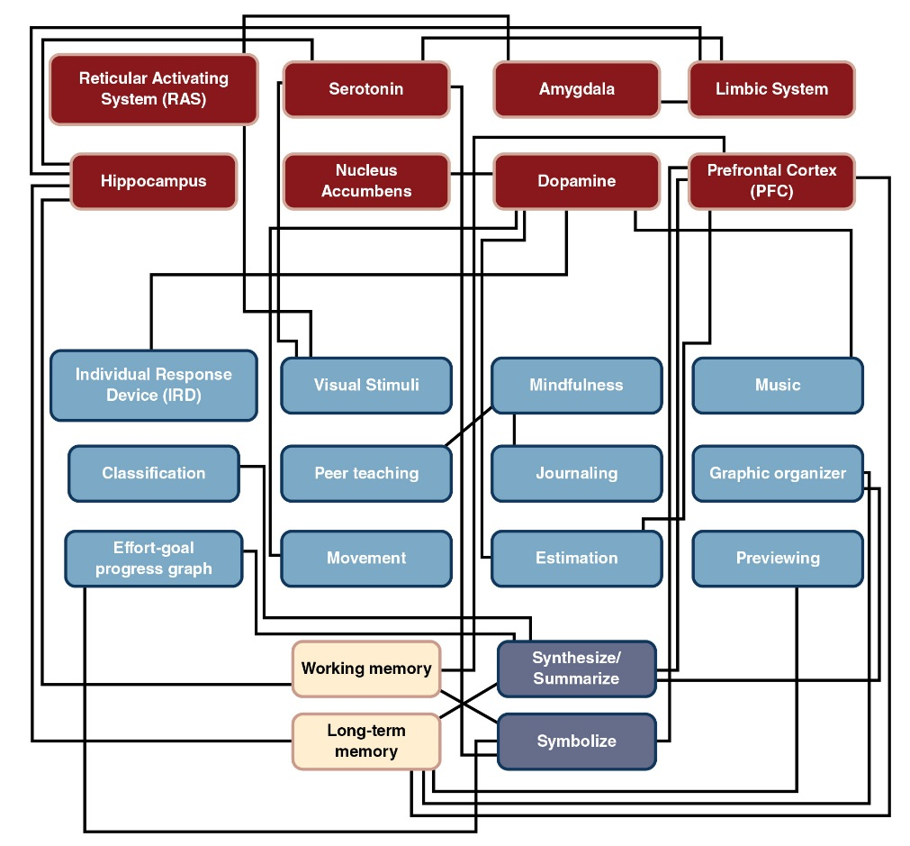
Many of these activities are equally as important for students entering higher education or entering a job. When students enter college or a new job, they are often unaware of the new requirements or the time it will take to complete those requirements. Consider a student writing a research paper for the first time in college; not only will the student need time to integrate, synthesize, and prepare the content, she will likely also have some learning to do about where and how to find research. She will need time to learn formatting and time to acquire skills in understanding how to read research. These are steps that students often neglect to take into consideration. Rather, they think they can quickly and easily find information using the Internet. If you have them complete an outline of the paper, it will help them understand the amount of time it will take them to go through and find credible resources appropriate to their paper. They will be able to correctly prioritize all the steps that go into completing a paper. Finally, providing feedback to students on their outlines will help them understand what areas they need to prioritize and can help students correct their behaviors.

Analyzing
To help students build their analytic skills, provide opportunities for them to use analysis in multiple ways. Considering the information explosion of multiple source access available to students today, we will need to help them learn how to analyze the validity of information as well as to use analysis to synthesize information from multiple sources, a variety of opinions, and various representations of data, such as graphs, statistics, and polls.

Media Analysis
Students can systematically build their analysis of source bias or accuracy throughout the school years when you provide opportunities for them to evaluate various media with regard to how they know if information is valid or misleading, fact or opinion. With young children, ask them to select a television commercial or magazine advertising a product they are familiar with. Then ask the student to find inconsistencies in the advertisement from what they really know about the product. For example, if they own a doll or action figure that was represented in a television commercial as moving independently and interacting with other action figures with various props, vehicles, buildings, and special effects, they may have been disappointed when they received the action figure and none of these accompanying items or capabilities came with it. Each time you encourage conversations in which students relate how commercials or other information was misleading or inaccurate, encourage them to give the reasons why so they begin to develop their own personal templates for assessing and analyzing validity.

Ask Yourself
In what ways are we still, as educated adults, influenced by media? Do your own brief media analysis. Think of a commercial that you find particularly effective. What is the overall feeling that’s trying to be evoked? How does that feeling relate to the product or service? Who is the target audience?
Older students will gain insight into critical analysis if they work in small groups to evaluate the one- or two-page brochures that one finds in hotels, train stations, or airports promoting businesses and activities in that city. You can collect four or five of these from different businesses promoting the same activity or different restaurants in the area and distribute them to four or five groups into which you divide the class. Each group is given the same assignment. They are to evaluate the information on the brochure and share with the class an analysis of whether their restaurant or river cruise is the best one in the city and on what grounds they are basing this analysis.
What happens typically is that the first group will report confidently that their restaurant is in fact the best one in the city, and they will quote directly from the brochure—voted “number one in the restaurant lovers’ poll,” was the critics’ choice for best restaurant, or received customers’ highest ratings. This may be a surprise to the other groups because they are likely to have found very similar claims on their brochures. This will be the teachable moment for discussion as to how one analyzes whether a poll, critic’s review, or reports of various awards are valid. Students will begin to understand that polls vary in validity depending on factors such as the number and variety of people who are included in the poll, how questions were asked, and what options were available. Similarly, they will develop insight about comments attributed to critics to help them recognize that anyone can be given the title of critic—including the restaurant owner’s wife and children—and that it is important to evaluate the objectivity and qualifications of reviewers in all forums.
When students in secondary school are building their skills of analysis to guide their independent research, there is a great opportunity to help them develop their analytic skills concerning website validity. It may be appropriate to motivate some students to begin this validity assessment on websites about a topic of personal interest. Other students may be ready to make these evaluations about websites geared to the topic they are investigating.
The first assignment will be for students to independently evaluate a number of websites on the topic and select one they think is particularly biased and unsupported and also select one they feel is very well supported and valid. Students will independently write down the clues or evidence that led to their selection of the websites they chose for each category. Students will then meet in small groups and compare not the specific website content, but the criteria on which they based their choices. Ask them what factors were particularly influential in their analysis about the validity of their websites.
It is likely that these small-group discussions will have significant agreement about the characteristics students found most representative of high validity and most representative of unsupported and biased information. The small groups then select a few of their validity evaluation criteria to share with the whole class. Once again there will be a great deal of overlap that will reinforce students’ awareness of the criteria that they used successfully as well in enlightening them as to other useful criteria that classmates used to analyze website reliability.
This kind of student-constructed analytic tool is much more powerful than any checklist you can provide for students to use to evaluate media validity. Because students first made the evaluations on their own and then had many reinforced by classmates as well as hearing classmates suggest other analytic tools, they are building not only their skills of analysis but also their confidence and awareness that information validity is as important as information itself and that they should continue to hone their skills in analyzing existing available media and new forms of global communication and media as they are introduced.

Using Diverse Forms of Media
Build students’ success at analyzing diverse media and formats of information presentation throughout the school years, as this will be a skill that they will need to utilize more and more often throughout their lives. Provide a variety and range of print and computerized media from various sources and from various time periods, including old and current textbooks and translated media from a variety of countries and cultures.
Younger students will be intrigued by the various interpretations of the Cinderella story in different countries and languages when they hear these translations and compare them to the story with which they are familiar. Other opportunities for students to analyze validity comes from the popularization of historical characters such as Pocahontas in the Disney films compared with a portrait of Pocahontas created during her life, as well as written descriptions of her appearance and actions.
An interdisciplinary approach from elementary school through higher education can incorporate analysis from literature, history, science, economics, art, and a variety of other courses and provides an excellent opportunity for students to interact with information and a variety of types of media with overlap of the aspects of the content that are emphasized in the interdisciplinary approach. An example would be the analysis of the value of incarceration from an economic perspective and from the historical perspective as a crime deterrent. This can include literature such as Victor Hugo’s Les Miserables and articles about imprisonment in federal penitentiaries where there are and are not opportunities for education.
Analysis of central historical questions can include information beyond history books with opportunities for students to evaluate conflicting perspectives. For example, when starting a unit about Westward expansion, students could be shown a painting done by a resident of an emerging city in a developing prairie town. This artist rendition might show Native Americans galloping into the center of town on horses, wielding tomahawks, wearing “war paint,” and wearing only loincloths for clothing. The townspeople, on the other hand, would be dressed in more familiar clothing and gathered without weapons or horses in conversational groups, with the appearance that these peaceful folks are about to be victimized by the approaching “savages.”
At the beginning of the unit, as the students evaluate this painting, they would be encouraged to describe the emotions it evokes in them and whether they consider it to be representational of what happened to most settlers and of the behavior of most Native Americans during that period. As the unit of study progresses, encourage them to journal or describe any changes in their feelings about the scene depicted. At the end of the unit, ask them to give their analysis as to who might have created the painting and if art, such as this, is a valid source of history as it happened or if it is limited to the perspective of different groups of people.

Employ Writing Activities
For both the development of the executive function of analysis and to build their skills and written communication, students need opportunities to analyze in writing. Writing as a form of analysis need not be limited to literature and history. In mathematics and science, writing analysis of one’s interpretation of the ideas or the interpretation of experts in the field with differing opinions will increase the way in which students synthesize and successfully communicate their analysis of information while at the same time increasing their opportunities to use subject-specific vocabulary and build understanding of complex material and recognize uniting concepts.
Writing activities are beneficial to students in other ways too. There is an established connection between reading and writing activities (Abadiano & Turner, 2002) such that reading and writing activities improve achievement when taught together, promote critical thinking, and foster communication (Cooper, 2000). Abadiano and Turner (2002) discuss how writing abilities increase when students have been exposed to a variety of texts. They learn about structure and have an increased ability to construct their own text based on models they have been exposed to. Moreover, writing for a variety of audiences can increase attention to different organizational features of a text and can help increase a student’s comprehension of the text. Taken together, these ideas suggest that incorporation of reading activities with writing activities could lead to better learning for students.

Using Judgment
Take a look at the examples below and see if you can find a mistake in either.

There are mistakes in both! Perhaps you did see them, but most people do not see the second “the” or the incorrect color of the four of hearts. The above are examples of inattentional blindness. Although the errors are clearly evident once they are pointed out, they are not initially evident. Inattentional blindness in interpreting these examples is well within normal limits. However, inattentional blindness regarding the interpretation of academic, social, and emotional sensory input has been increasing in response to the focus on single correct responses and specific procedures that students are told to memorize for specific problem solving. Examples might be to “use the quadratic equation when factoring an imperfect square” without students learning how the quadratic equation works and when it is of practical or relevant use to apply.
The “single question, single correct” multiple-choice response has become an emphasis of some educational systems. Students are pushed through an unrealistically dense curriculum without time to explore, discover, question, or try to find their own ways of solving problems. The result is they believe there is one correct response to each question and do not develop concept-level understanding of why that response is correct and what else it can be used for. The limitation to questioning single responses for specific problem solving without knowing the reasons or concept underlying the procedure has narrowed the perspective of a generation of students. As the brain develops habits geared to rapid efficiency and single responses, it grows increasingly dedicated to accepting the first retrieved response to new stimuli or questions as the single existing response.
Learning experiences need to go beyond single answers and applications to push students to resist their first response as correct or as the only correct response. Brains that have become habituated to unthinkingly following direct instructions and memorizing single correct answers may be restricted beyond the limitations of inattentional blindness. Without broader and more enriching experiences of interpreting data and developing solutions, students will miss information that is not specifically called to their attention, as in these examples. Single-response learning will not provide students with adequate preparation for the rapidly expanding information pool in the globalized, technological world awaiting them when they leave school. To prevent this passive, factory-model, unthinking stimulus response to questions and new information, you can provide opportunities for students to increase their comfort with taking time to draw their own conclusions, adapt what they have learned in new ways, and develop their executive functions such as judgment, estimation, reasoning, and creative innovation.

Estimation
Estimation is a form of judgment that students can start in the lower grades when they judge the number of beans in a jar and discuss strategies that helped them make more successful estimates. Judgment for estimation is not limited to the lower grades. In an art class or other class where students need supplies, there is judgment needed by the person from each group in determining the quantity and selecting from a choice of supplies that best fit the needs of the group but also considering the appropriate amount of supplies to take when the whole class must share them. Students can discuss in advance within their groups how much paint of each color they will need for the day’s project and their reasons for those judgments. A spokesperson can share the group judgment and the reasoning with you before making the supply selections. At the end of class there would be an opportunity for authentic consequence discussion, such as about which groups had inadequate supplies and which groups had taken more than they needed and what measures could be used to make more accurate judgments in the future.

Evaluation of Choices
When students are given opportunities to use judgment, it is always helpful for you to provide time for them to evaluate the criteria they used and the strengths of the different strategies and criteria upon which they made their judgments. Opportunities to create, test, and revise judgments include trial and error, hypothesis-guided experimentation, or evaluating whether an unfamiliar word in a sentence is complementary or derogatory based on context and preceding content.
Students can make judgments when they are invited to select library books. For example, you can ask them to select books that they believe they can read and understand in 30 minutes. They can then proceed with that task and evaluate the success of their judgments and what factors might need to be taken into consideration when they have the opportunity to repeat that activity the next week.

Classification
When I was in elementary school, we were required to memorize the names of the planets and their moons as well as their order in the solar system. Many years later when the planet Pluto was eliminated from the designated planets because it did not meet the criteria for a planet, I realized that it would have been more valuable if I learned what characteristics were used to classify something as a planet. It certainly would’ve prepared me for the shock from the elimination of Pluto.
The same opportunity for students to understand how judgments are made for other classifications will help them develop a conceptual understanding and the ability to adapt when new information becomes available or facts change once they leave school. These types of classifications are available throughout the curriculum, such as what defines plants versus animals, verbs versus nouns, states or territories of the United States, or the appropriate balanced diet. These types of activities can also integrate technology. For example, classifications could be done using a wiki or blog.

Negotiating the Social World
Judgment during school and thereafter also includes conflict resolution and fairness or justice. Teachable moments are available from areas of disagreement in the classroom or the playground. It is certainly productive to bring up potential problems during a neutral or comfortable class meeting. Students can be invited to discuss what would be a fair way to take turns when six students want to play foursquare. They could be invited to consider what they could say to a friend who they felt was being mean to a classmate.

Ask Yourself
What strategies do you employ to negotiate difficult social situations? Think about an occasion in which you were involved in a disagreement or dispute. How did you handle the situation? Were your methods constructive and productive, or could you have done things differently?
Secondary school students can evaluate fairness in a cross-curricular unit that includes math, science, physical education, and geography with respect to the evaluation of the fairness of runners competing in international competitions considering the advantages of living at high altitudes with lower oxygen content. These athletes will usually have higher amounts of hemoglobin in the blood to carry oxygen when they compete, and yet “blood doping” to enhance one’s hemoglobin with transfusions of one’s own stored blood is considered an unfair practice.

Policy Making and Government
Teachable moments also come from government rulings that students investigate when they are concerned about a local issue or policy that impacts them. If students feel that it is unfair for city property to be used for a parking lot instead of a skateboard park, they can evaluate the records of discussions that took place in the city council and make judgments about what information was fair, or the fairness of how much time was given to citizen comments versus discussions held by the council in private subcommittees. These types of analyses and uses of judgment are particularly engaging and relevant when students know they will have an opportunity to share their impressions and recommendations with the people or committees involved, either through a visit to the council, a classroom discussion with a council member, or by writing letters to the editor of the local paper.
In online education, students can discuss and evaluate controversial topics in discussion boards and in community journals. History classes might discuss and make judgments about important historical events. Classes on pharmacology could look at the fairness of drug laws across history and across the world. There are many opportunities to engage students in judgment activities that require them to look at equality, fairness, or conflict resolution across disciplines.

Reasoning
Reasoning, like the other executive functions, is something that develops progressively with the maturation of all individuals. Promote greater activation of the executive function networks by incorporating opportunities for building reasoning throughout the school year.
Reasoning is an opportunity for students to make stronger memories because they are engaging personally with choice and opinion regarding the learning. Incorporating reasoning and defense of their reasoning into learning promotes additional mental manipulation to activate the neuroplastic response in the newly formed memory to build a long-term memory. Using reasoning is consistent with the brain’s processing of information based on patterning and relationships. Deductive reasoning activates those patterns of prior knowledge as tools to evaluate new information. Inductive reasoning by guiding students to recognize governing concepts is also a tool for making connections between new and prior knowledge and extending understanding into concept memory.
Examples of opportunities for students to use their inductive reasoning are when they can use trial and error to evaluate underlying rules or governing concepts of science and mathematics, the best ways to plan defense in a soccer game, or how much clay they can successfully mold into a tall vase on a wheel without it collapsing, considering their level of experience. Students are activating their networks of deductive reasoning when they are guided to activate related memory circuits of prior knowledge to make the best prediction of an appropriate social or emotional response or to judge the reasoning used in the variations of rules, timing, and scoring used in college versus professional football.

Ask Open-Ended Questions
Strongly linked to successful reasoning is the ability to defend and support the choices, opinions, or predictions to which they are guided by their reasoning. Asking students open-ended questions can provide opportunities for students to practice reasoning as well as opportunities to defend their reasoning. Questions may include “Why do you think this cartoon shows the cows talking and all the other animals silent?” or “What strategies do you think are best to use when playing the game of Risk® or to win at Gin Rummy?” Once again, to raise students’ awareness and recognition of the strategies most successful for their reasoning, you will want to ask them how they arrived at their conclusions and where else they might apply that criteria for logical thinking and problem solving in the future.

Student Dyads
Try pairing students with classmates who have the same opinion on comfortable topics that do not require formal evidence. They share reasons for their opinions and select one or two that they feel are most convincing to share out in class discussion. Topics might include the following:
- favorite television show
- best breed of dog for house pet
- why they think an architect placed the windows where she did
Students can be given a variety of reasons that “experts” give in defense of the reasoning behind their choices and select the line of reasoning they feel is the strongest or best supported. This could include the reasons given by critics for their opinions about which movie is best picture of the year. Students can select from variations in rules or laws between states, differing conclusions on scientific data, or which of the strategies for solving math word problems is most useful (charts, diagrams, underlining, etc.). After evaluating which one they feel is most reasonable, students can then be paired with partners and can share their reasoning. When paired with students who share their opinions, the discussions will help them build confidence in their reasoning and ability to support the basis for their reasoning.
The Learning Catalytics app provides visible color demarcations of students who electronically answer questions posed by the teacher. The teacher or the students themselves can use the real-time display to link with partners of the same color when the task is to build up and support their shared reasoning or with classmates of different color demarcations to find partners with whom to discuss differences in reasoning.

Thinking Flexibly (Cognitive Flexibility)
When students have opportunities to consider multiple perspectives about what they see, hear, or otherwise experience, as well as have exposure to a variety of interpretations and approaches to problems, they develop cognitive flexibility. Substantial improvements in cognitive flexibility start to emerge between the ages of 3 and 7 (Diamond, 2006). Changes in ability to take the perspective of others occur in younger children. As development continues, though, older children (ages 6–7) gain the ability to act flexibly by inhibiting environmental tendencies (Craik & Bialystok, 2006). For example, visual stimuli in the environment may influence choices that individuals make. As children age they gain the ability to think past these visual influences and make choices based on understanding of relationships and goals.
Following this line of reasoning, Zelazo (2004) discusses the development of executive functions and the ability to think flexibly in terms of levels of consciousness. His report describes the development of levels of consciousness in young children; however, as he points out, these levels are also important to consider in older children as well as adults. For example, consider driving a car. After you have mastered this skill, it is possible to drive without full awareness. When driving without full awareness, you will be less likely to respond flexibly to changing conditions and more likely to make mistakes. Thus, being more aware and reflecting on information helps individuals use more complex knowledge and reduce errors. In the classroom, then, it is important to teach students not just to be more flexible in their responses, but also to use awareness and reflection of information, goals, and rules to help them evaluate situations and solve problems appropriately.
The flexible brain does not unthinkingly use the same criteria to evaluate every situation. When students build cognitive flexibility, they recognize the value in evaluating information beyond a specific question. An assignment regarding a Shakespeare play may require students to find three literary devices and analyze why Shakespeare may have elected to use “comic relief” or “double entendre” where he did. Students without experience in cognitive flexibility, in which they have learned to consider all aspects of a text, will have a more difficult time evaluating open-ended questions with multiple answers.
Those students with cognitive flexibility will go beyond that Shakespeare assignment, to read for understanding of the ideas and concepts he is trying to convey and use that background knowledge as a bridge to understanding the reasons behind his use of literary techniques. These readers will also take the time to read, and have an interest in reading, the play from other perspectives and purposes—understanding the historical period, enjoying the interpersonal relationships of the actors, and even predicting what might happen next.
There is early research into what are being called “adaptive neurons.” These neurons are found in the prefrontal cortex, where executive function networks are activated. In a recent study, this region was activated in laboratory animals when they successfully adapted their stimulus responses to changing “correct” answers set by researchers (Miller & Fusi, 2013; Stokes et al., 2013). If the animal, through trial and error, learns to associate the food with the box that is illuminated with a red light, regardless of whether the box is on the left or the right, it has figured out the rule it then follows to make more correct and faster choices. If the rule is then switched so the food is repeatedly placed in the container illuminated by the green light, it will take a number of failures of the red light as the guide to the food until the animal tries the one with the green light. This is the type of adaptive response change that appears linked to activation of the “adaptive neurons.”
This research supports the benefits of cognitive flexibility. When the “rules” change after the animal learns the rule of looking for food in the red-lit container, it is cognitive flexibility that allows it to break that habit after a few failed attempts to yield the food. Its response to this negative feedback of not getting the expected, learned result will be to return to the trial and error in search of a new pattern that will yield the reward. Thus, through cognitive flexibility, it will relinquish the first learned rule and adapt to the new code of going to the green-lit container. Without cognitive flexibility, the animal or human might keep trying the rule that was first learned until finally giving up without seeking a new rule.
Students for whom learning experiences are limited to memorization of facts and single procedures will develop the limiting habit of stopping when they find a single right answer. Their brains will not develop the more extended transferable neural networks, nor will they develop the self-confidence needed to think flexibly, try alternative approaches to problems, and experience the pleasures of creative innovation.

Prompting Self-Reflection
Students can recognize their ability to be flexible when prompted by teacher inquiry. Prompt questions can include these:
- How do you adapt when disappointed by changes in family plans?
- How do you react when a substitute teacher does things a different way?
- When you don’t get your first choice of the topic you want to write about, how do you find things you like about one of the other choices?
Students can also build cognitive flexibility when given assignments that require them to find more than one way of solving a problem or developing two different hypotheses for a phenomenon and giving their reasons for their selection.
Offering students two possible outcomes of the future event and asking them to consider both and devise a defense for these different outcomes would include predictions to questions such as these:
- Will it be mostly cloudy or clear at 11 a.m. next Tuesday?
- Who will be the winner of an upcoming election?
- Which city will be selected to host the Olympics?
- What will be the outcome of an upcoming Supreme Court decision?
Online course management systems provide a good way to promote and assess self-reflection in online students. Course management systems, such as Blackboard, include journals. You could have students reflect on their performance on assessments and discuss strategies they used in journal assignments at different points in the course. Students could also evaluate the effectiveness of strategies and discuss how they could change them in the future to increase performance. Another option is to use this kind of assignment in a discussion board. Here, students will be able to see how their strategies compare to those of their peers.
Like students, employees, too, could improve their flexibility and performance by participating in self-reflection. Appropriate questions to prompt employees to work on self-reflection might include the following:
- How would you adapt to the changing deadline of an important project?
- How would you react if you got a new supervisor?
- When you are given tasks that are not your favorite, how do you find things that you like about the task?
Additionally, when employees are charged with solving problems or developing a project, you might have them come up with more than one way to address the problem/project. They could also discuss the pros and cons of each solution.
Having students and employees engage in self-reflection allows them to reflect on their own capabilities to change and to adopt new strategies. When students and employees become aware of their adaptive abilities and their strategies, they can begin to apply them in different and new situations. These applications will help students be successful not only in the classroom, but also in social situations, and later career situations.

Artistic Perspective Taking
When students can evaluate perspective or technique in a work of art and then create their own variations of that piece of art, they are practicing cognitive flexibility. Similar experiences are available when students retell stories from the point of view of another character, create different endings for fictional stories or historical events, or describe the thoughts or behaviors of characters or historical figures in novel situations, such as Ben Franklin discussing the economics of today or Abraham Lincoln talking about our current immigration issues.

Georgios Kollidas, iStock/Thinkstock
When writing his famous satire, A Modest Proposal (1729), in which he purports that poverty in Ireland would be solved by cannibalism, Jonathan Swift needed to assume a wildly opposite perspective from his own. One task that will strengthen students’ theory of mind is to analyze satire in literature, film, or TV, and even to write their own.
Being able to take the perspective of someone else is referred to as theory of mind. Theory of mind is often discussed in relation to autism, in that individuals with autism are impaired on theory of mind tasks. They have difficulty picking up on social cues, which makes it difficult for them to determine what others might be thinking. In normal children this ability generally develops around age 4 or 5 (Wimmer & Perner, 1983). As children age, this ability becomes more developed. As a result, students of all levels can practice taking the perspectives of others to promote cognitive flexibility.
Even in higher education and in the workforce, individuals can engage in taking the perspective of others to help increase their cognitive flexibility. For example, college students could be assigned to describe different theories through the perspective of the individual who created the theory or another prominent theorist. For example, introductory psychology students could describe the theories of Freud from the perspective of Maslow. In this assignment, they have to understand both Freud and Maslow’s theories and be able to describe how Maslow would view Freud’s point of view.
To improve employee performance, employees could be asked to describe their performance in terms of others in the company. They would have to take on the perspective that other employees have about them, and they would need to be able to see how their work influences others. For example, a day shift employee could be asked to describe how a night shift employee might perceive her performance.

This Is Not A . . .
A fun activity to facilitate cognitive flexibility for younger students is found in the game “This is not a . . . .” This game offers children the opportunity to devise a new humorous function for a common object. If you give the first student in the circle a mechanical eggbeater, they would devise a function for the object that could be anything other than whipping eggs. They may say something like, “This is not an egg beater. It is a kite string winder.” They would pass the eggbeater to the next student, who would come up with another interpretation of its function such as, “This is not an egg beater. It is a drill to make double holes in the sand.”

Figure 8.6: Duncker’s candle problem
The box from the tacks becomes a sconce in this famous puzzle’s solution.
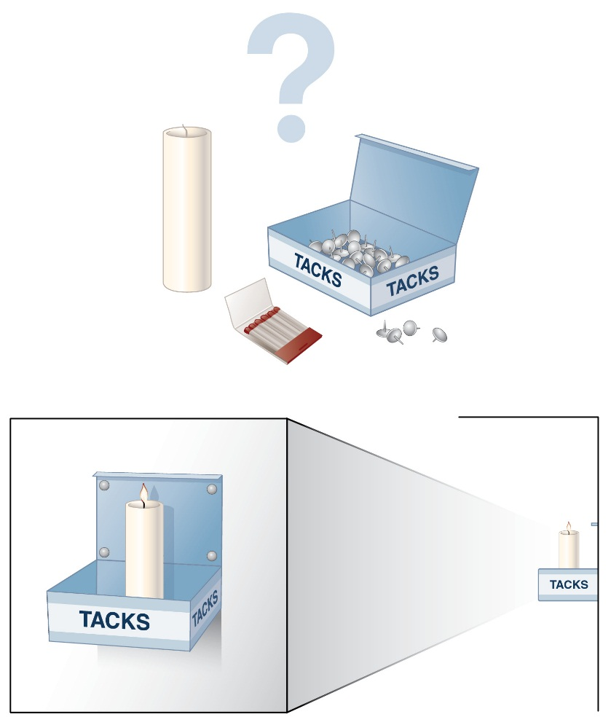

Ask Yourself
How flexibly can you think? Try to think of three different functions for each of the following items: a stack of textbooks, a pair of sneakers, a cereal bowl. After you’ve thought flexibly about these items, try to compose a list you could use for your own students.
The tendency to think of things in their usual terms is referred to as functional fixedness (Myers, 2008) and occurs when we are cognitively biased toward the uses of the object. Older students can be encouraged to think flexibly about things and find new and diverse uses for common objects. One common problem given to older students to address this is the candle box problem (see Figure 8.6). The candle box problem was developed by Duncker (1945). In this problem individuals are given a book of matches, a box of tacks, and a candle. They are asked to attach the candle to the wall in a way that will prevent wax from dripping on the ground when the candle is lit. The solution is to use the box from the tacks as a candleholder. Individuals need to attach the box to the wall with one of the tacks. Other problems that address functional fixedness also exist (i.e., the two-cord problem), as well as many comical pictures of creating new uses for objects on the Internet. Presenting students with these kinds of problems and asking them to use objects in new ways to solve different problems will help them be successful in the classroom and help them adapt new strategies for other life situations.

Focusing Attention/Inhibiting Distraction Influence
As you read in Chapter 2, the brain has an involuntary sensory intake filter, the reticular activating system, which regulates the intake of sensory input. With the development and strengthening of executive functions, students can build their facility for intentionally focusing their attention and inhibiting the influence of distractions. Help students recognize how their efficiency to understand and remember new information is strongly reduced when there are distractions. Increase their motivation to build their efficiency of attention and memory by building executive functions for “top-down” influence on the attention filter.
The development of attention and inhibition occurs throughout childhood and increases as children age. Vuontela et al. (2013) examined executive functions in a sample of 8–12 children. They found that the most active period of development for working memory and attention was between 8 and 9 years old. In contrast, inhibitory control had a more gradual developmental trajectory between the ages of 8 and 12. They also found that high inhibitory control was associated with better academic performance in 8- to 9-year-olds. However, low inhibitory control was associated with more emotional and behavioral symptoms reported by both teachers and parents in children aged 8–10.

Create Your Own Distractions
Students will come to better understand the impact of distractions if you take the time to show them. Provide very similar instruction followed by noncredit, self-corrected quizzes under a variety of conditions. They can test in optimal conditions, and then you can give them a test with a range of distracting noises—turn on a radio, keep dropping books, have a colleague come in and talk about “students” in your class so as to pique their interest. After they develop the awareness of the impact of distractions, they can be guided in a variety of strategies to use to inhibit the impact of these distractions. Invite students to also share their own strategies.

Self-Questioning
Tools and strategies include self-questioning before reading or watching an instructional video. Students would use their knowledge of the general topic or a previewed list of content vocabulary, chapter subheadings, or illustrations to create their own questions to which they will seek answers as they proceed with the reading or viewing. After the initial experience, they will need to practice this process to develop the habit of remembering to periodically stop and evaluate their questions in light of what they have just read.

Controlled Web Searches
Challenge students to do a web search without following links to websites that prompt their interest, but that they do not feel certain will add to the knowledge they seek. For students who become frustrated and anxious out of the strong desire to learn the information in the off-topic link, suggest that they write down or copy the address of the website so that they can visit it later. Graphic organizer software such as Inspiration.com can be used to write down tangents that grab students’ interests in the course of researching (or reading or listening to a lecture) that they want to follow up on later. By writing these down students will not have the concern that they will forget what they wanted to explore. Without that distracting stress, they will be able to maintain focus on the topic at hand.

Using Emotional Self-Regulation
From the time infants are able to self-calm instead of being limited to merely crying when uncomfortable, they are building emotional self-regulation. Helping students with strategies for self-regulation includes building understanding of how the brain responds to emotions, as emphasized in Chapter 4.
When students have opportunities to participate in collaborative group learning experiences with guidance and opportunities for reflection, they build their emotional control and develop increasingly productive responses to experiences that might otherwise be emotionally stressful. Working cooperatively in groups also promotes the development of communication skills and students’ capacities for productive responses to corrective feedback and learning from mistakes (rather than reacting to them as further evidence of the futility of their effort).
These types of activities might be particularly important during the teenage years, when individuals are vulnerable to risky decision making, peer pressure, and emotional outbursts. Maturation that occurs during early adolescence leads to marked improvements in reasoning, information processing, and expertise (Steinberg, 2005). However, adolescence is also a period of increased vulnerability and adjustment.
Steinberg (2005) suggests that there is increased development in brain areas that are responsible for the regulation of behavior in adolescence; however, changes in arousal and motivation that occur with puberty occur before the complete development of brain systems to regulate those behaviors. As a result, adolescents may exhibit a lack of control over emotional behavior or in emotional situations. Evidence to support this comes from research looking at decision making in teens, children, and adults. Tottenham, Hare, and Casey (2011) measured decision making in emotional situations versus nonemotional situations. They found that during emotional situations, teens had more difficulty inhibiting responses to social cues. However, when no emotional content was present, teens performed as well as adults. This pattern of performance was not noted in children or adults. This result as well as results from neuroimaging led Casey and Caudle (2013) to conclude that adolescents have trouble with self-control in emotional situations. However, Casey and Caudle (2013) also point out that an objective of adolescence is to gain independence and engage in new responsibilities. To meet these developmental objectives, adolescents need opportunities that will provide optimal brain development. Providing adolescents with the opportunity to reflect on emotional behavior and discuss how to make good decisions even within an emotional context can be helpful to meet the developmental objectives.

