5.1 Rewind—Fast Forward
The sequence of the chapters in this book follows the progress of sensory data through the brain as it is processed into long-term memory. In effect, we chart the journey of how we process information—and thus the journey of how we learn. The research about factors that influence student attention, which we discussed in Chapter 2 with the RAS, is the initial stage of this journey. How best to engage students’ attention and ensure that they get the most out of the information they do process is the subject of Chapters 3 and 4.
In this chapter, we look more closely at how we best encode sensory input into short-term memory and how patterning plays a crucial role in that process.

5.2 Key Concepts About Short-Term Memory
The brain constructs and expands learning into memory circuits through pattern recognition. After information passes through the amygdala en route to the upper brain, it enters the hippocampus (Figure 5.1). The hippocampus is where short-term memories are formed.
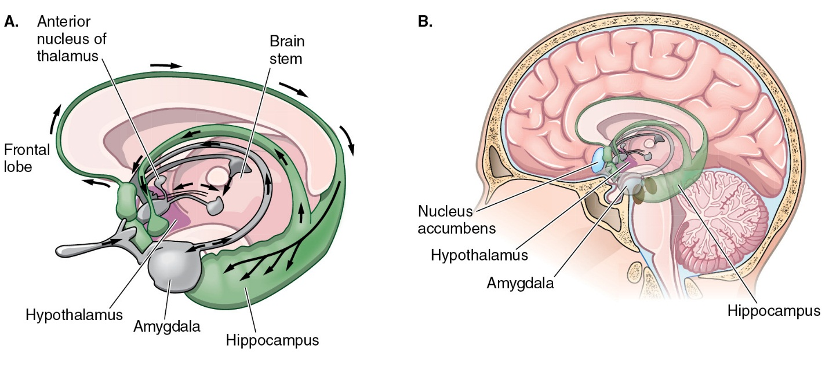
Once new information enters the hippocampus, it must connect with related information if it is to be encoded into short-term memory and ultimately retained as long-term memory. Early models of short-term memory and long-term memory suggested that information had to enter short-term memory and be held there for it to be consolidated into long-term memory (Atkinson & Shiffrin, 1968). However, subsequent research on short-term and long-term memory has illustrated that this is not always the case. Information can skip short-term memory and enter into long-term memory without our awareness (Myers, 2008). As a result of this and other work with amnesic patients, Baddeley and Hitch (1974) created the concept of working memory.
Working memory represents a more complex system and involves our conscious active processing of incoming sensory information. It is a system that is involved in several cognitive abilities, including reasoning, learning, and comprehension (Baddeley, 2003). The Baddeley and Hitch model of working memory (Figure 5.2) includes four components: a central executive, a phonological loop, a visuospatial sketchpad, and an episodic buffer.
The central executive is what directs our attention to incoming sensory input. The phonological loop allows us to keep information in mind by using subvocal rehearsal. For example, if I asked you to bring me milk, bread, and eggs from the store, you might repeat these three things—milk, bread, and eggs—in your mind to help you remember what to get at the store. The visuospatial sketchpad allows us to manipulate visual or spatial information (Baddeley, 2004). Finally, the episodic buffer helps to bind information into integrated chunks and is believed to play a role in sending information into long-term memory and retrieving old information from long-term memory. The buffer is important in terms of integrating information and creating new cognitive representations (Baddeley, 2000).
The phonological loop, the visuospatial sketchpad, and the episodic buffer are considered to be fluid systems. Fluid refers to their ability to change, reason quickly, and respond to information around us. In contrast, information in long-term memory would be considered crystallized, in that it is information that is already acquired. The concept of working memory is important because it provides a system for us to attend to important incoming sensory information and work on this incoming information by associating it with prior knowledge. As a result, to understand how short-term memories are created, we need to understand how the brain brings in and works on information.
Successful construction of short-term memory occurs when sensory information is brought to the hippocampus and related to prior knowledge activated from storage. This chapter will consider how information is brought into short-term memory and how it is worked on in working memory.

Figure 5.2: Baddeley’s model of working memory
All the elements of working memory must communicate with one another in order for an individual to solve problems and create memories.
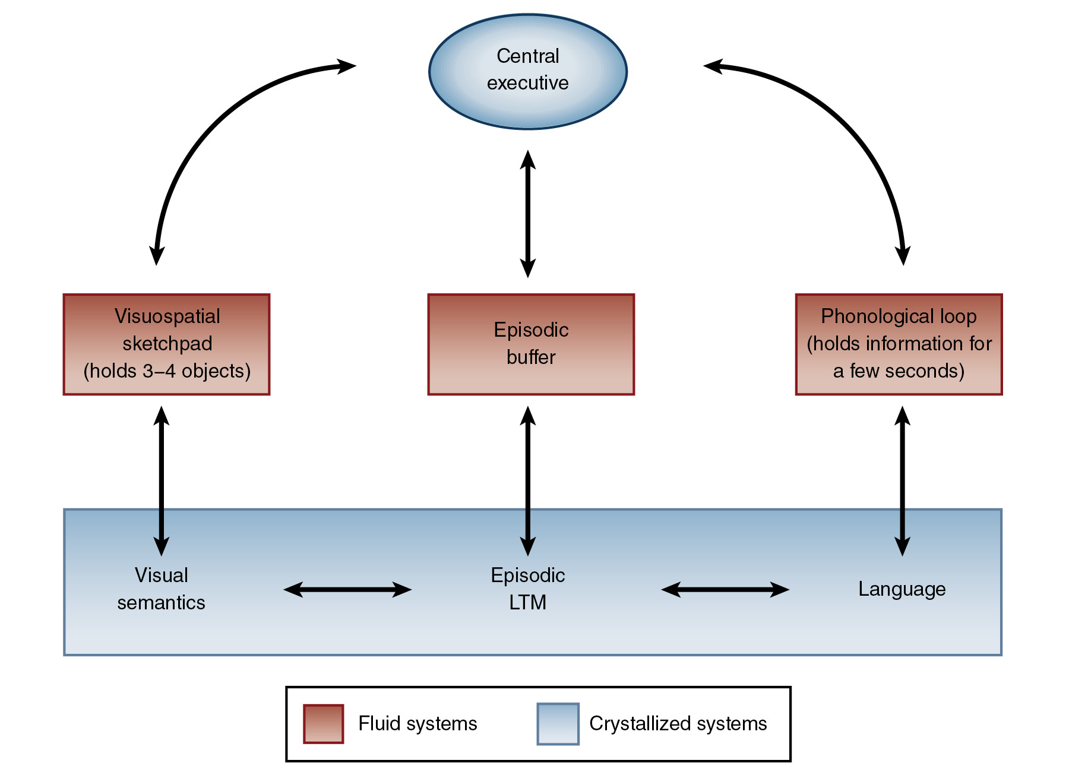
Source: Adapted by permission from Macmillan Publishers Ltd. Alan Baddeley, Nature Reviews Neuroscience 4, 829–839, Figure 5. Copyright © 2003.
Previous section
Next section

5.3 Short-Term Memory
Once new sensory input reaches the hippocampus, it must connect with related information from existing memory to be held as new short-term memory. This linking prior memory to new sensory input is called encoding. The brain is programed to seek patterns. It is this pattern seeking by which related prior knowledge is activated to meet the new input in the hippocampus.

Encoding: How New Input Is First Stored in Memory
Encoding is the process by which our brains receive information and convert it into memory. Two types of encoding exist. They are automatic processing and effortful processing. Automatic processing occurs when we process information without being consciously aware of it. For example, when walking down the street, you unconsciously read signs and register the meanings of words. In contrast, effortful processing requires our conscious attention to encode information. This type of processing produces accessible and durable memories (Myers, 2008). This is the type of encoding we want individuals to engage in when we are trying to teach them something.

Ask Yourself
What tends to distract you from effortful processing? What strategies have you developed to overcome or minimize such distractions? How else might encoding be interrupted in a learning context?
When sensory input reaches the hippocampus, it is available for consolidation into short-term memory (or working memory). The hippocampus retains information for less than a minute. The encoding process constructs a short-term memory if related prior memory, activated from long-term memory storage, is available in the hippocampus to link with the new information. Encoding occurs successfully when the neurons in the hippocampus become active and new synaptic connections can be made. Zeineh, Engel, Thompson, and Bookheimer (2003) recorded the activity of the hippocampus using fMRI during the learning of name-face combinations. They found increased activity in the hippocampus during the encoding phase of learning the combinations. As the trials progressed and individuals began retrieving the learned information, rather than encoding the information, the activity in the hippocampus decreased.
The importance of the hippocampus in encoding can also be seen individuals who have damage to the hippocampus. Perhaps the most famous case of an individual with damage to the hippocampus was H.M., a temporal lobe epilepsy patient. He underwent brain surgery in an attempt to reduce seizures. In the procedure, doctors partially removed his hippocampus, and he was subsequently left with the inability to create new memories for places, names, people, and experiences; however, some of his long-term memory stores were left intact (Kolb & Wishaw, 2009). Other examples of this can be seen when individuals experience trauma. For example, athletes typically don’t remember what happened to them right before a concussion. This is because the flow of information to the hippocampus has been disrupted by the blow to the head, causing a lack of consolidation of the material.

© John Rivera/Icon SMI/Corbis
Professional football player Andre Johnson suffered a concussion while playing a game in 2013. Even when wearing a professional helmet, such head trauma can cause loss of short-term memory.

The Holding and Working Part of Short-Term Memory

Although the terms short-term memory and working memory are often used interchangeably, working memory, as previously described, refers to a more complex system of short-term memory. Recall that the working memory system allows the brain to hold the information in mind and use the incoming sensory information for immediate purposes. Examples of holding information in working memory while a process is taking place that requires its use include remembering the beginning of a paragraph as we read through to its last sentence or remembering the initial numbers we use when doing a mental computation.
This holding aspect of working memory is limited not only in the amount of time it can hold information but also in the amount of information that can be held. Miller (1956) illustrated that the capacity for short-term memory is about seven plus or minus two chunks of data. Baddeley (2000) suggests that the phonological loop can hold pieces of information for a few seconds before they fade and that the visuospatial sketchpad can hold about three to four objects. The capacity for short-term memory and working memory increases as we age. The amount of data that can be held gradually increases through the elementary school years and usually reaches the maximum by the time children enter middle school. However, the limits above will generally not be surpassed without specific training and/or the use of specific strategies such as chunking. For example, after 230 hours of training, a subject, S. F., was able to increase his ability to recall a sequence of numbers from 7 digits to 79 digits (Ericcson, Chase, & Faloon, 1980). However, there is no evidence that building specific working memory skills in this fashion, such as digit recall, transfers to overall improvement in memory. Additionally, as you will learn later, many things can interfere with the efficiency of working memory so that it does not function at its maximum holding capacity.
Here is an example of working memory capacity:
- What is the sum of 1/5 + 1/10 (with mental math)? You were able to solve that problem because of working memory.
- Now try adding 9/17 + 12/76 (with mental math). The reason you cannot do this is because the amount of data and duration for which it needs to be held exceed the capacity of working memory.
Other examples of working memory include:
- holding an unknown word in mind while reading the rest of the sentence or paragraph for context clues with which to predict its meaning,
- following sequential verbal instructions,
- remembering the steps of a procedure or a sequence of verbal directions, and
- remembering numbers carried during long division until they are added to the next column.
Using working memory requires incorporation of brain areas outside of the hippocampus, including the frontal lobes (the central executive and the episodic buffer), language areas in the left temporal/parietal areas of the brain (for the phonological loop), and areas of the parietal and occipital lobes (for the visuospatial sketchpad) (Baddeley, 2000, 2003). The incorporation of other brain areas in the working memory process allows the brain to do more with the incoming sensory information. It also allows for individuals to have more problems using working memory. Thus, this system provides both pros and cons for learning.
Alloway and Alloway (2010) suggest that working memory tasks are a measure of a child’s learning potential. Their study found that working memory capacity predicted skills in reading, spelling, and math. Additionally, they state that “working memory at the start of formal education is a more powerful predictor of subsequent academic success than IQ during the early years” (Alloway & Alloway, 2010, p. 26). This makes it important for us as educators to recognize working memory abilities in students and attempt interventions or use teaching strategies that can improve working memory in students.

5.4 Patterning for Memory
Patterning is crucial to memory. Finding patterns in the information we engage with and the environments we engage in is crucial to effective learning and knowledge acquisition. This section focuses on three different ways in which we use memory patterning: for storage and retrieval, survival and prediction, and literacy and numeracy.

Patterning for Storage and Retrieval
Patterning with regard to memory refers to the meaningful organization and categorization of sensory data based on relationships or commonalities. The brain encodes new information by matching it to patterns of existing neural networks previously stored in memory. Such patterning allows for easier retrieval of that information.
The neural networks that process information based on relationships and commonalities are referred to as a perceptual representation system (PRS). The brain uses various types of PRS subsystems to understand patterns in our environment. It is through this pattern matching with previously constructed related neural networks that our brains recognize and make meaning of the thousands of bits of sensory input perceived every second. Basically, patterning allows the brain to store newly acquired knowledge.
We can see how patterning works in our own processing of information in the following example:
What color is this page?
What does a cow drink?
In which order did your answers to the second question come to mind?
- First thought, “milk,” second, “water”
- First thought, “water,” and no other
- First thought, “milk,” and no other
- Not “milk” or “water”
Why did your brain think of “milk” so quickly? Your brain has frequently activated the words “cow,” “milk,” and “white” together. The frequent activation of those bits of information connected them into a strong memory circuit in long-term storage. Through the process of neuroplasticity, which we will discuss in the next chapter, that frequently activated pattern is so strong that thinking about two elements of the pattern, white and cow, activated the third part of that pattern and rapidly sent it down to your hippocampus.
Although you probably know that cows drink water, the relationship of cows and water has not been as frequently activated in your memory as the relationship of cow, milk, and white. As a result, the less frequently used stored knowledge of cows and water was not your first retrieved response.
Optical illusions also work because of our brains’ patterning. Instead of our brains objectively reporting exactly what images are present, visual sensory intake is interpreted based on our prior experiences when we perceive the illusion. For example, even after we are shown with the straight edge that lines that appear to be nonparallel are parallel, when the straight edge is removed, the lines again appear not parallel even though we know that is not the reality.
Looking at gestalt theory can be another way to examine patterning in the brain. According to gestalt theory, the whole is greater than the sum of the parts. When we examine the world, we tend to combine all the pieces of information into a meaningful whole (Myers, 2008). In this way when we perceive information in our environment, we filter the information in a way that makes sense to us. Principles of gestalt theory show how our brains use organization to make sense of the world and see wholes (Myers, 2008). Figure 5.3 gives an example of a gestalt optical illusion.

Figure 5.3: The gestalt illusion of reification
The circle in the center of this drawing is not really there. It is an illusion created by your brain in an attempt to configure the drawing’s parts into a meaningful pattern.


Patterning for Survival and Prediction
To survive and thrive, animals need to collect and interpret information from their environments. The brain perceives and interprets new sensory information by associations to existing knowledge of what has previously been seen, heard, smelled, touched, and tasted. Previously stored data is used to predict the correct response to new stimuli with similar sensory representations.
For example, based on frequent links between cold temperatures and the behavior of the local rabbits in its hunting territory, our fox’s brain might establish a memory pattern. The memory would result from frequent repetition of the pattern of cold temperatures linked to rabbits entering their dens earlier in the evening. Therefore, on a cold evening, the fox might predict that the time to catch his dinner is earlier than usual, perhaps just as the sun goes down.
The human brain also evaluates sensory input (information) relative to existing stored repeated patterns. When presented with novel sensory input (change, unfamiliar questions, choices), our brains rapidly self-scan for memory patterns to match with the new information. Our brains activate stored memories to relate to new input. We then make predictions based on how the new input relates to our activated memories. Prediction occurs whenever the brain activates enough information from a patterned memory category to interpret the pattern of the new input. For example, if you see the number sequence 2, 4, 6, 8 . . . , you predict the next number will be 10 because you recognize the pattern of counting by twos. Depending on the result of the prediction made, the existing patterns relied upon to make the prediction are extended, fortified, or revised.
Prediction is often what is measured in intelligence tests as a measure of one’s ability to make accurate connections between the input of the questions and the brain’s neural network patterns of stored information and one’s ability to use that prior knowledge to respond successfully.
Successful prediction is one of the best problem-solving strategies the brain has. Through observations, experiences, and feedback, the brain learns more and more about the world and is able to make increasingly accurate predictions about what will come next and how to respond to new information, problems, or choices. This predicting ability is a basis for such outcomes as successful literacy, numeracy, test taking, appropriate social-emotional behavior, and creative innovation.

Patterning for Literacy and Numeracy
Reading is a process for which our brains are not genetically preprogramed, as we are for spoken language. Learning to read pushes the brain where it has not been designed to go. Learning to read is a process of progressively increasing pattern recognition. From early sound-letter patterns to the more mature reader’s ability to discern subtleties of nuance, foreshadowing, and irony in literature, literacy is an ongoing process of pattern recognition and expansion.
An example of patterning in the development of language is found in the difference between children who grow up speaking and hearing Spanish and those who grow up speaking and hearing English, with regard to the age at which they can successfully name colors.
When an unfamiliar word is heard or read, the brain seeks its meaning in contextual clues. When a young child who is surrounded by English-speakers, even a child familiar with the word “house,” hears a parent point and say, “Look at the red house,” if the child does not know the word “red,” the child will hear, “Look at the mumble mumble house.” When the child looks up at the house, his brain will no longer be holding onto the unfamiliar sounds of the word “red,” and no association pattern will form. In the Spanish language, however, the adjective red would come after the word house, such as in the description, “casa roja” or “house that is red.” With this association, the child recognizes and looks at the house and links its color with the new word. The presentation of the color word before the object is referred to as pre-nominal presentation and occurs most frequently in English, about 70% of the time (Thorpe & Fernald, 2006). However, the post-nominal presentation that occurs in Spanish can also occur in English. For example rather than saying, “Look at the red house,” parents could say, “The house is red.” In the second example, the color comes after the object and represents a post-nominal position. In an examination of color learning in 2-year-olds, Ramscar, Thorpe, and Denny (2007) found that when children were trained with colors in the post-nominal position, they learned the colors faster than when the color words were in the pre-nominal position. They suggest that this demonstrates the importance of sequence and timing in learning words and meaning. Moreover, it provides general support for the idea that the pattern of presentation of words influences our ability to learn.
As students grow and learn, they continue to expand their experiential database. As you’ll read in the following sections about strategies to build short-term and working memory efficiency in students, the more experiences they have, and the more guidance they receive during these experiences, the more likely they are to be successful when their brains develop the patterns with which to read novel words such as the following:
0UR M1ND5 C4N D0 4M4Z1NG 7H1NG5! 1MPR3551V3 7H1NG5. 0N 7H15 LIN3 Y0UR M1ND 1S R34D1NG 4U70M471C4LLY W17H 0U7 3V3N 7H1NK1NG 4B0U7 17.

5.5 Strengthening Short-Term Memory
Pattern recognition allows us to drive familiar routes without following specific verbal or written instructions each time. Pattern activation is how we can identify the name of or correctly “predict” most of the upcoming words of a very familiar song after hearing the first few bars of music. The more efficient the brain’s patterning systems and the more accurate the information stored in relational patterns (categories), the more accessible information is for successful predictions from responses to questions to behavior choices in novel situations. As patterns increase in content, through experience, predictions from literacy to responding to emotional cues are increasingly accurate and precise.
Students with strong patterning skills and more extensive background knowledge are more successful at knowledge acquisition and retrieval. They see or hear something new, slightly different from what they already know, and are able to of make sense of the information, respond appropriately, and add it to existing patterns because they can activate their patterning system and access a larger library of prior knowledge.
Pattern recognition is a function of the number, size, and accuracy of patterned networks of stored information. Students need opportunities for guided pattern building and recognition, practice of information that needs to be automatic, and experiences in recognizing patterns in new information so they can link new to existing categories in memory storage.
When important foundational information, frequently needed as the basis for new learning, is practiced to where it becomes automatic, working memory processing will be more efficient. As you help students increase patterning skills, they will further improve their short-term memory encoding success. Building students’ pattern recognition, expansion, and retrieval skills increases their brains’ capacities to “self-scan” efficiently in response to new input or problems and to find relevant links. You can help students build their patterning skills to increase their access to information they need for successful predictions.
Students’ abilities to recognize, construct, and extend patterns depends on their prior experiences. Throughout the grade levels, students with low patterning skills can have difficulties constructing new memories, building literacy and numeracy, or holding input briefly in working memory while processing related information. These students are particularly in need of interventions that boost their patterning skills. Examples of building patterning skills include sorting shapes, singing songs with repeated patterns, and listening to books with predictable patterns, such as those by Dr. Seuss.
Activities that allow your students to recognize and create patterns are particularly beneficial when they are linked to a clear, relevant goal. Once the brain has a goal in mind, it can more efficiently tune the perceptual system to search the environment and activate the related prior knowledge to link new information to existing memory categories. Even when you feel the learning goals are clear, check in with students periodically and ask them, “Why should you learn this?” If they are connected to the goals by relevance and interest, they will have greater success activating related patterns in prior knowledge throughout their learning.
Each of the following strategies progresses in levels from younger to older students.

Pattern-Identification Sorting Activities
Pattern linking takes place when students’ brains recognize something new as fitting into one of existing stored memory patterns. Shape matching and sorting activities can be done with the whole class or in pairs of students using blocks, tangrams, or other manipulatives. Demonstrate category sorting by making small groupings of objects that share simple characteristics, such as color, shape, or number of sides. Have your students select blocks or tiles they think fit with one of your groupings. If they are correct, ask them why their piece matches. As your students progress, add more complex patterns such as flat versus curved sides.
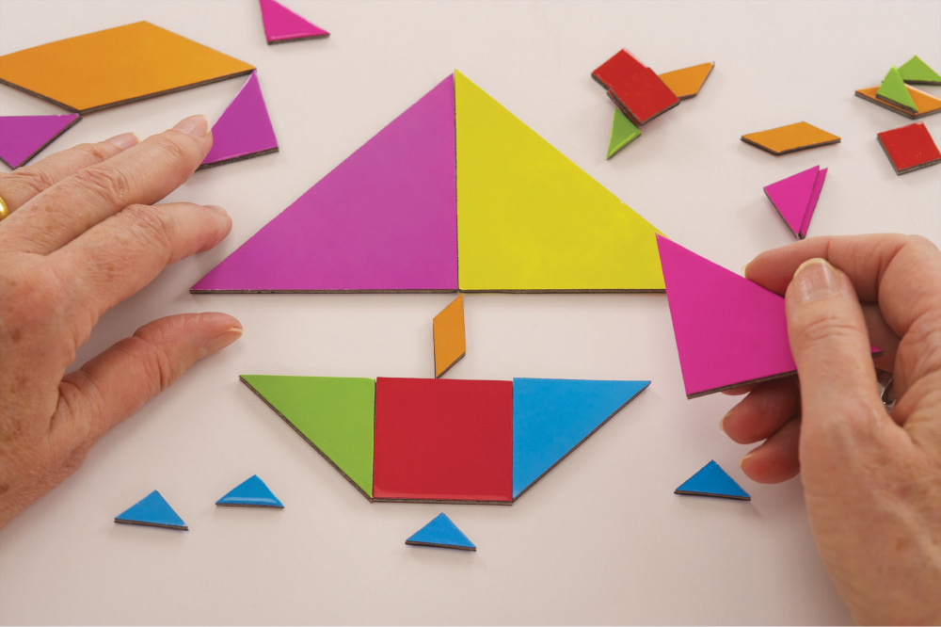
MAY/BSIP/SuperStock
Solving and creating puzzles with tangrams are great exercises for all the elements of working memory.
Your students will soon want to find their own patterns, such as objects with three, four, or five sides. Figure 5.4 shows how children will naturally use sorting activities to find such patterns. Avoid discouraging students’ participation by reducing error discomfort. Instead of directly telling them they are wrong, ask them to give their reasons for their choices. After listening to an incorrect explanation, consider if they hold a faulty concept that needs revision or if their error is more mechanical, such as putting a pattern piece in upside down. When possible, simply model the correct placement, then return control to the student. For example, if students are constructing a repeating sequence for partners to identify and they miss a component on the third repetition of the sequence, as in red, red, white; red, red, white; red, white, you need only place the missing red into their sequence. As you do so, verbally describe what you recognize as their pattern, and your reason for inserting the missing red. Then invite the students to continue with their pattern.
Older individuals, too, can benefit from experience with pattern recognition to increase cognition. For example, pattern recognition is closely associated with the recognition of opportunities by entrepreneurs (Baron, 2006), indicating that practice with recognizing patterns can be important not only in learning school material but in careers as well.
Educators in secondary and higher education can continue the use of pattern identification sorting activities by having students recognize patterns in storylines, or recognize trends or patterns in economic markets. Students can be taught to recognize patterns to help them connect concepts in your course. For example, students learning about the sensory pathways in the brain can be taught to recognize the pattern of the pathway of each sense (i.e., they all travel from sensory receptors, to cranial nerves, to the thalamus, to higher cortical areas).
A possible sorting activity for something like this might be to write the names of different brain structures in the sensory pathways down on individual pieces of paper. Students could pull the pieces of paper out of a hat and then sort them into different categories—for example, a category for cranial nerves or cortical areas. You could make this a small-group and then a large-group activity. In small groups students could be instructed to sort out all the brain structures in the categories. Then, they could all come together in the large group to construct each specific sensory pathway. When individuals understand the framework or pattern of something, they can fit the individual pieces into the pattern with more accuracy.

Figure 5.4: Increase in use of cognitive strategies with age
In a study of the development of cognitive memory strategies in children, Schneider, Kron-Sperl, and Hünnerkopf (2009) tested a group of children at intervals between the ages of 6 years and 10 years, asking them to remember as many words as they could from a list of 20 items that could easily be sorted into five categories. Results reveal a steady progression in the children’s unprompted use of sorting strategies and a corresponding improvement in the number of items recalled.
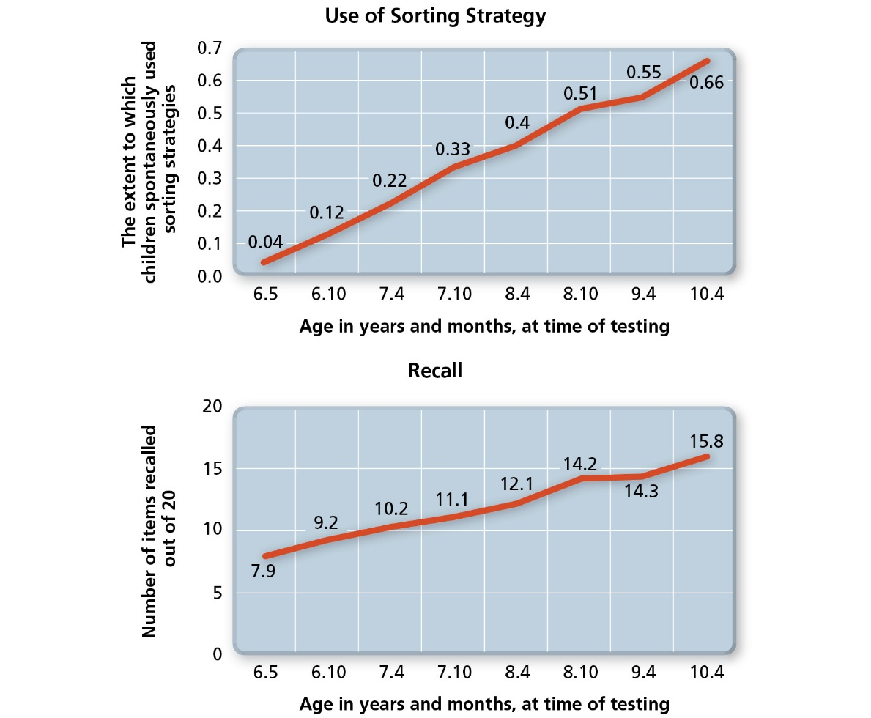
Source: Based on Schneider, W., Kron-Sperl, V., & Hünnerkopf, M. (2009). The development of young children’s memory strategies: Evidence from the Würzburg Longitudinal Memory Study. European Journal of Developmental Psychology, 6(1), 70–99.
Students in an online course could also complete sorting activities. Using a wiki, they could be instructed to sort different terms from the course into different categories. This example could be employed in the traditional classroom as well; students will appreciate the use of technology in their homework.
Additionally, following Baron’s (2006) work, employees should be trained in pattern recognition to make correct decisions. Depending on the area of employment, workers could be presented with trends in markets and asked to find patterns. Lawyers or psychologists or mental health professionals might be trained to look for specific patterns in behavior to predict when people might be lying.

Use Movement
Pattern seeking can also be an opportunity to incorporate movement, such as having the class move to a sheet spread out in the middle of the classroom, exploring the school building, or going outdoors. You could have students identify triangles that they see or take turns as the leader, whereby they decide what item needs to be identified in a pattern (e.g., a shape, color, texture, etc.).
Another option might be to use a more kinesthetic approach. In kinesthetic learning, students learn by doing something. A whole-class activity that is kinesthetic is to invite students with similar and different clothing to come to the front of the room. Next, students in the front and who are still in their seats could work out a pattern based on the clothes students are wearing. For example, if you call several students with jeans and several students with khaki pants to the front, the students could create a pattern of jeans, khakis, jeans, khakis, etc. You could also use student hair or eye color to make the pattern.
A way to increase participation in such an exercise is to invite the students to select other classmates who they believe fit the pattern. If they are correct, you invite the selected student to the front. In this system, the predicting students have their patterning recognitions confirmed while classmates continue to receive evidence to guide their pattern recognition.

Use the Overhead Projector
Use an overhead projector for another pattern recognition activity in which you sort a variety of items into two or three individual circles. Use items that can be seen with the overhead projector, often found in math manipulative kits, such as plastic coins, model animals, or varieties of small vehicles. You start with clustering items by their most obvious characteristics, such as putting only animals in one circle and vehicles in the other. Students respond with designated hand signals to indicate their recognition of the characteristic demonstrated by the sorting. As students advance in their pattern recognition skills, you can use only one type of object, such as the coins, and use their more specific characteristics when sorting them into clusters, such as size, color, or quantity they represent.

Use the IRDs
Recall from Chapter 2 that an individual response device (IRD) is a device students use to provide responses to questions in class. It can be high tech, like clickers for all students, or apps on an iPad®. Or it can be low tech, like small whiteboards and markers. While you are conducting your overhead projector demonstration, stop periodically to have all students predict with their IRDs what they discern the pattern is by having them write the number of the circle into which they predict you will place the next coin you hold up. They receive immediate feedback when they see where you do place that coin. If you find that a large number of students are not correct the first time, continue the sequence and if necessary state the names of the coins when placing them down before inviting students to predict again.

Mirror Constructions
Older students enjoy pattern recognition and construction as they build their patterning networks. Instead of partners simply adding pieces to their partners’ sequence pattern construction, they work in pairs to do “mirror constructions” to build the three-dimensional spatial pattern recognition systems needed for working with area, volume, and extended geometry. To build these patterning skills, as well as attention focus and cooperation, partners take turns being leaders and followers.
Leaders select from available tiles or tangrams one piece at a time to construct a shape such as a house. The following partners, sitting across from the leaders, would place their pieces immediately following the leaders’ placements in a mirror-type formation. If the leaders put a square in their lower left, the followers would put a square in their lower right position. At any point in the construction the followers could predict what object the leaders have in mind. Leaders do not say if the prediction is correct, but continue to place remaining pieces in place along with partners placing their mirror image pieces, as the construction advances. This format allows the followers to change their predictions or to reconfirm them—thus keeping the attention response to prediction that we discussed in Chapter 3 actively engaged.

Training Working Memory
As previously indicated, the maximum amount of data the brain can hold in the hippocampus while continuing to acquire related data or while actively using the information for some processing is limited to approximately seven plus or minus two bits or chunks of data. Baddeley (2000) suggested this number was even lower (three or four) for the visuospatial sketchpad.
There is some controversy, however, on whether or not individuals can be trained to improve their working memory. In a review of studies looking at training working memory in children and adults, Shipstead, Redick, and Engle (2012) found that there is not enough evidence to conclude that training working memory is effective, despite the fact that many commercial providers sell products that claim to train working memory and that claim to be backed by scientific research. Regardless of whether you can increase your students’ working memory or not, you can use teaching strategies that will help them use the working memory they have more efficiently. Improvement of strategies is also possible. Recall from earlier that S. F. was trained to increase his recall of numbers from 7 to 79 digits. He did this by grouping the numbers together in different three- and four-digit sequences as running times. Therefore, teaching students strategies for grouping or chunking could be a way to help them improve their working memory capacity on certain tasks.
In order to help students efficiently use the working processes of short-term memory, two approaches are better than one. As we discussed in Chapter 4, negative and stressful emotions can reduce flow through the amygdala to and from the prefrontal cortex. One approach to boost the holding power of short-term memory is to help students keep the amygdala from the high-stress reactive state. The interventions discussed for sustaining prefrontal cortex intake and output described in Chapter 4 promote top-down boosters to memory. Top-down refers to output from the executive function in the uppermost region of the brain down to the lower brain, including the emotional limbic system and the hippocampus. (Top-down processing is described in more detail in Chapter 2.)
Students can do more to reduce the effects of stress on their input flow (see Chapter 8 for more discussion on this topic). With guidance and practice, they can strengthen their developing executive function networks to increase their top-down control over working memory efficiency. Examples of the executive functions that can be engaged for this purpose include sustaining focused attention and resisting distracting input.

Meeting the Needs of Individual Learners: Technology and the Brain
From laptops to tablets to smartphones, technology is engrained in our culture, in our homes, in our classrooms, and in the way we learn. Some of us rely heavily on computerized devices to manage our schedules, remember our appointments, give us directions, research information, and manage our everyday lives. For better or worse, modern technology might be changing the way we think and the way our brains work.
Our brains are plastic and are shaped by the environment, so because our lives have changed due to our use of and exposure to technology, it is possible that our brains have changed as well. When we choose to store new information in a technological device, we may no longer be rehearsing some of this information in working memory in order to transfer the information into long-term memory. However, we are learning information and creating neuronal connections in ways that are also new. Small and Vorgan (2008) observed that “daily exposure to high technology—computers, smart phones, video games, search engines such as Google and Yahoo—stimulates brain cell alteration and neurotransmitter release, gradually strengthening new neural pathways in our brains while weakening old ones” (p. 42).
Now more than ever, children are exposed to environments that include technology, games, and interactive devices that older generations were not accustomed to. In their research, Small and Vorgan (2008) found that “the brains of the younger generations are digitally hardwired from toddlerhood, often at the expense of neural circuitry that controls one-on-one people skills. Individuals of the older generation face a world in which their brains must adapt to high technology, or they’ll be left behind . . .” (p. 3). In a study of brain activation during Internet searches, a group of 55- to 74-year-olds were selected who were either “net naïve” or “net savvy.” Using fMRI, patterns of brain activation were recorded while subjects performed a novel Internet search task or a control task of reading text on a computer screen. Researchers found that during the Internet search task, the net naïve group showed an activation pattern similar to their text reading task, whereas the net savvy group demonstrated significant increases in signal intensity in additional regions of the brain that are associated with control of decision making, complex reasoning, and vision, including the frontal, anterior temporal region, anterior and posterior cingulate, and hippocampus. The researchers concluded that for the net savvy group, Internet searching was associated with more than a twofold increase in the extent of activation in the major regional clusters group compared to the net naïve group (Small, Moody, Siddarth, & Bookheimer, 2009).
The implications for this data are interesting for learners. There is certainly no conclusive evidence as to brain changes resulting from technological approaches to learning. However, since neuroplasticity responds to brain activation, it is valuable to consider the advantages of adding computerized learning experiences to complement or support classroom instruction. Online learners may have the advantage of navigating the online world (mostly as net savvy learners or as those who will soon become net savvy) using and reinforcing the many brain regions involved in that process. In addition, online learners have requirements where 1:1 people skills, such as discussion boards and collaborating on group projects, are utilized and exercised throughout the coursework. However, unlike traditional learners, online learners typically don’t have to memorize information the same way. Online learners can utilize specific cognitive techniques, such as chunking or using mnemonic devices, to help retain information. Traditional classrooms might benefit from getting back to the basics and only integrating into areas of learning technology that is appropriate, useful, and meaningful.
Joanna Savarese, Ph.D.

Reduce Cognitive Load
Cognitive load refers to the amount of mental work required of working memory. A reduction in learning can occur when cognitive load is too low or when cognitive load is too high (Paas, Renkl, & Sweller, 2004). When cognitive load is too low, learners are not challenged and may disengage from the material. When cognitive demands exceed working memory capacity, students cannot simultaneously hold and use incoming information.

Ask Yourself
Recall occasions in either your school or working life when your working memory capacity was exceeded by cognitive demands—for example, in a new environment, with new people, or adjusting to a new instructor or boss. Identifying these instances of working memory overload will help you to be more mindful of those potential issues when providing instruction yourself.
As you are teaching, it is important to note how your students are responding to the material and your presentation methods. If material is complex, you can expect high cognitive load and thus should work on changing aspects of the presentation to reduce cognitive load for students. By providing students with beneficial strategies for learning, you can help decrease cognitive load and increase learning. As you are teaching, you might ask yourself, “What about this is complex?” or “How can I change my teaching strategy to decrease the complexity of the material?” Additionally, recall that when load is too low it can be detrimental to learning. So, in the classroom you want to promote load that comes from relevant mental activities to provide positive effects on learning (Paas, Renkl, & Sweller, 2004).
Additionally, the building up of their top-down emotional control helps students reduce the cognitive load. Cognitive load is reduced for students when their perception of threat, distractions, or other stressors is reduced or eliminated. Research examining the effects of emotion on cognitive load has found that emotion regulation disrupts cognitive abilities (Scheibe & Blanchard-Fields, 2010). For example, Muraven, Tice, and Baumeister (1998) found that individuals suppressing forbidden thoughts give up solving anagrams more quickly. Memory performance has also been noted to decrease when individuals conceal negative emotions (Richards & Gross, 2000). An example of this can be illustrated by an experiment conducted by Scheibe and Blanchard-Fields (2010). They measured working memory when individuals were suppressing feelings of disgust. The suppression of the negative emotion led to a decrease in working memory in young adults. The strategies available to build up top-down emotional control are particularly important to reduce cognitive load in advance of instruction or assessments that will require high efficiency of working memory either for coding new learning or for retrieving information already stored in memory when taking tests. The strategies discussed in Chapter 4, such as mindfulness, can help build emotional control.

Judy Willis on Cognitive Load
Other strategies include stopping after you give small segments of instructions and asking students to repeat these to you. Writing down information that students need to keep in mind as they engage in learning or assessments further reduces extraneous demands on their holding memory capacity. Cognitive demand on working memory is also reduced when there is less information that needs to be held while actively using new information for some processing.

The Brain at Work
Using checklists can help reduce cognitive load in almost any line of work. From airport flight control specialists to surgeons in the operating room, formal written checklists have been found to reduce risks and accident rates. In these examples, ongoing attention must be paid to blips on radar screens or cardiac monitors. These must be immediately evaluated on an ongoing basis and also considered with respect to existing patterns of the norm. Sustaining alertness and memory processing in these situations is a mentally intensive process.
Checklists reduce stress and cognitive load because they are visual reminders that activate existing prior knowledge and assure the people performing these tasks that no element of the safety procedure or flight/pre-operation preparation has been missed. With the stress of cognitive load reduced by the checklist, the brain can devote more efficiency to the ongoing processing of the new data as it is provided by the available monitors.

Increase Automaticity
Knowledge that has been used very frequently through practice, review, or application results in very strong, fast neural networks (e.g., cow, white, milk). Through neuroplasticity (Chapter 6), “practice makes permanent,” and these neural networks are automatic. There is no active effort needed to recall individual procedural steps once someone is a proficient bicycle rider or keyboarder. These processes get stored in long-term memory and in contrast to working memory, there is no limit on long-term memory. Additionally, when long-term memory is accessed while completing a working memory task, it does not increase the load on working memory capacity (Paas, Renkl, & Sweller, 2004). Thus, automaticity of needed foundational knowledge access reduces cognitive load by freeing up mental resources for the simultaneous holding and working processing in short-term memory. The more information students can access without the effort of juggling it in working memory, the more brainpower they can dedicate to new encoding and the short tasks of working memory. For example, in mental math of multiplying 11 × 15, you might first multiply 10 × 15. Because of automaticity, you do not need to carry out that multiplication step by step to get the product of 150. Now you can just hold the 150 while simultaneously retrieving the product of 1 × 15 as 15. It is then well within your power of holding about seven chunks of data to add the 150 and 15 and reach the correct mental calculation of 165. If you had to do each two-digit multiplication separately, as might be the case if you were asked to mentally calculate 97 × 61, your working memory would not have any quickly accessible automatic information, and the cognitive demands would exceed your working memory capacity.

Ask Yourself
Can you recall an instance in your life when a schema helped you outperform others? What about a situation you’ve experienced in which you did not have a schema in place and so performed worse than others? Explain.
For students, just as automaticity in these types of number facts facilitates working memory for mental math, so too does automatic recognition of the 50 most frequent sight words increase the efficiency their working memory has available to process unfamiliar words while reading.
Another strategy that can be used to increase automaticity is creating schemas. A schema organizes information in terms of how it will be used and is sometimes referred to as a mental map. Schemas combine many elements or components into one. Skilled performance can develop when lower-level schemas are combined together to create more complex schemas (Paas, Renkl, & Sweller, 2004). For example, an expert baker would have a schema for making a cake. This schema would include the ingredients it takes to make a cake, as well as things like temperature, altitude, or types of ovens that would affect the outcome of the cake. However, a novice baker would not likely have all of these elements in his schema for making a cake. So, when making a cake, having to consider those factors would increase the load on the novice baker’s working memory, and his performance would decrease.
Schemas can decrease working memory load in two ways. First, combining elements together frees up cognitive resources. Second, schemas can become automatic and a part of long-term memory, thus freeing up more working memory. You can help create schemas in your students or your employees by helping them organize the information they need to complete tasks. For example, for students to understand how neurons transmit information, they need to have a good schema of what a neuron is and looks like. By providing the necessary schema for a neuron early on, you can reduce the cognitive load that will be associated with learning about the action potential later. Additionally, the schema can become automated if it is repeatedly applied.

© Mo Khursheed/TFV Media/Corbis
Schemas mobilize us as well as allow us to generate creativity. Basketball players have a schema for basic layup principles, which then allows them to elaborate on that schema.

Create Acronyms
Acronyms are another way to help students build working memory efficiency with cues for memory retrieval. They are appropriate at all levels of instruction and will help students learn. Acronyms such as ROY G. BIV for the colors of the rainbow or HOMES for the names of the Great Lakes are memory tools that many of us still use today. Share the acronyms you use with students and encourage them to create their own. Stalder (2005) found that using acronyms increased performance on exams. Another way to incorporate acronyms into your classroom might be to repurpose familiar acronyms for students. For example, Sommers (2013) reports using WTF to mean “What’s This For?” This strategy helps to get students’ attention because they are familiar with using the acronym in another context and they will want to pay attention to see how it relates to the course. So, here you use the acronym to get information through the RAS (as described in Chapter 2) and then later use it as a way to improve memory for concepts in your course.

Bolster Procedural and Sequence Memory
Procedural or sequence pattern building increases successful encoding of procedural knowledge students must acquire, such as following the sequence for how they rotate through and carry out tasks at work stations, utilize computer programs such as Excel™, solve geometric proofs, or find and check out books in the library. Games that involve memory holding, such as Concentration, and games that practice building sequence memory of body movements in a dance, hand gestures corresponding to a song, or the beginning movements in the t’ai chi ch’uan build the brain’s success with forming subsequent procedural memories.

Incorporate Music
Playing musical instruments (especially when reading music is involved) increases working memory efficiency. In class, simple objects can be used as percussion instruments and students’ voices can take the place of instruments. Students will build memory efficiency as they learn to observe and repeat rhythms with more and more steps. Gradually build up their pattern construction as they practice imitating increasingly complex patterns of vocalizations. You can start with the same note/sound, such as “la” sung in a repeating pattern of soft-soft-loud, soft-soft-loud, etc., or short-short-long, short-short-long, etc.
Older students can vocalize to build procedural memory efficiency by learning to harmonize in groups. Being able to hold one’s notes when groups are divided for harmonizing or being able to come in at the right time with the right words when the class is singing a round are examples of skills that can come in handy to reduce cognitive load.
It always helps to promote success when you use dopamine boosters that reduce stress and increase attentive focus in advance of high cognitive load. Playing music, sharing a joke, or engaging in some stretching movements will cause working memory processing to proceed more successfully.
Playing songs with specific content that is related to your class can also be helpful for students. The song can give them something to connect the material to. Additionally, the song can prime them for the coming material. It can help bring to mind schemas that could be used to learn the upcoming information. This is a great way to incorporate music in the online classroom. In the asynchronous environment, it is nearly impossible to have students sing together, but you could embed clips of music that relate to the material.
Although the use of classical music to increase learning has been widely popularized, little evidence suggests that using classical music can increase memory (see also Chapter 1). This concept is known on the “Mozart effect.” This effect was widely popularized after Rauscher, Shaw, and Ky (1993) reported that listening to 10 minutes of Mozart increased performance on a memory test. However, since this study, many attempts have failed to recreate the effect of Mozart on memory (McCutcheon, 2000; Steele, Brown, & Stoecker, 1999; Steele, Ball, & Runk, 1997). The term Mozart effect is now used as an example to refer to the misapplication of brain research (e.g., Jones & Zigler, 2002).

Use a Single Integrated Source of Information
Recall that cognitive load looks at the amount of information that can be held and used in working memory. Research on cognitive load theory has discovered something referred to as the split attention effect. The split attention effect occurs in learning when individuals have to process multiple sources of information as they are learning. Kalyuga, Chandler, and Sweller (1998) demonstrated this effect by presenting students with either diagrams and text that were separated or diagrams and text that were integrated into one source. Students learned more when the diagram and text were integrated. It is thought that cognitive load is reduced when information is integrated. This effect might be particularly important to note when teaching in the online format. Students are reading and viewing all of the information on their computers. Having the visual sources of information integrated can help reduce the cognitive load on the students.

Use Multimodal Presentation Formats
Another finding from research on cognitive load is that of the modality effect. The modality effect takes into account how much visual or auditory material can be taken in at one time. Recall that Baddeley (2004) describes the visuospatial sketchpad as having a capacity of three to four items. If you present two pictures and visual text to describe a concept, you are likely overloading working memory capacity. To lighten the load, the visual text could be replaced with auditory information. This would allow transfer of some of the load to auditory processing, which is partially independent of visual processing (van Merriënboer & Sweller, 2005). Thus, in teaching at any level, information should be presented in a way that distributes the load across auditory and visual modalities.

Literacy Pattern-Building Skills
Strong patterning skills are important in developing literacy that involves recognizing the patterns of matching sounds to letters, roots, and affixes, or the endings used to conjugate verbs in different tenses, to name a few.
Even early sensory intake of the patterns of more complex verbal language influences children’s success with developing literacy. Children exposed to greater numbers of vocabulary words and more extended, complex, and rich sentences, even before they acquire verbal speech, have greater success relating to these aspects of speech and reading. When parents use extensive and varied vocabulary and use complete and descriptive sentences with their young children, it serves as a powerful literacy booster, similar to the time they spend reading to them. You can model this type of vocabulary and sentence structure in your own day-to-day classroom communications with students of all ages.
It is beyond the scope of this book to guide the teaching of reading to students throughout the grades. (Note: for this you can reference Judy Willis’ ASCD-published book Teaching the Brain to Read: Strategies for Improving Fluency, Vocabulary, and Comprehension). However, consider how you can promote the patterning skills that are valuable in literacy acquisition. The following are some strategies you can use.

Point and Read
The patterns of phonemic awareness—that is, understanding that letters have associated sounds—increase when you point to words as you read aloud. This lets students see a relationship between the symbols of letters that compose words and the words they hear. Research has noted that development of phonemic awareness is necessary for children to become good readers (Torgesen & Mathes, 1998). Moreover, Torgesen and Mathes (1998) note that children with stronger phonological awareness (the ability to recognize the distinct sound structures of words) respond better to reading instruction. Using the point and read technique with younger children can be a way to increase phonemic awareness and responsiveness to reading instruction.

Verbal Fill-in-the-Blank
When reading aloud a very familiar story or poem, leave out a word or phrase that is often repeated. You’ll find students jumping in to complete that sentence. This is facilitated by using books that have repeated phrases, such as “Sam I am” in Dr. Seuss’s Green Eggs and Ham, or familiar poems, sayings, or songs, such as “‘Twas the night before Christmas and all through the. . . .” When you pause, students will jump in with “house” without any formal prompting. After doing this as a whole-class exercise, to promote participation in any reluctant students, break the class into pairs and tell students that the next time you pause it is their cue for one student in the pair to whisper the completion words or phrase quietly to their partner. Then have them switch on the next turn.

Visualization
Visualization promotes procedural memory building. Encourage students to make mental pictures as they hear you tell or read a story. After your reading, invite students to describe or draw their mental pictures in the sequence in which they occurred. This tactic does not need to be limited to storytelling either. It can also be used with nonfiction to increase rigor in your classroom or to provide an activity for older students. You can also use visualization to check if your students have successfully understood material in their textbooks.
Visualization is also noted to produce improvements in motor sequences and movements. In a meta-analysis of 60 studies examining the effect of mental practice on sports performance, Feltz and Landers (1983) found that when mental practice is combined with physical practice, athletic performance improves. Mental imagery has also been noted to increase performance in surgical education (Immenroth et al., 2007) and in piano performance (Coffman, 1990). In a review of the applications of action visualization, Jones and Viamontes (2010) note that visualization is only effective for motor movements that have been performed. They also stress the need to create a detailed description of the movements to be visualized. Finally, they recommend engaging in three 15-minute visualization sessions per week combined with physical practice. These techniques can be applied in a variety of learning settings where individuals need to learn a sequence of movements, including typing classes, music classes, dental hygiene, cooking classes, medical procedures, athletics.

Find Patterns
For building patterns for literacy in older students, sorting activities can be used in which students predict the characteristic shared by words you group together. As with the activities mentioned earlier, where you provide examples of things with commonalities as students gain data to guide their prediction, you can do a similar activity with words as students seek to identify commonalities. These can include words that share beginning sounds, rhyming sounds, prefixes, roots, number of syllables, or verb tense. To increase the challenge and extend students’ brains’ patterning networks, show them groups of four words in which three share a commonality that one does not have. Have students identify the one that does not belong and explain why.

Ask Yourself
Take a moment to break out of the classroom and into a less formal context. What is your favorite genre of film? Action movies? Romances? Comedies? Does your favorite film in this genre adhere to this genre’s typical pattern of storytelling? What about a film in this genre that you didn’t like? When films fulfill what we understand of that pattern, we tend to like them more; when films break from that pattern, we might be less apt to enjoy them.
Even learning literacy concepts can be facilitated in older students through patterning practice. You can give examples and nonexamples of a category of speech, literary device, or words sharing other commonalities. Start by writing on the board the headings for two lists. One list is designated as “Examples” and the other “Nonexamples.” Students make a similar set of lists for their own use. You would then have a pattern or concept in mind, such as action verbs, and say verbs one at a time with a slight pause before writing each one down in the appropriate column. Some would be examples of action verbs and others would not. Students would copy the words as you put them into the appropriate columns. As students become aware of the commonality, they test their prediction by writing down the next word you say into the column on their paper to which they believe it belongs. When they see where you place the word onto your list, they will note if their predictions are correct. They continue this process until they have confirmed their predictions of the commonality by matching with your designation of the next several words. At that point, these students work independently to add words of their own choosing to their example list while you continue with the whole class. The activity culminates in students describing the commonality of the words in the “example” list.
In secondary education or higher education, students can be assigned to find patterns in their readings or videos that relate to class. Students would be assigned reading and asked to pick out a pattern they notice in the reading. For example, in a history class, students might pick out a pattern of civil unrest being followed by civil wars. Or students might be assigned to watch a movie for a psychology course and pick out a character’s pattern of behavior that leads to negative outcomes. After students have discovered a pattern in the reading or movie, they could present it to the class. Here all students will be able to learn from each other.

Frequent Summarizing
Summarizing while reading further helps students efficiently use their working memory to hold their maximum amounts of information in the hippocampus, while still acquiring the rest of the information. Scaffold students to build their independent summarizing routines by introducing systematic summarizing stops in class. If you read aloud to students, you can stop at different points and have students summarize what you have read to the rest of the class. In this way students will be engaging in reciprocal learning, whereby they explain their learning to others. The students get a chance to increase their metacognition by reflecting on what they have heard, and they also get a chance to engage in peer teaching. As previously noted (see Chapters 3 and 4), both of these strategies can be effective for learning.
You may be reluctant to use this strategy with older students; however, reading aloud to students of any age can be beneficial for learning. In undergraduate and graduate courses, reading aloud at the beginning of class can give students time to get settled and clear their minds. Students who are read to can also gain an appreciation for reading and increase their comprehension of complex concepts (Sharpe, 2009). Additionally, Dunlosky et al. (2013) note that summarizing is an effective technique for undergraduates or learners who already know how to summarize. The benefits of summarizing for middle schoolers would only show up after an extensive training program (Dunlosky et al., 2013).
Another summarization technique might be to make periodic stops during whole-class discussions or directed lectures during which students individually summarize and then share these with partners for confirmation or clarification. You can vary the way students represent their summary with the prompt to write a headline that would work for the preceding information if it were a newspaper story. Another variation is to summarize with a “tweet,” either through their devices or simply on a template with 140 spaces.
Students in secondary and higher education could also participate in an activity that many teachers call “popcorn reading.” In this activity, groups of students are each given a section to read in an article. After the students have completed the reading, they summarize their findings to the rest of the class.

Numeracy Pattern-Building Skills
Just as with literacy pattern-building skills, students who build their numeracy patterning abilities will have more accurate and rapid pattern-matching skills for encoding all new learning and holding input in short-term memory while using it. Figure 5.5 shows two problems with simple sequential patterns that can be given to students. The students’ increasing pattern prediction powers will be reflected in their successful short-term memory when they use their patterns to predict the sound or meaning of unfamiliar words; to recognize which procedures are called for in math word problems; and even to guide their prioritizing and organizing for doing extended homework assignments, reports, and studying for tests. Below are some strategies you can use.

Figure 5.5: Sequential patterns
See how fast you can identify the patterns in these two sequences.
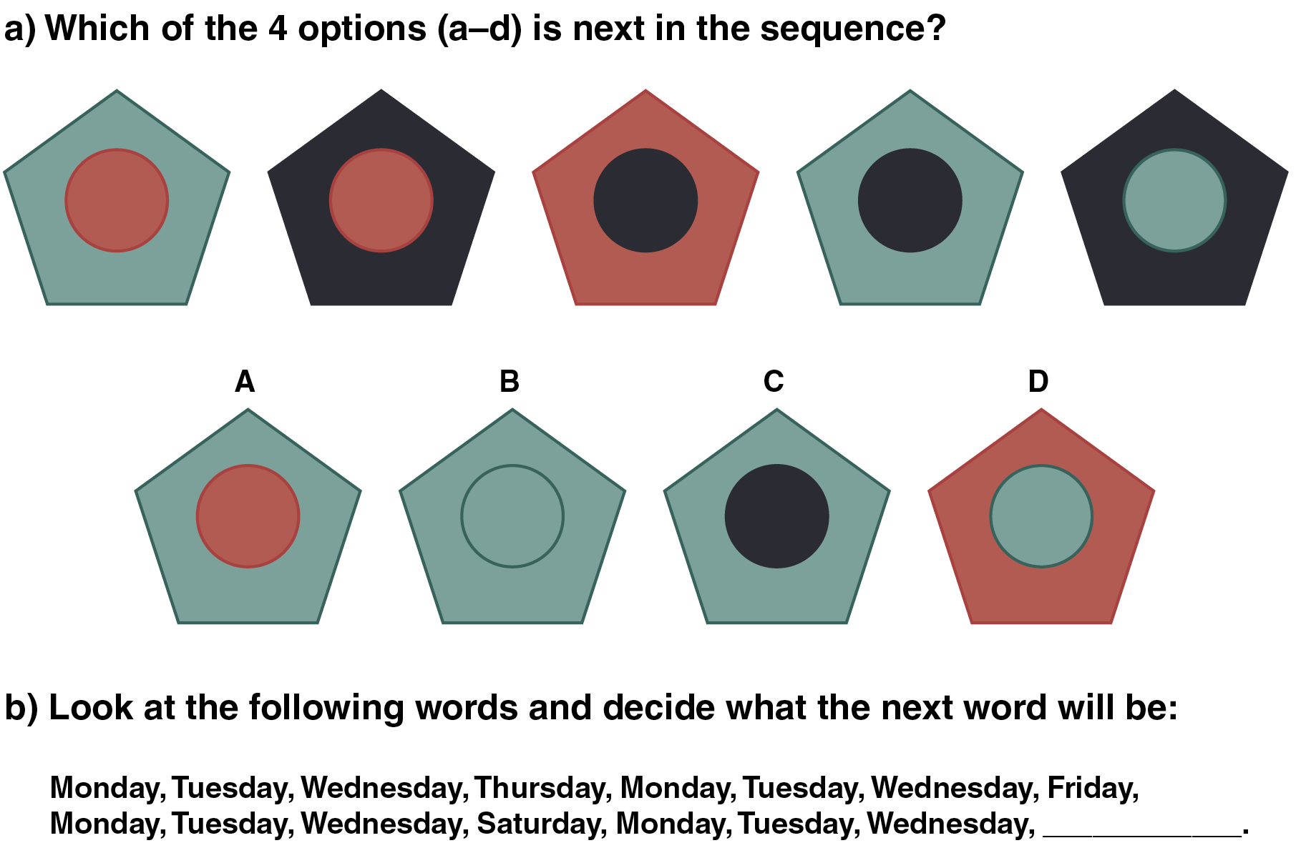

Puzzle Assembly
In mathematics, pattern recognition allows students to predict the next number in a sequence such as 7, 14, 21, __, __, __ or to recognize which procedure to do when word problems use phrases such as “all together,” “remaining,” or “left over.”
Assembling jigsaw puzzles is an excellent patterning skill-building activity, particularly for math. This increases awareness of patterns, as well as developing the spatial skills that are needed for numeracy, such as visual comparisons of quantities (which pile looks like it has more marbles), visually estimating quantities, understanding volume, transforming shapes, or working on the coordinate plane and other multidimensional math topics.

Nonsymbolic Number Estimation
An example of pattern recognition building is nonsymbolic number estimation (e.g., recognizing which cluster is greater). You’d create two clusters of the same object. Start with more obvious quantity differences (e.g., 20 in one cluster, 5 in the other). Gradually reduce the difference in quantity between the two clusters with the goal of having students recognize the smallest possible difference. Later, when these students begin to learn that symbols represent numbers, the symbols will acquire meaning more successfully because students will associate them with their existing neural patterning of nonsymbolic representations for more and less.

Tandem Sequencing
Sequencing is particularly valuable for building numeracy and can be differentiated for students’ varied mastery levels by pairing students with similar mastery level partners. This sequence construction and identification activity could be done with shape blocks or shape tiles.
One partner puts down a sequence such as triangle, triangle, square; triangle, triangle, square; and the observing partner, when ready to predict the pattern, picks up a title they believe will continue the sequence and places it accordingly. Remind students to follow your example if partners make an incorrect placement; they should simply move the misplaced object gently out of the sequence and continue to repeat their pattern, until their partner, when ready, tries again. Partners can ask for “talking pattern” clues for which the pattern designer names the characteristic of each tile as it is placed into the repeating sequence.

Use Classification
Practice with classifying information into categories via commonality recognition is valuable before teaching students how to solve certain types of problems. Just as sorting words into “sets,” such as past versus present tense, builds literacy patterning, sorting math word problems into categories that identify what process is required to find the solution is valuable before they move on to actually solving the problems. In this way, they will build the schema to recognize the process called for with enough automaticity to decrease the cognitive load of calculating the solution. Observing how students sort the cue phrases early in this process reveals misconceptions before they incorrectly interpret the process called for and make repeated mistakes when they calculate solutions.

Create Life-Sized Math Tools
Number lines are excellent for helping students recognize patterns involved in addition, subtraction, or positive and negative integers. Students enjoy working with large number lines created on the floor with masking tape or outdoors with chalk. Students can also build algebraic concept patterns by taking assigned places on a coordinate plane that you create with chalk or tape. When the coordinate pairs on which they stand accurately fit the criteria for the variables in a specific equation, the students should be able to hold a string in a straight line that extends from student to student. (For more suggestions for building patterning for numeracy, reference Judy Willis’ book Learning to Love Math.)

Activating Prior Knowledge
It is great to offer lots of patterns linking students to prior knowledge connections. It is an initial pattern encoding that catches new input for short-term memory construction in the hippocampus. It is then necessary for the brain to make further meaningful connections from the new information to long-term memory in the prefrontal cortex. Without these additional patterning connections, the short-term memory is likely to decay in about 20 seconds. Promoting as many patterning connections as possible for new input increases the likelihood that there will be durable links to permanent memory networks made when the short-term memory reaches the prefrontal cortex.
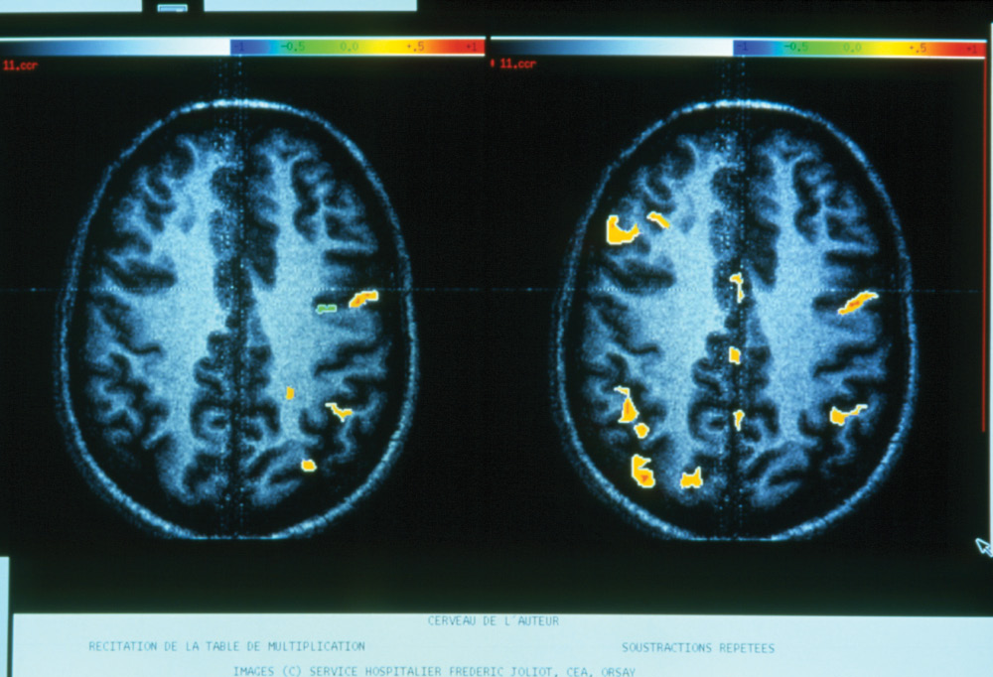
Pascal Goetgheluck / Science Source
The EEG on the left shows the brain activation of a person reciting multiplication tables, while the one on the right is of a person performing repeated mathematical subtractions. In order to solve problems using elements of working memory all over the brain, the brain also needs to access the mathematical information it has already stored in long-term memory.
As you’ve learned about the brain’s encoding of short-term memory through pattern matching, it follows that the most successful construction of short-term memory takes place when there has been activation of the brain’s related prior knowledge before new information is taught.
Prior knowledge consists of the information that students have already acquired through formal teaching, personal experience, or real-world associations and that is stored in their long-term memory banks. Assessing students’ amount and accuracy of prior knowledge, filling gaps in foundational knowledge, correcting misconceptions, and activating the most suitable networks of students’ prior knowledge before related instruction are the tools for successful new knowledge acquisition.

First Things First: Assessing Prior Knowledge
Just as students vary in their past experiences, previous formal instruction, and foundations of background facts and concepts, so they will also have variations in their prior knowledge. To be able to activate the prior knowledge needed for the acquisition of new learning, you’ll need to evaluate the prior knowledge that students already have and assess the accuracy of these memory networks. With that information you will be able to provide the instruction or guidance needed to fill in gaps of foundational knowledge and guide students in the revision of inaccurate understandings so they are ready for success in the acquisition of the new learning.
One way of evaluating prior knowledge while also activating networks of prior knowledge that will be useful in new learning is by administering pre-unit assessments. These are assessments that students will self-correct (for corrective feedback) and that will not be counted for grading purposes (so cognitive load is not hindered by that stress). These written pre-assessments alert both the students and the instructor to what the students already know or don’t know about a topic. You’ll have an early indication of individual students’ achievable challenge levels of mastery to guide your planning of differentiation.
Pre-assessments can provide a preview of the upcoming key concepts to stimulate the circuits of related prior knowledge. This facilitates subsequent activation of the appropriate patterns of memory needed to encode new learning.
By having students self-correct the tests, you’ll also be activating their dopamine-reward systems for promotion of attention and memory. When students make a prediction (by writing down what they think is the correct answer on the pre-assessment), they have more buy-in to listening when you provide the correct answer following the pre-assessment.
The ideal feedback is to provide the correct answers right after they complete the entire pre-assessment. You can do this by rereading the questions in order and providing their correct answers one at a time. Students will even intensify their brains’ responses to their answer predictions if they again write down their answers from their test papers onto their IRDs and hold these up before you reveal the answer to each question.
After students correct their own pre-assessments and indicate which questions were incorrect, you can collect these. Results will give you feedback about prior knowledge mastery and inaccuracies. You can then return the assessments to the students so they can make corrections as they acquire the learning of the unit and use these for their subsequent review.
If you are concerned that pre-assessments may not receive students’ focus because they are not used as part of students’ grade determinations, the first strategy would be to explain how the pre-assessment will facilitate their learning by activating prior knowledge. Students who understand the brain’s system of storing information in relational patterns will be more successful in their learning when they know and use strategies such as activating prior knowledge, making real-world and personal connections, and other pattern-stimulating strategies.
If students still need further incentives to focus on pre-assessments, you can let them know about your policy of periodically using some of the same questions that are on the pre-assessment in the quizzes and tests students will take throughout the unit. This can increase their buy-in and likelihood that they will listen to the correct responses you provide.
Even without a formal written pre-assessment, you can verbally question students about their foundational background knowledge if they can respond immediately to each question with their individual response devices. These also provide you with evidence of student knowledge gaps and misunderstandings to help you in planning of the instruction.
In online teaching, pre-assessments can be set up at the beginning of each learning module. You can also set up assessments so that the students can go back and review the correct answers, or so that they can take the assessment as many times as they want. Buy-in can be increased by using the strategies discussed above. In fact, a pre-assessment with regard to knowledge of the technology to be used in the course can be a great way to determine if the student needs training prior to taking the course. Technology can be a huge hurdle in online education, so adequate preparation of students is necessary.
Employees too can be given pre-assessments about their knowledge. You might use this to determine future training for the employee or to determine placement within the company, or even what office teams might work best in.

The Brain at Work
When people need to travel to a foreign country for work, they activate their prior knowledge about that country’s language, even if they are not proficient in their use of it. The task can be less daunting and memory encoding is facilitated when prior knowledge that they may not know even exists is activated. This takes place when they are reminded of words they already know as part of the English language that have Spanish origins, such as chocolate, plaza, cafeteria, or rodeo. They may also have prior knowledge of the names of stores, restaurants, and streets in the area that are Spanish words with which they are familiar. They may not know their Spanish meaning but have the familiarity of prior knowledge as to how the word is spelled on stores or street signs and how to pronounce these words. Examples of words that would help the future travelers because they are already used in the English language include fiesta, adios, and sombrero. It will also activate prior knowledge when they are shown examples of Spanish words that are very similar to their English equivalents, such as vacacion, luna, presidente, pantalones, and banana. This prior knowledge can be a mental template to which the new language can begin to link. Their memory of the experience will also strengthen because of personal relevance associated with the familiarity of these names and words.

Building Knowledge Bridges From the Past to the Present
There are also specific strategies you can use before and during a unit of instruction to activate prior knowledge. Helping students relate new information with their existing memories facilitates their brains’ detection of the networks that will successfully encode with the new learning.
Bulletin Boards Bulletin boards provide an opportunity to preheat related memory circuits. When you post pictures or display objects related to the upcoming unit of instruction, students’ brains will follow their instinctual awareness of the new sensory data in their environments. Just as other mammals use prior knowledge to predict the meeting of new sensory input, your students will automatically be doing some self-scanning as their brains evaluate existing patterns of prior knowledge to predict the meaning of new sensory input from the bulletin board.
In the online environment or in the work environment you could use email or announcements as your bulletin board. Send your students or employees pictures that will get them interested in what they are about to learn or do. You also have the opportunity to use music or video clips in this way as well.
Brainstorming Brainstorming about what they already know and what they want to learn about a new unit could be done with informal class discussions or with a KWL chart (described in Chapter 3). Reinforce any personal or cultural connections you are aware of that will help them relate to the new information. Current school, local, or national events that are of high interest to the students should also be discussed in terms of how the new learning will relate to those items. Watch a relevant video, such as those relating to math and science found on the following website: http://www.thefutureschannel.com/. You can also relate concepts to events that happen on TV shows or movies, or that appear in song lyrics. The Internet offers many opportunities to show brief clips of TV shows or movies in class that relate to concepts you will be teaching. Show students how what they are about to study relates to their lives or the world around them to activate these prior knowledge memories.
Reference Previous Lessons Activate prior knowledge that you know is foundational to the unit but that students’ brains may not recognize suit that purpose by referencing previous lessons and classroom experiences. Remind them of the things that they saw in demonstrations, heard from class speakers, or successfully demonstrated as understanding in formal and informal assessments. The following illustrates an example of prompting students to make these relationships: “Recall the discussion we had after the ducks landed in our athletic field last month? One of the ideas we discussed was that the increased building of homes in the migratory wetlands used by these migrating birds is resulting in loss of previous landing places that had met their needs. We wrote down that one of the things you were interested in was how birds are able to find their pathways for migration over long distances. Some of you predicted that magnetic fields might have something to do with it. You’ll enjoy thinking back to that discussion as we begin our unit of study on magnetism and electrical currents.”
You can also use more specific prompts for key information, such as reminding students about literary devices: “Recall the short stories you read before Halloween. We discussed how the authors’ use of foreshadowing increased your feelings that something bad was going to happen. Keep in mind that foreshadowing technique as you evaluate other ways that this author draws you into the story with literary devices such as flashbacks. Where have you noticed foreshadowing or flashbacks previously in other books or movies you found interesting?”
Use Analogies Analogies can strongly connect new learning to prior knowledge. For example, you could say to your class, “Just as all of us have variations in our physical characteristics, likes and dislikes, and the sounds of our voices that help us recognize one another, so do fish have characteristics that we can use to identify the species to which they belong. Your lungs provide your body with oxygen from the air, and gills of fish provide their bodies with oxygen extracted from water.” Making the experience of fish analogous to that of humans will allow students to better relate to the biological functioning of fish that might otherwise seem completely foreign.

Ask Yourself
In Chapter 3, you were asked to provide your own metaphor to describe the neurotransmission process. Now try to create one here for the processing of short-term memory that would help you or even a younger student understand and encode this process better.
Forge Cross-Curricular Connections Cross-curricular or interdisciplinary themes and spiraled curricula help students’ brains identify patterns to connect new information with previous experiences and memories to encode with new learning. When used effectively, cross-curricular approaches can increase understanding and help students transfer the content to other situations (Hickman & Kiss, 2010). Hickman and Kiss (2010) point out that compartmentalizing subjects is not a reflection of how information is presented outside of the education system. Additionally, they state that students need to be taught to connect material and transfer skills from one area to another to be prepared for the future.
To make the most of these cross-curricular classes, students often need explicit guidance to recognize connections. Keep in mind that although you see how the cross-curricular topics are evident in each subject area and how they relate across subject areas, students do not have your executive functions of overarching connecting themes—especially at the beginning of the units of study.
If the cross-curricular theme is positivity and negativity, for example, ask students how what they learned about magnets relates to what they’ve learned about positive and negative numbers. Once they recall that connection and what they have been learning about positive and negative numbers, their brains start activating relational connections of positivity and negativity that will link to the upcoming literature unit.
To continue with the above positivity and negativity example, you might ask students to consider books they’ve read that caused them to develop positive feelings or negative feelings about individual characters. Tell your students, “Let’s see how this author does that and if the characteristics that you find negative become even stronger when two negative characters come into contact with each other. Will relationships between two negative characters resemble what happens when two negative poles of magnets come into contact?”
Continue to encourage students to make cross-curricular connections as these units progress by promoting discussion of what students learned about the topic from the perspectives of their other classes or subjects. By keeping these discussions active, their brains will be facilitated in making similar connections with prior knowledge and extending the patterns of information incorporated into relational memory networks as they engage in your unit.
In higher education and online education, cross-curricular themes can be explored by completing projects with other classes or through co-teaching. For example, Bandyopadhyay, Coleman, and DeWolfe (2013) describe a project whereby students in a marketing course worked with students in an international management course. The purpose of their collaboration was to provide better career preparation for students who will enter a world where employers are calling for graduates with interdisciplinary understanding (Bandyopadhyay, Coleman, & DeWolfe, 2013). Co-teaching is another way to increase student understanding of multiple types of information. Experts in each field bring different perspectives to the classroom that can help students understand material and apply it in different ways to their future careers.
The following website has examples of cross-curricular topics and web links: http://www.cyberbee.com/intclass.html.
Use Graphic Organizers Perhaps the most powerful external representation of the patterns in which memories are encoded and stored is the visual patterning templates provided by graphic organizers. Using graphic organizers at the beginning of a unit can activate prior knowledge, and as students continue to add to these templates when additional knowledge is acquired, patterning continues in a manner most consistent with the way the brain organizes memory. In addition, graphic organizers increase understanding for students with a variety of strengths and background knowledge as they allow students to interact with new learning through a variety of linguistic and nonlinguistic visual, pictorial, or diagrammatic patterning systems.
Graphic organizers prompt students’ brains to discover patterns and relationships. Similarities and differences in graphic organizers such as Venn diagrams provide strong visual patterns that can grow as the unit progresses. Mind maps are physical representations of data in visually memorable, student-chosen ways that boost relational thinking through the unit.
Consider a graphic organizer created in a year when the Winter Olympics generate a lot of excitement. The Olympics could be a template to link with students’ learning about their anatomy lessons. As students learn new anatomy concepts, they can add the concept to a graphic organizer as it relates to the Winter Olympics. An ongoing project could be the construction of a mega-athlete who can perform different physical actions with different body parts simultaneously. A final figure could have the right foot skiing, the left foot snowboarding, and one arm lifting an ice-skating partner overhead, while the other maneuvers a hockey stick. Because knowledge of both anatomy and sports are linked in the diagram, so will those patterns become related in memory encoding and for subsequent facilitation of retrieval. Thinking of the sport will activate the memory of the anatomy.
Recall that summarizing while reading and listening helps students efficiently use their working memory. Graphic organizers require students to summarize as information is acquired. Graphic organizers provide an opportunity for students to actively process the sensory input from a variety of sensory intake sources, such as seeing, hearing, and visualizing, as well as the tactile experiences of writing and drawing, as they construct learning into personally meaningful patterns.
Graphic organizers are most effective for pattern building and linking when students know how the information is organized, especially when they choose their most successful ways of structuring new information so it is most logical and memorable to them. To facilitate student familiarity and choice of the graphic organizer they find most suitable to units of instruction, promote their experiences with the use of the multiple types of organizers. It is therefore ideal within schools and school districts if there is some formalization of the types of graphic organizers introduced at each grade level and even consistency of the websites on which these are stored or available as templates. In this way one or two new types could be introduced each year as students gradually build a compendium of these powerful tools for synthesizing information at the start of a unit and adding new information as the unit progresses in the type of pattern organization to which the brain is so responsive. See the Web Resources section at the end of this chapter for websites that have examples of graphic organizers in addition to those that have already been mentioned.

