1.1 Rewind—Fast Forward
As someone who is studying education or someone already in the field of education, you might be wondering how the material in this book will help you in your career. Or, if you are not directly involved in the field of education, you might be wondering how the material in this text can be useful to areas outside of education. This chapter is designed to give you an overview of the answer to those questions.
We will first explore the relationship between education and neuroscience. Neuroscience is a field of study that focuses on understanding the development and functions of the nervous system (including the brain and spinal cord). The field is interdisciplinary and includes chemistry, biology, philosophy, and psychology. In this text we will focus on the findings from cognitive neuroscience and how they relate to education. Cognitive neuroscience is a branch of neuroscience that focuses on understanding the neural basis of cognition. The research presented here illustrates how neuroscience can be beneficial for educators and help inform teaching practices. You will also get an overview of how to interpret neuroscience research, so that you can effectively evaluate it later in your career.
In order to understand how the brain is able to attend to information, process information, store information, and use it later, you will need to be familiar with some basic neuroanatomy; this chapter will provide you with a brief introduction to the anatomy and development of the brain as well, before concluding with a more detailed overview of the book as a whole.

1.2 Why Should Educators Learn Neuroscience?
The implicit goal of all education is to change students’ brains, by improving both their knowledge base and their understanding of information they acquire with the guidance of their educators. Although what we see in brain scans cannot predict exactly what a strategy or intervention will mean for individual students, the information can guide the planning of instruction.
Every class, assignment, and experience shapes the human brain. Understanding how the brain processes information into learning, knowing more about what it takes for students’ brains to be maximally responsive to information input, and finding explanations for how and why successful strategies work are ways neuroscience research is providing keys to the strategies and interventions best suited for individual students and specific topics. These are the powerful tools relevant to teaching and learning that can increase student and teacher joy, as well as helping us achieve the long-term goals of teaching. One of the long-term goals of teaching is to teach for transfer. Here, we want students to be able to apply what they have learned in the classroom to a variety of different situations. Neuroscience can help us do this.
This is a time when more professionals with backgrounds in the neuroscience of learning and education are needed in all areas of education—from the classroom to administration. The people most qualified for these jobs understand research as it becomes available, evaluate the quality of the research, and translate the results of valid research into applications with the potential to improve educational practices.
Neuroscience research also has practical applications in other areas of life. For example, material presented throughout this textbook can be applied in the workplace, in mental health professions, in parenting, or anywhere that you are attempting to create new knowledge or behavioral change.
The obvious goal of many educators is to have successful students. One of the ways to promote success in your students is to understand how the learning process occurs. The process of learning involves changing the brain. Thus, the selecting of instructional techniques and the designing of lesson plans can be aided by understanding neuroscience research. Bringing information from neuroscience research into the classroom is part of the field of educational neuroscience, or mind, brain, and education. This field includes research from cognitive neuroscience, developmental neuroscience, educational psychology, and education theory. Its major goal is to be able to apply principles from neuroscience research to the classroom.
The field of educational neuroscience is not new, per se. However, recent advances in cognitive neuroscience have led to increased excitement about and interest in the connection between neuroscience research and education practice. The result of this excitement has been both beneficial and problematic. Here we will focus on the benefits of educational neuroscience, and later in the chapter we will discuss some of the problems associated with the field through the examination of neuromyths.

Increase Student Success
Educational neuroscience’s biggest benefit is that it can help you effectively change teaching methods to increase learning in your students. Opportunities to improve education by examining findings from neuroscience research and applying it to the classroom already exist in a number of areas, including language learning, learning and the arts, and science learning.
Petitto and Dunbar (2004) describe how findings on language learning can help inform educational practices that can help students be more successful at learning language. In the United States, most children receive their first formal class in a second language in high school. This is a reflection of fear that exposing children to two languages simultaneously may interrupt normal language development. Additionally, some states (e.g., Massachusetts) have gone as far as withholding Spanish in public school classrooms from young children from Spanish-speaking homes (Petitto & Dunbar, 2004). Petitto and Dunbar (2004) report that the view of holding back second language exposure grew out of the idea that children exposed to two languages at once do not differentiate between the two languages until age three and beyond, suggesting that the two languages are fused and that children exposed to two languages simultaneously have delayed language development. However, research from Petitto’s lab reports exactly the opposite. In several different studies (Holowka, Brosseau-Lapré & Petitto, 2002; Kovelman & Petitto, 2002; Petitto, Katerelos, et al., 2001; Petitto & Kovelman, 2003) Petitto and colleagues have illustrated that when children are exposed to two languages from birth they reach linguistic milestones in each of their languages at the same time as monolinguals.
Petitto and Dunbar (2004) also report that monolingual children in a bilingual school were better readers than monolingual children in a monolingual school, that children exposed to two languages from birth had cognitive advantages in tasks that demand them to attend to and inhibit competing cues, and finally that early exposure to two languages does not change the neural organization for language processing; however, later exposure to a second language does change the typical pattern of language organization in the brain. These findings would seem to suggest that early exposure to two languages does not have detrimental effects on language development, but rather that early second language exposure is in fact beneficial to students. As a result, educators who apply these findings of updated policies on exposure to second languages can provide better learning opportunities for students.

Meeting the Needs of Individual Learners: English Language Learners (ELLs)
English language learners (ELLs) face many transitions and challenges as they enter into a new culture and a different community. The National Clearinghouse for English Language Acquisition refers to ELLs as those “who are not yet proficient in English and who require instructional support in order to fully access academic content in their classes” (Ballantyne, Sanderman, & Levy, 2008, p. 2). These students often have diverse educational backgrounds and experiences, some having been exposed to less formal educational settings than others. They are more likely to come from families who are less educated, and as a result have lower socio-economic status. Additionally, they are more likely to perform lower on standardized tests and have lower graduation rates compared to their non-ELL peers (NCELA, 2008). However, these students have one feature in common—they are all learning how to speak and operate in a world whose primary language is English. With over 5 million ELL students enrolled in America’s schools and a lack of professional training and support (NCELA, 2008), teachers, educators, and professionals working with these individuals must understand that both parties are traveling through uncharted territory.
Although these individuals may face many challenges, there are cognitive and structural benefits to learning a second language. In general, the frontal, temporal, and parietal lobes, including Broca’s and Wernicke’s areas, have been associated with language acquisition and bilingualism (Perani et al., 1998). Areas of the brain such as the corpus callosum and left frontal lobe have been found to be thicker and more populated with neurons in individuals who have learned a second language (Coggins, Kennedy, & Armstrong, 2004; Klein, Mock, Chen, & Watkins, 2014). Direct advantages to learning a second language also include increased cognitive flexibility, improved attention and task-switching capacities, better adjustment to environmental changes, improved cognitive and sensory processing, increased performance on tasks that require conflict management, and less cognitive decline with age (Marian & Shook, 2012).
How do we as educators and professionals effectively work with ELLs and make it a positive experience for everyone involved? First, keep in mind the age of the learner. Although it’s never too late to learn a second language, younger learners may have an advantage over older learners when acquiring a second language (Johnstone, 2002). Recognizing this will help keep your expectations in check. ELLs may be dealing with additional emotional, social, and cultural issues, so be mindful and empathetic regarding the many transitions these individuals are experiencing. Learn about the cultures of the individuals you are working with and be respectful of individual differences. Take time to understand your own biases, fears, and concerns working with this population. Stay positive, communicate with the individuals and their families as often as possible, and encourage them to open up about their feelings. If verbal expression is difficult, nonverbal measures such as art, multimedia, or music will help build trust and respect in the relationship. Speak clearly and slowly; make sure that the ELL can see your facial expressions and body language because many verbal and nonverbal cues are universal. Create predictable routines and schedules—this will increase environmental reinforcers. Utilize the students’ strengths; find a method of learning or communicating that works well for the student and run with it. Although you both may feel like tour guides in a foreign land, working together and being collaborative will help you navigate this journey.
Joanna Savarese, Ph.D.
Other significant improvements in student success and performance may be found by looking at the interpretations relating to training in the arts with cognition. In 2004 the Dana Foundation created a consortium for the study of why training in the arts can lead to higher academic performance. The foundation’s inquiry was about the possible relationship between training in the arts and enhanced cognition. The results of their 4-year study were reported in Learning, Arts, and the Brain. The group interpreted their findings as suggestive that training in the arts could correlate with brain changes that could be linked to enhanced cognition.
For example, Jonides (2008) reported that his research supported a correlation between training in music and acting and improvements in memory, claiming that the training affords students strategies for extracting material. The implication here is that musical and acting training may provide individuals with practice in memory tasks and more strategies for memory that they can apply in different settings. Spelke (2008) reported potential correlations between intensive music training with improved performance in geometry skills.
Cognitive control allows us to guide our behavior and is critical for learning. D’Esposito (2008) examined cognitive control in individuals who received formal training in music. D’Esposito’s interpretation of brain scans of individuals with formal music training compared to participants who did not have formal music training suggested greater cognitive control and better performance on tasks in the former group.
The results do not confirm the effects of musical training on cognition, nor do they directly correlate specific brain structural changes to music training. The findings from the consortium indicate that training in the arts may be beneficial to a number of different cognitive functions. Providing students access to arts education may be a way to improve performance in other academic areas.
The presented examples show how beneficial neuroscience research can be when applied correctly in the educational system. These examples provide teachers with the opportunity to understand how learning occurs in the brain and how different methods of instruction or different experiences can change the way the brain works. However, they also highlight the need for educators to work with neuroscience researchers in applying the research and asking future questions on how educational practices can change the brain.

Strengthening the Relationship Between Education and Science
Learning about the use of neuroscience research in education involves more than just being able to interpret and understand neuroscience research. Rather, more effective applications of neuroscience in the classroom will occur if educators and neuroscientists work together to examine current problems and direct future research.

Ask Yourself
What is your motivation to learn more about neuroscience? What do you hope to come away with by reading this text and taking this course? Write your answer down, and then at the end of the course, check it to see if you’ve moved closer to your initial goal.
Some educators are concerned that using neuroscience in the classroom could result in neuroscientists prescribing how to teach. However, the most successful applications of neuroscience research will occur when educators and neuroscientists work together. This will not only help guide specific areas of neuroscience research but also help direct the future of education. Tommerdahl (2010) describes a model for connecting neuroscience and education. In her model she describes neuroscientists as providing the raw ingredients, while educators work to experiment and test new recipes for the ingredients. In the end, the learner or student would receive the final meal that is a collaboration of neuroscientists and educators.
Educators can look to neuroscience for information about the brain that can help them design more effective educational programs. To do so, educators need to take an active role in furthering the field of educational neuroscience. Neuroscience provides us with the first part of the process in understanding how the brain works, but educators need to be involved in order to effectively use information on how the brain works in the classroom. Making the transition from lab to classroom will involve educators acquiring an understanding of scientific reports and data so that they will be better able to recognize valid applications of neuroscience research.

Better Assess Scientific Reports and Data
As previously pointed out, it can no longer be only neuroscientists, neurologists, and other specialists who have the training to recognize valid and invalid claims attributed to interpretations of research. With more and more neuroscience research dedicated to the evaluation of how the brain learns, educators will need to take on more of the challenges (and opportunities) of interpreting the validity and application of this research.
Scientific research is a complex process, of course, and this isn’t the forum to go into great detail about every aspect. But in this section, we briefly look at some of the critical aspects of the scientific process that are necessary to be aware of when beginning to assess the reliability and applicability of research beyond the research setting.

The Scientific Method
Keeping the scientific method in mind can help you effectively evaluate research. The scientific method (see Figure 1.1) is a procedure for conducting and carrying out research. It starts with observations and asking questions. For example, you might observe that your students have trouble learning a particular concept and want to know why this occurs. Your observations and questions would be followed by doing background research. For example, you would want to learn about the different characteristics of the concept that is difficult to learn. The next step would be to form a hypothesis or an educated guess to solve the problem you have discovered. For example, you might hypothesize that students have a hard time learning about the structures of the brain because they are not exposed to enough visuals. Following this, you would create an experiment to test your hypothesis. For example, you might conduct several lessons where students see pictures and manipulate models of the brain. After the lessons, students would be tested on the different anatomy to which they were exposed. The next step in your experiment could be to record and analyze the results. You might find that students performed better on tests of brain anatomy when they were exposed to pictures and models of the brain. Finally, you could make some conclusions based on the results. Your conclusion might be that students should be exposed to more brain pictures and models to effectively learn anatomy.

Figure 1.1: The scientific method
In order to be valid, all scientific research must follow all the steps of the scientific method.
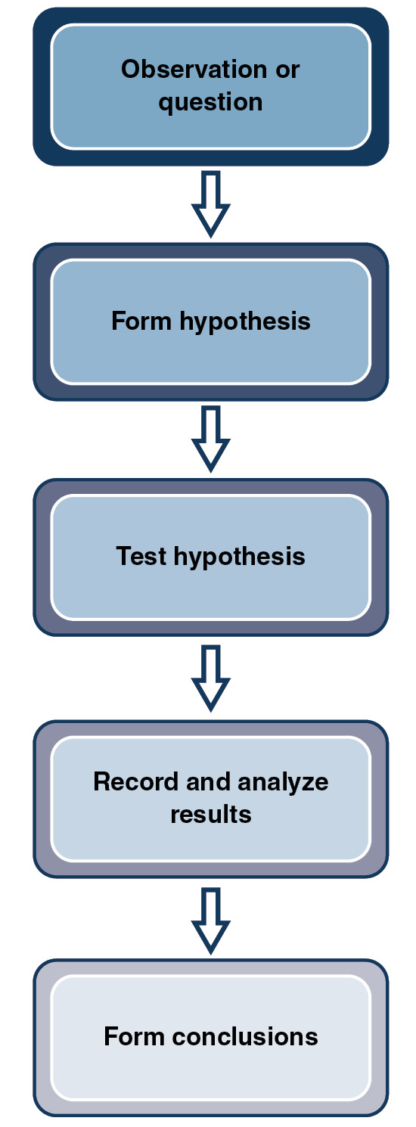

Correlation Does Not Mean Causation
Good quality, peer-reviewed brain research can give hard biological data and explanations, but educators need to be cautious about the claims made in any given journal article. Preliminary interpretations of early brain scan research, for example, have cautioned neuroscientists about drawing conclusions regarding how much neuroimaging connects with actual learning. For example, Gazzaniga (2008) points out that neuroscience often begins with correlations, whereby certain brain activity occurs with certain behavior. A correlation is a connection between two things and does not mean causation. As such, discovering how educational practices or interventions correlate with learning will require further research that addresses more direct, causal mechanisms for learning.

The Experiment: A Way to Test Causality
Determining cause-and-effect relationships requires the use of an experiment. An experiment manipulates one or more variables to determine what effect the manipulation has on another variable. In contrast, in a correlation study, the researcher measures the relationship between two or more things. No direct manipulation is made. An example of an experiment might be a teacher examining the effect of a video in a lesson plan on test performance, while a correlational study might involve examining brain activation that occurs while someone is watching a video. In the first example, the researcher would be manipulating the method of teaching instruction to determine if it changes test performance. In the second example, the researcher is merely measuring how two things occur together.
Other important controls for valid experimental research include placebo testing and double-blind studies. Placebo testing is when a group of subjects are told they are being given treatment as part of the study, but in fact are not. Thus, a placebo is something that seems to be real treatment but in fact is fake. For example, in a study that examines the effects of a new antidepressant, one group would be given the actual drug, while another group would be given something that has no active ingredient, a placebo. The group that receives the drugs would be called the experimental group because they are the group that is being experimented on, while the group that receives the placebo would be called the control group because this group provides the comparison to the experimental group. This allows researchers to control for claims by participants, and thus extract conclusions that have more validity in real-life settings. In our example above of the testing of an antidepressant, participants in the placebo group might report that they feel better just because they are taking “a drug”—even though that “drug” has no active ingredient; this is called the “placebo effect.” Scientists can then determine what effects are due to the drug and what effects are due to the placebo.
Double-blind studies are studies where both the participants in the study and the scientists who analyze the data do not know which results belonged to people in the control group or the experimental group. This reduces potential experimenter bias and thus strengthens the conclusions drawn from the study itself. See Table 1.1 for a brief checklist of other important items to consider when evaluating research.

Table 1.1: Scientific research evaluation checklist
- Check the number of variables: A variable is something in an experiment that can change and influence the results of an experiment. In an experiment there can be both independent variables and dependent variables. The independent variables are the variables that a researcher does not manipulate, while dependent variables are the variables that the researcher changes to evaluate their effects. For example, in an experiment examining the effect of a teaching method on learning outcomes, the teaching method would be the dependent variable and the measured learning outcome would be evidence of the impact of this dependent variable. Valid scientific research follows very strict criteria. Only one variable can be evaluated at a time, which means everything else in the subject groups needs to be as equal as possible.
- References: In the introduction, methods, and conclusion sections, if the authors refer to previous research or theories, do they provide references that accurately support their statements? Good research uses citations to refer to previous theories and research in the same area to support statements, ideas, and the development of new research.
- Validity versus reliability: When discussing research, the terms valid and reliable often come up. Validity refers to the accuracy of the measurements. For example, a test might report that it measures anxiety. However, it might actually be a better measure of depression than anxiety. In this case the measurement would be invalid. Reliability refers to the consistency of the measure. A measure would be reliable if it consistently produces the same results. For example, each time we give the same test to individuals we should find about the same results. In an experiment, it is important to check that the researchers are actually measuring what they say they are (validity) and that the measures produce consistent results (reliability).
- Who funded the research? For example, if a computer game for learning is evaluated by someone employed by the company selling the game, the validity is in question. Validity can also come into question if the researcher was paid to conduct the research. For example, if a pharmaceutical company pays an individual to research a drug that it stands to make money from, this may bring the research into question.
- Is the journal peer reviewed? Did other professionals who have the background knowledge relevant to the article review the article? Some journals are just commercial venues for anyone to pay and publish what they choose without anyone checking its validity. The publisher’s information at the beginning of the journal will provide this information. Peer-reviewed journal articles offer the best source of information because other professionals have reviewed the material and have had the opportunity to critique it before publication. This review process decreases the chances of inaccurate or unsupported claims being made.
- Separation of fact and opinion: Did the authors critique the implications of their research in terms of conclusions drawn from the data that are fully supported separate from their opinions of possible implications of the research? Authors should also support their conclusions with other research in the same area. If other researchers have found similar results, it will help support the findings. Did the authors indicate where further research would be valuable? Did they promote a commercial product without describing the existing similar products and describe objective research supporting the superiority of their product?

Ask Yourself
“References” are often associated with science and academics, but in what other aspects of your life do you rely on reputable sources for information? What sources do you trust? Why?
Once you have a firm grasp of the general criteria in evaluating research reports, you’ll be much better able to assess for yourself the validity of the findings. You’ll be equipped to judge if research results, such as neuroimaging data, are valid and potentially useful. You’ll be able to evaluate if the measurements of metabolic brain response to a particular strategy or technique of stress reduction suggests correlations allowing interventions that are reasonable to try in your classroom. Or, if claims are made, for example, regarding a product or strategy that pronounce it to be proven by brain research, you’ll know that anything that comes after that statement is not true. All of the controls needed for research to meet the medical model of control cannot be replicated in the real world. You’ll be better able, in short, to become a critical evaluator of the latest research that may help you improve your teaching strategies and so, therefore, the learning outcomes of your students.

Debunk Neuromyths
Understanding how to evaluate research not only puts you in a position to use the research to better your teaching, but it also puts you in a position to understand real and false claims about the use of neuroscience research in the classroom. Even some of the purest, most accurately reported neuroscience research has been misinterpreted. These misinterpretations of research are referred to as neuromyths.
People trying to capitalize on research with their elixirs, books, cure-all learning theories/centers, and curriculum packages have perpetrated much of the damage. Other well-intentioned folks have made errors of interpretation when they have been asked for scientific evidence to support the strategies they have been using successfully for years, and venture to do so without a neuroscience background. Consider the financial and socio-economic ramifications of some of the neuromyths that are still believed in the general population, including by parents and educators, who’ve not had the opportunity to build a background of neuroscience that would allow them to recognize the fallacies in some of the claims.
The following is a list of claims that have been made about the application of neuroscience research in the classroom. Some of these are true and some are neuromyths. As you read through them, consider if and when you have heard the ideas, as well as which ones you believe are true:
- Improvements in learning will be seen if children are classified and taught by their preferred learning style.
- We only use 10% of our brains.
- Brain development, including new brain cell connections, continues across the lifespan.
- There are left- and right-brain learners.
- Listening to classical music increases intelligence.
- There are critical periods for learning. After these critical periods have passed, individuals are no longer able to learn.
- Brain development involves the death of cells.
In the statements above, numbers 1, 2, 4, 5, and 6 are myths. If you believe these myths, you are not alone. In a recent study by Dekker, Lee, Howard-Jones, and Jolles (2012), it was found that 49% of teachers believed myths similar to the ones noted above. Additionally, they found that teachers with some small degree of knowledge of the brain were more likely to believe the myths. This finding is based on a theory that teachers with some slight knowledge of the brain may not have adequate background knowledge to accurately link the brain research to their classroom teaching. As you continue to read this text, you will learn more about how the brain works to process information. This learning will help you recognize real from false claims about the brain. To get you started thinking about how the brain works, the myths above are busted below.
Neuromyth 1: Improvements in learning will be seen if children are classified and taught by their preferred learning style.

Ask Yourself
Have you fallen prey to any of these myths? If so, which ones, and how did you first hear about them? What other myths did you once believe to be true? How did you come to believe them in the first place? How did you find out the truth?
This myth stems from two different sources. First, it comes from the idea that individuals have preferred learning styles. This finding is in fact true; however, it is not true that individuals process information better when it is presented to their preferred modality (Coffield et al., 2004). Another finding that has helped perpetuate this myth is the finding that information from the different senses is processed fully and completely in any specific area of the brain. There are certain areas of the brain highly associated with the processing of specific modalities of sensory input, but information processing is rarely limited to single brain regions and is more of a complex network among regions of the brain. Thus, when something is presented in the visual modality, there is transfer between this modality to other modalities of the brain. Assuming that only one sensory modality is involved in information processing is incorrect (Dekker et al., 2012). The Center for Educational Research and Innovation (CERI) provides additional information on the myth of learning types on their website http://www.oecd.org (search the term “neuromyths” at the top of the page). Additionally, you will learn more about how presenting information to multiple sensory modalities can be helpful in increasing learning in Chapters 5 and 7.
Neuromyth 2: We only use 10% of our brains.
This is perhaps one of the most commonly held neuromyths. Since the myth is so prevalent, it is difficult to determine how it was created. Possible origins of this myth are discussed by CERI on their website. Regardless of where the information came from, it is clear from neuroscience research that 90% of the brain is not inactive. Rather, you use all of your brain with some frequency over time. Evidence for this comes from numerous imaging studies that illustrate there are no inactive areas of the brain. What may be true about this myth is that certain areas of the brain become more active at different times. For example, when you are having a conversation with someone, you activate some regions of the cortex more than others; however, it does not mean that those other areas of the brain are inactive. In fact, they are still working. You will learn more about the 10% myth in Chapter 6.
Neuromyth 4: There are left- and right-brain learners.
The myth of left- and right-brain learners may link back to early research on split-brain patients, such as that by Gazzaniga and Sperry (1967). However, there are many examples of research examining the functions of the left and right brain before Gazzaniga and Sperry (e.g., Paul Broca, Carl Wernicke). In their classic research, Gazzaniga and Sperry examined the functions of the left and right hemispheres of the brain by working with patients who had had their corpus callosum removed to alleviate seizures. The corpus callosum is a massive bundle of white matter nerve circuitry that carries information between the hemispheres and connects their relevant processing and storage regions. Although parts of the brain are particularly active during certain memory or learning activities, the corpus callosum is constantly active as well, allowing communication across the brain’s primary hemispheres. However, when this structure is removed, the hemispheres function independently. In Gazzaniga and Sperry’s early research on split-brain patients, they noted different functions for the left and right hemisphere. Research following Gazzaniga and Sperry has also noted that differences in processing ability exist in the left and right hemispheres. Some of the major findings have been that the left hemisphere functions in language, analytical skills, and sequential problem solving, while the right hemisphere is more involved in processing emotion, creativity, music, spatial ability, and the whole picture. While these findings are in fact true, it is important not to overgeneralize the functions. Just because the left and right brains are different, this does not mean that learners are either right- or left-brain learners based on their capabilities or potential capabilities.
One of the earlier attributes given to people considered left-brain dominant was that they would succeed in analytical skills, but not in the arts. The right-brainers would need to work especially hard to keep up with the analytical left-brainiacs, and were advised to plan their education to support future careers that would use their creative right-brain skills.
This neuromyth was further intensified by mistaken beliefs that all mental capacity was hereditary and could not be changed via the environment or by experience. The fact is, there are essentially no cognitive, emotional, or procedural brain activities that are restricted to input and output from only one hemisphere. This left-/right-brain fallacy has actually resulted in a great deal of money being spent by individuals and school districts on programs that promise to increase the activity in the weaker hemisphere of the brain by activities that exercise and therefore increase the blood flow to the weaker side of the brain. For example, some have advocated for students to do cognitive, “cross-brain” exercises or tasks, such as using their right hand to cross the midline of their body and tap their left shoulder or pull on their left ear. The explanation was that by crossing the midline with one’s arms or legs there would be increased activation in the hemisphere targeted for “strengthening.” Exercises such as this, however, are obviously bogus since there is continuous activity in the corpus callosum just as there is continuous activity in both hemispheres confirmed on neuroimaging studies. Even in language, which is primarily localized in the left hemisphere, contributions are still made by the right hemisphere. The left and right hemispheres of the brain always work together, and there is no evidence that any specified interventions have any impact on this naturally occurring conversation between the hemispheres.
Neuromyth 6: Listening to classical music increases intelligence.
This neuromyth stems from a single study on classical music and memory. The original study was conducted by Rauscher, Shaw, and Ky (1993). While their original study did find positive effects of listening to classical music on memory, this finding has been hard to replicate. Despite little empirical evidence of this finding, misapplications of the research abound. Mothers are told to play classical music to their babies in utero, and some people believe that research proves that listening to classical music while studying will increase their learning and intelligence. This myth is discussed further in Chapter 5.
Neuromyth 7: There are critical periods for learning. After these critical periods have passed, individuals are no longer able to learn.
In order to understand and bust this neuromyth, one needs to understand the idea of critical periods. A critical period is a window of opportunity during which a specific kind of learning can take place. The claim, then, in this neuromyth is that there are so-called critical periods after which the brain structure cannot be changed. The claim is that if skills have not been acquired by some cutoff, or “critical period,” the window closes and these skills or knowledge cannot be acquired through learning or other interventions. However, we now know that brain change is essentially limitless, and although there are certain times during development when the ease with which the skills or knowledge can be acquired may vary, the door is never closed and efforts to help build reading, mathematics, or social and emotional skill sets in learners should never be abandoned due to the invalid assumption that their brains are past the point where they can improve. More current research now refers to critical periods as sensitive periods. With the term sensitive period, we can still note that learning will be easier during the window of opportunity, and as educators we should take advantage of these opportunities. For example, as pointed out earlier in the chapter, learning language is easier when we are younger. However, you can still acquire a second language later in life.
The neuromyths presented here represent the more popular myths that exist. However, there are more, and as interest in educational neuroscience increases, it is likely that these myths will continue to flourish. As educators, it is our job to seek out correct information and look for meaningful ways to apply it in the classroom.

Expand on Your Past Success
Even if you have not had the experience of teaching in the classroom, it is likely that you have had the experience of being in a teacher–learner situation. Perhaps you were teaching a friend how to use a computer program or helping a sibling learn to snowboard. You’ve also been in learning situations yourself, experiencing the benefits of teaching practices that have been most enjoyable and fruitful for you or of learning experiences that have been neither engaging nor rewarding.
Professional educators benefit greatly by the ability not only to recognize their most (or least) successful teaching and learning experiences, but also to be able to identify what characterized or resulted in the highly positive or negative outcomes. With the help of understanding the neuroscience of how the brain learns best and what conditions favor successful processing into memory, you will have more tools to analyze those teaching practices that are most successful. Beyond that, when you understand how certain interventions influence the brain and learning, you can expand those strategies as you recognize the mechanisms at work in the brain.
It also becomes quite clear in education that students differ in their most successful types of learning experiences. In Chapter 4, which discusses emotion with reference to the video game model, you’ll find that learning is most successful when it is geared to individuals’ levels of achievable challenge. This requires an individualized process whereby the teacher recognizes where the learner is in his understanding and mastery. Then, the teacher can adapt the level of challenge and rate of goal progression, allowing each student to experience the pleasure of achieving challenges with effort.
Especially with uniformity of instruction geared to test preparation, we have found the hazards of a one-size-fits-all instruction in which some students are bored because they’ve already reached mastery and others are frustrated because the pace exceeds their background knowledge. This problem also will be elaborated on in Chapter 4.
Brain scans cannot create lesson plans, but your understanding of the implications of this research can help you to plan instructional modes most suited to your students’ needs. Teachers who understand the why and not just the how to of their most effective teaching strategies can best meet the needs of individual learners and therefore plan instruction for the highest achievement of all their students.

Ask Yourself
What successes have you had in education, be that as a student, instructor, or designer? In what ways do you think understanding more about neuroscience can help you improve on those successes?

Position Yourself for Future Neuroscientific Innovation
The interface of science and learning will continue to guide educators in the development of the strategies, interventions, and assessments to prepare today’s students for the world of tomorrow. The more you know about the research-supported basis for a strategy or procedure, the more comfortable you will feel in your ability to interpret the implications of subsequent research. Educators with background knowledge about the neuroscience of learning will be in pivotal positions to recognize potential correlations from future neuroscience research to classroom interventions. You’ll be ready to innovate.
As neuroscience research continues to be more precise with improving technology, and the amount of baseline data accumulates to add statistical accuracy of the neuroimaging interpretations, the role of educators with foundational understanding about neuroscience will grow. With a background in neuroscience, you will be positioned to most effectively serve the needs of students and guide fellow educators through the inevitable transformations to come in education as more breakthroughs in neuroscience illuminate ways to best prepare children for the challenges and opportunities of the 21st century. The first step in gaining this background in neuroscience is to take a look at the nervous system. Understanding the anatomy of the nervous system will give you a framework with which to understand and interpret neuroscience research. The following sections give you an overview of some of the more important aspects of the nervous system that will come up in later chapters of this text. Additionally, we will examine how the nervous system develops to help you understand how the brain changes throughout the lifespan.

1.3 The Organization of the Nervous System
The nervous system is the body’s communication network. Some systems are confined to particular regions of our bodies. For example, the respiratory system is located in the chest (the lungs), the neck (the trachea), and the head (throat, mouth, and nasal passages). The nervous system, however, consists of nerve cells that extend throughout the entire body, from head to toe, fingertip to fingertip, processing an endless array of messages as we navigate our way in the world.
The nervous system is composed of two subsystems: the central nervous system and the peripheral nervous system. The central nervous system (CNS) consists of the brain and the spinal cord, whereas all the nervous tissue located outside the brain and spinal cord compose what is known as the peripheral nervous system (PNS) (see Figure 1.2). We will touch upon some functions of the PNS later in the text, but our focus here and for most of the text is almost exclusively concerned with the functioning of the brain in the central nervous system.

Figure 1.2: The nervous system
The nervous system is composed of the central nervous system (CNS) and the peripheral nervous system (PNS).
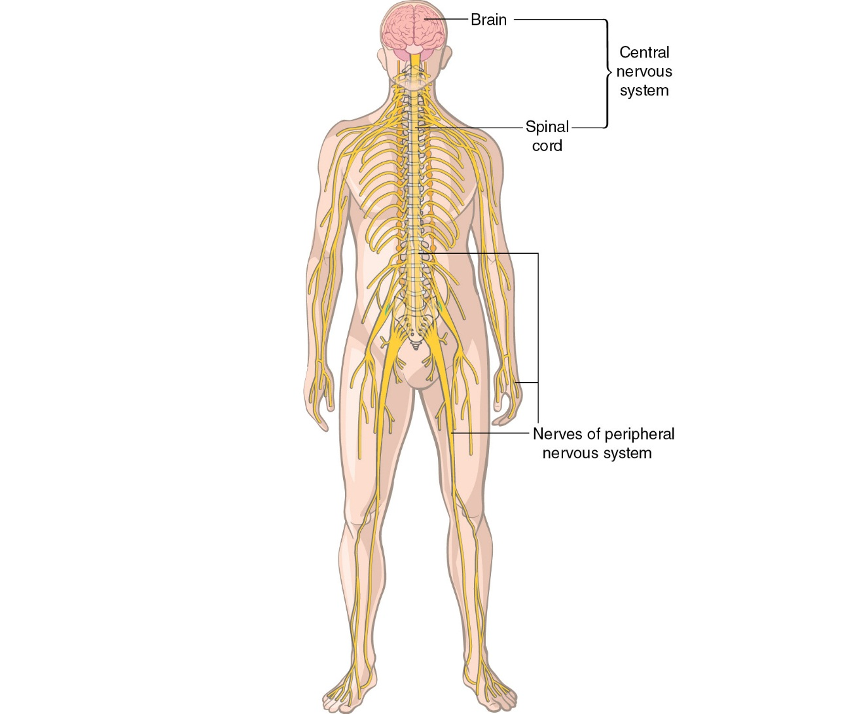

It is also important to become familiar with the cells of the nervous system. The nervous system contains multiple cell types. Of particular interest are neurons and glial cells. Neurons allow for communication within the nervous system and between the nervous system and other systems in the body. Neurons consist of a cell body, dendrites that carry input to the cell body, an axon, which is a long thick fiber that transmits information away from the neuron, and terminal buttons, the branches at the end of the axon (see Figure 1.3). You will learn more about the different parts of the neuron and their role in communication later in the text.
Glial cells provide supportive functions for neurons. There are actually about 10 to 50 times as many glial cells in the brain as there are neurons. However, because neurons provide the major means of communication in the nervous system, they get all the attention. Glial cells are important to consider, though, and not just because they outnumber neurons, but because they are needed for the proper functioning of the neuron. There are several different types of glial cells that each perform specialized jobs to keep neurons working properly. For example, astrocytes help clear away debris in the brain and transport nutrients to neurons, while Schwann cells and oligodendroglia (singular: oligodendrocyte) provide insulation in the form of the myelin sheath to the neurons.

Figure 1.3: A typical neuron and supportive cells
The cells of the nervous system take many forms and all support one another.
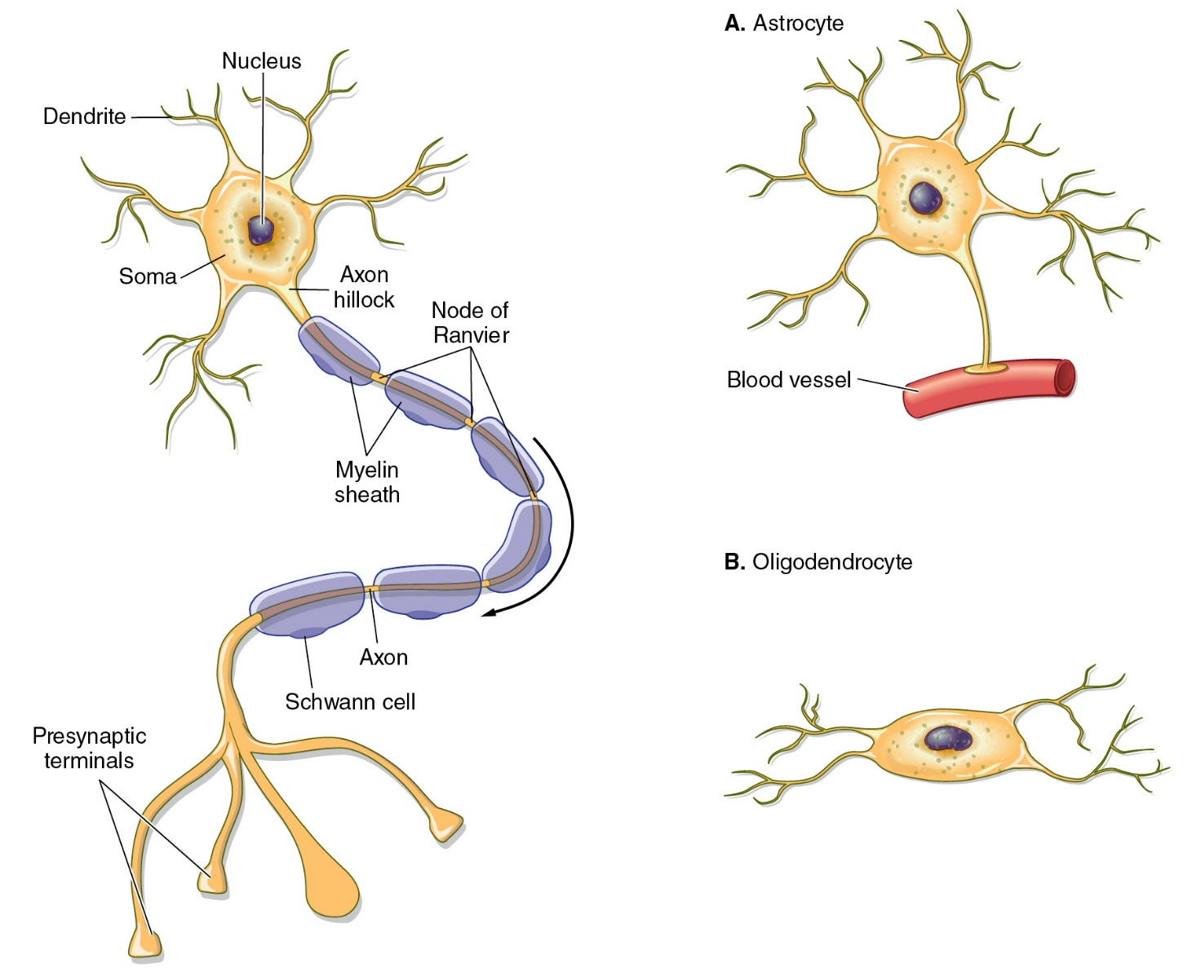

1.4 Structures and Functions of the Brain

Ask Yourself
Before reading any further, let’s see how much you know about the brain. Try to list as many parts of the brain as you can. Then also try to explain what you think each part does.
The brain serves as the executive control for the human body. Most of us have virtually identical structures situated in the same locations within the skull. For all vertebrates, the brain can be divided into three parts: the forebrain, the midbrain, and the hindbrain.
In humans, the hindbrain is located at the bottom, the midbrain is located on top of the hindbrain, and the forebrain, which is the largest component in humans, sits on top, covering not only the tiny midbrain but also the larger hindbrain. Figure 1.4 shows the positions of the forebrain, midbrain, and hindbrain in the human brain.

Figure 1.4: Major structures of the brain
The forebrain, midbrain, and hindbrain are each composed of specific brain structures.
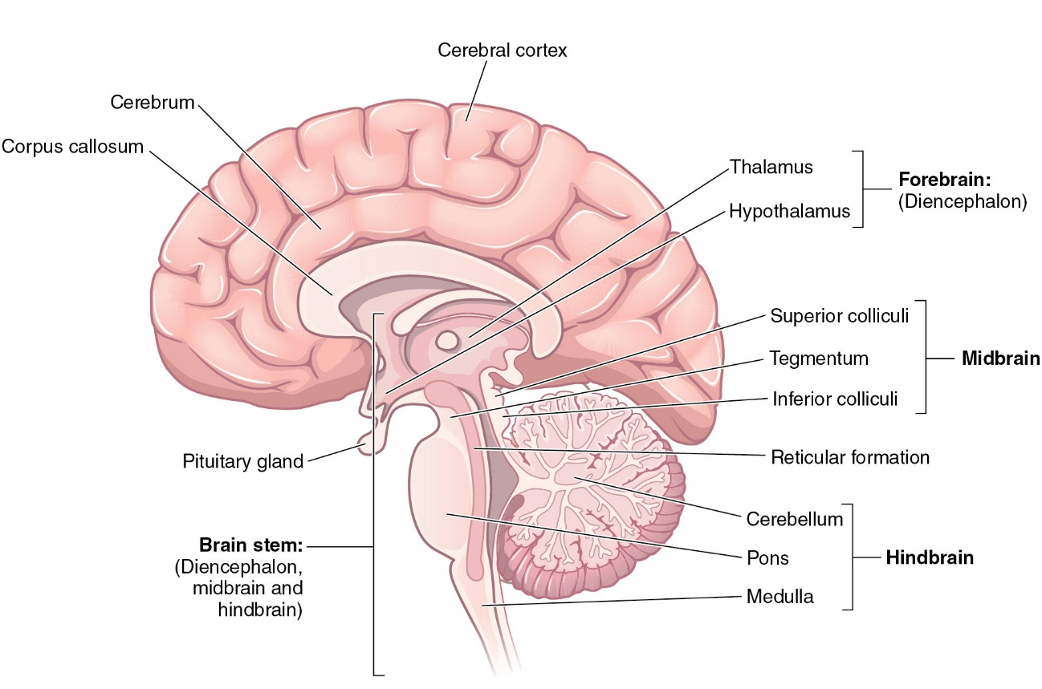

The Hindbrain
Three structures make up the hindbrain: the medulla, the pons, and the cerebellum. The medulla is located directly above, or superior to, the spinal cord. This means that all information coming from and going to the spinal cord must pass through the medulla. Indeed, the medulla contains a great deal of white matter holding tracts that relay information between the spinal cord and higher brain areas. Gray matter is also found in the medulla, however. White matter refers to myelinated axons of neurons, while gray matter refers to the cell bodies of the neurons. Clusters of neurons, known as nuclei, are scattered throughout the medulla. Some nuclei regulate life-support functions, such as breathing, coughing, or swallowing. Damage to these nuclei can result in death. Other nuclei in the medulla receive sensory information or send motor commands to muscles in the head, neck, and trunk.
Located directly above the medulla is the pons. The word pons means “bridge” in Latin. The pons is a bridge-like structure that is composed almost entirely of white matter, or tracts, conveying information between the higher brain regions and the medulla and spinal cord. Information leaving your forebrain travels down tracts through your midbrain to your hindbrain and spinal cord, passing through the pons. Neural messages coming from the medulla and spinal cord pass through the pons before traveling to higher brain areas.
The cerebellum lies to the rear of both the medulla and the pons. For our purposes, you should know that it is divided into two hemispheres: right and left. Each hemisphere contains a cerebellar cortex (gray matter) and underlying white matter. This architecture (gray matter situated over tracts of white matter) gives the cerebellum a characteristic tree-like appearance when it is viewed in cross-section. The neurons in the cerebellum are responsible for coordinating muscular activities, including those involved in rapid and repetitive movements.

The Midbrain
The midbrain is the smallest of the three major divisions of the brain. In the human brain, it is roughly the size of a large acorn. The midbrain can be divided into three parts: the dorsal portion, the ventral portion, and the tegmentum, which lies between the dorsal and ventral areas.
The dorsal area contains four structures that look like little hills: the superior colliculi and the inferior colliculi. You have two superior colliculi and two inferior colliculi in your midbrain: one of each on the left side of your brain and one of each on the right side. The superior colliculi are important in processing visual information. The inferior colliculi are involved in relaying auditory information to the cerebellum and forebrain.
The ventral area of the midbrain consists of tracts relaying neural information between the hindbrain and the forebrain. Finally, the tegmentum, the section between the dorsal and ventral portions of the midbrain, contains a number of important structures that play a vital role in movement, attention, pain relay, emotions, and sensory processing.
The reticular activating system (RAS; reticular formation), which runs from the hindbrain to the forebrain, takes up a large portion of the midbrain. The RAS plays an important role in keeping you awake and alert. If you are listening to a lecture in the classroom and you are having trouble keeping alert, your RAS is not very active. However, if your teacher suddenly dropped a book, your RAS would become active and alert you to the noise. Other ways to activate the RAS, as you’ll see in Chapter 2, can be used to engage students in the classroom. Examples include presenting something that is attention grabbing, like a curious picture, an unexpected song, or a strong smell into the classroom.

The Forebrain
The largest part of the human brain is the forebrain, and this is the area we are most concerned about with regard to learning. This area of the brain produces some of the most interesting human behaviors, such as thinking, creating, imagining, and emoting. The forebrain is composed of two primary structures, the diencephalon and the limbic system, each of which is particularly crucial to attention and knowledge acquisition. Let’s examine each of these forebrain structures, beginning with the diencephalon.

The Diencephalon: Taking Care of the Body’s Business
The diencephalon is located directly above the midbrain. Information from the midbrain must pass through the diencephalon in order to reach the higher parts of the forebrain. While the lobes of the brain play a critical role in such aspects of our lives as voluntary control, thinking, perception, and memory storage, the diencephalon is a processing center for things that go on without our conscious awareness or volition. The structures in the diencephalon take care of business that supports the body without our conscious supervision.
The diencephalon is composed of two components, the hypothalamus and the thalamus. The hypothalamus is a control center that is in charge of maintaining the overall metabolic state of the body. To do this, the hypothalamus maintains body temperature, signals for the release of hormones from the pituitary gland, activates hunger and thirst responses, and maintains the biological clock—our circadian rhythm. A circadian rhythm controls our circadian cycle, which is a change in biological and behavioral functioning over a 24-hour period. For example, we have different levels of alertness throughout the day. Typically, levels of alertness increase until about midday, and then decrease. After a period of rest, alertness levels increase again until evening and then begin to drop again. Our circadian rhythm responds to external cues such as the setting and rising of the sun or changes in the seasons.
The sensory processing component of the diencephalon, the thalamus, receives all sensory information before it goes to the specific lobe of the brain where it is analyzed. In the case of smell this process is a little different. When sensory information comes in from the nose, it is first processed by the primary olfactory cortex in the base of the temporal lobe. Next, it is passed to the thalamus, which relays the information to the orbitofrontal cortex (located in the frontal lobe) for further processing of smell information. In other senses, the information would pass through the thalamus en route to the primary cortical area. It should be noted that sensory pathways in the brain also project to other structures. For example, there is a branch of the taste pathway that travels to the limbic system. However, as sensory information is transmitted to higher cortical areas (i.e., the visual cortex in the occipital lobe or the orbitofrontal cortex for smell), it passes through the thalamus. It is in the thalamus that sensory information is evaluated for its characteristics (is it sound, a visual image, a report of pain coming from the left foot?) and directed on to the lobe of the brain where it is more specifically identified (What sound is it? What is this a visual picture of? Is the foot pain sharp, burning, or a numbness?). The thalamus is composed of a large number of nuclei, or clusters of neurons, that relay information to and from structures in the forebrain, especially the largest structure, which is called the cerebrum. It is the function of the nuclei in the thalamus to process incoming information and pass it on to the cerebrum. Thus, the thalamus acts like a switchboard operator relaying information between the cerebrum and other parts of the brain. There is evidence that the thalamus also receives information from the cerebrum and plays an important role in attention (Haber & Calzavara, 2009; McAlonan, Cavanaugh, & Wurtz, 2006; Sillito, Jones, Gerstein, & West, 1994; Zikopoulos & Barbas, 2006).
The diencephalon, together with the midbrain and hindbrain, makes up the brain stem. In terms of evolutionary development, the brain stem is considered to be the oldest part of the brain.

The Limbic System
The hippocampus, amygdala, and nucleus accumbens, together with a handful of regions in the midbrain, diencephalon, and cerebrum, make up the limbic system (see Figure 1.5). Limbic comes from the Latin word limbus, meaning “boundary.” The limbic system appears to form a boundary between the brain stem and the higher centers of the brain. The limbic system functions in the production and experience of emotion. The hippocampus gets its name from its seahorse-like shape (hippo means “horse” and kampus means “sea monster” in Greek). In addition to the role it plays in emotions, the hippocampus is responsible for some types of learning and for the creation of permanent, or long-term, memories. Damage to the hippocampus can produce memory loss. Further discussion of the hippocampus will occur in Chapters 5 and 7 when we discuss short-term and then long-term memory.
The amygdala is located at the tail end of the hippocampus’s seahorse shape. It is almond shaped in appearance and has emotional-reactive regions. One such region evokes fear and escape behaviors when stimulated, and another elicits responses of rage and aggressive attack behavior when activated. The aspect of the amygdala that evokes fear will be of particular interest to us as we examine educational environments and teaching practices that may induce fear responses and thus create obstacles to effective learning. Discussion of the role of the amygdala in the learning process will occur in Chapter 4.

Figure 1.5: The limbic system
Several structures throughout the brain make up the limbic system.
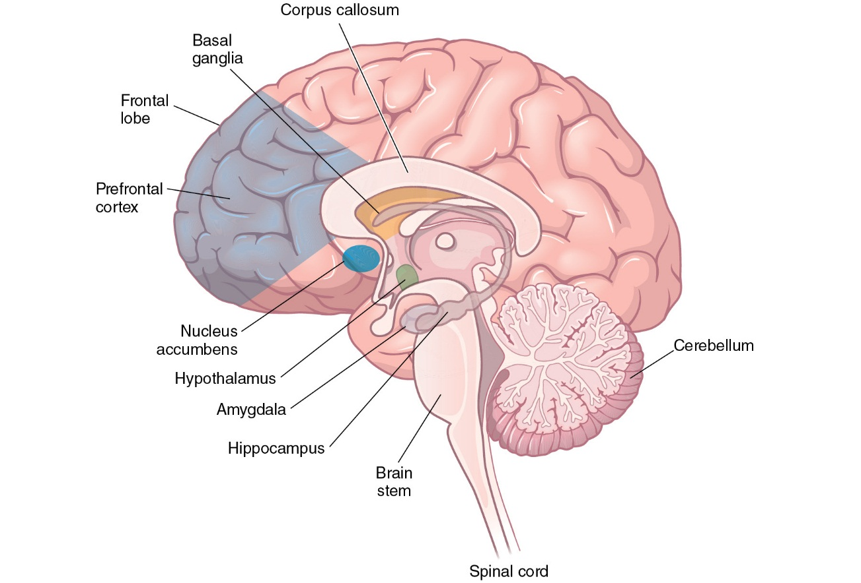
The nucleus accumbens is a central component of the limbic system and is involved in goal- directed behavior (Goto & Grace, 2008). It has connections to the amygdala, hippocampus, and the prefrontal cortex (all of which will be discussed later). The nucleus accumbens is also part of the brain’s reward center. This area of the brain is involved in feelings of pleasure associated with natural reinforcers—for example, pleasure associated with eating chocolate or enjoying music, as well as the pleasure response to gambling and some drug addictions. The feelings of pleasure we experience occur when the nucleus accumbens releases dopamine. Further, Ikemoto and Panskepp (1999) report that dopamine release from the nucleus accumbens is related to the direction of attention to novel events; the ability of individuals to approach and investigate those novel events, particularly when they are related to reward or pleasure; and the maintenance of responses toward environmental cues that help survival. As a result, dopamine release from the nucleus accumbens plays a role in the learning process. In the classroom, you want your students to direct their attention to information being presented, investigate the information you present, and continue to maintain those responses to increase their learning of material. You will learn more about the role of dopamine in learning in Chapter 3. The role of the nucleus accumbens will be further discussed in Chapter 6.

The Basal Ganglia
The basal ganglia consist of several clusters of neurons found in the base of the forebrain. Together, these structures contribute to the production of movement. For example, you notice that your hands are dirty and decide to wash your hands. The basal ganglia initiate this washing behavior.

The Cerebrum
The cerebrum (cerebrum means “brain” in Latin) is by far the largest structure in the brain—so large, in fact, that when the skull is removed from the top of a person’s head, the dominant structure that can be seen is the cerebrum (Figure 1.6). The rest of the forebrain, the midbrain, and the hindbrain are tucked underneath the cerebrum in the skull.

Figure 1.6: The cerebrum
The brain’s cerebrum is where most higher-level cognitive functioning takes place.
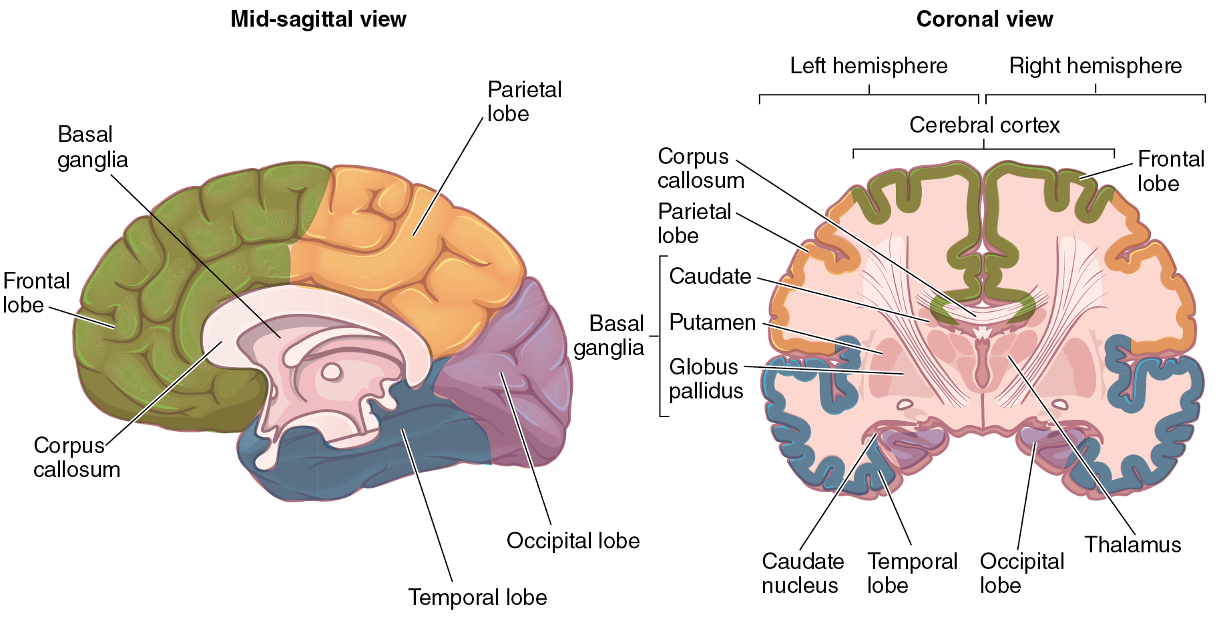
The cerebrum is organized like the cerebellum, with a cortical layer called the cerebral cortex, which consists of a thin layer of gray matter and white matter beneath the cortex. This matter helps deliver information to various parts of the cortex itself as well as other parts of the brain.
The cerebrum has two halves, called cerebral hemispheres. That is, you have a left cerebral hemisphere and a right cerebral hemisphere. It is important to recall from the discussion of neuromyths earlier in this chapter that the contributions of the left and right hemispheres to functions such as language, mathematics, emotional processing, and artistic abilities are not clear-cut. Brain-scanning technologies have confirmed that both sides of the cerebrum are activated during most higher-cognitive functions. The left hemisphere typically shows greater activation than the right during certain aspects of speech production and language comprehension. These actions involve contributions of both sides of the brain in communication. Research has suggested that some people even lack specialized hemispheric skills (Gazzaniga, 1989; Schambra et al., 2011).
These hemispheres are further divided into four additional subdivisions. These are called lobes and are further distinguished by names derived from those of the bones that cover them: the frontal lobe, the parietal lobe, the temporal lobe, and the occipital lobe (Figure 1.7). Although each lobe has specialized functions, the four lobes in each hemisphere communicate with each other and with the lobes in the other hemisphere. Communication between the hemispheres is made possible by the corpus callosum.

Frontal Lobe: Reasoning and Learning Center
Brain investigators divide the frontal lobe into three separate regions, each with its own special functions: the motor cortex, the premotor cortex, and the prefrontal cortex. The motor cortex contributes to fine motor coordination (remember the cerebellum and basal ganglia contribute to this as well). Many neurons in the motor cortex communicate directly with the motor neurons that control muscle contractions. Located immediately anterior to (or in front of) the motor cortex, the premotor cortex processes information about intended movements and sends that information on to the motor cortex.

The prefrontal cortex contains a number of regions that have been demonstrated to control a variety of executive functions, including efficiency of short-term memory (working memory), decision making, and prioritizing behaviors. When you are trying to decide whether you should do your laundry, watch television, or call your mother, it is your prefrontal cortex that weighs the alternatives and empowers you to make a decision. In the prefrontal cortex, the most anterior region under the forehead, are the neural networks that direct highest cognition and emotionally reflective processing. These networks direct such high-level functions as reasoning, judgment, emotional self-control, and goal-directed behavior. The role of the prefrontal cortex in learning is discussed in Chapters 4 and 8. The prefrontal cortex plays a critical role in who you are, what you do, and most importantly for our purposes, how you learn.

Figure 1.7: The lobes of the brain
Each of the brain’s four lobes specializes in a different function, but they all work together in order to think and perform tasks.

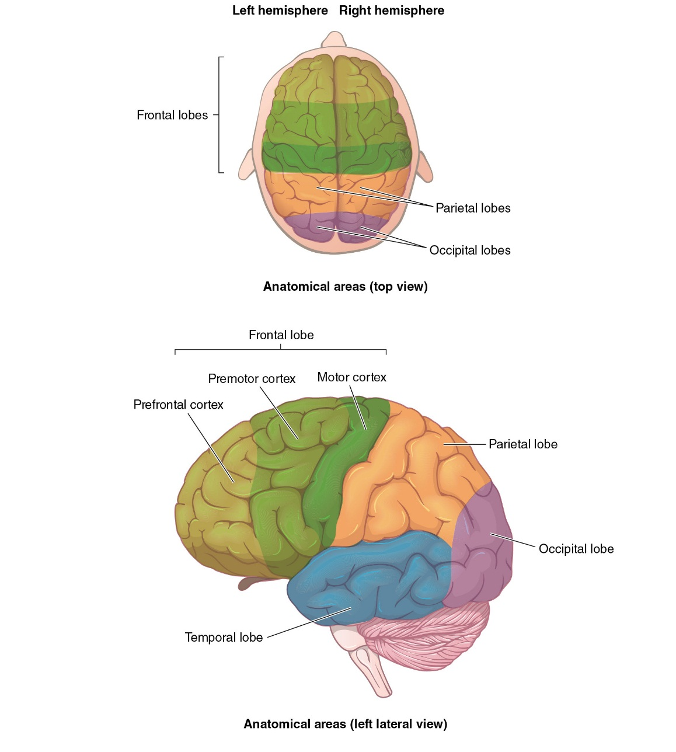

Parietal Lobe: Somatosensory Processing
Further back in the brain are the parietal lobes, separated from the frontal lobes by a particularly prominent depression in the wrinkled surface of hills and valleys that compose the brain’s outer layer, the cerebral cortex. Within the parietal lobes are the ultimate receptors that interpret sensory input arriving through the sensory intake system. The variety of separate parietal lobe intake signals come from a variety of sensory receptors, including those responsive to pressure, temperature, light touch, vibration, and pain. These receptors compose the somatosensory system, which refers to sensation that comes from our skin and body.

Occipital Lobe: The Brain’s Eye
The occipital lobes are situated at the back end of the cerebrum, behind the parietal lobes. The principal function of the occipital lobes is to process visual information coming from the eyes. The occipital lobe receives information about the images detected by the eyes, analyzes that information by breaking each image into tiny components, and then reconstitutes the image after communicating with the frontal, parietal, and temporal lobes.

Temporal Lobe: Sound and Language Processor
The temporal lobes, on each side of the brain, deep behind the ears, are responsive to sensory input from the auditory systems. In the temporal lobes sounds are evaluated and ultimately stored. It makes sense, then, that language comprehension is largely regulated in the temporal lobe. It is also within the temporal lobes that an important system of emotional and memory processing is located.

The Brain’s Unique Circulatory System
The brain tissue receives the oxygen, nutrients, and other metabolites it needs not directly from the circulating blood but indirectly from its unique circulation of clear fluid composed of especially filtered components from the blood supply in the spine. This fluid is called cerebrospinal fluid (CSF).
You will learn more about the role of CSF in neural communication in Chapters 3 and 6.
Now that you have an idea of what structures make up the brain, we will turn to development. Brain development is an important part of educational neuroscience in that it provides us with information about how anatomy and skills develop over time in response to both genetics and the environment.

1.5 Brain Development Across the Lifespan
Neuronal development begins shortly after conception and doesn’t end until the baby is born. During this gestational period in the womb, the production rate of neurons in the unborn fetus reaches up to 250,000 per minute. Essentially all the neurons a baby carries into the world at birth and through its entire life are created during the gestational period.
The mature human brain contains billions of neurons and trillions of support cells. Although there is some minimal construction of new neurons after birth, the supporting glial cells continue to divide and multiply throughout life. Glial cells are support cells that roam free in the brain and help stabilize synapses and provide myelin to axons. Among other functions, specialized glial cells construct the strong insulation that builds up around axons. This insulating myelin, mentioned earlier, increases the efficiency of brain circuits, including the durability and speed of memory retrieval.
The number of neurons decreases during one’s lifetime, almost from the time of birth. Although it may seem counterintuitive, this process, called neuroplastic pruning, actually makes the brain more efficient and makes way for the connections among neurons to be constructed in response to sensory input that forms memories. Think of it as you might any streamlining process; getting rid of excess material allows for swifter and more efficient processes to take place. So although the number of neurons decreases, the number of neural connections increases, and this latter development is of vital importance.
A single neuron, by itself, cannot hold even the simplest memory. Neurons are only useful in networks with other neurons; they become efficient as their connections form and build circuits and networks of communication with other neurons. Although a number of large networks of connections is in place in newborns, in response to genetic coding, these are nothing like the sophisticated and intricate circuitry the brain develops as memory becomes stored in neural circuits. Think, for example, of a roadmap where the view is from a great distance, such that you only see the larger interstate roads. These would be the connections between major parts of the brain that are present at birth. As time and experience progress, more roads will be constructed and the communication among neurons that constitutes memory becomes more refined.
As evidence of this increasing connectivity, at birth there are estimated to be approximately 2,500 synapses per neuron in the cerebral cortex. As babies continue to receive more sensory information into their cerebral cortexes, the connections among neurons increase with the development of more axon dendrite circuits. With the increasing roadways of these circuits, by the time a child reaches age 2 or 3, the average number of synapses per neuron reaches up to 15,000.
The number of synapses continues to increase throughout life, although the rate of formation levels off. What changes with each new experience, idea, memory retrieval, and sensory intake is the location of the connections and synapses. This is the brain’s wonderful responsiveness, described as neuroplasticity. As you will discover in Chapter 6, this pruning away of unused networks is associated with strengthening of the networks that are the most frequently used. This strengthening comes in the form of the myelin installation that wraps around the axons.
Neuroplasticity includes both the formation of new synapses and the pruning away of unused synapses and connections. Just as neurons that are not used as part of connecting circuits are pruned away, small connections of neurons, axons, and dendrites receiving little activation are also eliminated so that more of the brain’s limited supply of oxygen and glucose are available for the roadways that are the most active. To continue with the developmental streamlining of neuroplasticity, the most used roadways in the maturing brain develop the most synapses and synaptic pruning eliminates the unused synapses and dendrites. Pruning is dependent on which information is used. In this way, the environment does play a role in which connections are maintained and which connections are lost. Pruning occurs throughout the lifespan. For example, gray matter increases at early ages; however, around the time of puberty gray matter loss begins. This gray matter loss is related to the pruning of unused synapses and connections and represents the brain’s maturation, including the increase in myelin in the most used circuits. Maturation first occurs toward the back of the brain and then starts to move forward. Pruning and the increase in myelin in most active networks in the frontal lobes occur last, at the end of adolescence (Gogtay et. al, 2004). By the time adulthood is reached, there are thousands of synapses per neuron in the cerebral cortex.

1.6 Analyzing the Brain: How We Know What We Know
You might be asking as you read this chapter, how do we know what we know about the brain today? How can we know what the brain is doing and how it processes information? Good question.

Ask Yourself
Return to the brief pre-test you took on the brain’s structure. How accurate was your initial list of parts and their functions? Try to add to this list now using the information you just learned from this section.
The past few decades of research from neuroscience have provided extraordinary progress in our understanding of how the brain admits information and processes it en route to it becoming memory. The advances in the technological tools we use to examine the brain are the primary reason we’ve been able to do this. Advances in functional neuroimaging technology in particular have allowed for much of this progress. The research findings that have resulted from these new and enhanced technologies have proven invaluable to modifying and creating altogether new methods for teaching and learning. In this section, we briefly highlight the most common ways that cognitive neuroscientists study the brain today—or, in other words, we discuss how we know what we know!
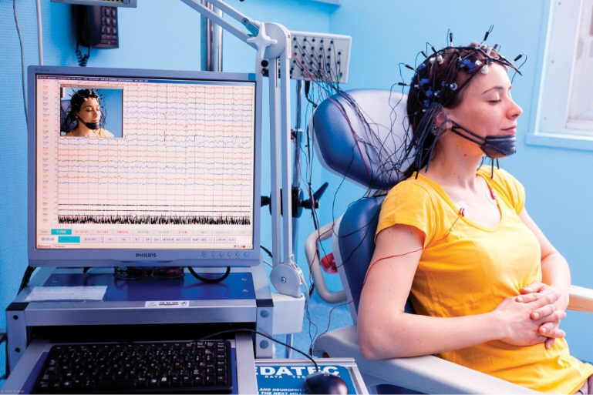
Each one of the nodes in this photo is recording the electrical activity of a specific part of the woman’s brain. The readout on the monitor is called the electroencephalogram (EEG).

Electroencephalography
One way of recording brain functioning is by examining the brain’s electrical activity. Studies of the brain’s electrical activity by way of electroencephalography (EEG) show the pattern of movement as information travels through the brain. For example, bursts of brain activity from the reticular activating system can be followed milliseconds later by bursts of electrical activity in the emotional processing system. This can then be followed by increased electrical activity in the lower reactive brain or the higher reflective prefrontal cortex executive function zones. From these electrical monitoring scans, we find evidence that the emotional state of the brain strongly influences which part of the brain processes the incoming information. EEGs enable investigators to measure brain responses in milliseconds, or thousandths of seconds. An example of an EEG study that is perhaps important for the field of educational neuroscience comes from Park et al. (2013). They tested working memory under different illuminations while recording EEG. Their results indicated that changes in light level significantly affected brain activation. Specifically, it was noted that brighter lights produced changes in the frontal lobes of the brain that reflected a reduction of working memory load; however, the change in brain activation was not related to behavioral performance. Participants performed the same on the working memory task in both dark and bright conditions.

Magnetoencephalography
Magnetoencephalography (MEG) is a technique that enables investigators to measure the magnetic fields generated by active brain cells. Just as an electric current flowing through a wire produces a magnetic field, so too do the incredibly small electrical currents generated by neurons. These microscopic magnetic fields are measured using a special “captor,” which is lowered over the subject’s head.
Like the EEG technique, MEG accurately records brain activity within milliseconds. It is more sensitive to the speed of brain transmission than EEG because magnetic fields can pass through bone and skin without the distortion that occurs with the transmission of electrical currents. However, like EEG, MEG does not allow precise localization of brain activity. While EEG is capable of measuring electrical signals from the cortex and from the stem regions, the MEG cannot pick up signals from deep within the brain. In a MEG experiment, Prendergast et al. (2013) found significant activation in the prefrontal cortex during the encoding and recognition phases of memory. These results help us further understand how the memory systems of the brain work.
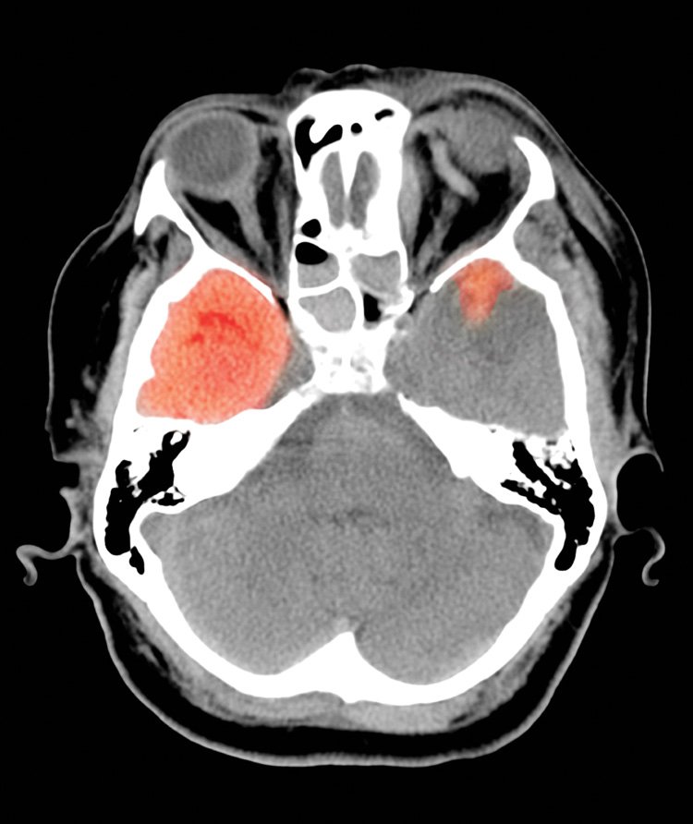
Kallista Images/SuperStock
A 67-year-old woman fell and hit the left side of her head. A computed tomography (CT) scan can help doctors identify the exact location of her injuries.

Computed Tomography
Also known as computerized axial tomography or computer-assisted tomography (CAT), the computed tomography (CT) scan provides three-dimensional images of the brain. Tomography involves passing X-rays through the head at various angles and obtaining a large number of two-dimensional X-ray images or slices, which are then converted into a three-dimensional image by the computer. This method is used to establish links between behavior and specific brain regions (Filler, 2010). One such example of this is a study conducted by Wolters, Brouwers, Moss, and Pizzo (1995).
Although CT scans can provide us with information about what the brain looks like, they can only produce a static picture of the brain. That is, the image produced by a CT scan is an image of the brain at one moment in time, such as a photograph. In contrast, the images produced by EEG and MEG are dynamic images. A dynamic image means that it is an image of the brain while it is conducting a task or processing an emotion. Therefore, these other imaging techniques are more likely to be used when we are examining the learning process, whereas a CT scan is more likely to be used to examine the effects of trauma on the brain, or to locate a tumor or damage from a stroke.

Positron Emission Tomography
Many investigators use positron emission tomography (PET) scans in their studies of brain function because the images produced by PET are much more detailed and they are also dynamic pictures of the brain. In the PET technique, the subject is injected with a radioactive isotope. Remember that blood flow in the brain is increased in those regions that are most active. This means that active regions contain the most radioactive isotopes and release the most radiation. A detection device is placed around the subject’s head while the subject is performing a task, such as looking at a word or pointing to a stimulus. As the subject participates in the task, certain brain areas become increasingly active, and blood flow increases in those areas. Images of those increased areas of activity are created. Studies that use PET technology are producing a wealth of information about how the brain works. More recently, the PET technique has been modified to allow for the study of specific chemicals in the brain (Torigian et al., 2013).
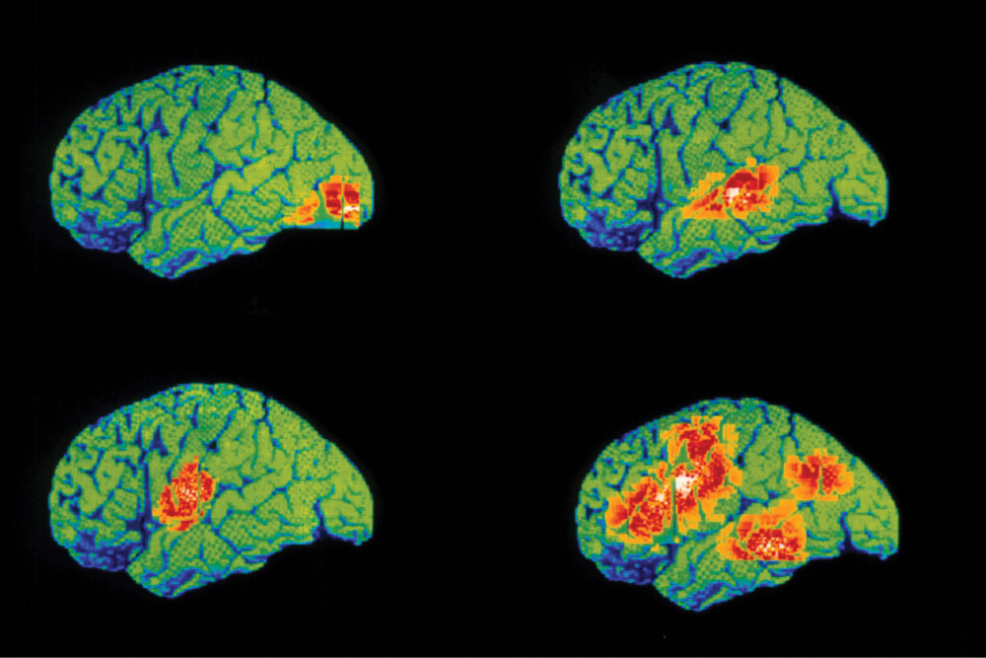
WDCN/Univ. College London/Science Source
Many of the areas of the brain discussed in this chapter can be seen in action here with a PET scan. The upper left image shows the occipital lobe activated by vision, the upper right shows how hearing activates the temporal lobe, and the lower left shows language areas and speech areas in the motor cortex activated by speech. The lower right scan is of a person thinking of verbs and speaking about them, which generates high activity all over the brain, including the motor cortex.
The information to be gained from PET studies is important. However, PET cannot accurately record the time course of many cognitive activities. It takes minutes to make a PET image, and most cognitive functions occur in less than a second.

Functional Magnetic Resonance Imaging
Functional magnetic resonance imaging (fMRI) is a measurement technique that is built on conventional magnetic resonance imaging (MRI) technology (Song, 2012). While MRI is used to produce detailed, static images of the brain, fMRI permits measurement of blood flow through a brain region, which is an indicator of activity in that region. fMRI is as close as we’ve come to getting “moving pictures” of the brain’s activity. An example of fMRI in research on learning and the brain can be noted from the research conducted by Fugelsang and Dunbar (2005), who used fMRI to measure changes in the brain after learning different science concepts. They found changes in brain activation after learning occurred.
The fMRI technique is noninvasive and does not require administration of radioactive chemicals, which means that subjects can be tested repeatedly without risk of exposure to radiation. Moreover, fMRI has a time lag of about 1 second (Stehling, Turner, & Mansfield, 1991), which is far superior to that of PET. EEG and MEG are capable of recording brain activity within milliseconds of its occurrence and, hence, provide a more accurate measure of the time course of brain activity than does fMRI. However, fMRI is much better for localizing a specific function in the brain than are EEG or MEG. See Table 1.2 for a summary of these methods.

Table 1.2 Summary of brain imaging methods
Imaging Method | Type of Image Produced | How it Works
EEG | Dynamic | In an EEG, multiple electrodes are attached to different regions of the brain. The electrodes record the electrical activity of the brain and send the information to a computer for analysis. Scientists are able to determine which areas of the brain are most active. However, this method cannot record the activity of structures deep in the brain.
MEG | Dynamic | In an MEG, magnet detectors are placed around the head to record the magnetic fields that are generated by the electrical activity of the neurons. It is similar to EEG in that it records activity at the surface of the brain.
CT | Static | In a CT scan, an X-ray is used to produce a three-dimensional image of the brain.
PET | Dynamic | In a PET scan, metabolic activity of the brain is measured. A participant is injected with a radioactive isotope that circulates through the blood. Areas of the brain that have more activity have increased blood flow. A detector around the participant’s head is able to record the areas of the brain that have higher levels of the isotope in them.
fMRI | Dynamic | In an fMRI, a magnet and a radio frequency are used to measure the areas of the brain that are most active. When brain activity increases, those areas of the brain require more oxygen, which is carried to the brain by hemoglobin. The fMRI detects the active areas of the brain by detecting increased blood flow to the areas.

1.7 Organization of This Book
The sequence of the chapters in this book follows the progress of sensory data through the brain as it is processed into long-term memory. In effect, we chart the journey of how we process information—and thus the journey of how we learn. The research about factors that influence student attention, for example, is at the initial stages of this journey in Chapter 2. We now have neuroscience research tools that literally show the types of sensory information that are most likely to attract and hold student attention and gain entry to the brain’s higher neural processing. And so this chapter starts us off on the benefits derived from the confluence of neuroscience and best educational practices.

Reading Strategies
It will be uploaded in another attachment

