Question 1:
"Sportsman Shoes" Please respond to the following:
Determine how Sportsman’s human resources practices should assess existing practices to best support their shift in competitive strategy. Provide specific examples to support your response.
Determine the kinds of challenges Sportsman will face specifically in the area of compensation and which competitive strategy will serve them best in the future. Explain your rationale.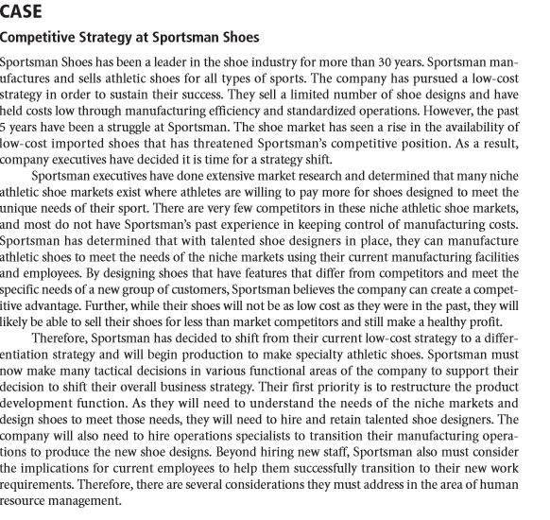

Question 2:
"Compensation Systems" Please respond to the following:
Analyze the compensation professional’s goals to determine which would be the most difficult for you to realize. Discuss ways you might be able to overcome these difficulties.
Create a list of five best practices that any organization could use to leverage a compensation system for positive impact. Provide specific examples to support your response.

