Exercise Set 6.4 (6, 10, 12, 14, 26)
6-14, Find the total area bounded by the x-axis and the curve y = f(x) on the indicated interval.
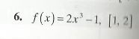
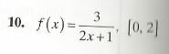
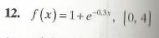
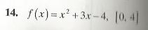

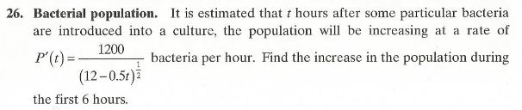

Exercise Set 6.5 (4, 6, 10, 16, 18)
4-16, Find the area of the region bounded by the graphs of the given equations.
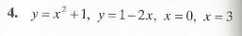
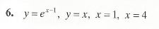
10. $y=\frac{1}{x+1}, y=e^{0.7x}, x=0, x=2$
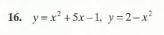

For 18, determine the area pictured (check each answer using a graphing utility if possible). Determine the limits of intersection if necessary.
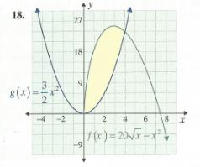

Exercise Set 6.6 (4, 8, 14, 20, 24, 28)
4 & 8, verify that the differential equation has the given function as a particular solution.
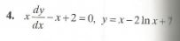
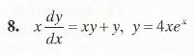
14, find the solutions of each separable differential equation.
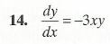
20-28, solve each initial-value problem or obtain a general solution as indicated. (refer to table below of solutions in the next if necessary.)
