Question 1
- Given 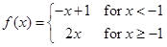, evaluate f ( -2 )
 | A. | 4
 | B. | -8
 | C. | -6
 | D. | 3
5 points

Question 2
- What is the size of the matrix product
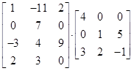
 | A. | 4x3
 | B. | 3x4
 | C. | 3x3
 | D. | 4x4
5 points

Question 3
- Given A = 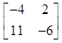, find the inverse of A.
 | A. | 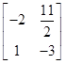
 | B. | 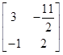
 | C. | Does not exist.
 | D. | 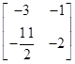
5 points

Question 4
- Let h(x) = x² - 1 and let k(x) = x - 2, then (h ৹ k)(x) =
 | A. | x² - 1
 | B. | x² - 3
 | C. | x² - 4x + 3
 | D. | x² - 2x + 5
5 points

Question 5
- Determine b to the nearest tenth. Using Law of Sine
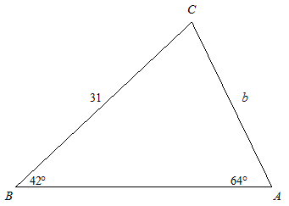
 | A. | 28.8
 | B. | 27.2
 | C. | 25.5
 | D. | 23.1
5 points

Question 6
- If f(x) = x - 2 and g(x) = 3x + 1, then (f + g)(x) =
 | A. | 2x + 1
 | B. | 4x + 1
 | C. | 4x - 1
 | D. | x - 1
5 points

Question 7
- Given f(x) = x² - 9 and g(x) = x - 3, find 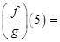
 | A. | 5(x + 3)
 | B. | x + 3
 | C. | 8
 | D. | ¹⁄₈
5 points

Question 8
- Find the inverse of f(x) = 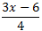
 | A. | ⁴⁄₃x + ⁸⁄₃
 | B. | ⁴⁄₃x + 2
 | C. | ⁴⁄₃x - ⁸⁄³
 | D. | ⁴⁄_{3x - 8}
5 points

Question 9
- Find the value of b.
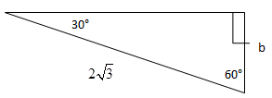
 | A. | 2√3
 | B. | 4√2
 | C. | √3
 | D. | 3
5 points

Question 10
- If f(x) = 5x + 3 and g(x) = x² + 4, what is (f ৹ g)(0) ?
 | A. | 13
 | B. | 7
 | C. | 3
 | D. | 23
5 points

Question 11
- Solve
3x –y = 7
-3x+y = 5
 | A. | No solution
 | B. | (1, -4)
 | C. | (1, 8)
 | D. | (0,0)
5 points

Question 12
- If cos(α) = 2/3 what is the value of tan(α) ?
 | A. | ^{√5}⁄₂
 | B. | ^{√5}⁄₃
 | C. | ¹⁄₃
 | D. | 5
5 points

Question 13
- Solve for x
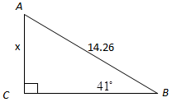
 | A. | 8.46
 | B. | 9.36
 | C. | 8.97
 | D. | 7.65
5 points

Question 14
- The angle of depression is the angle between the horizontal and the line of sight looking _________________________ to an object.
 | A. | backwards
 | B. | sideways
 | C. | up
 | D. | down
5 points

Question 15
- If cos(α) = ¹⁄₂ what is the value of sin(α) ?
 | A. | ^{√3}⁄₂
 | B. | ¹⁄₃
 | C. | ²⁄₃
 | D. | 5
5 points

Question 16
- Based on the picture below, how tall is the tree to the nearest foot.
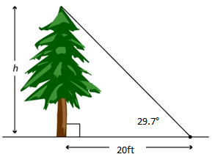
 | A. | 594 ft
 | B. | 11.4 ft
 | C. | 136.1 ft
 | D. | 14.7 ft
5 points

Question 17
- 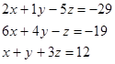
 | A. | ( -1, -2, 5)
 | B. | No Solution
 | C. | ( -1,0,13)
 | D. | ( 0,1,-6)
5 points

Question 18
- Pilot John Smith sees a small boat at an angle of depression of 29o. If the altitude or the air craft is 4km, find the surface distance x between the plane and the raft is approximately________?
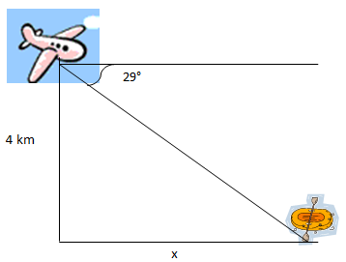
 | A. | 8.73km
 | B. | 3km
 | C. | 6.42km
 | D. | 7.21km
5 points

Question 19
- State the domain of the following function: √x - 4
 | A. | (4, ∞)
 | B. | [0, ∞)
 | C. | (5, ∞)
 | D. | [-4, ∞)
5 points

Question 20
- What is 120 degrees converted to radians?
 | A. | 3 radians
 | B. | π radians
 | C. | ^{2π}⁄₃ radians
 | D. | ^{π}⁄₁₂ radians

