Matrices
Please answer the following problems, clearly showing all steps. You MUST use the specified methods for problems 7, 8, and 9. Using a different method will yield ZERO points.
Calculate. If not possible, put undefined:
Problems 1, 2, 3, 4, 5, and 6 = 5 points each
- V + W
- 3Z
- WZ
- Determinant of W
- YV
- W + 4V
Problems 7, 8, and 9 = 10 points each
Use Cramer’s Rule (determinants) to solve.
- 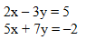
- 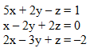
- Use the inverse matrix method to solve
