Ta-Nehisi Coates' 'Between the World and Me' soberly details what it's like to be black in America
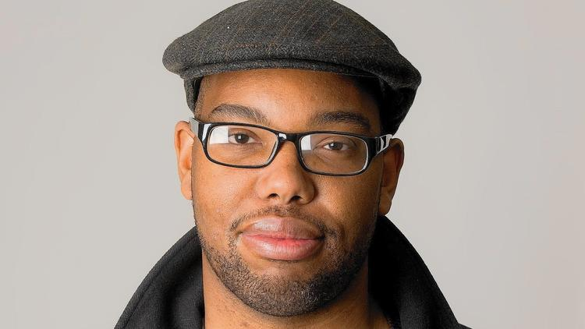 By Lawrence Burney Baltimore City Paper
As a black child growing up in America, receiving "the talk" is inevitable. Not the talk about where babies really come from, but the talk that brings you to reality—and that talk comes in stages. I remember walking home with my mother as a young child. She came to pick me up from my grandmother's house right off Harford Road and 25th Street and we walked down 25th, under the train tracks and to our house on Aisquith Street in East Baltimore. We began to talk on the way there. I can't remember who sparked the conversation but I do recall that it was about skin color and race.

She asked me what race I thought she was and I said "brown" due to her caramel-toned skin. She then asked me about my grandmother, whose skin is much lighter. I told her that Grandma was "white" and that I (much lighter than I am now) was as well. She quickly corrected me and told me that light skin wasn't what made you white and that our family was, in fact, black no matter the tone of our skin. This was hard for me to grasp but I accepted it as truth.

The talk continued over the next few years. Conversations about skin color progressed into ones about why police were always in our neighborhood and why my older sister was beaten by police when she was a teenager. When I became a teenager, my father regularly gave me talks on how to always stand my ground against white people, as they would surely attempt to exercise their perceived superiority over me—passively or overtly. None of these exchanges have ever left me, even the ones I can't remember.

Those experiences are mirrored in Ta-Nehisi Coates' new book "Between the World and Me," which is structured as a letter from the author to his 15-year-old son, Samori, on what it means to be black in America. Early on, Coates mentions Abraham Lincoln's Gettysburg Address where the former president proclaimed, "that government of the people, by the people, for the people, shall not perish from the earth." This is mentioned to give insight on what the term "people" has meant over time in America. Coates reminds his son, "In 1863 it did not mean your mother or your grandmother, and it did not mean you and me." Even some people who were actually considered "people" were subject to the illusion of race, like Jews, Irish, Italians and other Europeans immigrants who eventually graduated to whiteness in order to further denigrate those of a darker hue. Coates calls these people The Dreamers: people who enjoy their privilege but wince at the thought of accepting the origins of that privilege—the abuse, exploitation, and destruction of black bodies and psyches.

At one point, Coates recounts noticing the difference between the luxuries of comfort that whites on television experienced compared to the overcast of fear in the West Baltimore neighborhood he grew up in. He relives the terror he felt being pulled over by the notoriously racist Prince George's County Police Department in his early 20s. He tells Samori about his college friend, Prince Jones, who was unlawfully killed by the same PG County police who illegally followed him over state lines to northern Virginia. While reading "Between the World and Me" is a rewarding experience in the fact that more African-American stories need to be shared and that Coates is a superb writer, at times, reading it feels like a heavy burden; the fuel that fires this extended letter is Coates' perpetual fear for the safety of his young, black male child—safety that he can only assure when Samori is in his presence. Coates recalls his son staying up until 11 p.m. to hear the verdict from the Trayvon Martin case, only to be crushed by another Dreamer being let off the hook for destroying a black life. Even with his son going to his room to cry out his sadness, Coates elected not to comfort him, believing it to be dishonest and ignoring the reality of what it means to be black.

I remember that night too. I was at home with friends when an alert from my New York Times app popped up informing me that George Zimmerman would not receive any jail time for murdering Trayvon. I remember feeling empty; too empty to cry like Samori did. That feeling has returned each time a black person has been slain only to be further disrespected by the law. I felt the same emptiness when my own 4-year-old daughter innocently confessed to me that she was scared of the police and I felt even emptier when I did not know exactly how to reply. There isn't a feeling much lower than knowing that nothing in my power can save her from possibly suffering the same fate as a Sandra Bland. A 4-year-old child should be afraid of "monsters" under the bed, or loud thunder or the dark. But as a black person, that fear of the establishment is present and justifiable from an early stage—even before you can articulate why.

While generous and seemingly genuine, Toni Morrison's declaration of "Between the World and Me" as "required reading" feels like it's geared toward whites or non-blacks. If you are black, there's a great chance that by the time you've gotten to Coates' book, you were aware of its message before you even learned to read.

