Engineers have proposed a single-span suspension bridge across 8-km wide strait. The plan includes suspension towers 370 meters high at each end.
Use the Trapezoidal approximation (n=4) to estimate the total length of the cable (in meters) that is given by
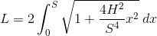

Round intermediate and final answers to the nearest ten-thousandths.
