Linear Programing Question:
Use a graphical procedure and manual calculation to determine the optimal solution to the following linear program for decision making purposes. Excel Linear Programing has been used to generate the following graph on the objective and constraints (please notice that you do not need to create this program in Excel, just use the outcomes given here to answer the questions): Objective: Minimize cost C C= 0.5 Xa + 0.4 Xb
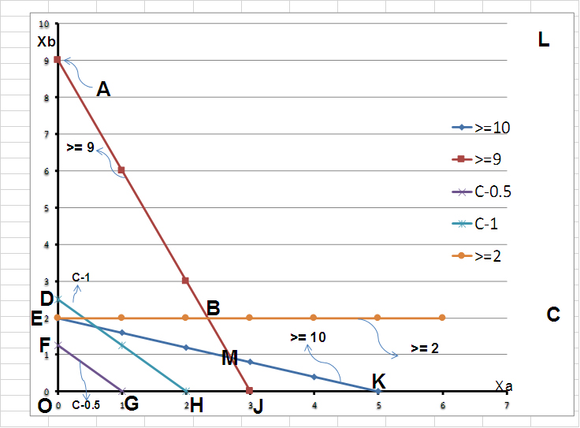

Subject to:
2Xa + 5Xb >= 10
3Xa + Xb >= 9
Xb >= 2
Where Xa & Xb are >= 0
Please notice Xa is taken on x-axis and Xb on y-axis
Required:
Note: Questions should be answered by looking at your objective and constraints and the provided Excel’s graphical results (No Excel program needs to be developed):
a) Identify the feasible region by the areas bounded with the letters. For example, you could identify your feasible solution region as: Area EBJ (just as an example). Hint, you need to test a point in each of the inequalities to decide the solution for each of them, and then decide what will be the final feasible solution region that matches all these inequalities.
b) Show your optimum corner on the graph, as an example, point H, or D, or F, or whatever you think the correct optimum corner is. Calculate the coordinates(Xa & Xb) for this optimum point using the intersection of the 2 lines that create this optimum corner (mathematically and exact values, not just guessing from the graph). Hints, there are 2 trial cost lines plotted on the graph [C=1, & C=0.5] to show the direction of minimizing the cost within the feasible region.
c) What is your minimized cost value for this model?

