Name: ____________________________

Student Number: ____________________

Answer the questions below. Make sure to show your work and provide complete geometric explanations for full
credit.

- Are and congruent? Explain.

2. What are two other names for ?

3. Write the converse of the statement. If the converse is true, write true; if not true, provide a counterexample.

If x = 4, then x² = 16.

4. What are the converse, inverse, and contrapositive of the following true conditional? What are the truth values of each?
If a statement is false, give a counterexample.
If a figure is a rectangle, then it is a parallelogram.

5. Complete the two-column proof.
Given:
Prove:

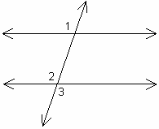
Drawing not to scale
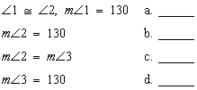

6. Write the two conditional statements that form the given biconditional. Then decide whether the biconditional is a good
definition. Explain.

Three points are collinear if and only if they are coplanar.

7. Identify the form of the equation –3x – y = –2. To graph the equation, would you use the given form or change to another form? Explain.

8. Find the values of the variables. Show your work and explain your steps. The diagram is not to scale.

9. Line p contains points A(–7, –9) and B(4, 0). Line q is parallel to line p. Line r is perpendicular to line q. What is the
slope of line r? Explain.

10. For the two quadrilaterals below, and Complete this congruence statement for the two quadrilaterals.
___?___

11. Are congruent? Justify your answer.

12. Explain how you can use SSS, SAS, ASA, or AAS with the definition of congruent triangles to prove that .

13. In the figure, , , and . Prove that .

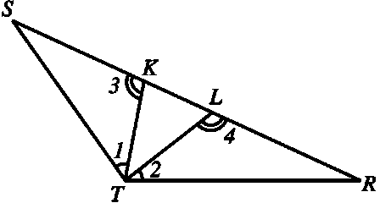

14. B is the midpoint of and D is the midpoint of Solve for x, given and

15. Complete the indirect proof.

Given: Rectangle JKLM has an area of 36 square centimeters. Side is at least 4 centimeters long.
Prove: KL ≤ 9 centimeters

Assume that a. ____. Then the area of rectangle JKLM is greater than b. _____ , which contradicts the given information that c. _____. So the assumption must be false. Therefore, d. _____.

16. P, Q, and R are three different points. PQ = 3x + 2, QR = x, RP = x + 2, and . List the angles of ΔPQR in order from largest to smallest and justify your response.

17. Find the measures of an interior angle and an exterior angle of a regular polygon with 6 sides.

18. Isosceles trapezoid ABCD has legs and and base If AB = 6y – 6, BC = 4y – 7, and CD = 7y – 12, find the value of y.

19. Verify that parallelogram ABCD with vertices A(–5, –1), B(–9, 6), C(–1, 5), and D(3, –2) is a rhombus by showing that it is a parallelogram with perpendicular diagonals.

20. Can this quadrilateral be a parallelogram? Explain.

