Which function is shown on the graph?

f(x)=−1/2cosx
f(x)=1/2sinx
f(x)=−1/2sinx
f(x)=1/2cosx
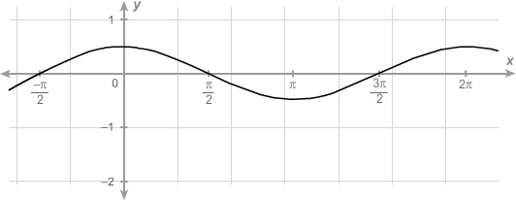

Graph ​ g(x)=2cosx ​.
Use 3.14 for π .
Use the sine tool to graph the function. The first point must be on the midline and the second point must be a maximum or minimum value on the graph closest to the first point.

What is the frequency of the sinusoidal graph?
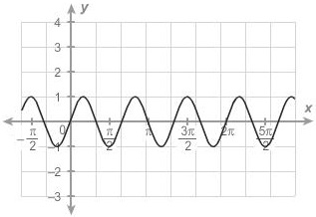

Enter your answer in the box.

Which equation represents the function on the graph?

f(x)=sin2x
f(x)=sin1/2x
f(x)=cos2x
f(x)=cos1/2x

What is the period of the function f(x)=sin1/6x ?

1/2π
6π
π/6
1/6

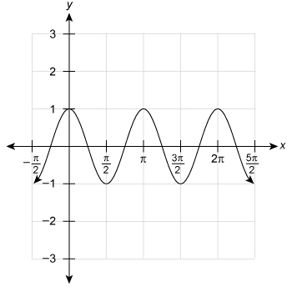

Graph ​ h(x)=2sin(2x)−3 ​.
Use 3.14 for π .
Use the sine tool to graph the function. The first point must be on the midline and the second point must be a maximum or minimum value on the graph closest to the first point.

Graph ​ g(x)=4cos(2x)−2 ​.
Use 3.14 for π .
Use the sine tool to graph the function. The first point must be on the midline and the second point must be a maximum or minimum value on the graph closest to the first point.
Which graph represents f(x)=6cos(4πx) ?

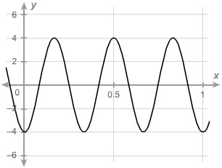
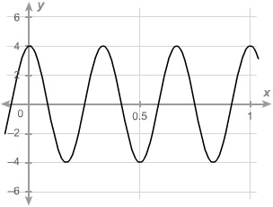
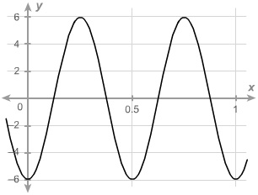
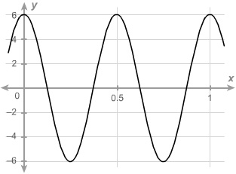

A cosine function has a period of 3, a maximum value of 20, and a minimum value of 0. The function is a reflection of its parent function over the x-axis.
Which function could be the function described?

f(x)=10cos(3x)−10
f(x)=−10cos(2π/3x)+10
f(x)=−10cos(3x)+10
f(x)=10cos(2π/3x)+10

A sinusoidal function whose frequency is 3, maximum value is 15, minimum value is −3 , and y-intercept is (0, 6) .
Which function could be the function described?

f(x)=9sin(x/3)+6
f(x)=9sin(6πx)+6
f(x)=9sin(6πx)+3
f(x)=9sin(3x)+3

The table shows the height in centimeters, that a weight bouncing from a spring would achieve if there were no friction, for a given number of seconds.
Time (s) | Height (cm)
0 | 0
0.75 | 15
1.5 | 0
2.25 | −15
3 | 0
3.75 | 15
4.5 | 0
5.25 | −15
6 | 0
From its resting position, how long does it take the weight to bounce one direction, then the other, and then back to its resting position?
Enter your answer in the box.
s

The graph shows the distance y, in centimeters, a pendulum moves to the right (positive displacement) and to the left (negative displacement), for a given number of seconds x.
How many seconds are required for the pendulum to swing from its position furthest to the right to its position furthest to the left?
Enter your answer in the box.
s
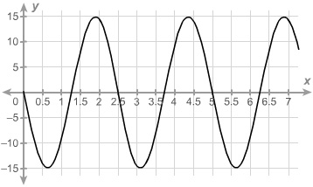

The graph shows how many centimeters above a table top, y, a painted spot on an automated hamster wheel is for a given number of seconds x.
How many degrees is the painted spot turning in 0.75 s?
Enter your answer in the box.
°
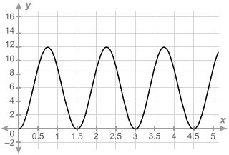

The average daily maximum temperature for Laura’s hometown can be modeled by the function f(x)=4.5sin(πx/6)+11.8 , where f(x) is the temperature in °C and x is the month.
x = 0 corresponds to January.
What is the average daily maximum temperature in May?
Round to the nearest tenth of a degree if needed.
Use 3.14 for π .
Enter your answer in the box.
°C

The temperature of a room during an experiment can be modeled by the function f(x)=23.7cos(πx/60)+18 , where f(x) is the temperature °F and x is the number of hours into the experiment.
What is the lowest temperature the room reached during the experiment?
Round to the nearest tenth of a degree if needed.
Use 3.14 for π .
Enter your answer in the box.
°F

The Colossus Ferris wheel debuted at the 1984 New Orleans World’s Fair. The ride is 180 ft tall, and passengers board the ride at an initial height of 15 ft above the ground. The height above ground, h, of a passenger on the ride is a periodic function of time, t. The graph displays the height above ground of the last passenger to board over the course of the 15 min ride.
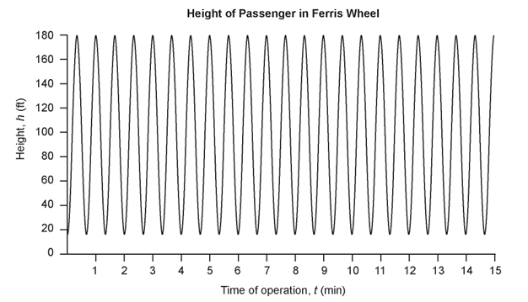
Sine function model: where h is the height of the passenger above the ground measured in feet and t is the time of operation of the ride in minutes.
What is the period of the sine function model? Interpret the period you found in the context of the operation of the Ferris wheel.
Answer:
The duration of the ride is 15 min.
- How many times does the last passenger who boarded the ride make a complete loop on the Ferris wheel?
- What is the position of that passenger when the ride ends?
Answer:
A power outage occurs 6 min after the ride started. Passengers must wait for their cage to be manually cranked into the lowest position in order to exit the ride. Sine function model: where h is the height of the last passenger above the ground measured in feet and t is the time of operation of the ride in minutes.
- What is the height of the last passenger at the moment of the power outage? Verify your answer by evaluating the sine function model.
- Will the last passenger to board the ride need to wait in order to exit the ride? Explain.
Answer:

