EScore: ______ / ______
Name: ____________________________
Student Number: ___________________
Short Answer: Type your answer below each question. Show your work.

1 | Verify the identity. Show your work.  cot θ ∙ sec θ = csc θ  cot θ ∙ sec θ = csc θ  given cot θ = cos θ / sin θ, and sec θ = 1 / cos θ:  cos θ / sin θ ∙ 1 / cos θ = csc θ  1 / sin θ = csc θ  given 1 / sin θ = csc θ. Thus:  csc θ = csc θ
2 | A gas company has the following rate schedule for natural gas usage in single-family residences:  Monthly service charge $8.80  Per therm service charge  1st 25 therms $0.6686/therm  Over 25 therms $0.85870/therm  What is the charge for using 25 therms in one month? Show your work.  What is the charge for using 45 therms in one month? Show your work.  Construct a function that gives the monthly charge C for x therms of gas.  The charge for the first25 therms is the monthy charge of $8.80 plus the 25 therms, and thats $0.06686*25 therms. So the for the charges above the 25 therms you take what we just did and add $0.85870(x-25), and that ends up look like: $8.80+$0.6686*25+$0.85870(x-25). The x there at the end represents the number of therms used above 25. So the x in our case would be 45; $8.80+$0.6686*25+$0.85870*(45-25)
3 | The wind chill factor represents the equivalent air temperature at a standard wind speed that would produce the same heat loss as the given temperature and wind speed. One formula for computing the equivalent temperature is  W(t) = $\left\{\begin{matrix}t \\ 33-\frac{\left(10.45+10\sqrt{v}-v\right)\left(33-t\right)}{2204} \\ 33-1.5958\left(33-t\right) \end{matrix} \right.$ $\begin{matrix}if 0≤v<1.79 \\ if 1.79≤v<20 \\ if v≥20\end{matrix}$  where v represents the wind speed (in meters per second) and t represents the air temperature . Compute the wind chill for an air temperature of 15°C and a wind speed of 12 meters per second. (Round the answer to one decimal place.) Show your work.
4 | Complete the following:  (a) Use the Leading Coefficient Test to determine the graph's end behavior.  (b) Find the x-intercepts. State whether the graph crosses the x-axis or touches the x-axis and turns around at each intercept. Show your work.  (c) Find the y-intercept. Show your work.  f(x) = x²(x + 2)  (a).  (b).  (c).
5 | For the data set shown by the table,  a. Create a scatter plot for the data. (You do not need to submit the scatter plot)  b. Use the scatter plot to determine whether an exponential function or a logarithmic function is the best choice for modeling the data.  Number of Homes Built in a Town by Year  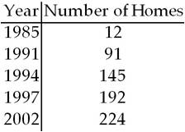
6 | Verify the identity. Show your work.  (1 + tan²u)(1 - sin²u) = 1
7 | Verify the identity. Show your work.  cot²x + csc²x = 2csc²x - 1
8 | Verify the identity. Show your work.  1 + sec²xsin²x = sec²x
9 | Verify the identity. Show your work.  cos(α - β) - cos(α + β) = 2 sin α sin β
10 | The following data represents the normal monthly precipitation for a certain city.  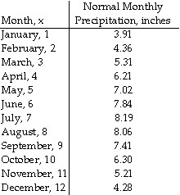  Draw a scatter diagram of the data for one period. (You do not need to submit the scatter diagram). Find the sinusoidal function of the form that fits the data. Show your work.

.

11. | The graph below shows the percentage of students enrolled in the College of Engineering at State University. Use the graph to answer the question.  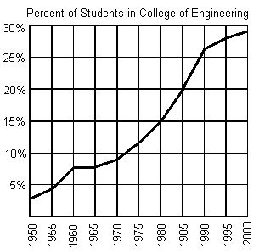  Does the graph represent a function? Explain
12. | Find the vertical asymptotes, if any, of the graph of the rational function. Show your work.  f(x) = $\frac{x-4}{x(x-4)}$
13. | The formula A = 118e^{0.024t} models the population of a particular city, in thousands, t years after 1998. When will the population of the city reach 140 thousand? Show your work.
14. | Find the specified vector or scalar. Show your work.  u = -4i + 1j and v = 4i + 1j; Find $\left\|u+v\right\|$.
15. | Find the exact value of the trigonometric function. Do not use a calculator.  $$\cot\left(-\frac{5π}{4}\right)$$
16. | Find the x-intercepts (if any) for the graph of the quadratic function.  6x² + 12x + 5 = 0  Give your answers in exact form. Show your work.
17. | Use the compound interest formulas A = Pe^{rt} and A = P${\left(1+\frac{r}{n}\right)}^{nt}$ to solve.  Suppose that you have $11,000 to invest. Which investment yields the greater return over 10 years: 6.25% compounded continuously or 6.3% compounded semiannually? Show your work.
18. | Find functions f and g so that h(x) = (f ∘ g)(x).  h(x) = (6x - 14)⁸
19. | Begin by graphing the standard absolute value function f(x) = | x |. Then use transformations of this graph to describe the graph the given function.  h(x) = 2 | x | + 2
20. | Find the reference angle for the given angle. Show your work.  -404°

Score: ______ / ______

