Andrew is filling the pool in his backyard.

Which units would be most appropriate to describe how fast the pool is filling with water?

Select **each** correct answer.

* 

in3/s

* 

cm3/min

* 

gal/h

* 

L/h

Solve for *a*.

f+a−−−−−√−r=m

* 

a=m2+r2−f

* 

a=m2−mr+r2−f

* 

a=m2−2mr+r2−f

* 

a=m2+2mr+r2−f

Solve for *x*.  
  
0 = 7*x*² + *x* + 5

* 

x=−1±i105−−−√14

* 

x=−1±i34−−√14

* 

x=−1±i139−−−√14

* 

x=−1±i120−−−√14

Which expression is equal to (x2)2−(x5)2 ?

* 

x4−2x7−x10

* 

(x2−x5)(x2+x5)

* 

(x2−x5)(x2−x5)

* 

x4−2x7+x10

Elena deposits $800 in an account that pays her 3% annual interest compounded monthly.

Which equation represents the account balance *A* after *t* years?

* 

A=800⋅(1.03)12t

* 

A=800⋅(1.03)t

* 

A=800⋅(1.0025)12t

* 

A=800⋅(1.0025)t

What is the inverse of f(x)=5x3 ?

Enter your answer in the box.

f−1(x) =  

What are the coordinates of the point that corresponds to  7π/6 on the unit circle?

* 

(3√2, −1/2)

* 

(−3√2, 1/2)

* 

(−3√2, −1/2)

* 

(−1/2, −3√2)

The function f(t)=1050⋅(1.012)t models the amount of money in an account after *t* years.

What does 1050 represent in this situation?

* 

The amount of money in the account after 5 years.

* 

The initial money deposited in the account.

* 

The interest amount in the account after 10 years.

* 

The amount of money in the account after 2 years.

What is the angle measure, in degrees?

5π/12

Enter your answer in the box.

What is the length of the radius of a circle with a central angle of 140° that intercepts an arc with length 24 cm?

Use π=3.14 in your calculation.

Enter your answer to the nearest tenth of a centimeter in the box.

 cm

What is the exact value of tanθ when cosθ=3/7  and  θ  lies in Quadrant IV ?

Simplify all radicals and rationalize the denominator, if necessary.

Enter your answer in the box.



Enter the missing angle measures, to the nearest degree, in the boxes.

m∠A = °

m∠C = °

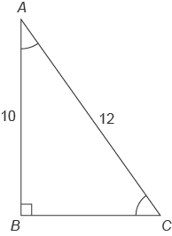

1. Graph the function .

Answer**:**

A blank coordinate plane. The horizontal x-axis ranges from negative 6 to 4 increments of 2. The vertical y-axis ranges from negative 2 to 8 in increments of 2.


(Score for Question 2: ___ of 3 points)

1. One of the zeros of the function is . Factor the function. Show your work.

Answer:

(Score for Question 3: ___ of 3 points)

1. A ramp is made using a board. The board is 12 ft long. The ramp is 3 ft high. What angle does the ramp make with the ground? Round your answer to the nearest tenth of a degree. Show your work.

Answer:

What is the period of the sinusoidal function?  
  
Enter your answer in the box.



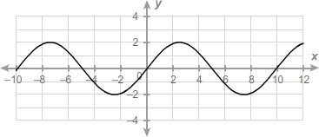

What is the minimum of the sinusoidal function?

Enter your answer in the box.



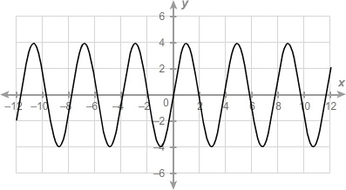

What is the maximum of the sinusoidal function?

Enter your answer in the box.



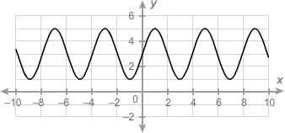

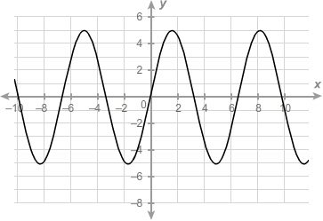

What is the equation of the midline of the sinusoidal function?

Enter your answer in the box.

*y* = 



What is the amplitude of the sinusoidal function?

Enter your answer in the box.



