SHORT ANSWER. Write the word or phrase that best completes each statement or answers the question.
Evaluate.
- ∫ (3x⁸ - 7x³ + 7) dx
Find the integral.
x 6
- ∫ + dx
6 x
x dx
- ∫

(7x² + 3)⁵
- ∫ 16p2e(4^{p3}) dp
Solve the problem.
- The rate of expenditure of a particular machine is given by M'(x) = 6x x² + 5, where x is time measured in years. Maintenance costs through the second year are $52. Find the total maintenance function.
Evaluate the integral.
3
- ∫ (2x³ - 8x⁻²) dx Two decimal places.
1
-1
- ∫ 5x⁻⁴ dx Express the answer as a fraction. -2
Evaluate the definite integral.
3 x
- ∫ dx Four decimal places. ₀ (3x² + 3)³

Use the definite integral to find the area between the x-axis and the graph of f(x) over the indicated interval. Write the answer as a fraction.
- f(x) = 2x - x²; [0, 2]
3
- f(x) = ; [1, 3] x3

Find the area of the shaded region.
11)
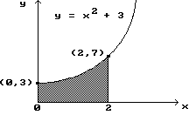
12)
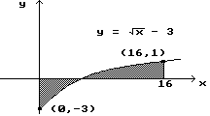
Hint: solve
x
- 3 = 0 to find the point needed.
Solve the problem.
- A certain company has found that its expenditure rate per day (in hundreds of dollars) on a certain type of job is given by E'(x) = 2x + 4, where x is the number of days since the start of the job. Find the expenditure if the job takes 6 days.
Find the area bounded by the given curves.
- y = x³, y = 4x
Solve the problem.
- Find the consumer's surplus if the demand function for an item is given by D(x) = 30 - x², assuming supply and demand are in equilibrium at x = 4.
Find the general solution of the differential equation.
dy ² - 4x
- = 24x

dx
Find the particular solution of the differential equation.
dy ² - 4x + 20; y = 20 when x = 1 17) = 6x dx

