Lane Ch 14/17

2. The formula for a regression equation is Y’ = 2X + 9.
a. What would be the predicted score for a person scoring 6 on X?
b. If someone’s predicted score was 14, what was this person’s score on X?

6. For the X,Y data below, compute:
a. r and determine if it is significantly different from zero.
b. the slope of the regression line and test if it differs significantly from zero.
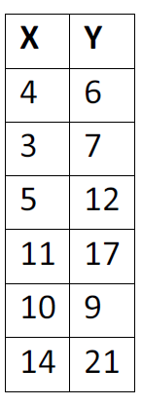
c. the 95% confidence interval for the slope.

5. At a school pep rally, a group of sophomore students organized a free raffle for prizes. They claim that they put the names of all of the students in the school in the basket and that they randomly drew 36 names out of this basket. Of the prize winners, 6 were freshmen, 14 were sophomores, 9 were juniors, and 7 were seniors. The results do not seem that random to you. You think it is a little fishy that sophomores organized the raffle and also won the most prizes. Your school is composed of 30% freshmen, 25% sophomores, 25% juniors, and 20% seniors.

a. What are the expected frequencies of winners from each class?

b. Conduct a significance test to determine whether the winners of the prizes were distributed throughout the classes as would be expected based on the percentage of students in each group. Report your Chi Square and p values.

c. What do you conclude?

14. A geologist collects hand-specimen sized pieces of limestone from a particular area. A qualitative assessment of both texture and color is made with the following results. Is there evidence of association between color and texture for these limestones? Explain your answer
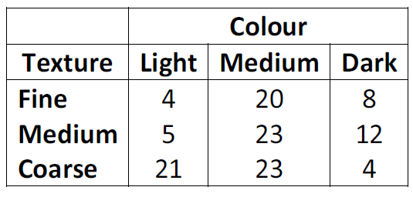

Illowsky Ch 11/12
Decide whether the following statements are true or false. Explain Why?
70. The standard deviation of the chi-square distribution is twice the mean.

Use the following information to answer the next twelve exercises: Suppose an airline claims that its flights are consistently on time with an average delay of at most 15 minutes. It claims that the average delay is so consistent that the variance is no more than 150 minutes. Doubting the consistency part of the claim, a disgruntled traveler calculates the delays for his next 25 flights. The average delay for those 25 flights is 22 minutes with a standard deviation of 15 minutes.

113. df = ________

12.3 The Regression Equation
66. Can a coefficient of determination be negative? Why or why not?

Use the following information to answer the next two exercises. The cost of a leading liquid laundry detergent in different sizes is given in Table 12.31.

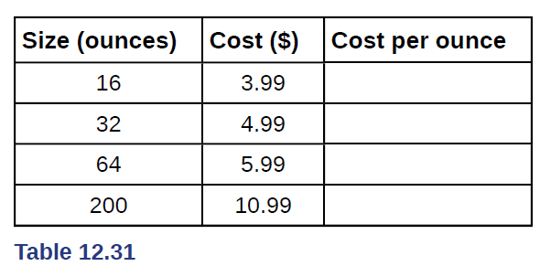

82.
a. Using “size” as the independent variable and “cost” as the dependent variable, draw a scatter plot.

b. Does it appear from inspection that there is a relationship between the variables? Why or why not?

c. Calculate the least-squares line. Put the equation in the form of: ŷ = a + bx

d. Find the correlation coefficient. Is it significant?

e. If the laundry detergent were sold in a 40-ounce size, find the estimated cost.

f. If the laundry detergent were sold in a 90-ounce size, find the estimated cost.

g. Does it appear that a line is the best way to fit the data? Why or why not?

h. Are there any outliers in the given data?

i. Is the least-squares line valid for predicting what a 300-ounce size of the laundry detergent would you cost? Why or why not?

j. What is the slope of the least-squares (best-fit) line? Interpret the slope.

