- Here are the summary statistics for the weekly payroll of a small​ company:
lowest salary equals=​$300
mean salary=​$500,
median=​$500
range =​$1400
IQR=​$700
first quartile=​$400
standard deviation=​$350.

Do you think the distribution of salaries is​ symmetric, skewed to the​ left, or skewed to the​ right? Explain why.
Select one:
a. There is not enough information to estimate the shape of the distribution.
b. The distribution is skewed to the left because the mean is equal to the median
c. The distribution is skewed to the right because the mean is equal to the median.
d. The distribution is symmetrical because the mean is equal to the median.

- Use the empirical rule to solve the problem.
At one college, GPA's are normally distributed with a mean of 3 and a standard deviation of 0.6. What percentage of students at the college have a GPA between 2.4 and 3.6?
Select one:
A. 84.13%
B. 68%
C. 95%
D. 99.7%

- According to a study by a Riviera economist, last year mortgage interest rates in Massachusetts varied according to a normal distribution with a mean of 5.8% and a standard deviation of 0.15%. What proportion of rates exceed 6.0%?
Select one:
a. 0.0918
b. 0.9082
c. - 0.0916
d. 0.5517

- The area under the standard normal (Z) distribution to right of 5.1 is approximately:
Select one:
a. 0
b. 1
c. -1
d. 0.6950

- Find the value for the standard normal variable (Z) that has an area 0.15 to the right..
Select one:

a. 1.04
b. - 1.04
c. 0.5596
d. - 0.5596
- The distribution of the length of a major league baseball game is approximately normal with a mean of 170 minutes and a standard deviation of 15 minutes. What fraction of games last less than two hours?
Select one:
a. 0.0004
b. 0.9996
c. 0.3707
d. 0.6293

- Refer to the standard normal distribution picture below. Use the Z table to obtain the shaded area [P(Z < 1.34)].
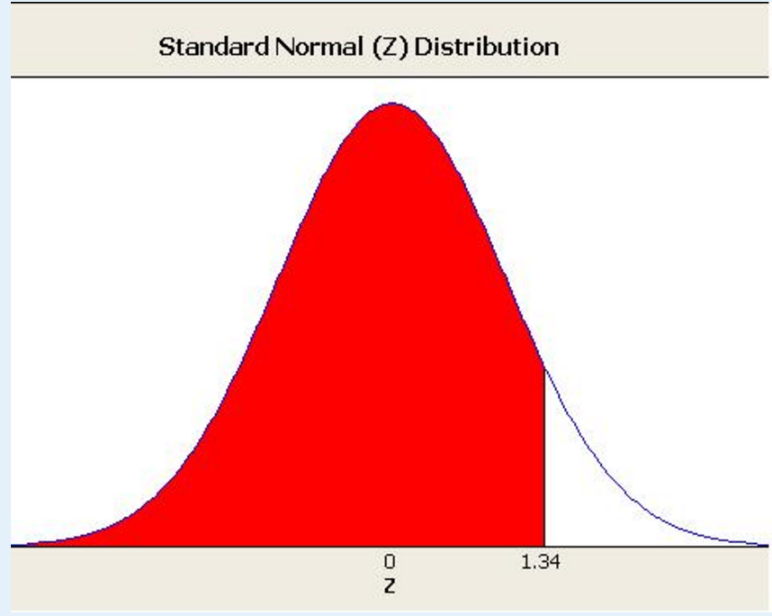
Select one:
a. 0.0901
b. 0.9099
c. 0.5517
d. 0.4483

- Use the empirical rule to solve the problem.
The amount of Jen's monthly phone bill is normally distributed with a mean of $55 and a standard deviation of $12. What percentage of her phone bills are between $19 and $91?
Select one:
A. 99.7%
B. 68%
C. 99.99%
D. 95%

- The area under the standard normal (Z) distribution to the left of 1.11 is
Select one:
a. 0.8665
b. 0.1335
c. 0.5438
d. 0.4562

- Find the value for the standard normal variable (Z) that has an area of 0.75 to the right.
Select one:
a. - 0.67
b. 0.67
c. 0.7734
d. - 0.7734
- The area under the standard normal (Z) distribution to right of Z₈₀ is 0.2. The value for Z₈₀ is approximately:
Select one:
a. 0.7881
b. 0.84
c. - 0.84
d. - 0.7882
- The distribution of heart rate for patients suffering from heart disease is approximately normal. The central 95% of heart rates for such patients lies between 73 bpm and 121 bpm (as shown in the picture below).
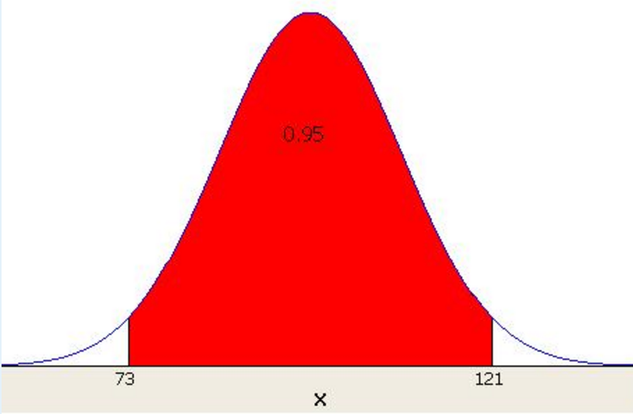
What is the (approximate) mean and standard deviation of heart rate? Do not use the Z table.
Select one:
a. Mean = 97, Standard deviation = 12
b. Mean = 97, Standard deviation = 24
c. Mean = 100, Standard deviation = 12
d. Mean = 100, Standard deviation = 24

- Use the empirical rule to solve the problem.
The systolic blood pressure of 18-year-old women is normally distributed with a mean of 120 mmHg and a standard deviation of 12 mmHg. What percentage of 18-year-old women have a systolic blood pressure between 96 mmHg and 144 mmHg?
Select one:
A. 95%
B. 99.7%
C. 68%
D. 99.99%

- Corey has 4929 songs in his​ computer's music library. The songs have a mean duration of 243.5 seconds with a standard deviation of 114.78 seconds. One of the songs is 359 seconds long. What is its​ z-score?

Select one:
a. 0.51
b. 1.01
c. 1.00
d. 0.50

- The distribution of the length of a major league baseball game is approximately normal with a mean of 170 minutes and a standard deviation of 15 minutes. The Commissioner of Baseball would like to announce that “0nly 10% of games last longer than X minutes”. To the nearest minute, what is the value for X?
Select one:
a. 189 minutes
b. 151 minutes
c. 182 minutes
d. 158 minutes

- The area under the standard normal (Z) distribution to right of - 0.24 is:
Select one:
a. 0.5848
b. - 0.5848
c. - 0.4052
d. 0.4052

