RES-845: Module 2 Problem Set Solutions
GAF, Consumer Satisfaction, and Type of Clinical Agency (Public or Private)
1. | Identify the independent variable. Identify the dependent variable(s).  AGENCY TYPE (PRIVATE OR PUBLIC). GAF and CONSUMER SATISFACTION
2. | Are there any missing values for any of the variables? If there are, what do you recommend doing to address this issue?  OF COURSE! REPLACE MISSING VALUE WITH THE MEAN OF THE ENTIRE SERIES.
3. | Were there any outliers in this data set? If outliers are present, what is your recommendation?  YES! DELETE THE ENTRY BECAUSE THE VALUE WAS NOT VALID (EXCEEDED THE POSSIBLE VALUE).
4. | Check the independent and dependent variables for statistical assumptions violations. If there are violations, what do you recommend?  THE GAF VIOLATED THE NORMALITY ASSUMPTION. ONCE THE OFFENDING VALUE IS DELETED, THE NORMALITY ASSUMPTION IS INTACT.
5. | Write a sample Results section, discussing your data screening activity.

GAF, Consumer Satisfaction, and Type of Clinical Agency (Public or Private)
Descriptives
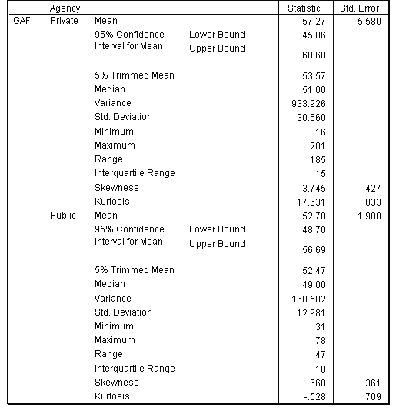

Extreme Values
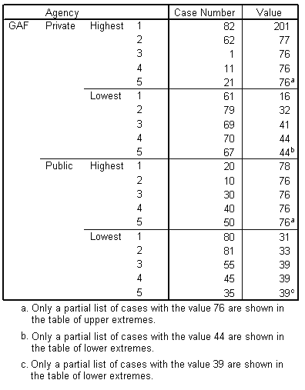
GAF Stem-and-Leaf Plot for
Agency = Private
Frequency | Stem & Leaf
1.00 | Extremes | (=<16)
1.00 | 3 . | 2
.00 | 3 .
8.00 | 4 . | 14444444
3.00 | 4 . | 567
5.00 | 5 . | 11111
5.00 | 5 . | 55555
.00 | 6 .
.00 | 6 .
1.00 | 7 . | 1
6.00 | Extremes | ( >=76)

Stem width: | 10
Each leaf: | 1 case(s)
GAF Stem-and-Leaf Plot for
Agency = Public
Frequency | Stem & Leaf
1.00 | Extremes | ( =<31)
1.00 | 3 . | 3
6.00 | 3 . | 999999
3.00 | 4 . | 334
11.00 | 4 . | 66666666999
11.00 | 5 . | 33333444444
10.00 | Extremes | ( >=69)

Stem width: | 10
Each leaf: | 1 case(s)
