Be sure to include all steps of hypothesis testing even when not asked specifically: null and alternative hypotheses, test statistic, p value, and decision.

Lane 11/12

18. You choose an alpha level of .01 and then analyze your data.
a. What is the probability that you will make a Type I error given that the null hypothesis is true?
b. What is the probability that you will make a Type I error given that the null hypothesis is false?

13. You are conducting a study to see if students do better when they study all at once or in intervals. One group of 12 participants took a test after studying for one hour continuously. The other group of 12 participants took a test after studying for three twenty minute sessions. The first group had a mean score of 75 and a variance of 120. The second group had a mean score of 86 and a variance of 100.

a. What is the calculated t value? Are the mean test scores of these two groups significantly different at the .05 level?
b. What would the t value be if there were only 6 participants in each group? Would the scores be significant at the .05 level?

Illowsky Ch 9/10
65. Previously, an organization reported that teenagers spent 4.5 hours per week, on average, on the phone. The organization thinks that, currently, the mean is higher. Fifteen randomly chosen teenagers were asked how many hours per week they spend on the phone. The sample mean was 4.75 hours with a sample standard deviation of 2.0. Conduct a hypothesis test.

Choose one of the following for this multiple choice question:
The null and alternative hypotheses are:
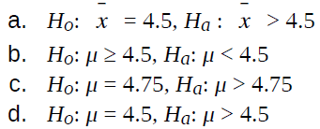

71. Previously, an organization reported that teenagers spent 4.5 hours per week, on average, on the phone. The organization thinks that, currently, the mean is higher. Fifteen randomly chosen teenagers were asked how many hours per week they spend on the phone.
Choose one of the following for this multiple choice question:

The sample mean was 4.75 hours with a sample standard deviation of 2.0. Conduct a hypothesis test, the Type I error is:
a. to conclude that the current mean hours per week is higher than 4.5, when in fact, it is higher
b. to conclude that the current mean hours per week is higher than 4.5, when in fact, it is the same
c. to conclude that the mean hours per week currently is 4.5, when in fact, it is higher
d. to conclude that the mean hours per week currently is no higher than 4.5, when in fact, it is not higher

NOTE
If you are using a Student's-t distribution for one of the following homework problems, you may assume that the underlying population is normally distributed. (In general, you must first prove that assumption, however.)

77. An article in the San Jose Mercury News stated that students in the California state university system take 4.5 years, on average, to finish their undergraduate degrees. Suppose you believe that the mean time is longer. You conduct a survey of 49 students and obtain a sample mean of 5.1 with a sample standard deviation of 1.2. Do the data support your claim at the 1% level?

80. At Rachel’s 11th birthday party, eight girls were timed to see how long (in seconds) they could hold their breath in a relaxed position. After a two-minute rest, they timed themselves while jumping. The girls thought that the mean difference between their jumping and relaxed times would be zero. Test their hypothesis.

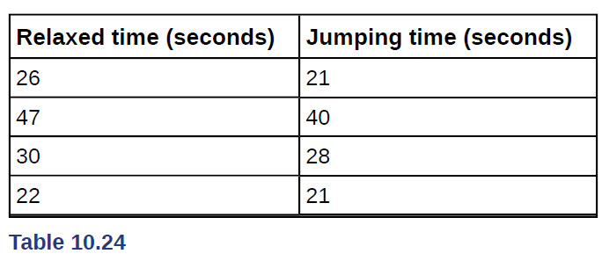

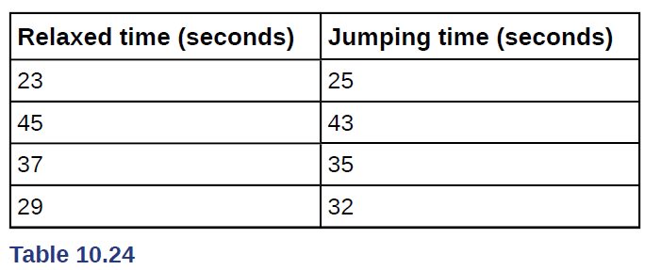

91. A powder diet is tested on 49 people, and a liquid diet is tested on 36 different people. Of interest is whether the liquid diet yields a higher mean weight loss than the powder diet. The powder diet group had a mean weight loss of 42 pounds with a standard deviation of 12 pounds. The liquid diet group had a mean weight loss of 45 pounds with a standard deviation of 14 pounds.

120. A golf instructor is interested in determining if her new technique for improving players’ golf scores is effective. She takes four new students. She records their 18-hole scores before learning the technique and then after having taken her class. She conducts a hypothesis test. The data are as follows.

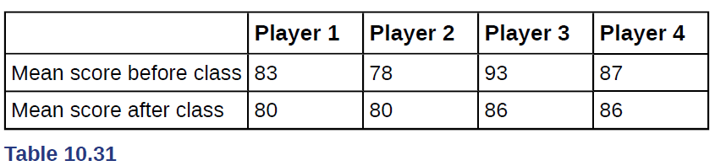

The correct decision is:
a. Reject H₀.
b. Do not reject the H₀.

