RES-845 Assignment Instructions

2 Parts
1. Identifying Variables
2. Module 2 Problem Set

1. Identifying Variables

Details:
Clearly identifying the independent and dependent variables in a study is a critical aspect of any research project. The dissertation is no different. This assignment will allow you to practice your skills in identifying research variables.

General Requirements:
Use the following information to ensure successful completion of the assignment:

- In a study investigating the effects of humor on memory, Schmidt showed participants a list of sentences, half of which were humorous and half were non-humorous. Schmidt found that participants consistently recalled more of the humorous sentences than the non-humorous sentences, demonstrating that the use of humor increased participants' recall of sentences.

- This assignment uses a rubric. Please review the rubric prior to beginning the assignment to become familiar with the expectations for successful completion.

- Doctoral learners are required to use APA style for their writing assignments. The APA Style Guide is located in the Student Success Center.

- This assignment requires that at least two additional scholarly research sources related to this topic, and at least one in-text citation from each source be included.

Directions:
In an essay (250-500 words), address the following items:

1. Identify the independent variable for this study.
2. Describe the scale of measurement used for the independent variable.
3. Describe the scale of measurement used for the dependent variable.
4. Provide an example of a simple study using Schmidt as a model. State the purpose of the research (Schmidt's purpose was to examine the effects of humor on memory), the research question (Schmidt's research question was: What are the effects of humor on memory?), the independent variable, and the dependent variable for your study.

2. Week 2: Problem Set
Details:
This problem set introduces you to an SPSS data set. You will perform some initial data screening activities and report your output.
General Requirements:
Use the following information to ensure successful completion of the assignment:
- Review "SPSS Access Instructions" for information on how to access SPSS for this assignment.
- Download “Module 2 SPSS Data File" and use it for this assignment.
- Download "Module 2 Problem Set" and use it for this assignment.
Directions:
Perform the following tasks to complete this assignment:
- Conduct necessary analyses using SPSS so you can answer the questions listed in the exercise.
- Submit your responses to the exercise questions as a Word document.
- Submit the SPSS Output files showing the analyses you performed in SPSS to compute the answers for related questions. (Note: You will need to copy the SPSS file to a Word doc for submission.)
RES-845-R-Module2.SPSSDataFile.sav.zip

RES-845: SPSS AccessInstructions.docx
SPSS Access Instructions

SPSS (Statistical Program for the Social Sciences) is a computer program that is the de-facto standard used by research institutions and universities for the completion of quantitative analysis. As a doctoral learner, knowledge of quantitative research techniques and the application of these methods as provided in the application software is a required doctoral competency. Doctoral learners are required to use SPSS during several courses to complete specific assignments. Doctoral learners may execute SPSS Base Module and Advanced Statistics in one of two ways.
SPSS Installation on Learner's PC or MAC
SPSS Base and Advanced Statistics Modules may be installed on a PC or MAC computer. The combined program is very large so please make sure you have at least 2 GB of available disk space on your computer. Once the program file is downloaded, you may access SPSS software to complete classroom assignments and perform quantitative analysis as related to your own research. Actual installation can be performed in less than five minutes after the file has been downloaded. However, the initial download may exceed 60 minutes if your Internet connection is relatively slow. In some instances when the download exceeds 60 minutes, the download may not complete. Should you experience issues when attempting to download the SPSS file, please access the SPSS Server (below). Please use the following links to obtain installation instructions and the program file:
- Instructions: How to install SPSS on your PC
- PC Download File – 32 bit
- PC Download File – 64 bit
- Instructions: How to install SPSS on your MAC
- MAC Download File
All SPSS programs installed on learner computers employ a security activation key which is in effect for 12 months. Should you receive a message indicating your SPSS software is out of date or requires a new activation key, simply follow the instructions referenced above. The update is typically completed in less than five minutes.
SPSS Server Access
The SPSS Server provides a convenient alternative method to access SPSS Base and Advanced Statistics Program via the Internet. Instead of downloading the entire SPSS program onto your computer (which can exceed 60 minutes), you may access the SPSS program via the Internet by downloading a small activation file (in less than five minutes). Once the activation file is downloaded, you may access SPSS software from any location where you are connected to the Internet to complete classroom assignments and perform quantitative analysis as related to your own research. Please use the following link to obtain instructions on how access the SPSS Server.
- Instructions: How to access the SPSS Server
Remember that when completing course assignments using the SPSS server, it is necessary to first download the SPSS data file (.SAV) prior to accessing the SPSS Server. Once the data file is download to your computer, you can OPEN the file directly from SPSS.

Technical Support
Should you encounter any technical issues when attempting to install SPSS on your computer or access the GCU SPSS Server, please contact GCU IT Technical Support at 877-428-8447. Hours of operation: Monday – Friday: 6 AM – Midnight; Saturday and Sunday: 7 AM – Midnight (AZ time). Should you require assistance using SPSS to perform analysis, please contact your GCU faculty member.

RES-845: Module 2 Problem Set Solutions
GAF, Consumer Satisfaction, and Type of Clinical Agency (Public or Private)
1. | Identify the independent variable. Identify the dependent variable(s).  AGENCY TYPE (PRIVATE OR PUBLIC). GAF and CONSUMER SATISFACTION
2. | Are there any missing values for any of the variables? If there are, what do you recommend doing to address this issue?  OF COURSE! REPLACE MISSING VALUE WITH THE MEAN OF THE ENTIRE SERIES.
3. | Were there any outliers in this data set? If outliers are present, what is your recommendation?  YES! DELETE THE ENTRY BECAUSE THE VALUE WAS NOT VALID (EXCEEDED THE POSSIBLE VALUE).
4. | Check the independent and dependent variables for statistical assumptions violations. If there are violations, what do you recommend?  THE GAF VIOLATED THE NORMALITY ASSUMPTION. ONCE THE OFFENDING VALUE IS DELETED, THE NORMALITY ASSUMPTION IS INTACT.
5. | Write a sample Results section, discussing your data screening activity.

GAF, Consumer Satisfaction, and Type of Clinical Agency (Public or Private)
Descriptives
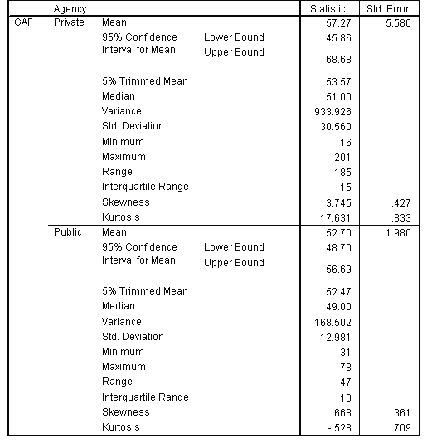

Extreme Values
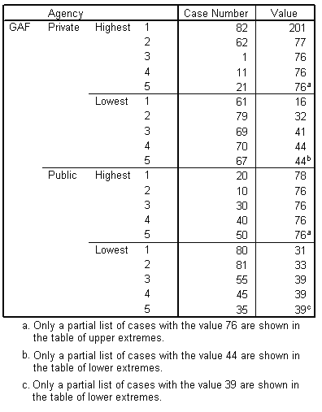
GAF Stem-and-Leaf Plot for
Agency = Private
Frequency | Stem & Leaf
1.00 | Extremes | (=<16)
1.00 | 3 . | 2
.00 | 3 .
8.00 | 4 . | 14444444
3.00 | 4 . | 567
5.00 | 5 . | 11111
5.00 | 5 . | 55555
.00 | 6 .
.00 | 6 .
1.00 | 7 . | 1
6.00 | Extremes | ( >=76)

Stem width: | 10
Each leaf: | 1 case(s)
GAF Stem-and-Leaf Plot for
Agency = Public
Frequency | Stem & Leaf
1.00 | Extremes | ( =<31)
1.00 | 3 . | 3
6.00 | 3 . | 999999
3.00 | 4 . | 334
11.00 | 4 . | 66666666999
11.00 | 5 . | 33333444444
10.00 | Extremes | ( >=69)

Stem width: | 10
Each leaf: | 1 case(s)
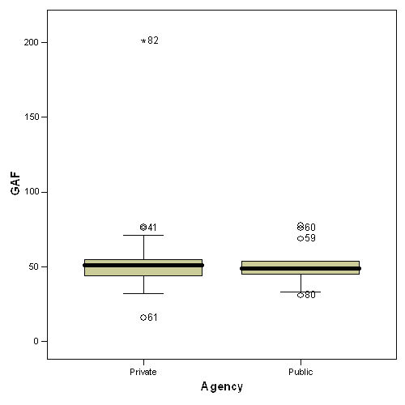

RES-845-R-Module2 ProblemSet.docx
GAF, Consumer Satisfaction, and Type of Clinical Agency (Public or Private)

This study was conducted to assess if there are differences between GAF and consumer satisfaction between public or private clinical agencies.

Use the SPSS data file for Module 2 (located in Topic Materials) to answer the following questions:
- Identify the independent variable. Identify the dependent variable(s).
- Are there any missing values for any of the variables? If there are, what do you recommend doing to address this issue?
- Were there any outliers in this data set? If outliers are present, what is your recommendation?
- Check the independent and dependent variables for statistical assumptions violations. If there are violations, what do you recommend?
- Write a sample result section, discussing your data screening activity.

