aaa - RES-845 Lecture 2

https://lc-grad3.gcu.edu/learningPlatform/user/users.html?token=CapRmgJ3PeLXTU63NmEVlgim2kR%2b25HQxQlh%2bqRczpvkQQqccTqGpjOGnd%2bQABDy&operation=home&classId=2075869#/learningPlatform/loudBooks/loudbooks.html?viewPage=past&operation=innerPage&topicMaterialId=ea5841e6-6c1b-48d8-ab83-8dceb4b5ab9c&courseId=&contentId=fe35c553-7649-4573-83a4-dde764f90113&

Using the Statistical Package for the Social Sciences (SPSS) for Data Screening and Analysis

Introduction
The Statistical Package for the Social Sciences (SPSS) is an essential tool for quantitative research. Learning to navigate SPSS is a requirement of doctoral students in their preparation for quantitative research. This module will introduce data entry, variable naming and coding, as well as screening data, using SPSS. The module will also serve as an initial practice session for becoming familiar with the basics of SPSS and for performing basic data cleaning and screening.
Basics
There are three main windows in SPSS that will be of importance: the data editor (data view), the variable view, and the output viewer.
The Data Editor
The data editor is set up like a spreadsheet. Each column is a variable and each row is a score for the same subject on each of the variables.
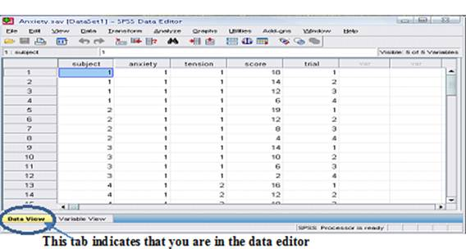

Numbers may be entered directly into this page, or they may be cut and pasted from a spreadsheet.
To save the database, go to File → Save as. The saved file will have the extension, .sav. The variable view (also saved as .sav file)
Each of the columns in the data view represents a different variable. Each of the variables has to be given a name, and the scale of measurement of the variable has to be identified. Other information is also added as needed, such as labels for discrete variables (nominal, ordinal), to keep track of what the number codes mean.
This is what the data view would look like if the variables had not been named. Notice that the row above row 1 only has headings such as VAR00001, VAR00002, etc.
Move to the Variable View to provide information about the variables.
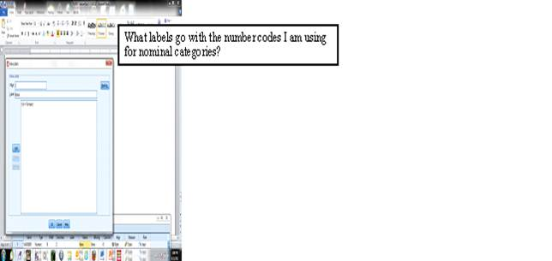

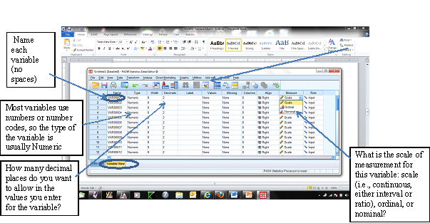
There are two independent variables that go with the above example of data: the anxiety level and the tension level of a work group. In this 2 X 2 factorial design, each participant is put into one of four conditions of a contrived asynchronous online work group over a 4-week period: the group behaviors (posts) of the others are designed to show low anxiety with low tension, OR low anxiety with high tension, OR high anxiety with low tension, OR high anxiety with high tension. The dependent variable is the participant's score for the total number of constructive posts she or he posts in a one-week period. The trials variable indicates the time for the repeated measure: 1 = total posts during week 1; 2 = total posts during week 2; 3 = total posts during week 3; and. 4 = total posts during week 4. Thus, the completed variable view could look like this:
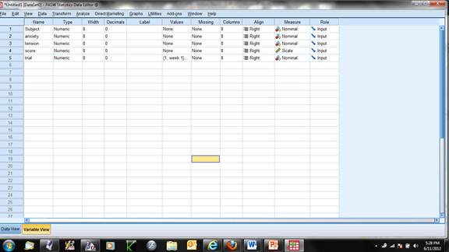
The Output Viewer
After SPSS conducts an analysis, the results will be displayed in the output viewer. It will also indicate if there are errors. When the information in the output viewer is saved, the file will have the extension, .spv.
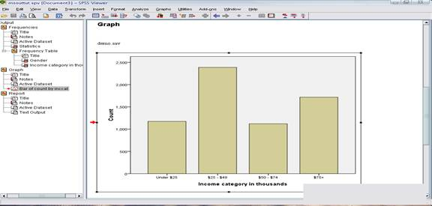
When you download a dataset (.sav file) as part of your assignments, the data view and variable view will be completed for you. You will create output views as you do the exercises.
Computing Frequency Counts and Descriptive Statistics
The first analyses you will run in SPSS will be to receive basic descriptive statistics of your data. For continuous variables, basic descriptive statistics include information for each variable, such as total N (total data points), frequency of occurrence of each value in the variable, cumulative frequency, minimum value, maximum value, range, mean, standard deviation, skewness, and kurtosis.
Consider the following data. Here for gender, 1 = female, and 2 = males. Compute some descriptive statistics for the two continuous variables, height and weight.
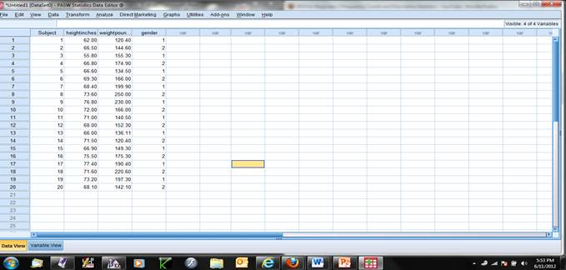

To do this, go to the tool bar and find "Analyze." Click on this to reveal a dropdown menu. Select "Descriptive Statistics" from this menu, and a second menu will appear; select "Descriptives" from this menu.
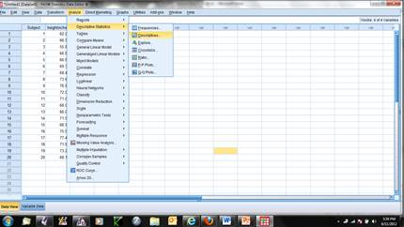
After selecting "Descriptives," a box appears from which the user can select the variables for which descriptives are desired. Also provided are options for what in particular is desired from the analysis. In this instance, the researcher moves the variables heightinches and weightpounds from the left box to the right box by highlighting the variable and then clicking on the arrow between the boxes. Clicking on Options presents the researcher with the next box in which the descriptive statistics desired as output can be checked. In this case, the researcher has chosen mean, standard deviation, minimum and maximum values, range, skewness, and kurtosis. Close the Options box by clicking on Continue. The data is now prepared for SPSS to compute these. Click on OK at the bottom of the Descriptives box.
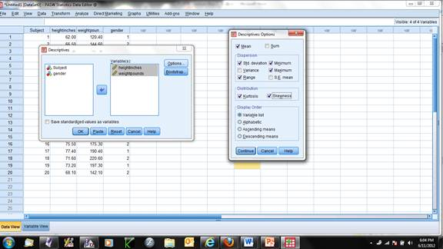
The output screen will pop up while the program is performing these analyses. Within a few seconds, the answers appear. Here is the output screen for these analyses:
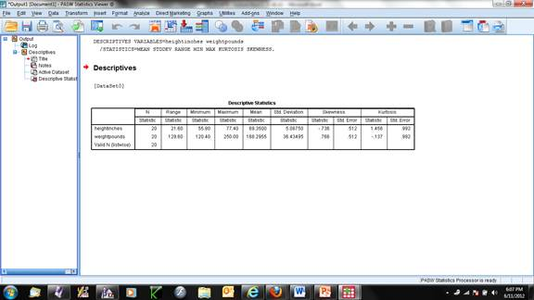

This information, plus frequency counts, could also be obtained by choosing Frequencies, instead of Descriptive Statistics, from the Analyze menu. The process would look something like this:
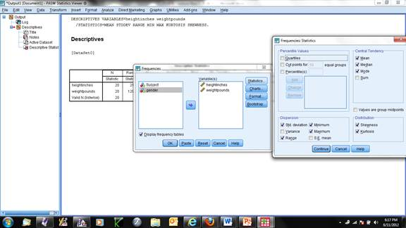
In addition, clicking on the Charts option and selecting how the frequencies should be presented gives the following:
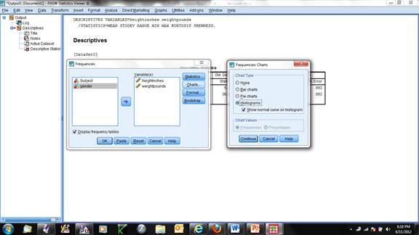

Using the above with these selections gives the following in the output window:
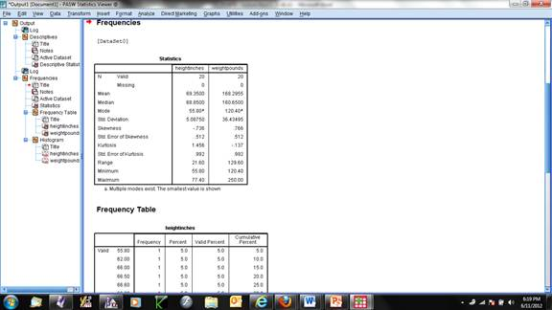

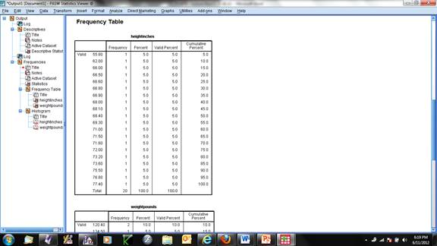

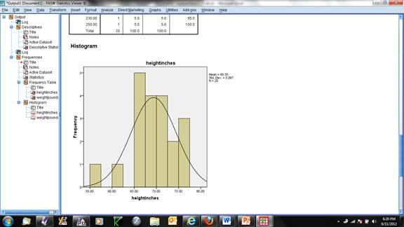

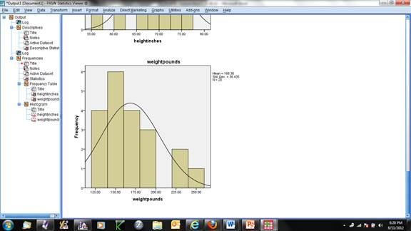
You will be carrying out various activities using SPSS to describe data and to evaluate the data in terms of underlying assumptions, which were discussed in Module 2.
Conclusion
This module reinforces the notion that every statistical analysis is based on assumptions about the nature of the data. Before a researcher can perform a statistical analysis, whether univariate or multivariate, he/she must make sure that the data are accurate and fit the assumptions of the intended statistic.

