What is the value of tan A ?

15/17
15/8
8/15
8/17
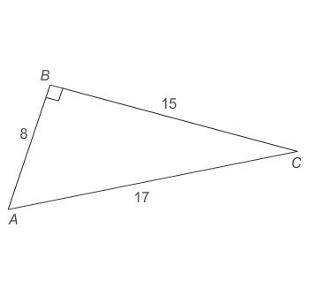

2. Which angle has a sine value of 24/25 ?

∠F
∠E
∠D
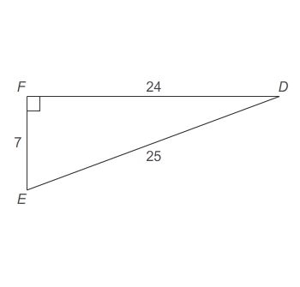

3. Right triangle ABC is similar to right triangle DEF . The cosine of angle A is 4041 .
What is the exact value of cosF ?

40/41
40/9
9/40
9/41

4. Right triangle PQR is similar to right triangle UVW . The tangent of angle U is 2845 .
What is the exact value of sinP ?

45/53
45/28
28/53
28/45
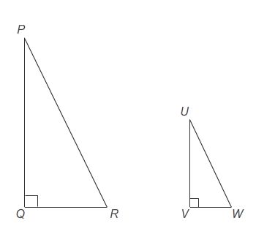
5. Melissa is standing 40 ft from a tree. The angle of elevation from where she is standing on the ground to the top of the tree is 50°.
How tall is the tree?

Round the final answer to the nearest tenth.
Enter your answer in the box.

