Data Analysis Assignment #3
Spring 2017
STAT 250

Your submitted document should include the following items. Points will be deducted if the following are not included:
- Type your Name, STAT 250 with your correct section number (e.g. STAT 250-xxx) and Data Analysis Assignment #3 centered on the top of page 1 of your document.
- Number your pages across your entire solutions document.
- Your document should include the ANSWERS ONLY to the following FOUR questions with each answer labeled by its corresponding number and subpart. Keep the questions in order. Do NOT include the questions in your submitted document.
- Generate all requested graphs and tables using StatCrunch.
- Upload your document onto Blackboard as a Word or pdf document using the link provided by your instructor.
Elements of good technical writing:
Use complete and coherent sentences to answer the questions.
Graphs must be appropriately titled and should refer to the context of the question.
Graphical displays must include labels with units if appropriate for each axis.
Units should always be included when referring to numerical values.
When making a comparison you must use comparative language, such as “greater than”, “less than”, or “about the same as.”
Ensure that all graphs and tables appear on one page and are not split across two pages.
Show all mathematical calculations when directed to compute an answer ‘by-hand.’
When writing mathematical expressions into your document you may use either an equation editor or common shortcuts such as: can be written as sqrt(x), can be written as p-hat, can be written as x-bar.

Instructions
This data analysis assignment will use both StatCrunch applets to simulate random actions and the results from a survey administered to a nationwide random sample of high school students found in our StatCrunch group titled CensusAtSchool.
We will consider the survey results as our population for the following questions.
Question 1
The CensusAtSchool data set contains results from a survey question in which students were asked “Which is your favorite season? Spring, Summer, Fall or Winter.” The survey results, rounded to two decimal places, are shown in the table below.
Frequency table results for Favorite_Season:
Count = 450
Favorite Season | Frequency | Relative Frequency
Fall | 152 | 0.34
Spring | 68 | 0.15
Summer | 132 | 0.29
Winter | 98 | 0.22

However, what if we are only interested in the percent of students who stated that Summer was their favorite season. Now, there are only two possible responses, Summer or Not Summer. The revised table is shown below.
Favorite Season | Frequency | Relative Frequency
Summer | 132 | 0.29
Not Summer | 318 | 0.71

1a. We are planning to select 40 people from our data set. Calculate ‘by-hand’ the standard error for the proportion of people who stated that Summer was their favorite season in a sample of size 40. Show work including the formula and round your answer to four decimal places.

For parts 1b-1c:We will now use an applet to investigate sampling distributions of a proportion. Under Applets, open the Sampling distribution applets shown below. Enter the value for p, the proportion of students whose favorite season is Summer in the “Population: binary”, then click on compute.
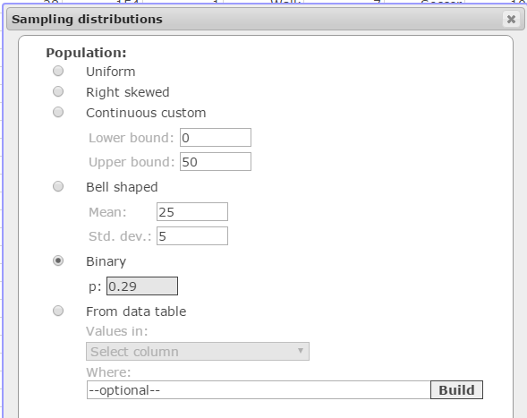
Under ‘Binary’ enter the proportion of students whose favorite season is Summer.
1b. Simulate selecting one sample of size 40 by first entering the sample size and then clicking ‘1 time’. Copy your results into your document.
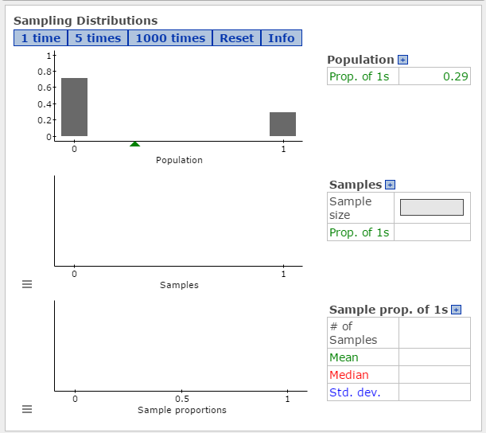
1c. Click ‘Reset’ on the top bar to start over and now click ‘1000 times’ using a sample of size 40. Copy your results into your document.
1d. In a sentence, compare the value of the standard deviation of the sample proportions found in the output of your 1000 simulations to the value of the standard error calculated in part 1a.

1e. Describe the shape of the graph of “sample proportions” for students whose favorite season is “Summer” shown in part 1c and also compare its mean to the population mean of 0.29.

Question 2
For this question, we will investigate how a change in the confidence level affects confidence intervals for population proportions. We will use the StatCrunch applet shown below. Let the population proportion be 30% (p = 0.30) and sample size, n, equal to 100. Throughout this question, both n and p will remain constant but the confidence level will vary.
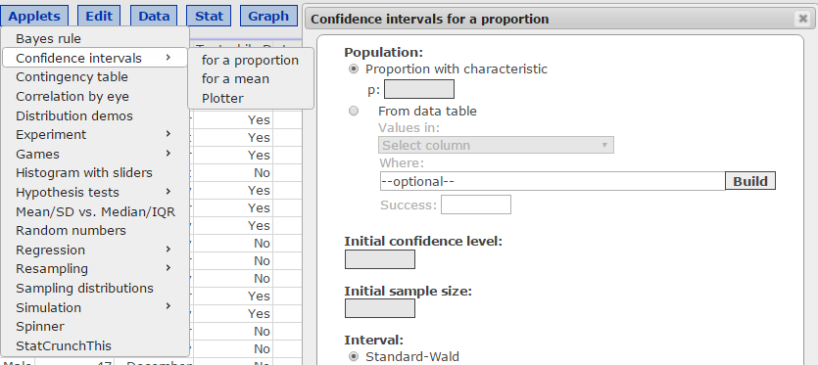
Box 1: Enter the given population proportion, 0.30

Box 2: Enter the given confidence level. Start with 0.90
Box 3: Enter the given sample size, n=100
2a.Use the applet to construct 1000 intervals following the steps below.
Step 1: Open the applet as shown above.
Step 2: Enter the values for p and n given above.
Step 3: Enter the confidence level of 0.90
Step 4: Compute!
Step 5: Use the Reset button to clear the screen
Step 6: Select 1000 intervals.

Copy your graph into your document.

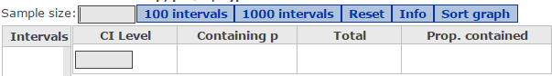

Use the CI Level box for parts 2c and 2e

2b. In a sentence, compare the “proportion contained” value shown in your graph to what we would expect this value to be when using of a 90% confidence level.
2c. DO NOT HIT THE RESET BUTTON! Change the “CI Level” box to 0.95. Copy the graph into your document.
2d. In a sentence, compare the “proportion contained” value shown in your graph to what we would expect this value to be when using a 95% confidence level.
2e. DO NOT HIT THE RESET BUTTON! Change the “CI Level” box to 0.99. Copy the graph into your document.
2f. In a sentence, compare the “proportion contained” value shown in your graph to what we would expect this value to be when using of a 99% confidence level.
2g. In a sentence describe what happens to the width of the confidence interval as the confidence level increases but everything else (p and n) remains constant.

Question 3
Item #30 on the Census at School survey asked the high school students the following question:
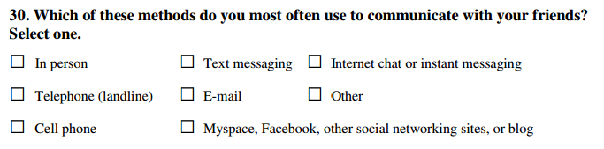

Fifty-eight percent of the students stated that “Text messaging” is the most often used method to communicate with their friends. We will use this value as the population proportion (parameter) representing the percent of all high school students who use “Text messaging” as their preferred method of communicating with their friends. We will use StatCrunch to select a simple random sample of 40 students from our population by following the steps below.
Step 1: Select Data -> Sample
Step 2: Select the column Communication_With_Friends
Step 3: Enter a Sample size of 40


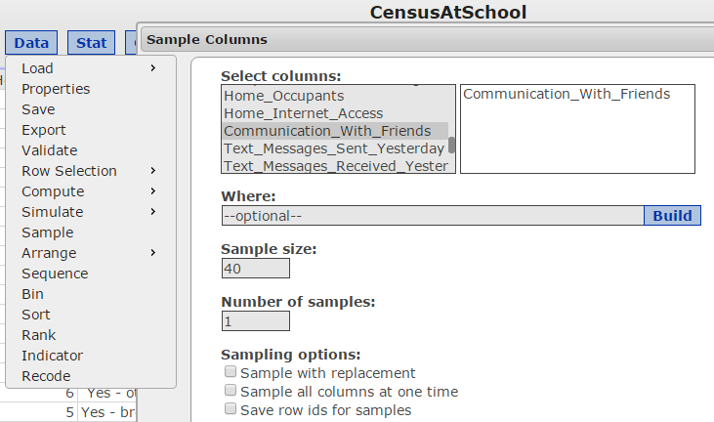
IMPORTANT!
Scroll down to the bottom of the page and check this box before you hit Compute!

You should now see a new table that contains your sample of 40 students.
3a. Find the proportion of students in your sample of size 40 who use “Text messaging” as their preferred method of communicating with their friends by selecting STAT →Tables → Frequency and then selecting Relative frequency.
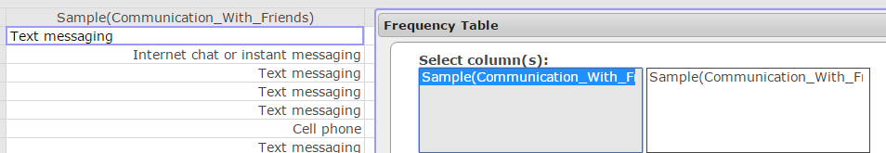
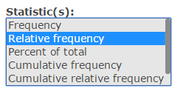
Copy this table into your document and state the proportion of students in your sample of size 40 who use “Text messaging” as their preferred method of communicating with their friends rounded to two decimal places.
3b. You will use your sample data to construct a confidence interval. Since we selected a random sample from the population and our population is at least ten times larger than our sample of size 40, we must only check that the final condition required to apply the CLT (the sample is large enough) has been met. Perform this necessary check, show all calculations and state if all conditions have been met.
3c. Regardless of your answer to part 3b, now use StatCrunch and your sample of 40 students to construct a 95% confidence interval for the proportion of students who use “Text messaging” as their preferred method of communicating with their friends.
Step 1: Select STAT->Proportion Stats ->One Sample->With Data
Step 2: Select your sample, enter Text messaging in the success box and select confidence
interval
Copy and paste the result into your document.
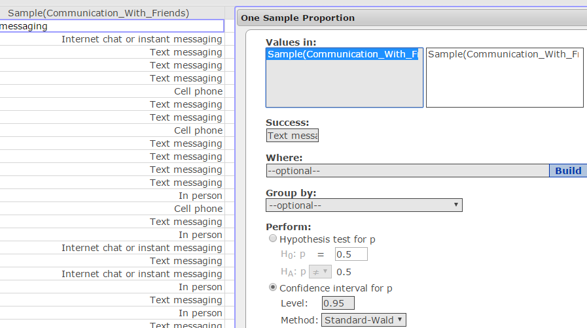
In the Success box type: Text messaging
Note: case sensitive

3d. Use your result from part 3c to state the lower and upper limits of the confidence interval as a percentage rounded to one decimal place in the following format (lower limit %, upper limit %).
3e. Interpret this confidence interval in a complete sentence in the context of the question.
3f. Recall that the population proportion was found to be 58%. Does your confidence interval support this value? Explain your answer in a sentence.
Question 4
According to the American College of Allergy, Asthma, and Immunology, 40% of all children have allergies. A high school teacher believes that the percentage of high school students who have allergies is more than 40%. In order to test her claim, she will take a sample of size 30 from the population of high school students. (Recall that we are using the CensusAtSchool data set as the population).
4a. State the null and alternative hypotheses for this claim, defining the researcher’s parameter of interest.

You will now select a sample of 30 students from the CenusAtSchool data set using the same procedure used in question #3 to test the hypotheses in part 4a.
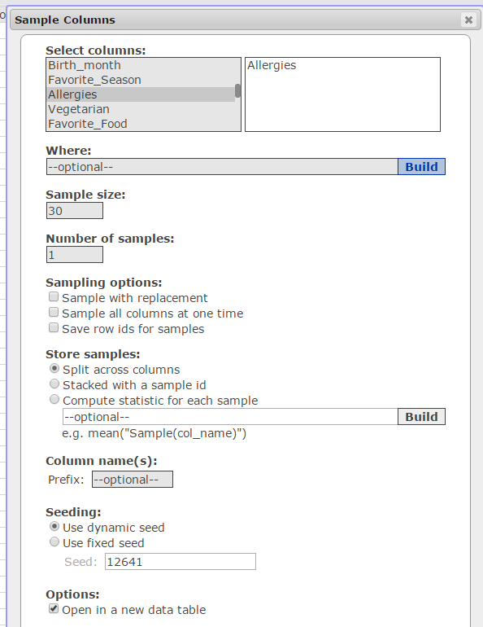
Step 1: Select Data -> Sample

Step 2: Select the column Allergies

Step 3: Enter a Sample size of 30
IMPORTANT!
Scroll down to the bottom of the page and check this box before you hit Compute!

4b. Use StatCrunch to conduct this hypothesis test by following the steps below:
Step 1: Select STAT->Proportion Stats ->One Sample->With Data
Step 2: Select the variable, Allergies, enter Yes for success.
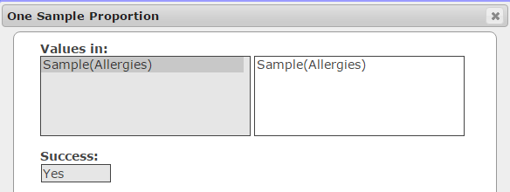
Warning: Case sensitive
Step 3: Enter the values for the null and alternative hypotheses from part 4a.
Step 4: Click Compute!
Copy and paste your results into your document.
4c. Verify the value of the test statistic, Z-Stat, shown on the output in part 4b by calculating this value ‘by-hand.’ Show the formula for the test statistic (shown in your formula packet) with the correct values substituted into the formula.
4d. State and explain the meaning of the p-value shown in your output from part 4b in the context of the question.
4e. Using a significance level of 0.05 and your p-value, do you reject or fail to reject the null hypothesis? Justify your answer in a sentence.
4f. Based on your decision in part 4e, state your conclusion regarding the teacher’s claim in a complete sentence.

