Part One:

What I Know:

- I know that parents want physical education to be taught as other subjects in schools.
- I know that type two diabetes is caused because of overweighting.

What I Don’t Know:

- Obesity is a major issue and increasing among children in the United States.

What I Want to Know:

- Are teachers trying to help students to participate in physical activities in shcools?
- What are the reasons that prevent students from doing physical activities in schools?
- What should students and their parents and teachers do to reduce the probability of obesity?

Part Two:

Physical education (PE) is an area that teaches students about physical activity. It covers the best ways to engage in physical activities and the best physical activities to practice at particular times. A large number of parents suggest that physical education is as important as other subjects taught in schools. The parents and the teaching bodies in all the departments properly appreciate physical education in the USA as the study reveals (Burgeson, 2011).

Physical activities are among the most crucial aspects of a healthy development, and good performance of children. According to the US department of Health and Human Services, children are supposed to engage in physical activities for approximately 60 minutes in a day. The National Association for Sport and Physical Education (NASPE) has set up policies for schools to ensure physical education programs are implemented in the institutions with the use of appropriate facilities and channels (Washington, DC: U.S Department of Health and Human Services, 2008).

The significance of having physical education in school is to control and prevent youth from obesity and overweight (Kahan and Mckenzie, 2015). In nowadays, the main health concern for children and adolescents is obesity. According to the Centers for Disease Control and Prevention (CDC), in the past thirty years, obesity has more than quadrupled in adolescents and doubled in children. The physical education time decreased from 2000 to 2006, according to the report of the Government Accountability Office (GAO). Skolnikoff and Engvall suggested from schools to address “real world needs” such as teaching students to make better lifestyle choices and preparing them to enter the workforce (2016).
Some reasons prevent students from doing physical activities. Students had pressures in public schools to meet performance objectives that get rid of time for physical activities. Also, teachers of physical education noticed that students attitudes prevent them from success in the course. If they are not interested in physical activity, they call students who are interested as “nerds” or “geeks” (Skolnikoff and Engvall, 2016).

Physical Education is a key to reduce and prevent the probability of obesity among students in the United States. Students need to excess energy intake to prevent overweight problem (Kahan and Mckenzie, 2015). Energy Expenditure (EE) is the amount of calories or energy that a person has to carry out a physical function such as digesting food, circulating blood, breathing, or physical movement. It is a measure in kilocalories or calories. For people to lose weight, they should learn how to burn lots of calories than they eat. Therefore, they need to decrease calorie intake, increase energy expenditure, or do a combination of both to establish a calorie deficit (Scott, 2016).

Kahan and McKenzie created table 1. It is about EE formulas and data calculation. They determined the estimated cumulative EE per class for elementary, middle, and high schools. They calculated the estimated EE data: (1) Kilo-calories for girls and boys per grade (1-10) according to both average state policy guidelines and National Association for Sport and Physical Education (NASPE), (2) Kilo-calories per class per school level according to both average state policy guidelines and NASPE, and (3) ten years cumulative Kilo-calories for girls and boys across grade (1-10) according to both NASPE and average state policy guidelines (2015).

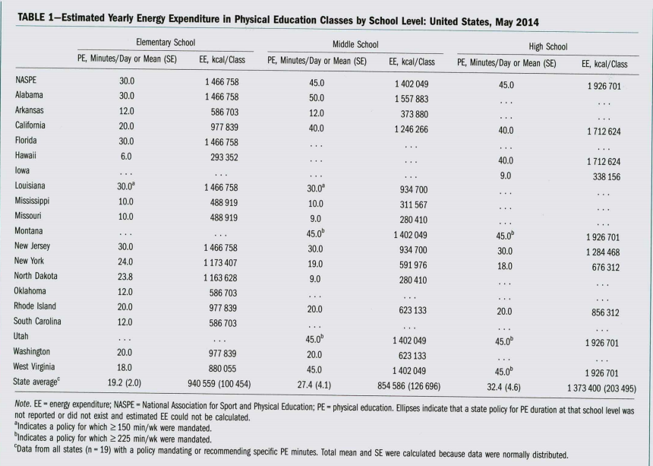

Kahan and McKenzie noticed the large variability across the three school levels and the sataes for both the estimates EE and the Physical Education (PE) minutes per day. For instance, at elemntary school, the comulative estimated EE for New Jersey, Louisiana, Florida, and Alabama was 1 466 758 kilocalories across grades (one through six), which was five times higher than Hawaii. At middle school, the range of more than one million kilocalories between North Dakota and Missouri (280 410 kcal) and Alabama (1 557 883 kcal) reflected a variation of more than five times between duration guidelines. At high school, the range of 1.6 million between the states: West Virginia, Iowa, Utah, and Montana reflected a variation of five times between the Physical Education duration guidelines. Altogether, the NASPE recommendations were higher than the mean state guidelines for PE minutes per day for elementary (10.8 min; 69.6%), middle (17.6 min; 60.9%), and high (12.5 min; 72.2%) schools (2015).

