Microsoft Excel 2013
Introductory Data analysis and presentation
EXCEL WORKSHOP
This workshop contains exercises that cover the following procedures:
- Simple calculations, including summation and averaging data, and filling down data series
- A column chart with one data series
- A column chart with two data series
Note: This document is best viewed in ‘Print layout’ format. In order to copy numerical values from tables in the document and paste them into Excel, you will need to first save this file to your H: drive

Tips on using this Workbook
Home ribbon, Data ribbon = terms used by Excel to refer to part of the toolbar

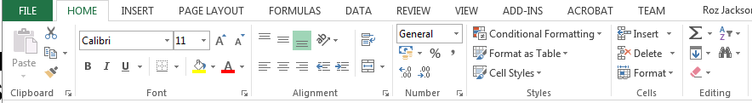
Instruction:
Font tab ≡ name of a tab (e.g. on the Home ribbon)
‘Enter’, ‘Ctrl’, ‘Alt’ ≡ keys on the keyboard
⇒ ‘Font’ ⇒U = point cursor at relevant Tab (e.g. ‘Font’ tab) on the ‘Home’ ribbon, then click on the required icon (e.g. ‘Underline’) with the LH mouse button
‘Ctrl’ + C = hold down both keys at the same time
Type “Date” = type whatever is inside the quotation marks, but omit the quotation marks
Type “a suitable title” = input an appropriate title for this table, graph, etc. (do not write what is written in italics)
Type =AVERAGE( = type exactly whatever is written in bold
NOTE: If the ribbon and tabs are not visible, then select the ‘Ribbon display options’. It is advisable to select the ‘Show Tabs and Commands’ option

A. Perform simple calculations in Excel, including summation of data
Exercise objectives:
By the end of this exercise, you should be able to:
- Input data into Excel worksheets within the same workbook
- Format a table in Excel
- Use text wrapping in column headings
- Perform simple calculations in Excel
- Sum and average data
- Copy equations
Exercise outline:
A company’s monthly balance sheet for 2009 is shown in Table 1. You are required to determine the net profit for each month and the total income, expenditure and profit for 2009.
IMPORTANT NOTE:
Read the instructions A.1 to A.5 before you start inputting the data in Table 1.
Table 1: Income and expenditure in 2009
 | Income  (£) | Expenditure (£)
Jan | 256 | 291
Feb | 365 | 310
Mar | 414 | 345
Apr | 514 | 389
May | 498 | 411
Jun | 532 | 404
Jul | 467 | 387
Aug | 371 | 378
Sep | 538 | 415
Oct | 487 | 421
Nov | 520 | 431
Dec | 357 | 351

IMPORTANT:
For this exercise, DO NOT use the ‘Insert Table’ facility in Excel and DO NOT use shading (for column headings, etc.).
Input the data in Table 1 into an Excel spreadsheet (Sheet 2) as follows:
A.1 In cell A1 write “Table 1. - plus a suitable title for this data”
Write “Income (£)” in cell B3 and “Expenditure (£)” in cell C3 and “Profit (£)” in cell D3. The ‘Centre’ the text of the column headings

To Centre Text
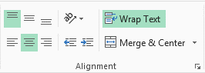
⇒ Highlight cells B3-D3,
⇒‘Alignment’ tab on the ‘Home’ Ribbon
⇒ click on the ‘Centre’ function

NOTE: Alignment of text in Tables
Always left-align all the text or numbers in the first column of a table
NOTE: Table Titles
Always input the table title in the same column as the first column of data and left-align the text. DO NOT make the first column as wide as the table title (as the text in the title will automatically be spread across the other columns, so long as it is left-aligned).
A.2 Text wrapping:
Highlight the column headings, e.g. cells B3-D3
In the ‘Home’ Ribbon ⇒ ‘Alignment’ tab ⇒ Wrap Text.
Adjust the width of the column so that the (£) is shown in the line below the heading in each column.
Note, you may need to also adjust the height of the row to see the (£) below each of the headings.
To alter the height of a row:
- move the cursor to the column of column labels (1, 2, etc. in grey boxes at the far left of the spreadsheet), to the dividing line between two of the grey boxes of numbers, the cursor should change to a bi-directional arrow, click on this, hold down the mouse key and drag to widen the column.
A.3 Top align text
To display the column headings at the top of their row:
Highlight the relevant column headings
In the ‘Home’ Ribbon ⇒ ‘Alignment’ tab ⇒ Top alignment
A.4 Input the months in column A. Input “Jan” in cell A4 and use ‘Fill down’ to add the remaining months to December
‘Fill handle’
Note: Using ‘Auto fill’
Highlight the cell containing ‘Jan’ (using the LH mouse button), then point the cursor to the at the bottom right-hand corner of the highlighted area - the cursor will change to a cross (+). Hold down the mouse button and drag the cursor down the required number of additional cells (12 cells in total for 12 months). Excel will automatically fill in the remaining months.
A.5 Input the values shown in Table 1 in columns B and C
Either type in the numbers in the Excel table OR (if you are using an electronic version of this workbook) highlight the numbers in the Word file ⇒ ‘Ctrl’+C ⇒ in cell B4 of Excel worksheet ⇒ ‘Ctrl+V’ to paste the values.
Note A: Simple Calculations in Excel
- write your calculation in an empty cell
- all calculations must start with “=”
- Excel uses the following symbols in calculations:
subtract: -
add: +
multiply: *
divide: /
- To perform a simple calculation using data in different cells, input the cell addresses into the equation, e.g.
To add the number in one cell (B4) to the number in the next cell (C4), the equation would be for example:
=B4+C4
as soon as you ⇒ ‘Enter’ after inputting the equation, Excel will calculate the answer.
- It is not necessary to type the address of each cell into the equation. If you go to cell D4 and type “=”, then click on the number in cell B4, Excel will automatically write B4 in your equation. You then type “+”, then click on the number in cell C4, this will then be added to your equation.
A.6 Calculate profit: for each month:
NB: Profit = Income - Expenditure
In cell D4, type the equation: =B4-C4 ⇒ Enter
To copy this equation to the other cells in column D:
Highlight cell D4, using the LH mouse and the ‘Fill handle’, drag down the required number of cells to calculate profit for Feb to Dec
NOTE: Using fill-down to copy equations)
Highlight the cell containing the first equation, point the cursor at the ‘fill handle’, i.e. at the at the bottom right-hand corner of the highlighted area - the cursor will change to a cross (+). Hold down the LH mouse button and drag the cursor down the required number of additional cells. The equation will be copied to every cell.
A.7 Sum the Income, Expenditure and Profit for the whole year as follows:
Highlight the empty cells below the columns of numbers (i.e. cells B16-D16) and click on in the ‘Editing’ tab

(NB: this is the quick method for summing data, when the sum calculation is in a cell immediately next to a list of data)
Write a suitable heading in cell A16, e.g. “Total”

Note B: Simple statistical calculations in Excel
To perform statistical calculations on a range of data, the cells containing the data range need to be given in brackets, as shown:
(B4:B15)
- Equation to sum a series of numbers:
=sum(B4:B15)
- Equation to average a series of numbers:
=average(B4:B15)
- Equation to count a series of numbers:
=count(B4:B15)
- Equation to determine the maximum number in a series:
=max(B4:B15)
- Equation to determine the minimum number in a series:
=min(B4:B15)

A.8 Calculate the monthly average income:
In the cell below the total income (calculated in A.7), type “ =average( “ then using the LH mouse, highlight the monthly income values to be averaged, i.e. cells B4 to B15 ⇒ Enter
NB: Using this method, it is not necessary to type the “ ) “ at the end of the equation, as Excel inputs this automatically.
Write a suitable title for this row in cell A17
A.9 Calculate the monthly average expenditure and profit:
NB: It is not necessary, to input equations for each of these, as the equation for average income can be copied across.
Highlight the cell containing the equation for average income in column B ⇒ use the LH mouse to click on the ‘Fill handle’, drag across to the adjacent cells in columns C and D

B. Use of a column chart to plot a single data series
Exercise objectives:
By the end of this exercise, you should be able to:
- Input symbols
- Produce a column chart with only one data set
Exercise outline:
Mercury has been widely used in Brazil in the extraction of gold; this has led to high concentrations of this mercury in many rivers. In order to see whether the coastal waters off Brazil were also becoming contaminated with mercury, samples of sediment were taken from a number of stations off the Paraiba do Sul River, Brazil (the site of each sampling point is shown in Figure 1). The mercury content of each sediment sample was analysed.
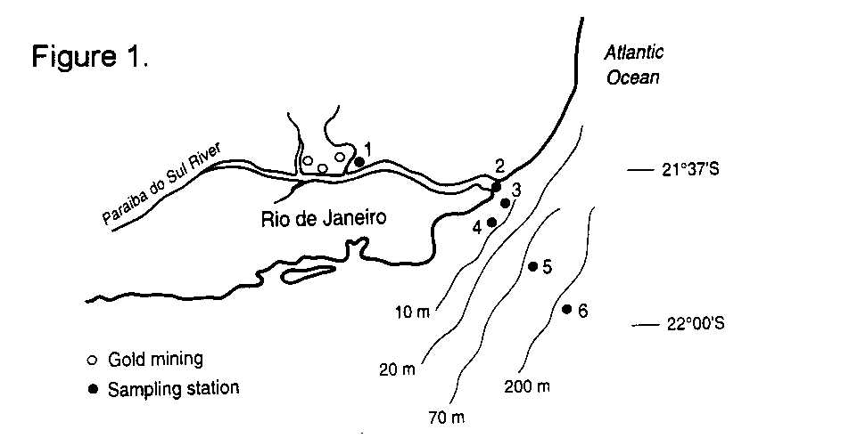

Table 2: Mercury content of sediment from the coastal waters off the Paraiba do Sul River, Brazil
Station Mercury (µg/kg dry wt.)
1 545
2 209
3 198
4 178
5 105
6 95

B.1 Data input
Open a new worksheet in the same Excel file you were using for the Excel Workshop 2 exercises (which should be saved to your H:drive). NB: It may be necessary to insert a new worksheet.
To input a new worksheet into an existing workbook (i.e. within the same file)
In a new Excel workbook, you are provided with one worksheet (Sheet1) in which to input data. To add extra worksheets within the same workbook, i.e. the same file:
- Use the ‘New Sheet’ button (next to the ‘Worksheet tabs)

B.2 Input the data into a new Excel worksheet, producing a suitable table and headings as in previous exercises
NB. To type “µ” ⇒ ‘Insert’ ribbon ⇒ Symbol, highlight the required symbol (if it is one of the most recently used ones).
If the symbol is not shown ⇒ More Symbols ⇒ Scroll down to find the required symbol ⇒ Insert ⇒ Close
B.3 Produce a Chart (graph) of this data:
Highlight the cells containing the station number and mercury data (do not include the column headings.
⇒ ‘Insert’ ribbon ⇒ Charts tab ⇒ ‘Column’
⇒ select the 2-D Clustered Column option

B.4 Format the chart axes
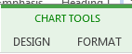
You can now use the ‘Chart Tools’ functions and ‘Chart Elements’ to edit you chart or the data in the chart.

Show the axes lines on your chart
Highlight the vertical axis on your chart, in ‘Chart Tools’ select Format, then ‘Format selection’. The ‘Format Axis’ pane will appear on the right of the spreadsheet.
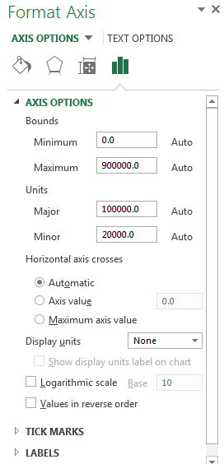
In the ‘Format Axis’ pane, select Text options’ then ‘Tick marks’

Select the following tick mark option:
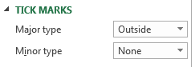
If the vertical axis line is not visible, select the ‘Fill and Line’ option. Then in ‘color’, select black

Repeat the above instructions, this time highlighting the horizontal axis. Then close the ‘Format Axis’ pane

B.5 Remove the gridlines
Click on ‘Chart Elements
Chart Elements
Deselect ‘Gridlines’. Your chart should now look like this:
B.6 Label the chart
In the ‘Chart Elements’ menu, select ‘Axes Title’
Input the following labels for the axes
‘Primary horizontal’ axis = Sample Station
‘Primary vertical’ axis = Mercury (µg/kg dry wt.)
NB: To insert text into an axis label box, click on the box on the graph, write the text in the ‘Formula bar’ (as shown below), then click ‘ENTER’
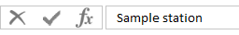
- Click on the X & Y axes labels and increase the font size to 11
- Change the axis label colour to black

The graph should look as follows:

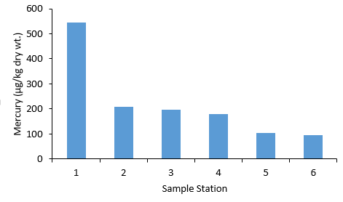
C Use a column graph to plot more than one data series
Exercise objectives:
By the end of this exercise, you should be able to:
- Produce a bar chart for two (or more) data series
- Add labels to a chart
Exercise outline
Welch et al. (2000) studied the microbial quality of water sources in rural communities of Trinidad in 1998. They sampled 167 homes and obtained the following results.
Table 3: Percentage of samples contaminated with total and faecal coliforms.
 | Percentage of Household supplies contaminated
Source | Total coliforms | Faecal coliforms
Piped supply | 55 | 40
Standpipe | 87 | 72
Truck | 90 | 70
Rain water | 92 | 55
Spring or well | 84 | 78

C.1 Input the above data into a new Excel worksheet
- Input the title for your table. Leave a row between the title and the table column headings
- Do not leave spaces between rows or between columns within the table
- Type the column headings. To make the table appear as above, widen the first column to fit the heading text (as instructed in earlier exercises), but NOT so that it fits the whole of the table title!
To make the column headings appear as in the table, use text-wrapping (see A.2)

C.2 Produce a Chart (graph) of this data:
The only suitable graph for data based on different sample sources is a bar chart, with the water sources plotted on the X-axis.
Using the mouse, highlight the data headings, i.e. the row immediately above the columns of numbers and the cells containing the sources and the data (DO NOT include the ‘Percentage of Household supplies contaminated’ row)
⇒ ‘Insert’ ribbon ⇒ Charts tab ⇒ ‘Column’
⇒ select the 2-D Clustered Column option

C.4 Format the Chart axes
Format the chart axes as in B.4-B.5
C.5 Input suitable labels on the chart
See B.6
- Input the following labels for the axes
‘Primary horizontal’ axis = Water source
‘Primary vertical’ axis = Households (%)

C.6 Move the Legend
Select ‘Chart Elements’, ‘Legend’ and ‘Right’

The graph for this data should be presented as follows:
Figure 1 Microbial quality of water sources in rural communities of Trinidad in 1998 (adapted from Welch et al. 2000)

D. NOTES ON CHARTS
- To produce a chart, the data that corresponds to the X-axis (horizontal axis) should be in the left-hand column of the data table in Excel.
- The label on the Y-axis should be parallel with the axis
- If there is only one data set on a graph, i.e. one line or one set of columns, then there should be no legend on the graph
- If you intend to copy and paste the graph into a Word document, do not insert a title on the graph in Excel. The graph should have only one title and the title should be shown beneath the graph in the Word document and labelled as Figure 1, etc. (as shown above)

